**Tired of kids whining during their walks? Feeling like you don't have enough time in the day to fit both fun and education in?**



**THE LEARNING**

**WALKS**

**Looking for a way to make your walks fun, educational, and enjoyable for both you and your little humans?**

**Then congrats! These walks are filled with fun, inspiration and specific ideas to make your time more enjoyable and help you both challenge yourselves!**

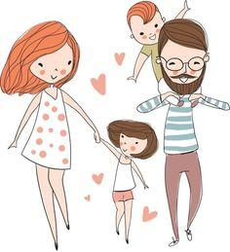

**A few notes for parents**

**Welcome!**

In the busy world we live in, many have a hard time fitting our own lives, chores, quality time with kids, and some education in. I’ve tried life on both sides of the fence: as a working mom, and as a stay-at-home mom as well. Many believe that as a stay-at-home parent one has much more time to spend with the little humans, and even though it is true to an extent, in most cases it comes with other responsibilities, and fitting everything in is a huge challenge. I designed The Learning Walks as an answer to both of these problems. Through taking my approach, you will be able to fit quality time, fun, and learning into your time with your little ones. Some of these walks require a short prep, some can be done without it. 

**The structure**

Most walks have a similar structure, including a prep for the walk or a short brief for parents; a check list; the walk itself with guidance what to look for and how you can explain it to your kids; fun facts (sometimes both for kids and parents to help you stay excited during the walk, after all research shows that excited parents bring up excited children); interesting stories; additional ideas & games revolving around the theme; some walks have an experiment; and Imaginarium that helps your kids get their creative juices flowing and work on their imagination and creative thinking.

**Additional guidance**

* **Try to show and surprise your kids rather than explain and lecture**, at this age this helps them focus and lengthens their attention span
* **Playing is the natural way of learning in toddlers and preschoolers. The areas of their brain responsible for assiduity, willpower and longer attention spans aren’t developed yet, so trying to have them sit and learn is counter-productive**, and in the worst cases can even deter your kids from willingly engaging in educational activities later on, so **relax, play, and have all the fun while encouraging them to learn something new and expanding their interests!**
* Most of the walks have multiple interesting facts, phenomena and experiments. **Try to focus on just a few at a time, as long as you see it keeps your child interested. The point is not to squeeze in as much knowledge as possible, but to light up the interest and curiosity**. We don’t want our walk to become a boring lecture on physics, chemistry, or biology, so focus on a few explanations or experiments at a time and save a couple more for another walk. As for interesting observations and fun facts, you can just point them out without further explanation to sow a seed for the future!

I’ve tried these activities and games with kids of different ages, and most of them are appropriate on the average for kids anywhere between ages 3 and 7. However, do keep in mind that development levels and attention spans are very different at that age, so if your child seems bored and uninterested, try to pick a few facts and activities that you believe would resonate the most with their current interests and mood, and keep the rest for future use. Simultaneously if you think that your child would be interested in some of the fun facts meant for older kids or parents, feel free to share and see how they react! There are some facts that would be easier to grasp for older kids, and I added a note to those to clarify.

Many walks have an experiment (or even a couple). Experiments like these awaken inquisitiveness in children, and even though they don’t understand the actual reason behind some phenomena, they become more and more curious about the world, and you bring up lifelong learners.

Material is based on a number of different approaches and theories, including the Theory of Inventive Thinking (TRIZ), Theory of Constraints (TOC), Systemic Thinking, and much more. Some of the approaches that I offer in the Imaginarium section were borrowed from TRIZ and other methodology (e.g., “the tiny humans method”; Method of Focal Objects; “Fantastic binominal”) and you can easily apply them to explain other concepts and discuss different ideas. If you have any comments regarding age appropriateness, program structure, or walks in general, as well as any additional ideas for games, experiments, or themes – shoot me an email at [nstapinski@gmail.com](mailto:nstapinski@gmail.com) . I genuinely appreciate your feedback and comments as well!

________________

*Legal Disclaimer*

*The information in this document is intended solely for the personal noncommercial use of the user who assumes full responsibility for its use.*

*© 2019-2020 Nadiya Stapinski All rights reserved*

*No part of this document can be reproduced or distributed to any third party without a written consent from the author.*

**“Created by Nature or Humans?”**

**Walk 1 Let’s Have Some Fun!**

**Brief for parents:** During this walkwe are interested in anything and everything. If you think about it, every object that surrounds us can be placed into two categories: created by nature or designed by humans. So prepare your child before the walk by suggesting them to notice as many objects around you as possible, even better yet to find things you didn’t notice before on your walks, e.g., a bird’s feather, grass pushing through a hole in the road.

**Let’s begin!**

In the very beginning of your walk or as you are getting ready, tell your little one(s) about different objects around us and mention that all of them were either created by nature – or are manmade. For instance, sun in the sky, clouds, trees, grass, rain, birds, squirrels (whatever you see that makes sense) were created by natural forces, while your home, clothes, mini scooter they are riding – were all manmade. If you have one, bring a magnifying glass – kids love playing “detective”!

During your walk, ask your child to say who created?… a staircase on your way, rocks, flowers, slides at the playground and so on – nature or humans? It will be more fun if you come up with some ideas that would be more challenging to decide upon. For example:

* if you have a sandbox around, make some shapes out of sand (or build a whole sandcastle if you are at the beach) and deliberate whether it was made by nature or humans
  + If your child just responds with a simple answer (“nature” or “humans” or “me!”), try to encourage the dialogue by asking why they think so. With older kids you can argue for a bit saying for example: “I disagree! I think this castle was created by nature because sand comes from nature!” or “How about 50/50?” If done right, this way you are teaching them critical thinking skills, and helping them learn how to participate in an argument while staying calm and friendly – win-win!
* If you have some flowers in your backyard or some wild flowers close by, or access to a farm with flower picking, make a small bouquet and deliberate whether it was manmade or nature made. You can also use this opportunity to show your kids how to cut flowers, tell them that if a plant’s roots are pulled out, it will likely die.
* During fall, collect some fall leaves and “treasures” such as pine cones etc. and make a little project at home, another great reason to deliberate about the subject!

**More ideas:**

* Get a child-friendly camera (an instant camera would be a great choice for kids, even young ones since they are big, chunky, simple to use, and render immediate results!) and give it to your little one. Let them take photos of the fun objects you talk about, then you can make a collage of those photos, or categorize them into the two groups (and learn categorization, as well as letters for “NATURE” and “Humans” in the meantime!)
* When you get home, you can come up with riddles. You can create a few for the other parent, and if your child likes the idea, they will continue the game with you! E.g.:
  + It’s colorful and beautiful, it’s half created by nature, and half by people, it smells amazing and mommy really likes when you get those for her!
* Another fun thinking game is choosing a manmade object and finding equivalent things in nature or vice versa. E.g., a chair was designed by people, but rocks, tree trunks, and just ground are natural things that can be used for the same purpose – sitting on.
* Encourage your child to use the magnifying glass on your walk, and with the “treasures” you collect to see those up close! Ask questions about the color, texture, smell of those objects to encourage sensory and language development!
* See some more ideas to play with the objects you’ve collected at home and discuss whether the final results are made by nature or humans - in this case you ;)

**Fun Facts**

Talk about nature-inspired inventions. Explain to your child that Nature has created way more objects than humans, and many of our ideas were borrowed from nature, then share some examples:

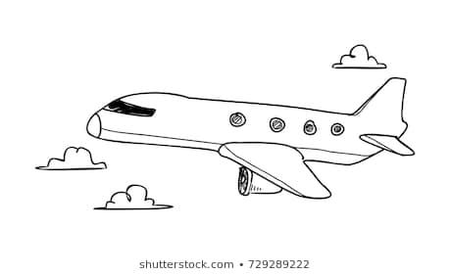

* Flight and airplanes: Inventors studied the flight of birds with a desire to fly like them and travel long distances over oceans, mountains, plains and deserts.
  + *For older kids*: In Great Britain, Stringfellow had built a small unmanned glider in 1848. Later on, it was the gliding flight of albatross, a sea bird, which inspired the inventors in 1856 to design a glider. Later on in 1903, the Wright Brothers were propelled to design the first-ever powered airplane, Kitty Hawk. Today, with advanced technologies, we see aircrafts of all kinds up in the sky flying and appearing like birds.
* Suction cups: suction cups are nearly magical tools that can be used to attach to or tightly grip flat surfaces and they are used to stick some of your bath toys to the bath walls! They were likely inspired by octopus suckers that allow octopus to attach to uneven surface
  + *For older kids*: Using principles of vacuum and pressure, they can be used to stick objects to walls or even scale tall buildings.
  + Octopus suckers are actually a much more advanced version of the human-made kind, with tiny concentric grooves on the edges of every sucker allowing them to grasp uneven surfaces even underwater
* Velcro: you can find it right on your shoes (or on astronaut’s suit!) and it was inspired by the burdock plant when parts of the plant stuck to his dog’s hair
  + *For older kids*: In 1941, the Swiss engineer George de Mestral looked at the burrs under a microscope and noticed they contained hundreds of tiny hooks that could catch on loops of hair or clothing. He developed a material based on this and called it Velcro, from the French words "velours” that means velvet, and "crochet” that stands for hook.

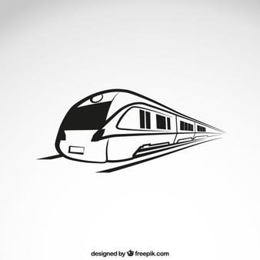

* Fast speed trains: scientists studied birds and invented bullet trains which have beak-like front fashioned like that of the kingfisher.
  + They observed that the beaked front in birds helps them minimize air pressure when they fly or plunge into water, just like the kingfisher. Taking this idea, inventors designed modern trains with a beak-like pointed front design to reduce air pressure and noise during traveling. This approach has been used for airplanes that fly at higher altitudes.
* Medical tape: this is material that doctors use to help sick people after surgeries feel better. It is based on spider silk, one of the strongest materials in nature, estimated to be five times stronger than steel by weight, yet also flexible and lightweight! Spiders can spin silk that is either sticky, to catch prey, or non-sticky, so that they can use it for pathways.
  + *For older kids*: Scientists recently developed this tape and it is used for attaching tubes or sensors to the delicate skin of newborns babies and the elderly people because, just as spider’s silk, it can be peeled off a wound without damaging the tissue underneath.

**Fun Fact for Parents**

* The name of science that looks into the life’s best scientist, or nature, for inspiration, has a name – biomimicry. Instead of consuming nature's resources, biomimicry looks to the natural world for innovation inspiration, resulting in high-tech analogs of natural materials and designs.

**Imaginarium**

*Let your imagination roam free talking about this (or other!) idea(s):*

What if we learned to create animals, plants, even other people (like cloning)? What would change in the world?

* E.g., we won’t have to grow plants any more or need fields, people could just get the plants from a factory, more people will be able to get healthy food, but it means we’ll need to build more factories.
* We could create the pets we want that never existed in nature – for example a puppy that purrs like a kitty and repeats words after you like a parrot!
* We could create fruits and veggies that taste like different foods, for example broccoli with chocolate flavor!
* This future could be scary because the effects of this science are unknown…

***Make sure that both of you have a chance to talk, contribute to the conversation, learn, and have fun!***

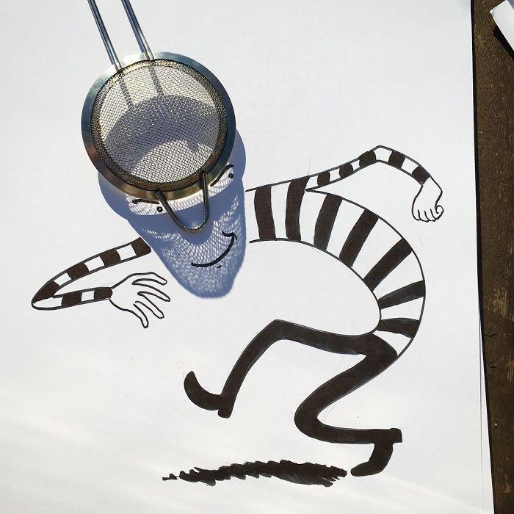

**“Shadows”** 

**Walk 2**

**Before the walk:** Before you head out, ask your child what he or she thinks shadow is, where it comes from? Make sure to note particularly interesting answers in your special notebook. It will be fun to re-visit in a year or two, and just fun to look back at eventually!

**Let’s begin!**

Let’s start with looking at our own shadow! Ask your kid where their shadow is. In front, behind, on the side? See where the sun is.

* Shadow is a dark shape that appears on a surface when someone or something is between the surface and a source of light (sun in this case).
* *For older kids:* For a shadow to be formed an object must block light. The object must be opaque or translucent to make a shadow. A transparent object will not make any shadow, as light passes straight through transparent objects

In a sunny spot (that should stay sunny for the next few hours) have your little one spread their arms out and use chalk to draw around the shadow. Also trace your child’s shoes with sidewalk chalk. You can use different colors to paint the shadow (see Appendix). *For older kids,* you can ask for their help to draw around your shadow as well. Come back throughout the day, and ask your child if he thinks the shadow will move, and if so, how? Will it be longer? Shorter? Wider? In the same place? After your walk, come back to the same spot, ask your child to put his feet in the chalk outline feet, and trace the shadow again.

* Did it get bigger or smaller?
* Did the position of the shadow against the sun change if you are standing in the same position?
* Can you face towards the sun and see your shadow? (no, in this case the shadow will always be behind)

During the walk, look for shadows that “belong” to different objects on your way, e.g. cars, fence, tree, bush, swing. You can use a camera or your phone to take photos of the shadows and then play a guessing game – what object the shadow comes from?

* Do the objects always have a shadow? Walk into a building and ask your kid where the shadow went. Again, make sure to write down the most interesting answers!
* Another game: You stand behind your child with your arm extended, holding an object. The task is for the child to guess the object by its shadow!
* Bring small lego pieces or animal figures (giraffes turn out great!) and a piece of paper. Draw around their shadows.
* Put on a hat or two and enjoy some funny shadows!
* Do you think someone can have two shadows at once? When? (if there are two sources of light, e.g., if you stand in between two lights in the evening, and both of them reflect of your body – you will cast two shadows, try to find a spot like that and show it to your child)
* Try to “run away” from your shadows, jump on them, and play “shadow tag”!
* There is room for experiment in the darkness too. Just bring a flashlight and make shadows for different objects yourself, you can experiment at different angles and sides!

***Check out Appendix for a few examples!***

**Fun ideas to continue the conversation at home:**

* Make a shadow puppet theater! You won’t need anything but for a source of light and your own hands (and imagination of course!) Just google how to do it, here is a tutorial I found on YouTube: <https://www.youtube.com/watch?v=Kz8wP2RYy64>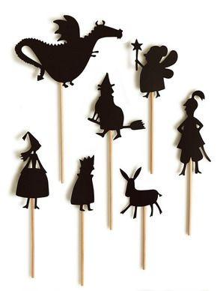
* If you have time on your hands and want to do smth more elaborate, a shadow theater would be another great option. Here is a [tutorial](https://www.youtube.com/watch?v=-hL28SkHf1g) I found on YouTube. This one is a [simpler version](https://www.youtube.com/watch?v=lGZlJS3anw8).

**Fun Facts**

* Shadows length: The Sun makes the longest shadows at the beginning and end of the day, when the Sun is lowest in the sky and the shortest shadows at midday, when it’s highest in the sky.
* Shadows and graphics: When you watch your favorite cartoons, pay attention. Cartoonists always add shadows because they add reality to an image!
* *For older kids:* There is a place where we don’t have a shadow***:*** At noon on the equinoxes of March 21 and September 23, the right angle formed by the sun’s rays and the objects at the equator (middle line of the Earth - make sure to find it on a map or globe!) casts no shadow.

**Experiment**

Years ago people didn’t have clocks or watches, so they needed to use nature to understand what time it is. In different times, people used water clocks, sand clocks, even flower clocks, one of the first clocks was sundial. It uses sun and shadows to understand the time. We can build one right now!

* *For older kids:* A sundial dating to the 13th century B.C. and considered one of the oldest Egyptian sundials, was discovered in Egypt's Valley of the Kings

Draw a circle on the ground. Put a straw, a pencil, or just a long stick in the center secured by rocks. You can also bring a paper plate and glue an unsharpened pencil to it. See where the shadow falls and mark that place with a rock or another small object. Check what time it is and write the right number in that spot, e.g., 9 for 9 a.m. You can write the numbers around the circle (note that sundial has 24 numbers, not 12) . After the walk, stop by the sundial again and see where the “arrow”, the shadow from the straw or the stick, is. The key thing to see is that the shadow “moves'' around the circle. You can continue the experiment the next day – stop by and take a look at the sundial, see where the shadow is. Most kids get extremely excited when they discover this phenomenon!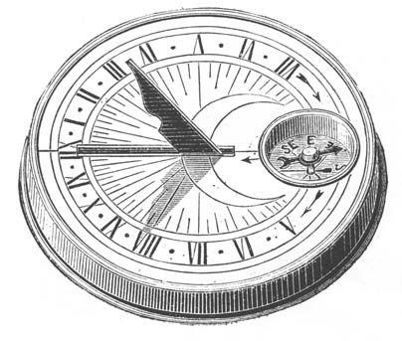

For little scientists who would like to make a more accurate sundial: <https://www.exploratorium.edu/science_explorer/sunclock.html>

**Interesting story (for kids 5+)**

The time you get from your sundial is likely a little different from the time on your watch, simply because it is solar time, not standard time. The two aren't exactly the same. The sun is constantly moving across the sky, and even several miles away its position will be slightly different. According to solar time, noon is the highest point of the sun in the sky. It means that noon where you are is a little different from noon at a place a few miles east or west.

Until 1883, people used solar time with each town or village keeping its own time. Standard time in the US was implemented in 1883 to make sure that trains are expected on schedule across the whole country.

**Imaginarium**

* Ask your child if the shadows had colors, what color would his or her shadow be? What about yours?
* What if shadows were alive? Where would they live? What would they eat? What would be their fun activities?
* Try to come up with some funny shadow doodles on your own! For examples, see appendix!

***Let that imagination roam wild and free!***

**Books to read**

**“Gruffalo’s child”** by Julia Donaldson - [Amazon link](https://www.amazon.com/Gruffalos-Child-Julia-Donaldson/dp/0142407542/ref=sr_1_2?dchild=1&keywords=Gruffalo%E2%80%99s+child&qid=1600883256&s=books&sr=1-2)

“Gruffalo” and “Gruffalo’s child” are both great books to read, but to complement this walk I recommend the latter because the shadow helps the mousie at the end ;) A cartoon is available online as well.

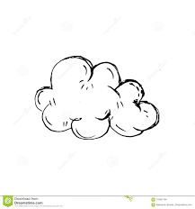

**“Sky”**

**Walk 3**

**Before the walk:** Ask your child what the sky is: at 3-4, most children already have an idea about what it is, even though it can be different from reality. Again, no need to correct them, listen and write the most interesting (or cute) ideas down! 

**Let’s begin!**

It’s time to use our props if you brought them! Spin the ball in your hand and tell your child that we live on planet Earth, and it is round shaped like this ball (at this age, that’s as far as we should get!) and it’s also very very big, so we can’t tell that it’s round shaped. Then wrap the ball with the plastic bag and explain that just as this ball is now protected by the bag, the Earth is protected by a layer of air, also called atmosphere. It is like a blanket around the Earth, and it only lets in warming rays from our Sun while protecting it from the harmful Sun rays. Without the atmosphere, it would get really hot in the daytime, and extremely cold at night. When we look up, we see a part of the atmosphere above us, and that’s what we call the sky. So the sky is really just air.   
  
Now look up at the sky and try to name as many things one can see there:  
 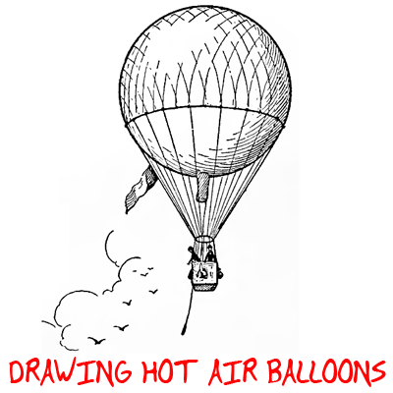

* During the day: birds, clouds,
* At night: moon, sun, stars, clouds
* Manmade objects: airplanes, helicopters, kites, hot air balloons, parachutes
* Nature objects: rainbow, clouds, stars, lightning, rain falling from the sky…

*\*In this and other walks we will reiterate some of the things we talked about in our previous walks. It is important to re-attend those subjects to help memory development, to help them see new ideas and connections with the newly-introduced subjects*

When you begin your walk, try to find a part of the sky with some clouds (the fluffier the better!) Take a picture of it (just use your phone for immediate results). Look at the picture with your child. At the end of the walk, take a photo of the same part of the sky, compare both photos. Are they the same? What has changed? Talk about why (clouds are moving).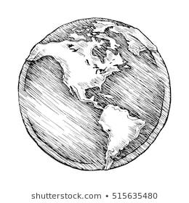

* You can “catch” some air in the plastic bag you’ve brought and wrapped around the ball. Ask what color the air is. If the answer is “white”, clarify “as milk? But you can’t see anything through milk!” We can see the clouds in the sky, and we can’t see through them as we can through the air. What do you think they consist of? Brainstorm your ideas with your child and just write them down!

**Interesting story**

Tell your child that for a long time people didn’t know what Earth and the sky actually looked like, and had many ideas. Many people believe that Earth is flat, covered by the sky as a dome or a roof (you can use the same plastic bag over a flat plate or other flat surface to demonstrate). They thought that the sky rises on one side of the ocean and slowly moves around the Earth and sits on the other side, slowly going down in the ocean again. They used to believe the Earth is the center of the Universe (center of the world) and all stars and planets move around the flat Earth.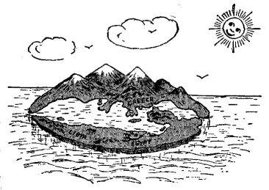

**Fun Facts**

* Types and weight of clouds: There are different types of clouds and they only seem so light! An average cumulus (a fluffy cloud that you see in nice weather) can weigh more than a million pounds (but can be 200-300 thousand pounds too, equal to 20-30 African elephants), and a heavy thunderstorm can pack billions (or even trillions) of pounds of water in one tiny part of the sky!
* Airplane trace: Did you notice the lines the airplanes leave behind in the sky? The reason is the heat from the pipes of the plane mixes with the cold water droplets in the sky that make icy, white crystals which form a trace!

**Fun Fact for Parents**

* Weather as a weapon: During the Vietnam war, the U.S. carried out Operation Popeye, a “cloud-seeding” mission to try and stimulate clouds in Vietnam to increase rainfall and lengthen the monsoon season. After the operation was declassified in 1974, the United Nations banned the weaponization of weather.
* Olympics: During the 2008 Olympics in China, 30 airplanes, 4,000 rocket launchers, and 7,000 anti-aircraft guns were used to stop the rain. Shooting various chemicals into any threatening clouds to shrink raindrops before they reach the stadium.
* Cuban socialism: One proposal to get rid of Fidel Castro was to spread rumors that he was the Antichrist, then fake the second coming. A U.S. submarine would project an image of Jesus on clouds close to Havana while firing star-shells. A loudspeaker would be used as the voice of Jesus, urging cubans to renounce communism. Source: <https://mysteriousuniverse.org/2012/08/faking-the-second-coming/>

**Imaginarium**

* If you did catch a day with fluffy clouds in the sky, let’s imagine what they look like. If your little ones have a hard time seeing that elephant you are trying to show them, you can take a photo of the cloud and then point at the screen and explain: “here is the head, and ears, and his tail!”, or better yet, use a pencil on your phone to draw markings around it!

(see an example of a puppy I saw and showed my daughter in Appendix!_

* You can also come up with a story about the clouds together. Come up with an idea who could live in the clouds (for example, airmaids or cloud mermaids, or clo-prechauns for kids who are into leprechauns) and clouds are their countries. Talk about how they live, how they communicate with the other creatures who live on neighboring clouds, what do they see below them. If you are having fun, you can come up with multiple stories about these creatures with your child, or even make drawings to illustrate them!

**Books to read**

**“Cloud**” by **Eric Carle -** [Amazon link](https://www.amazon.com/Little-Cloud-board-book-Carle/dp/0399231919)

[Read out Loud on YouTube](https://www.youtube.com/watch?v=jWVwkdL98Rs)

A classic by Eric Carle for the youngest readers, but also a great introduction to play and explore.

As a continuation of the story, you can come up with your own story about a little cloud and what forms and shapes it took. Use shaving foam or hair foam to make some funny clouds on a blue piece of paper. Add some cotton balls and make your own “cloud city”. Imagine what “cloud people'' are doing – maybe taking rain showers? Or having a competition whose voice is louder and we hear them as thunder?

Or make meringue clouds (and munch on them!) Here is one recipe: [Meringue clouds recipe](https://www.foodnetwork.com/recipes/food-network-kitchen/meringue-clouds-3364197).

**“Cloudette**” by Tom Lichtenheld - [Amazon link](https://www.amazon.com/Cloudette-Tom-Lichtenheld/dp/1627795014)

[Read out loud on YouTube link](https://www.youtube.com/watch?v=fiTvZofEJ60)

A cute book about a little cloud called Cloudette. Sometimes being small has its advantages.

**“Air”** 

**Walk 4**

**Before the walk:** Today we’ll talk about air, and will also try to touch base on the subject that can be challenging even for adults: gravity & free fall of different objects. As always, try to show and surprise more than explain and lecture ☺

**Let’s begin!**

Ask your child what people cannot live without. Listen to their answers. Then ask what we cannot live without even for a few minutes? Explain that we need air to breathe (and we need to breathe to stay alive). Have them hold their breath for a few seconds and see if it’s possible to stay this way for longer ☺ You can actually set the timer and count the number of seconds or watch the seconds on your clock (a fun way to introduce your little one to the clock and work on counting!)

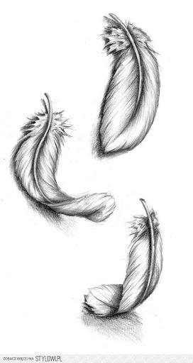

When you just walk outside, choose one of the items on the list and hold it at shoulder height and drop it to the floor. Ask the children what happened when you let go of the ball. Try it again with another item and ask again. Did the same thing happen? Climb up a higher structure, for example on top of the slide at a playground and drop the objects with different weights.

* You can use the things on the list or other objects you can collect on your walk, for example a rock, some leaves, a stick etc. Continue with each item in the bin, asking your kid to help you drop the items. Lead the child to identify that all objects, when let go, will fall to the floor. Ask the child to share what they notice about how each item falls, if it is fast or slow, and what they think might make it so.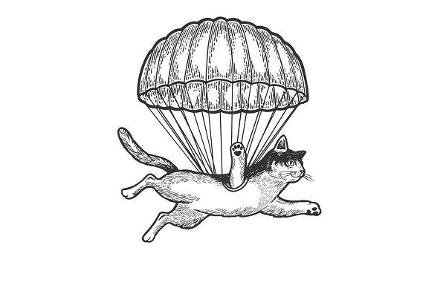
* What changes the speed of the free fall? Even many adults will tell you that it depends on the weight of the object, but that’s not the case! It depends on the surface area and density of the objects. Here is an experiment to showcase this. Take two pieces of paper that have the same weight. Crumble one and keep the second one flat. Ask which one they think will fall down faster. Look and you’ll see that the crumbled paper will fall faster because its mass is smaller and the density is higher. **Flat piece of paper takes more space** and **air resists the fall**, so it **falls slower**. *You can do this experiment with the child, but there is no need to explain the reason to kids under age 5-6. Experiments like this awaken inquisitiveness in children, and even though they don’t understand the actual reason behind some phenomena yet, they become more and more curious about the world, and you bring up lifelong learners.*
* If you think your child is interested, you can also explain that gravity is a force that pulls things to the center of the earth, or simply to the ground. It’s what makes us stick to the ground, and be able to walk and not hover above it. We saw how some objects fell faster than others, but they all fell. Gravity is the reason for this!
* Mention that fishes live under the water and that there is no air there. Now wonder out loud how they breathe there. Let the young curious mind wonder!

**Experiment**

* Ask your child to sit on the floor and place her hands on her stomach, feeling her body moving while breathing air. Give her a straw and ask her to blow in it to move pieces of paper or cotton around with her breath (or make bubbles!).
* Have your kids run around or do jumping jacks and see how their breathing changes. Explain that being physically active like running causes our bodies to require more air!

**Fun facts**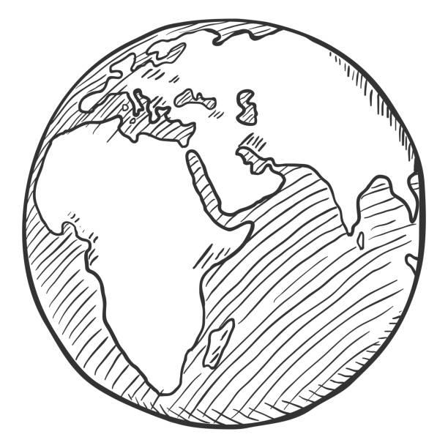

* Planets and weight: Different planets have different strengths of gravity, which is why the weight of objects is different on the Moon, or Mars, than on Earth. So on different planets we can weigh much less or much more!
* Vacuum: It’s hard to imagine, but in vacuum (with no air) all objects fall with the same speed – an elephant, a feather, or us humans!

For kids 5+

* Gravity: While we have found that some of their tested objects seemed to fall faster than another, the truth is that all objects fall at the same rate.

Gravity works exactly the same on all objects unless air resistance affects the objects. A balloon or a crumpled piece of paper will have more air / wind resistance than a crayon, therefore those objects will take longer to fall. This is also why parachutes are so effective.

* Air content: Air is a mixture of different gases. The air in Earth’s atmosphere is made up of about 3/4 nitrogen and 1/4 oxygen. Air also has small amounts of lots of other gases (carbon dioxide, neon, and hydrogen). While air is mostly gas, it also holds lots of tiny particles like dust and pollen, smoke, and other particles from cars and power plants. These are contributors to air pollution.
* Air also contains water: When it’s a hot summer day, you’ve likely heard the word “humid.” What it means is the amount of water that the air can hold before it rains.

**Interesting story**

Just like on water (ocean or lake), there are waves that form in the air! Bigger and smaller, more and less often (with higher and lower frequency). These waves allowed us to send (or transmit) information through the air at vast distances and that’s what allowed us to develop appliances such as TV, radio, cell phones. They don’t use air to breathe like we do, but they use it to send information far, far away.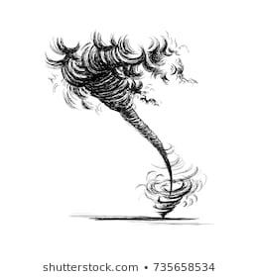

**Imaginarium**

Other planets have different types of atmosphere. For example, Venus is known for extreme winds up to 85 m/s (300 km/h; 186.4 mph - just imagine, it’s faster than any tornado on Earth), while Mars is known for dust storms, which can turn into what resembles small tornadoes. Imagine that the air would change and we would have extremely strong winds and dust storms all the time. How would life change? Maybe we would have to constantly wear masks/other protection? Or move underground? Would birds be able to fly? How would transportation change?

**Fun ideas to continue the conversation at home:**

* If you come up with something that your child is interested in in Imaginarium, suggest they make a drawing of this “new world” when you get home!
* Ask your kids to draw pictures about air and what they’ve learned about it

**Books to read**

* "**Air Is All Around You**" **by Franklyn M. Branley** – [Amazon link](https://www.amazon.com/Air-Around-Lets-Read-Find-Out-Science/dp/0060594152/ref=rtpb_1/146-2496367-0001523?_encoding=UTF8&pd_rd_i=0060594152&pd_rd_r=648c3e87-ff79-4644-9a85-3cb6fc1e0f56&pd_rd_w=y0KWH&pd_rd_wg=8dKz0&pf_rd_p=49740592-2805-416d-896c-b)

[YouTubeRead-out-loud](https://www.youtube.com/watch?v=1N021zN2K5k)

The book offers simple experiments that can be used in discovering air, requiring ingredients that can be easily found in most homes. Curious young minds will also discover the difference between fish and humans when it comes to breathing underwater.

* **“Flora’s Very Windy Day” by Jeanne Birdsall** - [Amazon link](https://www.amazon.com/Floras-Very-Windy-Jeanne-Birdsall/dp/0547994850)

[YouTube Read-out-loud](https://www.youtube.com/watch?v=WFj1NOW2yCI)

This book is mostly about relationships between siblings, but still is relevant to our subject, and many kids love it (especially relevant if you have a younger kid, older siblings can really relate).

* **“Kite Day: A Bear and Mole Story” by Will Hillenbrand -** [Amazon link](https://www.amazon.com/Kite-Day-Bear-Mole-Book/dp/0823427587/ref=pd_sbs_3/133-2693610-6865916?pd_rd_w=8gAgl&pf_rd_p=4b6b5072-e9bd-4f30-a3af-a1f5d52978ec&pf_rd_r=3V3N3HJTZ5S9QWWG8EV9&pd_rd_r=c203efe1-8d4b-4b40-bba3-95c069de67f9&pd_rd_wg=zPplU&pd_rd_i=0823427587&psc=1)

[YouTube read-out-loud](https://www.youtube.com/watch?v=2JY8LV6KJ5Q)

Short and sweet story about wind, kite, and more. Wonderful segway to take a kite out as well!

**“Living and Nonliving Things”**

**Walk 5**

**Before the walk:** Today we’ll be watching about Living and Nonliving things. Begin with telling your child that there are both living and nonliving things in nature. You don’t need to explain the differences between the two: your child will understand them during the walk as they observe and process the information.

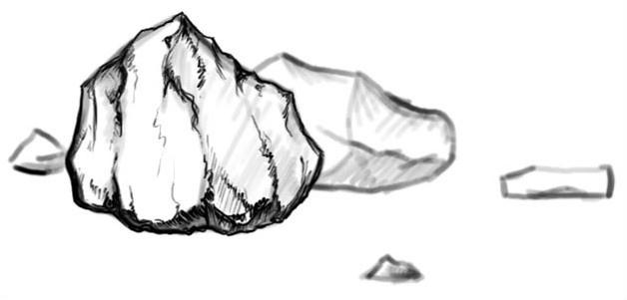

Your main task is to emphasize the differences that children will notice and point out themselves. For example, the rock isn’t breathing, doesn’t grow, eat, or reproduce (your child will likely only point one thing out, and that’s perfectly fine!) – so it’s nonliving. While a flower consumes water (basically, eats), grows, and is able to reproduce through seeds.

When you notice manmade objects around you, such as stairs, a bench, or a fence, point out that man made objects aren’t living.

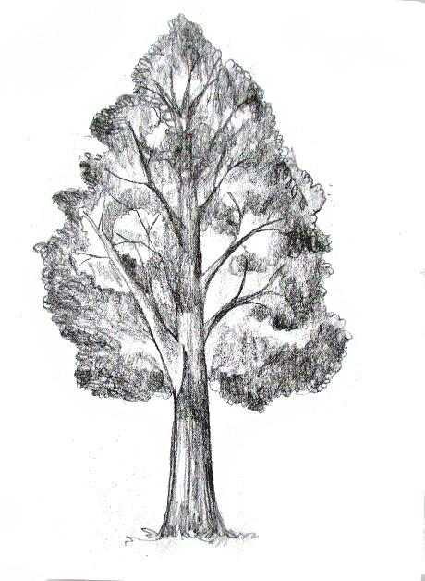

Often children say that living objects have an ability to move, and nonliving objects don't move. Give them an example of a tree or a bush (a living object that doesn’t move) and nonliving objects that do move (e.g., clouds moving in the sky, wind blowing, sun, rain, or even a car). See what they say. Make sure to write their response down if it’s something funny!

**Let’s begin!**

Start with a short conversation about living and nonliving things, providing examples is key: a caterpillar, a flower, that fir tree outside are living beings, while sun, clouds, mini scooter, rocks are nonliving. Let your child ask you a few questions if she has them.

Try to keep your attention on the objects around you and discuss whether they are living or nonliving. What matters isn’t the right answer, but the child’s curiosity, interest, willingness to learn about the world around them, and for kids 4-5+ the way they attempt to explain their answer or idea. E.g., is a feather from a bird living or nonliving? What about a stomp left behind from a tree? How about mowed grass or leaves that fell from a tree? Waves rushing through the lake?

* Find a rock and a flower or leaf on your walk. Look closely at them: how are they different? If you can find some rocks, collect a few on your way home, and a few flowers too, maybe even make a bouquet. Let younger kids play with the rocks for a fun sensory activity, try to break them with a little hammer if you have one. Put the flowers in water, and in a few days when they dry out, point it out – we picked them a couple of days ago, and now they died. We plant a seed, water it, it grows and develops into a plant, grows, blossoms. While rocks don’t grow, change, or die.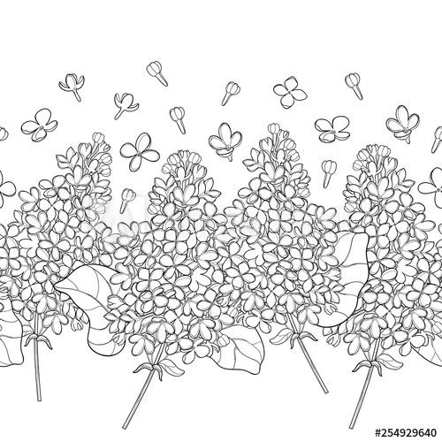
* *For older kids:* ask why the flowers you’ve picked died (because they were picked). What is it that they get from the earth and the roots that allows them to live? If you break the rock, will it die?
* Look at the leaves, grass, insects on your walk closely, if you brought a magnifying glass – use it too. Tell them that plants are alive and they are breathing and eating. What do they use to breathe? (E.g., their roots, stems, leaves?) 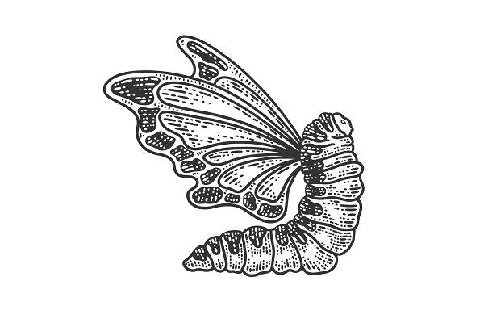
* Again, *the key is an attempt to help them notice something new rather than get them to the right answer as this helps their critical thinking development.* E.g., a child can say they breath with roots or stem because after you picked the flowers they stopped breathing and dried out. **If your child gives you a wrong answer**, ask the leading questions to show that this hypothesis isn’t exactly right. For example, there is air around the flowers and they could continue breathing this way. If at some point your child isn’t interested any more or can’t answer your question, let it go. **Don’t try to force the right answer with multiple hints or answer it for them immediately.** They might even come back to you in weeks or months, you’ll be surprised.
* At the end of the walk make sure to ask again: how living and nonliving things are different?Children often take time processing new information and might come back to you on this subject later, but this way they are learning to look for answers rather than simply consume information.

**Interesting story**

Is it possible to create living things from nonliving things? There is an idea that like other planets (Mars, Venice, Jupiter…) Earth didn’t have life many, many years ago. Somehow, living things and living nature come into being. Scientists have been trying to recreate this in their laboratories for many years, but so far they haven’t been able to do it. Many people believe that our planet and all living things were created by God.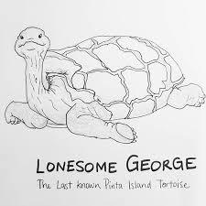

It is surprising, but we still can’t create a living being through science. For example, if a rare endangered animal becomes extinct, we will never be able to see them again, that’s why we create special conditions for them to be able to live and recreate. For example, Saber-toothed Tiger, Wooly Mammoth, or Pinta Island tortoise (you can look up Lonesome George and show your kids).

In recent years, scientists have been able to clone animals! The first animal ever cloned was Dolly the sheep, and now they’ve been able to clone rats, mic, goats and more. Recently, the black-footed ferret has been successfully cloned, it’s the first endangered species ever cloned. If they ask, explain that cloning is the creation of a copy of a cell (everyone and everything consists of cells) or of an entire living thing. The copy is called a clone. A clone has exactly the same DNA as the original cell or living thing - so it is exactly the same.

* *You can be more specific with your religious or scientific beliefs, but it’s always good to offer your child other opinions and express that people have differences in their thinking. For older kids, you can also learn more about cloning here (1 minute long video):* <https://www.youtube.com/watch?v=v2H0OneqbDA>

**Fun Fact for Parents**

* Artificial Mind: We live in a world where non-living things act like living things. So, it comes as no surprise if our children find it difficult to distinguish between living and non living objects. We talk to Alexa and Siri, online TV apps recommend shows that we would like, and we see driverless cars around us, so the difference is much harder to grasp for this generation. I’ve heard kids say things like: “Plants should be non-living creatures because they cannot talk but Siri should be real (because she talks back)”. There are numerous anecdotes that young children think there's a little person inside the device. Children are actively trying to figure out how to conceptualize these devices — are they alive or not alive? “Is it a real person in there?" So ask your kid if Alexa - if you have one - is a living being or not and have fun.
* The issue has not yet been exhaustively studied, but some research indicates children understand a device like Echo or Google Home is a piece of technology, but they also see these gadgets in psychological terms — as having emotions, as being capable of thought and friendship, and deserving of moral treatment

**Imaginarium**

Imagine that the rain is alive! He lives, grows, has kids (or maybe he is a young rain and isn’t sure how to do his job well yet). It lives in the clouds and travels around the world. Let’s come up with a story about a living rain together!

* Depending on your child’s age and participation, you can take one of the **three approaches**: for younger little ones, tell them a story yourself, and maybe they will help you with details here and there; you can take turns and each person adds a new fact/action to the story line; if your child is old enough and is eager to do it, just let them tell you their story and listen attentively. Kids live when we are interested in their world and their imagination!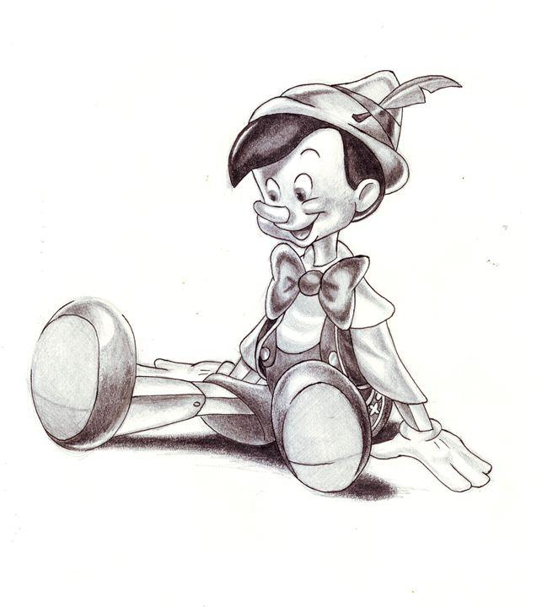
* In the future, point out stories and cartoons where nonliving objects become living and get human-like qualities (e.g., Pinocchio).

**Fun game to play at home (“Guess What”)**

* Say you have an object in mind and they need to guess what it is. It’s easier to try it out with another adult a couple of times first for them to grasp the idea. You can take a few cards from a game or simple print outs with you on a walk with things like a toy, a tree, an animal (use a combo of living and non-living). Your kid gets 5 chances to guess the object on your card. They can only ask questions which have a yes or no answer (again, model with other adults or older kids first).

For example:

* Does it talk?
* Does it breathe?
* Does it walk on its own?
* Is it in nature?
* Is it human made? etc.

If you play this game regularly, you will see that your children are starting to understand living and nonliving things way better. It gets easier for them to distinguish between living and non-living things because they start asking each of these questions in their minds. My daughter asked me if fruits are living things because plants “give birth to them”, try to answer this one!

**Books to read**

* "**Do you Know Which Ones Will Grow***"* by Tom Slaughter - [Amazon link](https://www.amazon.com/Know-Which-Ones-Will-Grow/dp/1609050622/ref=sr_1_1?dchild=1&keywords=Do+you+Know+Which+Ones+Will+Grow%22+by+Tom+Slaughter&qid=1600882294&s=books&sr=1-1)

[YouTube read-out-loud](https://www.youtube.com/watch?v=MPmnqewTa1I)

This book focuses on the ability to grow, one of the aspects of living things. Cute rhymes like this one: ““If a duckling grows and becomes a duck, can a car grow and become a truck?”

* **“Living and Nonliving”** by Carol K. Lindeen - [Amazon link](https://www.amazon.com/Living-Nonliving-Nature-Basics-Lindeen/dp/1429600004/ref=tmm_hrd_swatch_0?_encoding=UTF8&qid=1600882196&sr=1-1)

This book describes how living things are different from nonliving things, focusing on the fact that living things grow, change, breathe, need food, move, react to their environment, get old, and die. I took a look at a number of books, and I think this one provides the simplest explanation for preschoolers and kindergardeners.

* *For kids 5+*: “**Living Things**” by Adrienne Mason - [Amazon link](https://www.amazon.com/Living-Things-Starting-Science-Adrienne/dp/1550743430)

This one is full of activities such as building your own worm farm, “tattooing” a plant, testing your lung capacity, creating a soda-bottle habitat for sow bugs, baking bread in order to “feed a fungus,” an “eating game” to explore how animals bodies are adapted to their environments, secret smells game, and more.

**“Trees”** 

**Walk 6**

**Before the walk:** Today we’ll be observing the trees and looking to understand their different parts, such as roots, trunk, and leaves. Often kids don’t notice the differences between trees until we draw their attention to them, and it’s an excellent place to start a conversation about sustainability and usefulness of everything around us.

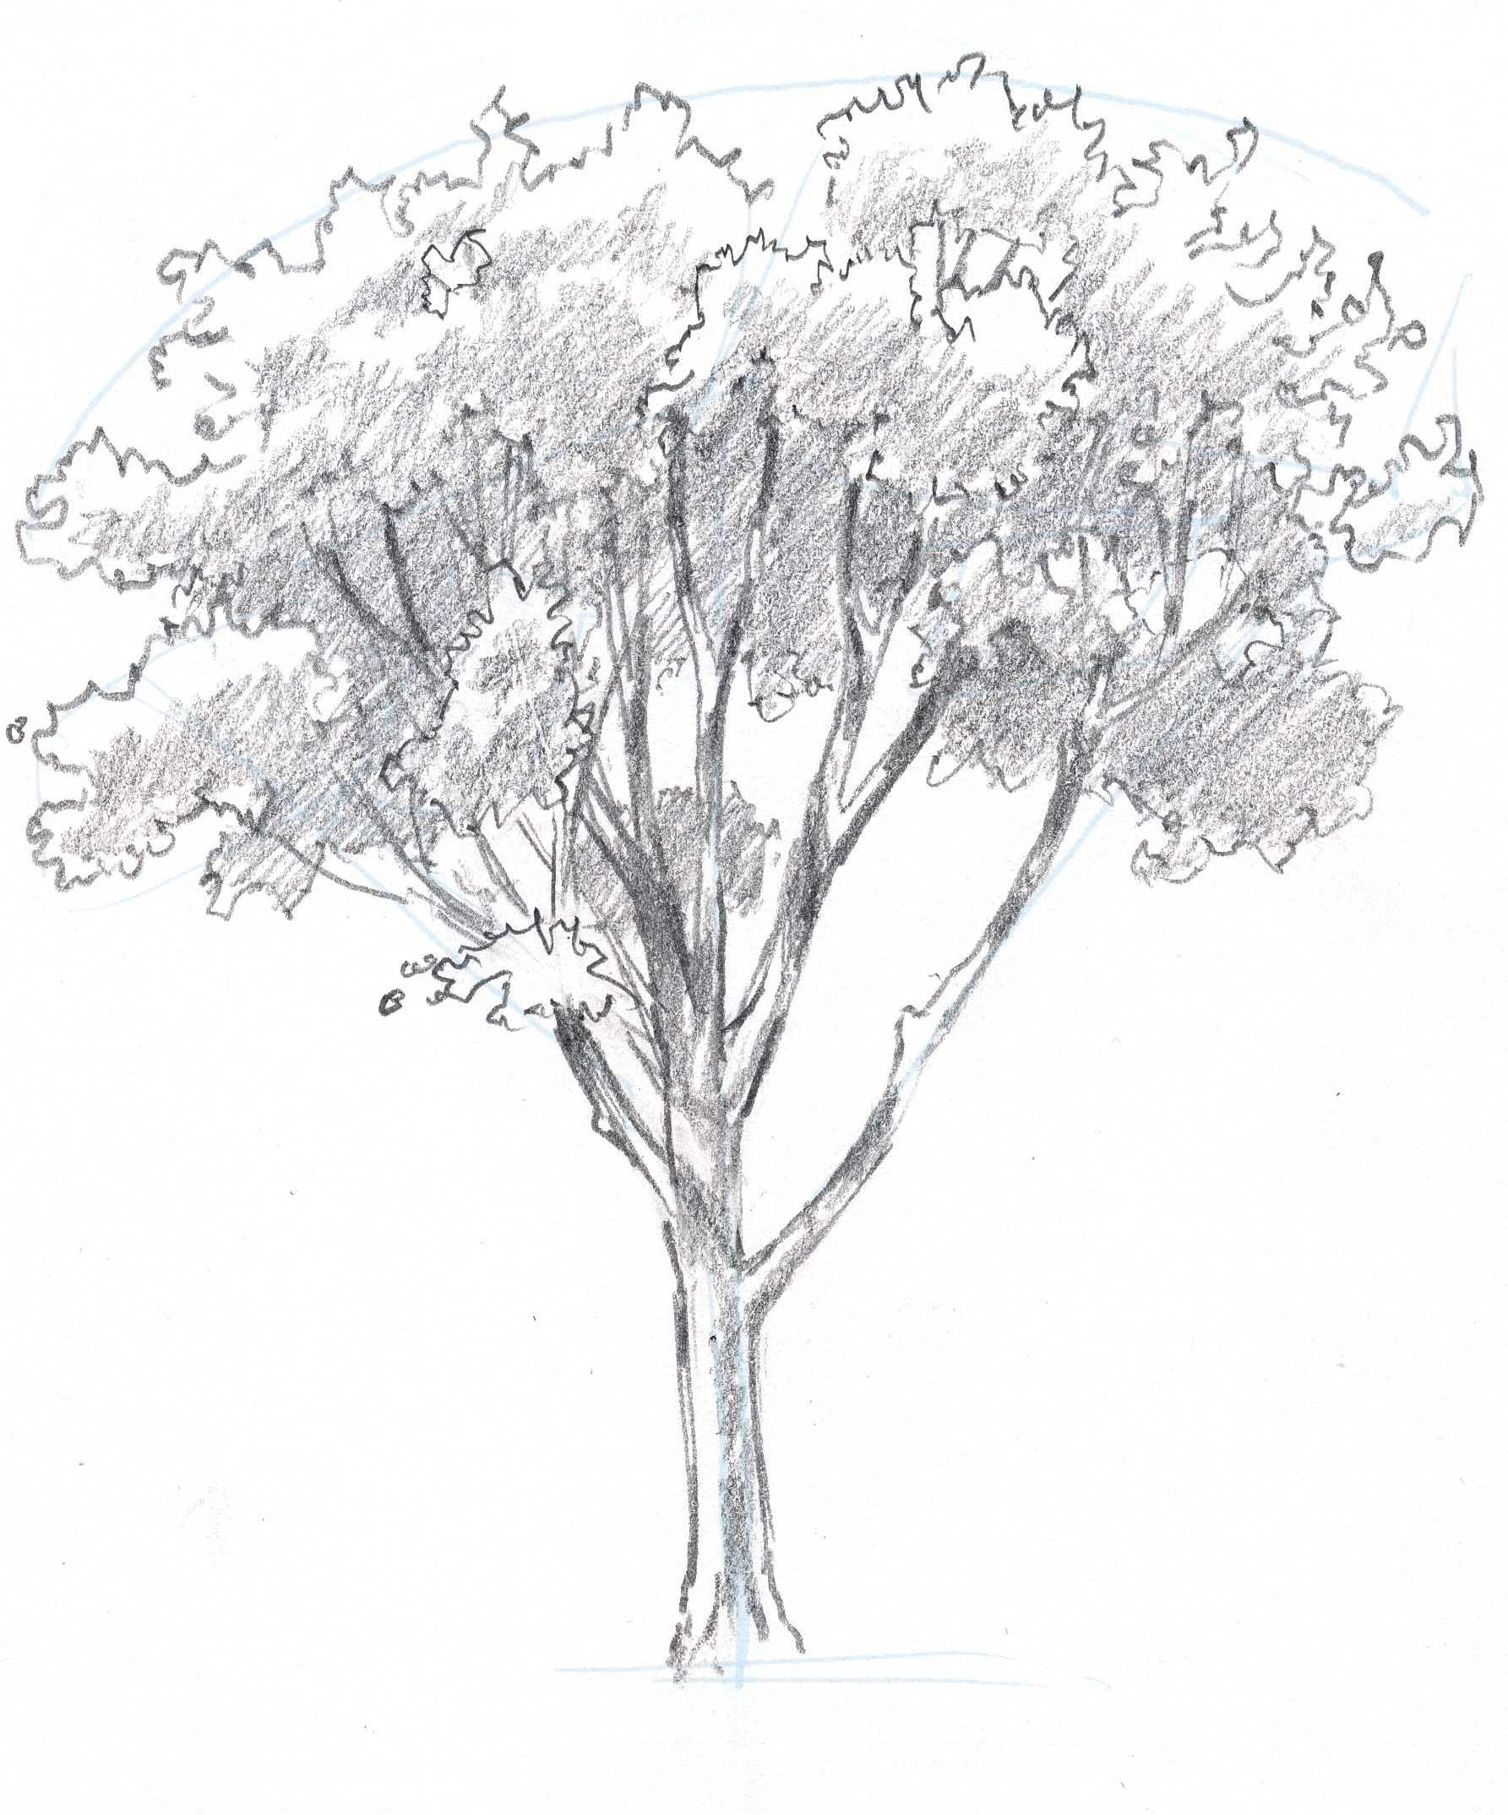

**Let’s begin!**

Let’s learn about the trees today! What kind of trees do you know? What is a tree? Is it living or nonliving (always great to loop back to the things we’ve previously talked about and help little ones connect the dots). How is a tree different from other plants? How is it different from grass? And from a bush? (grass doesn’t have a firm trunk and branches such as trees and bushes/shrubs).

* As you walk outside, find a location with a few different trees around you. Ask your child how many different trees can you see? How are they different from one another? If they have a hard time seeing the differences, point at the shape of leaves, shape of the leaf crown, some of them can have needles instead of leaves, or different color of bark.
* Try to guess the age of a few trees. E.g., “that oak tree is big and tall and has a thick trunk, it’s probably over 50 years old. Like our grandpa! And this birch tree is still very young, has a thin trunk, it might be only 4-5 years old, just like you!” **The idea isn’t to get the age perfectly, but explain your thinking: thicker, taller trees are likely older than shorter thinner ones.**
* Bring a few pieces of thin paper, crayons or street chalk, and tape with you. Tape paper to a tree trunk and rub with the sides of chalk or crayons. You can experiment with several trees and see that patterns the bark leaves are different.
* Ask your child what they think a tree needs its bark for. Point out that in winter when the trees lose their leaves, and other plants die - the trunk stays (it might help them realize that bark is protecting the trunk from cold).
* Tell them that not all trees in the world have the same bark. Some of them change color, and some shed their thin bark as if they are hot (e.g., Strawberry tree).

We’ve talked about the trunk and bark, now time to see what other parts trees have (**roots and leaves**). Find a tree where the roots are coming above the ground, come closer and take a look, touch the roots.

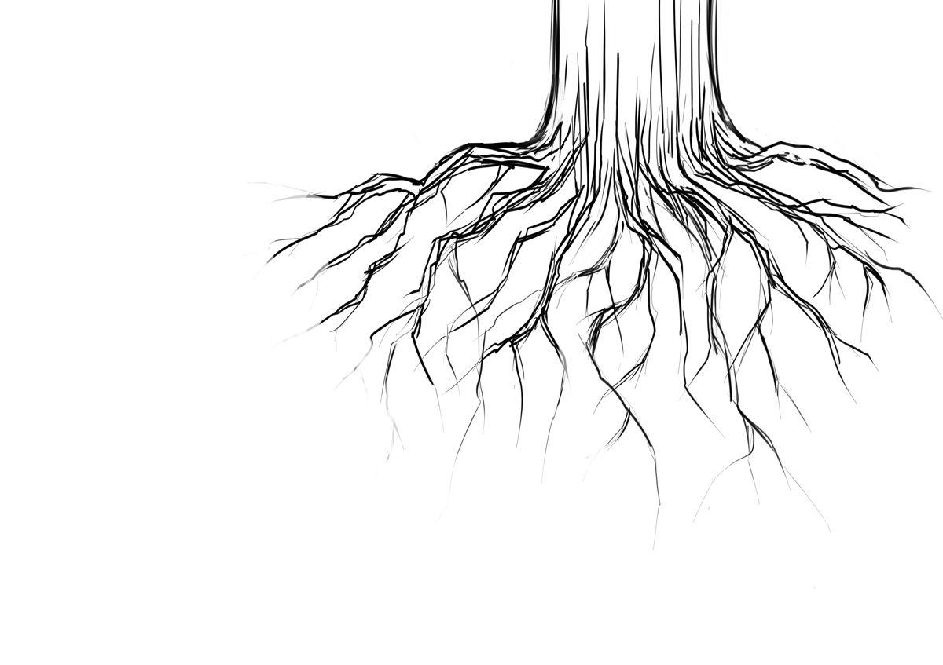

* Ask your child why a tree needs roots? Why are they so much bigger than the roots of other plants? (trees get nutrients and water from soil through their roots, and since they are much larger than other plants, their roots need to be bigger to soak in more nutrients). Also, they keep the trees grounded and help them stay in the soil through strong winds and rain.
* Now find a shorter tree and show your child a branch with some leaves. Touch them to see if they are soft, what color they are. Do they have pointy edges or not? How many leaves are there on one stem (some trees have one, and some several).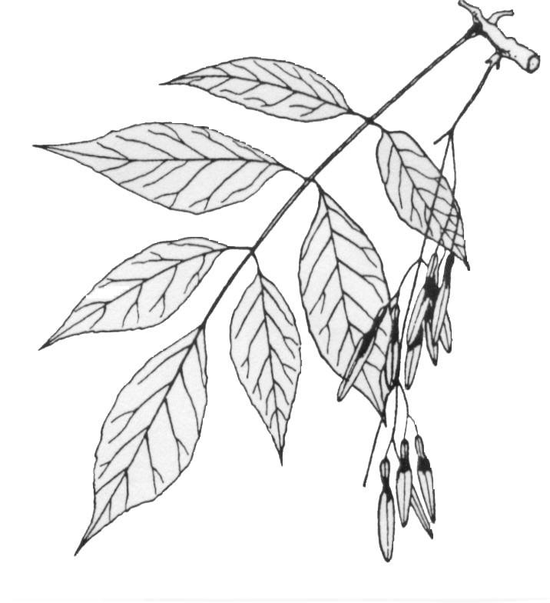
* Remind your child that trees need food to live (we’ve talked about it during our walk on Living and Nonliving things). Where does the tree get food from? It turns out that tiny leaves produce food for the entire tree! They need sun, air, and water (that tree soaks through the roots) to produce nutritious juice that feeds the entire tree. Bark or trunk or branches can’t produce food for the tree without the leaves.
* Give your child a riddle: **“Can you think about a tree that will never have leaves, even in summer?**” Many kids will remember about pine trees, if not, you can add this clue to a riddle if you celebrate Christmas: “We often find gifts under it for Christmas”. Ask your child how needles are different from leaves (firm, thin, stay on the tree even in winter).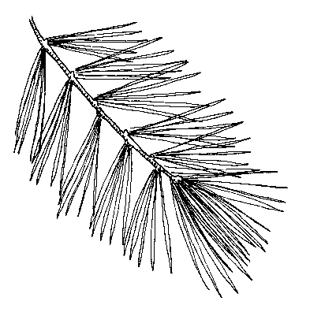
* Find a pine tree and look closely at its needles. Scientists discovered that needles are actually regular leaves that are rolled up very tightly! This shape is an adaptation that allows evergreens to conserve water.

At the end of many branches you can see lighter and softer needles, these are the new young ones, this way these trees grow every year. Don’t forget to take pictures and use the magnifying glass.

* You can find some pine cones underneath, look closely at them and see some nuts. People don’t eat these nuts, but who does? (squirrels, birds).
* Think about other trees you’ve looked at. Do they produce pine cones? What do they produce then? (egg corns, chestnuts, blossom/flowers and some trees even produce fruits). Do pine trees ever blossom?

**Fun Facts**

* The largest tree: General Sherman, a giant sequoia, is the largest tree (by volume) in the world, 275 feet (83.8m) tall which is as tall as 44 pickup trucks! Giant sequoias are the tallest trees in the world. They grow in California and they are among the longest-living organisms on Earth! Though no one knows the trees' exact birthday, the oldest ever recorded is 3,200 years old!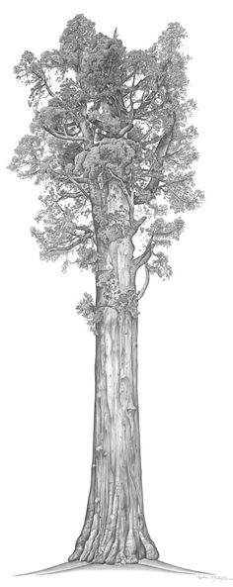
* The shortest tree: Most trees are pretty tall, right? That’s true, but there are some tiny trees in the world as well! The world’s shortest tree specie is the Dwarf Willow. It is rare to find one more than 2 1/2 inches tall (so it’s about as tall as a grown up person’s finger). They grow on frozen tundra in the Arctic.
* Bark: Tree bark differs in content depending on where the trees are. For example, some types of trees (like birch) contain oils that protect them from some insects and birds. Bark can even protect some other types of trees from fire! It serves as habitat (home) for many insects and plants, and even as bark dries out, some species, e.g., bats, choose to live in it.
* Rainbow Eucalyptus: Most trees around us are covered with brown or gray bark, some have white bark (like birch trees). There are some trees with multicolored bark in the world, for example a tree in Hawaii known as “Rainbow Eucalyptus” (picture is Appendix). When the tree is young, its bark is bright green, but with age it changes and becomes multicolored!

**Interesting story**

Trees may look passive and helpless, but some of them are savvier than they seem! They produce chemicals to combat leaf-eating insects, but some can also send airborne chemical signals to each other warning nearby trees to prepare for an insect attack. Then some trees become more resistant to insects after receiving these signals!

Trees' airborne signals can even convey information outside the plant kingdom. Some are able to attract predators and parasites that kill the insects, like calling 911. Apple trees under attack by caterpillars can release chemicals that attract caterpillar-eating birds *(*based on a 2013 study*)

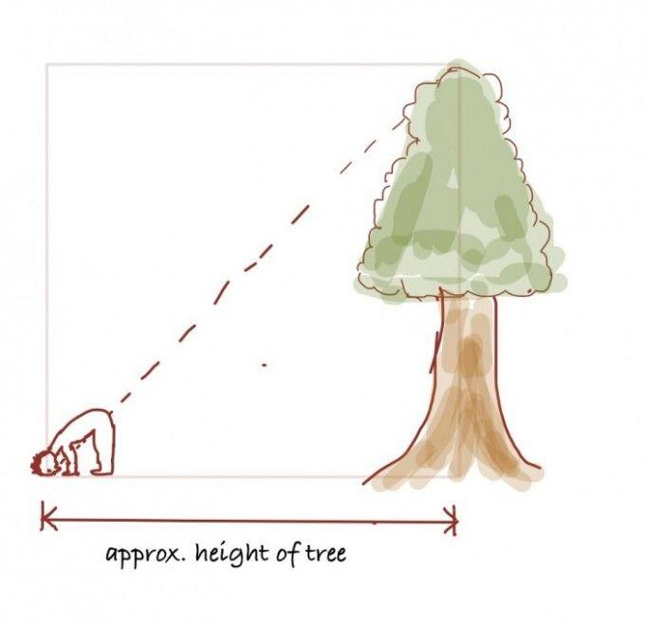

**Experiment**

Let’s measure how tall a tree is! Here is how we can do it!

1. Bend over and see if you can see the top of a tree.
2. If you can’t see the top, keep moving away from the tree until you can.
3. When you can see the top, you are just as far away from the tree as its height is

**Imaginarium**

1. There are all sorts of unusual trees in the world. Can you come up with your own unusual tree? Maybe chocolate muffins grow on it instead of fruit? Or it’s a glass tree, or one with Christmas toys growing on it? Then you can make a prototype with legos, play dough, or draw one. *Please email us pictures, we love to see your work!*
2. Remember we talked about Giant sequoias that have been around for centuries? Some pine trees around us have been around for a very long time too. Life was very different back then: people were riding horses and carriages, farming their land, and making their own clothes. Can you imagine if trees could see everything around them and could talk? What kind of stories do you think they could tell us about those times? Or about animals around them? How would they communicate with each other? Would their voices change over time as they grow and get older like people’s voices?

**Books to read**

**“Why Evergreen Trees Keep Their Leaves” by Lois Walker –** [Amazon link](https://www.amazon.com/Why-Evergreens-Keep-Their-Leaves/dp/1641701587/ref=sr_1_1?dchild=1&keywords=Why+Evergreen+Trees+Keep+Their+Leaves&qid=1600881977&sr=8-1)

[YouTube Read-out-loud](https://www.youtube.com/watch?v=t2aEIABjNO0)

Encourage your child to show his emotions as the story is told. Tell her that it is okay to frown or look angry or upset when trees act mean towards the little bird. It is also fine to look happy and joyful when the evergreen trees help the little bird. This way we are working on Emotional Intellect and developing self-reflection!

**“The Giving Tree” by Shell Silverstein** - [Amazon link](https://www.amazon.com/Giving-Tree-Shel-Silverstein/dp/0060256656/ref=sr_1_1?crid=10MKR2ZIV9ND4&keywords=the+giving+tree&qid=1647985115&s=books&sprefix=the+giving+tree%2Cstripbooks%2C75&sr=1-1)

[YouTube Read-out-loud](https://www.youtube.com/watch?v=GYX8Ex-hLec)

Every day the boy would come to the tree to eat her apples, swing from her branches, or slide down her trunk...and the tree was happy. But as the boy grew older he began to want more from the tree, and the tree gave and gave and gave. This is a tender story, touched with sadness, and filled with teachable moments allowing you to talk to your kids about giving and taking (both, from others, and Mother Earth), sadness that we feel for the tree, and so much more.

**“Tree Full of Wonder” by Anne Smithers** - [Amazon link](https://www.amazon.com/dp/B09M47GT47?geniuslink=true)

Lovely rhyme, vibrant colors, educational and unique picture book showing the unbreakable bond between people and trees and teaching kids how to protect them and why it matters.

**“Trees – Part 2: Sticks, Twigs, and Change”** 

**Walk 7**

**Before the walk:** Today we’ll be observing the trees again, but rather at a different angle. We know that everything around us belongs to different systems. For example, an organization consists of multiple departments or branches, and evolves over time. Seeing things around us from this perspective is called systemic thinking. It allows us to understand how parts of a whole are interconnected and can affect each other.

Systemic thinking requires multiple skill sets to establish a holistic view of a system and explain its behavior. It enables people to gain significantly deeper insights into challenging situations and complex domains, and it’s something we can help our kids develop starting early on. We’ll start today by looking at different objects and exploring what they were in the past, where they came from, and what they might become in the future. The question “what was this stick before?” is simple, yet it helps us pause and see things through a different perspective and think about the past and the future.

**Let’s begin!**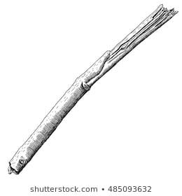

Find a stick on your walk and ask your child what it used to be. First, agree that it used to be a tree. Now you can locate a tree you think it came from, or if there aren’t trees around, come up with a little story about this stick and how it ended up on the ground. Maybe a bird carried it here, or strong wind, or maybe a puppy was playing with it at the park next door and didn’t want to leave it behind? Take a close look at it, use your magnifying glass. Compare it to the branches from the trees around you – does it look like one of them?

* Ask what would cause the tree branches to fall off (wind, strong snow in winter or rain during other seasons, a bird, animal, or a human breaking it)
* Try to break the stick. If you can find several sticks to try and break them, it would be great. Note that some sticks will break much easier than others that you can bend, but they still won’t break easily. Ask: “What do you think helps it stay stronger?” (water or tree juices – if it just recently broke off, it has more liquid in it. “Where do you think it disappears later?”)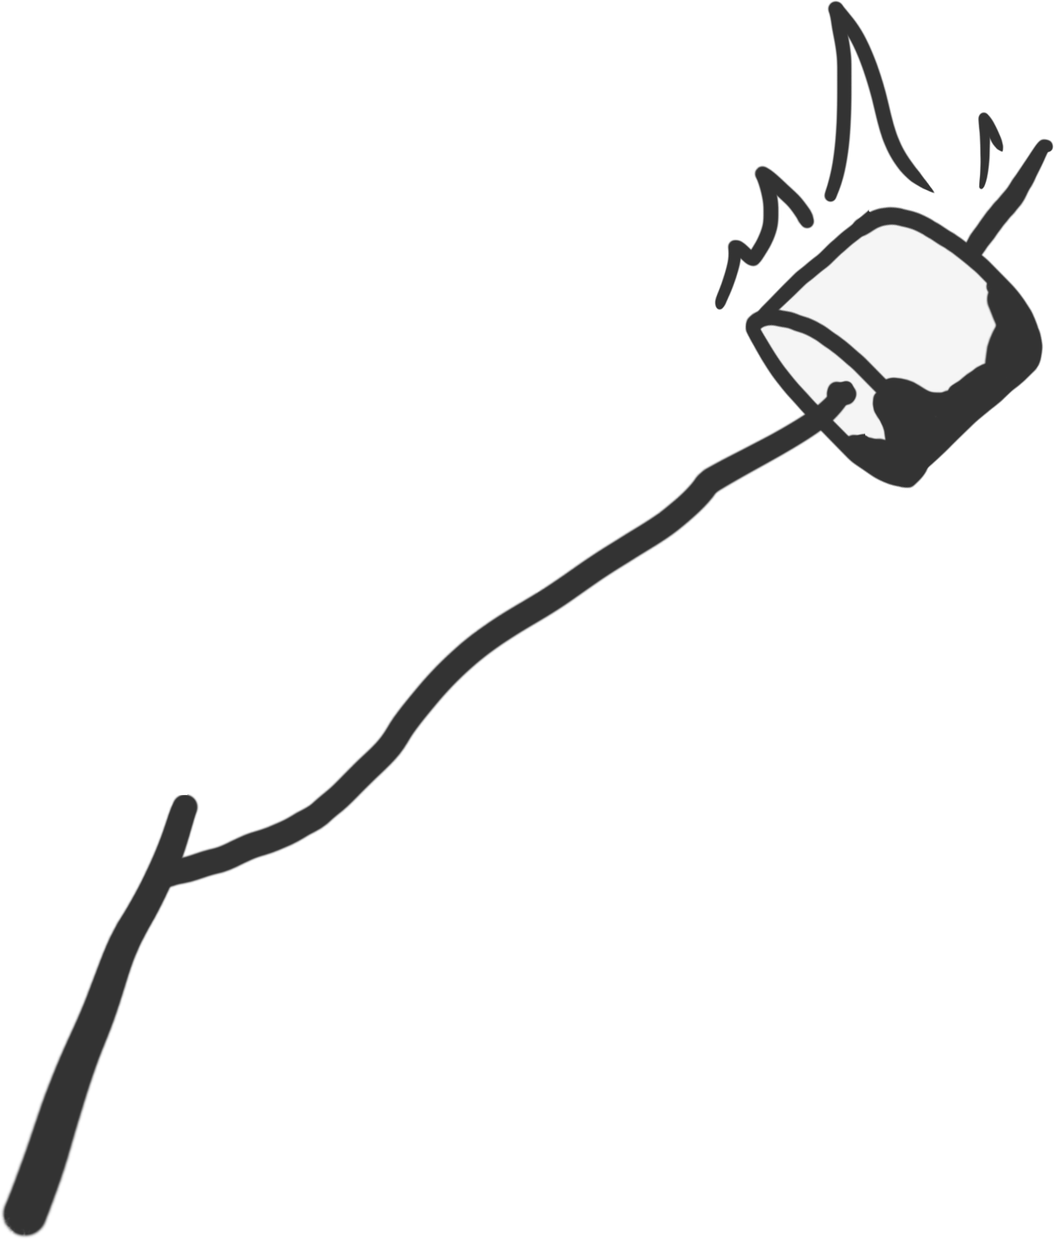
* Now try to imagine what this stick can become in the future. People use sticks and twigs to make all sorts of things, including twig baskets and hangers, fences, even furniture!
* Who else uses sticks and twigs? (Birds to make nests, bears and other animals for their dens)
* You can collect a few twigs and create one of the projects I’ll share in Appendix when you get home (a candle jar or a tree craft) if you are up for a challenge. You can also give your kids a piece of paper, glue and colors to create a simple collage of the twigs and color them.
* Tell your child about **annual rings**. Even better if you can **find a stump** and show them. Explain that each year, a tree forms new cells, arranged in circles called annual rings or annual growth rings. They are the circular rings found on the end of a log or tree stump. Each set of rings signifies one year of growth. Each year of growth has two distinct growing seasons: spring and summer. In the spring, trees take advantage of all the moisture in the soil and grow bigger in diameter. The annual rings show the amount of wood produced during one growing season. We can even get information about the climate change, drought, and fires from the annual trees. Check out a picture in the Appendix to learn more!
* Ask your child this riddle: what or who else has annual rings? (when you are done guessing, you can look it up together! Multiple marine animals have them, and even some mammals on their horns)

**Interesting story**

The Native Americans discovered the specific qualities of branches, twigs and tree roots that make them perfectly suited for specific tasks.

For example, willow branches are straight and flexible. Because of these sturdy qualities, many Native American groups used willow to make their arrow shafts, brushes for painting, baskets, dream catchers, and even to make dolls and other stick figures (*see Appendix*).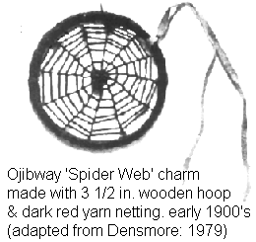

* Note for parents: This is a great segway to tell your little ones about Native American tribes and get them interested in that historic period, learn about their lifestyle, make a teepee tent at home, and of course play! If your child expresses interest in a topic, always use this opportunity to broaden their knowledge. Remember that free play helps them incorporate knowledge better.

**Fun Facts**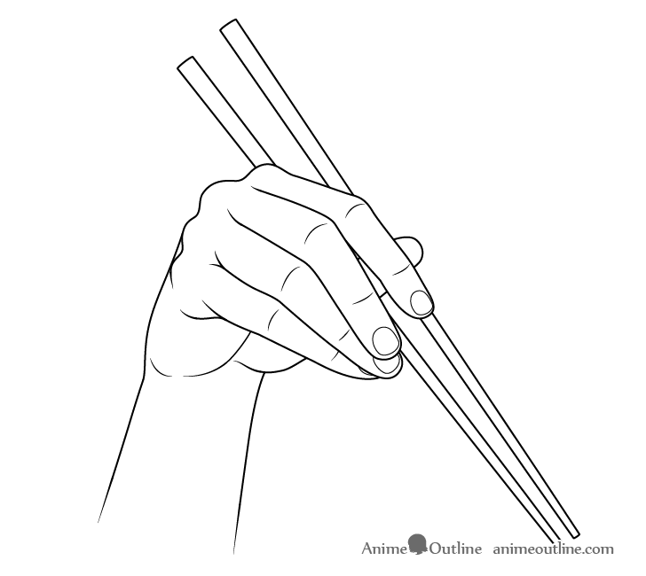

* Chopsticks: Did you know that many people prefer eating their food with sticks rather than a fork? They are called chopsticks, and you might have seen it in Asian restaurants. You can use two sticks you find outside to show your child how you move chopsticks to pick up food. Also, that’s a great excuse to find 2 sticks that look alike – in thickness and length.
* The key to eating with chopsticks is simply to move only the top chopstick. The bottom stick is held stationary in your fingers while the top stick — controlled by your first two fingers and thumb — is moved to pinch bites of food.
* The scientists consider eating with chopsticks healthier than eating with forks (see fun facts for parents!)
* Fire: You can use two sticks to start a fire by rubbing them against each other, but it can be very hard and takes a lot of time.

**Fun Facts for Parents**

* Chopsticks & Health: Research shows that eating with chopsticks is healthier than eating with a fork because it lowers the glycemic index of the food you consume, thanks to the way it makes you eat it. Eating with chopsticks meant eating less at a time and eating more slowly, thus the glycemic index of the food decreases. Eating slowly is good for digestion.
* Additionally, eating with chopsticks can be good for the brain. Those of us brought up using regular utensils find them a fascinating challenge, sometimes quite frustrating, thus the muscles and nerves utilized in chopstick manipulation are quite different from those of most people. Thus, using new skill (just as brushing your teeth with your non-lead hand) creates new neural pathways in your brain!

**Imaginarium**

As you are collecting sticks, try to look at their shapes and imagine what they look like: maybe a grasshopper, an arrow, a little stick man, or a palm tree? Come up with a little story for each figure. If you are having a hard time with a storyline, use the following method to get your imagination going:

Join two objects that you wouldn’t expect together. For example, a grasshopper if that’s what the stick looks like, and something around you. Let’s say playground. Now we have a grasshopper that came to the playground - what kind of adventures is he going to encounter there? Maybe meet a friend? Or have a fun day playing on the swings?

**Books to read**

**“Stick Man”** by Julia Donaldson(alternatively you can watch the short movie made by Netflix in 2015) - [Amazon link](https://www.amazon.com/Stick-Man-Scholastic/dp/1407170716/ref=pd_lpo_14_t_0/146-2496367-0001523?_encoding=UTF8&pd_rd_i=1407170716&pd_rd_r=0bf82456-e4dc-4200-8e52-23a045036338&pd_rd_w=XxtwY&pd_rd_wg=9f1Ka&pf_rd_p=7b36d496-f366-4631-94d3-61b87b52511) - [YouTube Read-out-loud](https://www.youtube.com/watch?v=8aN9GoPO-Ro)

Adorable story about Daddy stick finding his way home. And a fun example for our Imaginarium exercise!

**Fun activity to continue the conversation at home:**

What do these little sticks look like to you? Many of them look like tiny humans, can you think of what they are feeling? Through our posture we show what we feel like in the moment – can you guess? Can you stand the same way they are standing? *(*fun exercise for emotional intellect development and just to take funny pauses for gross motor skills)*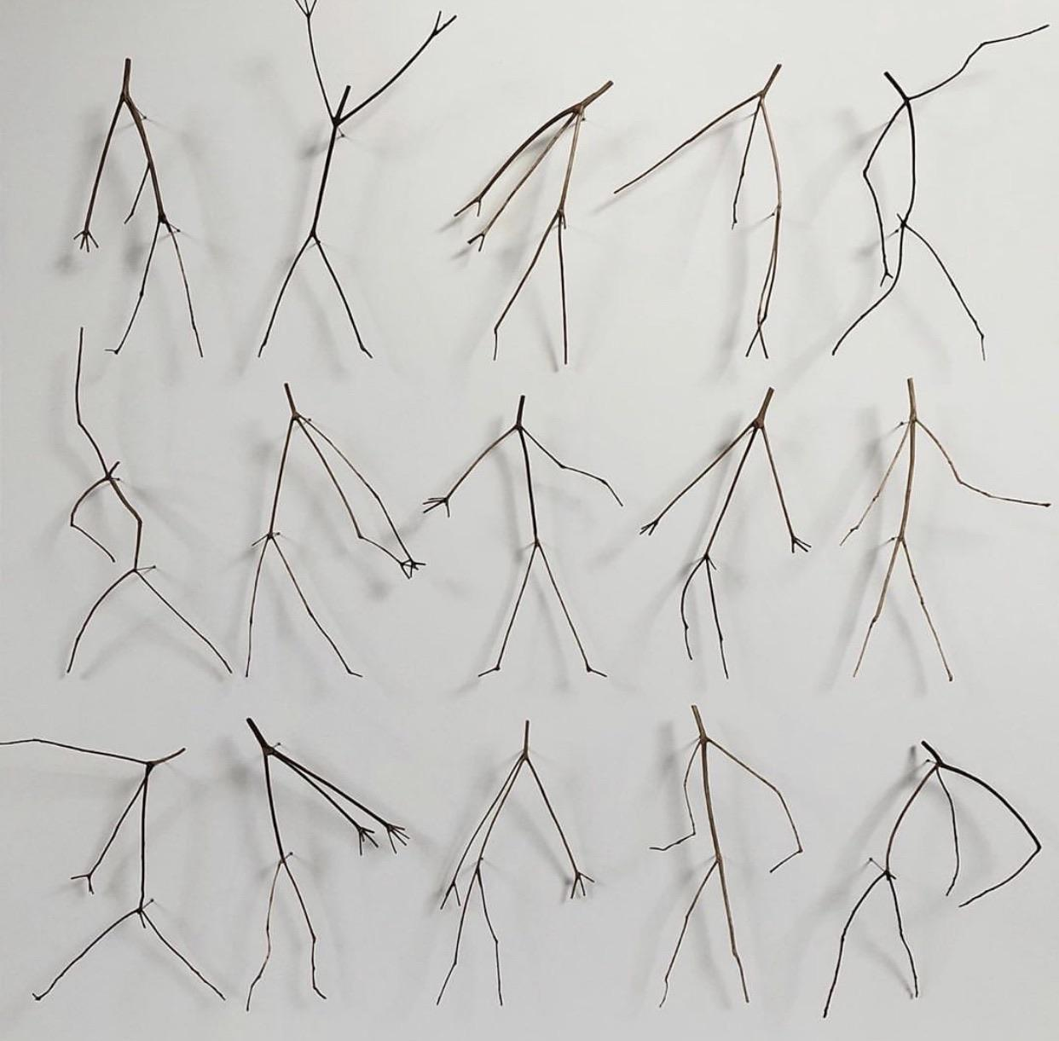

**“Map”**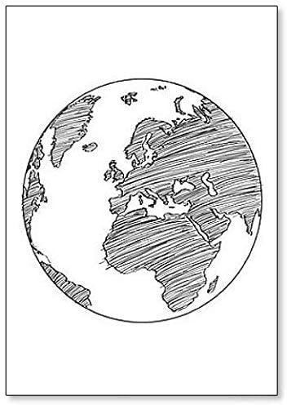

**Walk 8**

**Before the walk:** Today we’ll be observing the world around us through a map and introducing our kids to the fact that maps represent objects around us through symbols, and this walk requires a little bit of preparation. Make a Google map screenshot of your home and neighborhood, it needs to include your walking destination (e.g., park or playground). Print it out, and make sure it’s larger scale to make it easier to interpret. 

*\*This exercise helps with both visual spatial processing and symbolic processing development.*

**Let’s begin!**

Have you ever seen a real map? Let’s look at it! Ask why people use a map. Take your map and mark your favorite places on your route, e.g., a playground, a duck pond, a coffee shop, frozen yogurt, a construction site. *You can mark them simply with crosses or make a simple drawing to represent what it means – this way we help kids understand that a symbol on a map represents a certain meaning.* Help your child find your home. As you walk, take a picture of each site on your way. Why does a picture look so different from the map?

* You can show your child a Live view or Street view on Google map. To do it, press on a location, a small photo will appear in the bottom left of the screen, press on it (this feature might be different on different phones). Explain that these maps are so detailed because they are actual photos taken through cars driving around and drones. To get images of difficult terrain, they sometimes attach a camera to a trolley or a snowmobile or a tricycle or even a camel. 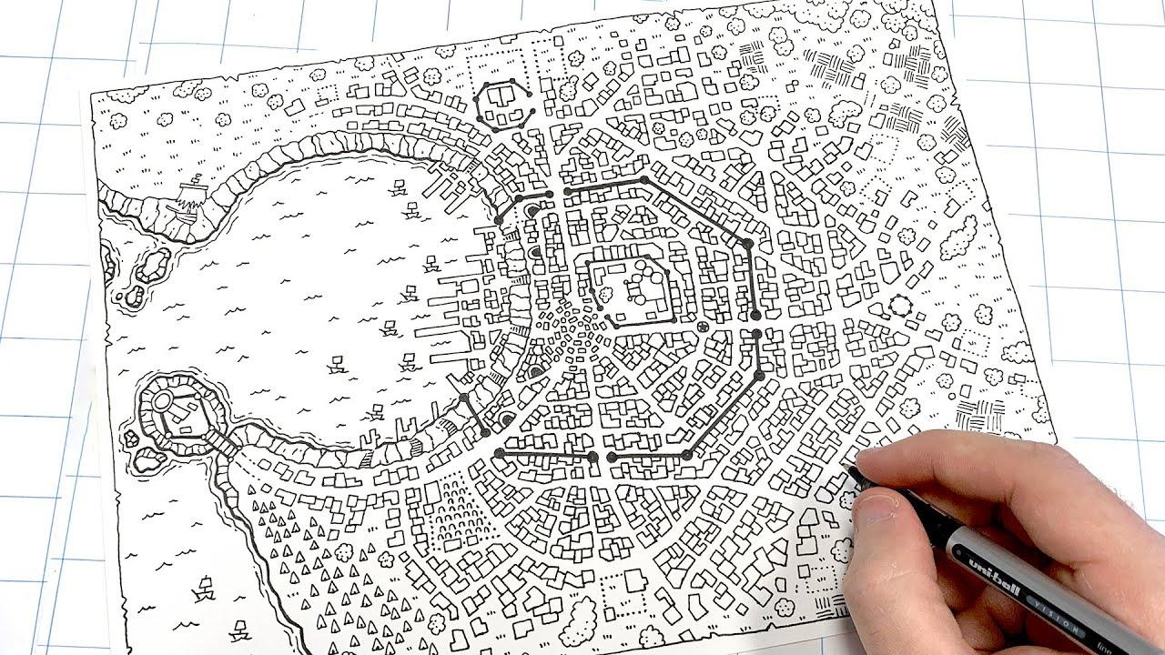
* Many years ago, most maps were drawn by professional artists.
* A fun activity for today is a quest. While your child doesn’t look, hide a snack or a toy somewhere in a park or at the playground. Then take a piece of chalk and draw a very basic outline of the place around you on the ground. For example, mark the swing set, a slide, entrance or some trees if you are at the playground and mark the place where the “treasure” is hidden. Your child’s task is to find it based on the map. If they are interested, you can take turns, and they can hide a toy for you to find it.
* When you make it back home, outline your route on your map with a dotted line. Let your child connect the original signs on your map and show you how you moved. If you took a different route back, you can see what your “loop” looks like – is it round, oval, square shaped?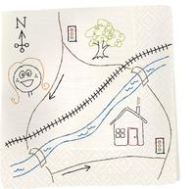
* Another fun activity is mapping your neighborhood or street yourself, but I would suggest to do it on a different day. Simply use crayons and paper (we like to use large stretches of brown wrapping paper), make a simple drawing of your house first, and go from there.
* When you make it home and if your kids are still interested in the subject (or on a different day if not), you can map your home, have them map their own room or a backyard. You can put together a treasure hunt for them. To do it, just hide a “treasure” somewhere and map the area. You can also draw signs on multiple pieces of paper and hide the next hint on every step: draw a table on a piece of paper and give it to your child, on that table they will find the next paper with a drawing of their bed, on the bed their will be a drawing of his shoes, and at the end of the way they will find their prize.
* You can show your little ones how to make primitive map symbols. See an example in Appendix.

**Interesting story**

In the mid-19th century, there was a cholera outbreak in London, and someone made a map of cholera cases and was able to find a specific public water pump that was the culprit, and the spread of sickness was stopped. You see, maps can be used for very different reasons!

**Fun Facts**

* Map Mistakes: In the past, cartographers (people who made maps) had limited resources and unsurprisingly made mistakes when drawing maps. For example the first map of Africa (*in 1798)* featured the massive Mountains of Kong. The only problem was they didn't exist. Even so, the Mountains of Kong would be placed on maps of Africa for the next 100 years.
* Different Maps: For many years the world map didn’t look the way we see it now. For example Mediterranean sea was considered to be the center of the map (and the Earth itself), America wasn’t on the map as it was discovered later

**Fun Facts for Parents**

* Map censorship: Map censorship is a common historic practice that actually still exists today. For example, you won't find military bases on most maps, and in the U.S., nuclear waste dumps often don't appear on the geological survey maps, which experts believe is just out of sheer embarrassment.
* Paper towns: Modern mapmakers often incorporate fake towns into their maps on purpose. These are known as “paper towns”, “phantom settlements,” or (for some reason) “bunnies.” The thinking behind this is avoiding plagiarism (which is very common): if the cartographer comes across another map with the same fake town, they know it is a copy!
* North: North may be at the top of maps today, but that wasn’t always the case. During the middle ages, most Western maps put east at the top instead. In Latin, the word for east is oriens, so to hold the map correctly, you had to “orient” it—that is, make sure East was on top. This is where we get the word “orientation” today.

**Imaginarium**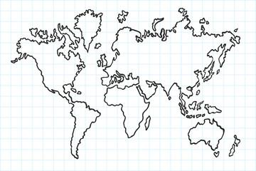

We know that Earth, our planet, is round. But for many years people believed that it is flat. How do you think it’s possible to know what the continents look like? (pictures taken from air).

What do you think would happen if Earth was flat after all? We likely wouldn’t be able to fly planes in both directions, ships would “fall off” the edge, sun would rise and set at the same time everywhere in all countries…

**Experiment (if you have access to sea/ocean)**

If you are able to watch a ship sail off to sea, watch its mast and flag as it fades off into the distance, you will likely notice that it does not "fade off into the distance" at all; instead, you will see its mast and flag appear to slowly sink. The ship sailed beyond the point at which you would see it. Just to be sure, bring a pair of binoculars with you so that you can see even farther off into the distance.

It's as if you're watching it go over to the other side of a hill. This can only be explained by a sphere-shaped planet.

**Fun activity to continue the conversation at home:**

Another fun activity that has to do with maps is creating your own map of a magic country. If your kids are interested in let’s say Peppa Pig, you can create the map of Peppa world, or a map of Arendelle if they are into Frozen, a map of Oz world was something I enjoyed even more than my daughter.

Here is how you do it:

1. Pick your theme: If they don’t have favorite characters from books or cartoons yet, you can even create your own magic kingdom (or a country populated by different kind of transportation if your kids are into cars, or maybe a Jurassic world if they love dinos)!
2. Mark a few main points, connect them with roads, and make some tree/town/village/other important landmarks markings. You can draw your landmarks with crayons or paints, use paper or tin foil to create some 3D towns if you’d like, or tinfoil to make an ice skating rink, even glue some flowers and other natural materials to show woods, meadows etc.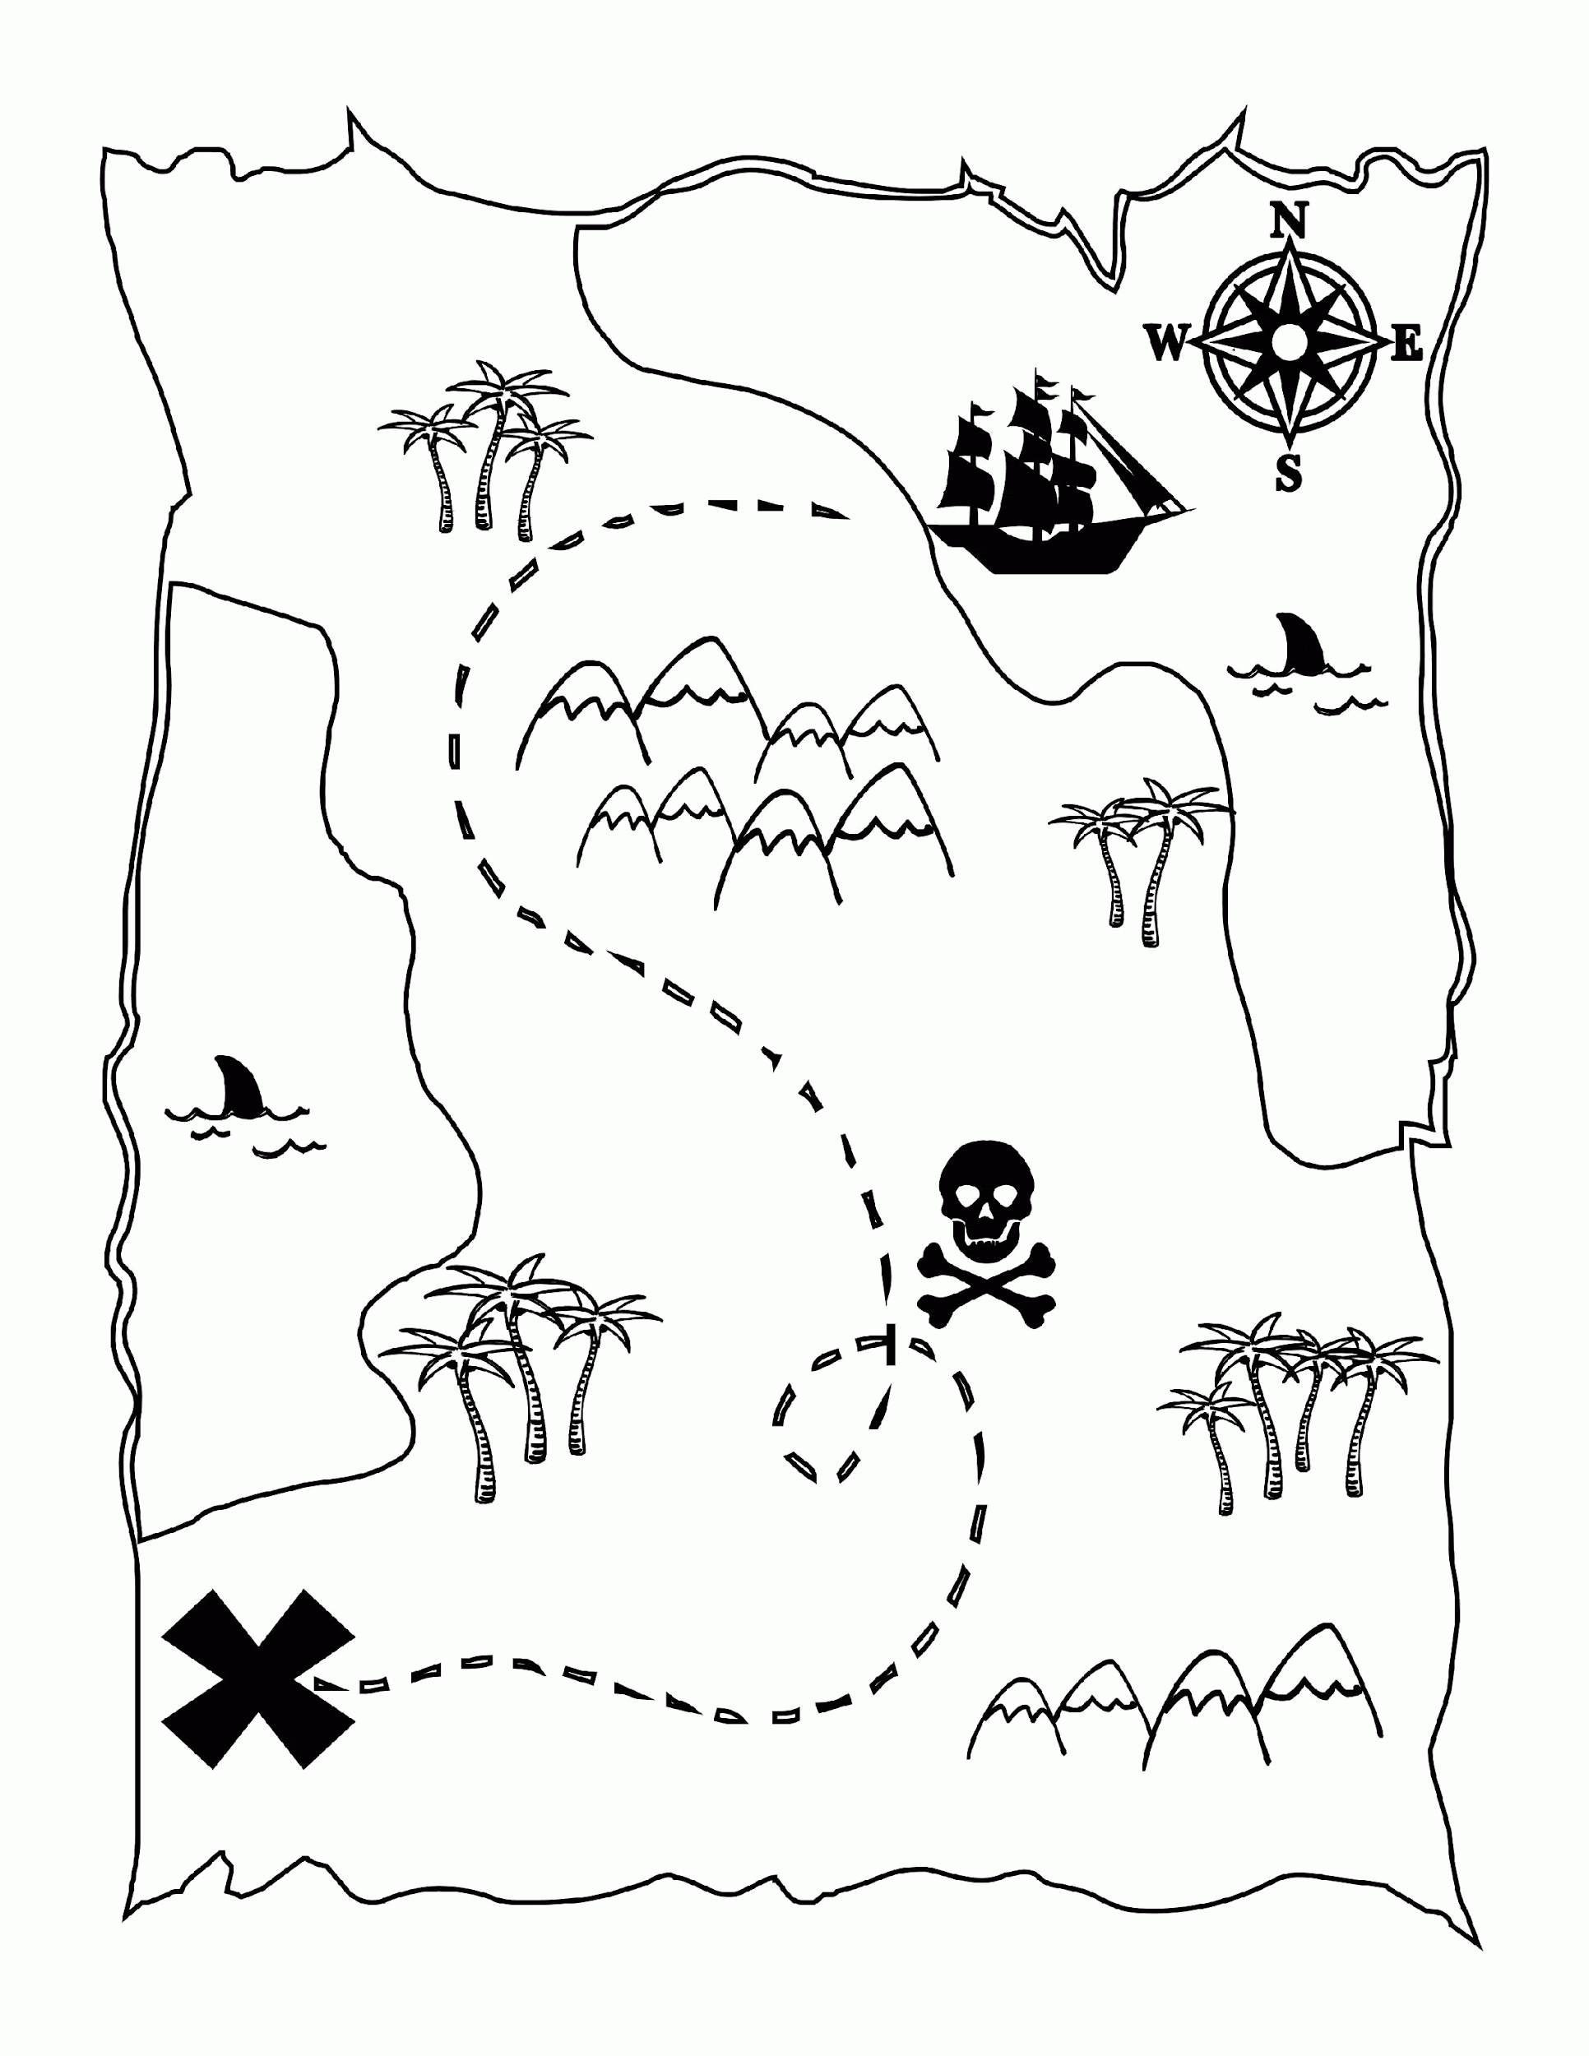
3. Name the country and develop main characters. What are the main villages/towns and roads? Is there a magic forest of gnomes or bandits? Are there kind fairies that live by a fairy well? How do people travel? Most kids have a blast with this activity.
4. Your kids can use the map to play as well – get their little toys or lego characters to travel the roads, cross the rivers, and get lost ☺

**Books to read**

**“How I Became a Pirate**” **by Melinda Long** - [Amazon link](https://www.amazon.com/How-Became-Pirate-Melinda-Long/dp/0152018484)

[YouTube Read-out-loud](https://www.youtube.com/watch?v=ro5E4BUaHeo)

In the story, a young boy helps a band of pirates bury some treasure in his backyard. He then draws up a map of his backyard to show the pirates where the treasure is buried. Kids between 5 and 7 love it and it introduces them to the idea of mapping everything around them and treasure hunt related play.

“**What the Ladybug Heard**” **by Julia Donaldson and Lydia Monks** – [Amazon link](https://www.amazon.com/What-Ladybird-Heard-Julia-Donaldson/dp/1509892478/ref=pd_lpo_14_img_1/146-2496367-0001523?_encoding=UTF8&pd_rd_i=1509892478&pd_rd_r=efef1ff2-f2bb-4cc5-9389-068d587c4245&pd_rd_w=TbBbt&pd_rd_wg=is3xR&pf_rd_p=7b36d496-f366-4631)

[YouTube Read-out-loud](https://www.youtube.com/watch?v=Eu9mPX7DuLA)

Another cure book about thieves planning on a farm (who of course need a map), one of those books that kids ask to read over and over again, and you can’t get the rhymes out of your head for days.

**“Rain”** 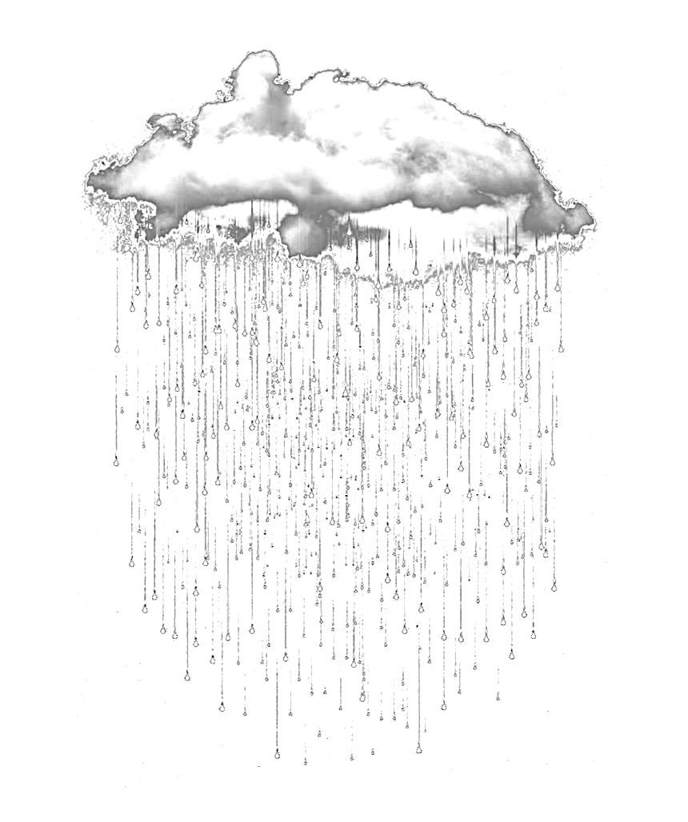

**Walk 9**

**Before the walk:** As the name of this walk suggests, it would make more sense to talk about the rain when it’s actually raining outside, but preferably the rain is light enough and allows you to walk. We’ll touch base on a few more complex things such as the water cycle on our planet, rainbows, ripples in the puddles and your kids might ask you questions. Answer their “why’s” and “how’s” and follow the path of their inquiry, but make sure to only focus on a few subjects at a time and provide them with simple explanations and show them interesting facts rather than confusing them with complicated details! Posing interesting questions that make them wonder and pointing out unexpected things does much more for their developing minds and growing curiosity than giving them a lecture filled with details and information that likely won’t be absorbed or retained.

**Let’s begin!**

Look into the window before heading out for your walk. Ask what the weather's like today. Does it look like it’s raining? Try to predict if it’s going to rain for a long time or not (and you can discuss if your prophecy was right later when the rain stops). What does it mean “to rain”? Where does the rain come from? Does the water come from the sky in different forms? (some kids might remember that it can also fall from the sky in the form of hail, sleet or snow).

* Before you head out for your walk, place an empty glass or a bottle somewhere out in the open. Explain to your child that this way you can measure how much water the rain brought. Most kids are very excited for the results of this little experiment.

Do you think this is “good weather” or “bad weather”? Why? Explain that rainy weather is often referred to as “bad weather”, but also there are plenty of people and animals who enjoy the rain. Can you think about what’s good about it? For example, when it’s very hot outside and the rain comes, doesn’t it feel good? Have you ever seen farm animals playing in the rain?

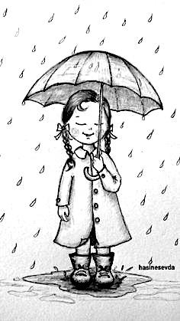

Remind your child about one of our previous walks when we talked about living and nonliving things. What do living things need to survive that rain can give them?

If they have questions, you can explain that rainfall is very important for the survival of plants and animals. It brings fresh water to the earth's surface. If we have less rain, there is water scarcity and in some cases it can even cause the drought when grass is yellow and animals lack food.

What about the opposite – when there is too much rain? What would happen? Maybe floods that cause harm to buildings and people, or animals’ dens and habitat.

* *Note for parents:* Understanding that certain things (like weather or rain) can bring BOTH good and bad is a great way to help kids develop critical thinking. Most of the situations in our life can be good and bad at once, and being able to look at them from several different angles is a great ability to develop. You can implement this exercise into other areas of life and look for pros and cons of other things, e.g., the zoo (great to see wild animals, but they are kept in captivity), pandemic (e.g., many people get sick and lose their jobs, but we can spend more time together as a family), even going or not going to a store. 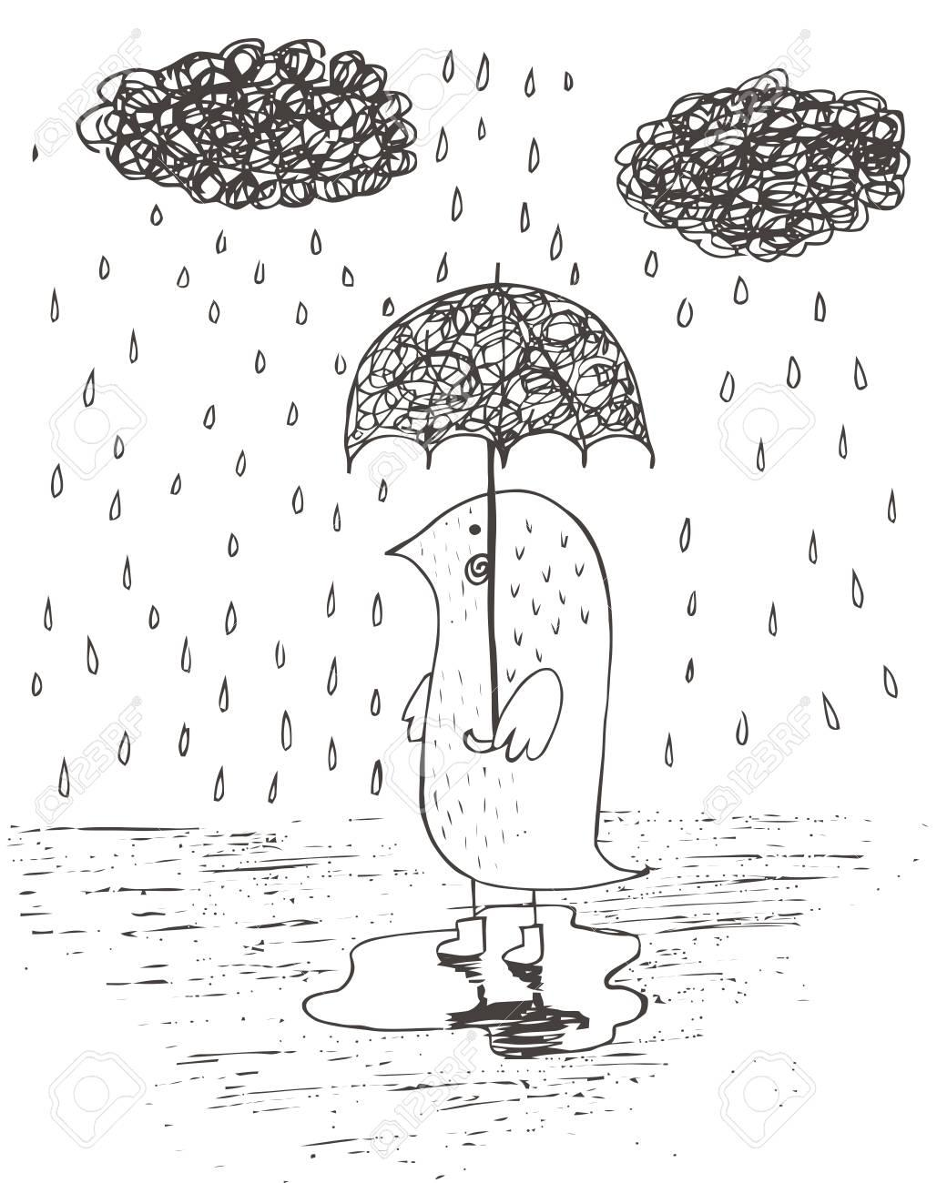

Now ask your child to smell the air. What does it smell like? We know that water itself doesn’t have a smell, but the rain does – why is it? (the smell is debris, small particles of dust and pollen the rain kicks up from the air mixed with ozone). Ask your child to look up at the sky. Remember we talked about the clouds? Do these clouds look different than the ones we see up in the sky on a sunny day?

Now ask how they think water gets to the clouds? It’s raining right now, so the water leaves the clouds and hits the ground – how does it get back?

* *Note for parents:* Just pose the question so that they would start wondering about this unless they ask further questions. Remember, we aren’t trying to make it a lecture! If they are asking questions, *younger kids (3-4)* use the “tiny humans method” and explain that rain is like a million of tiny humans who get heavy and parachute from the sky like droplets. Then the sun comes out and they get dry and it makes them much lighter, so they break away from the puddle and go into the air back into a cloud, and then come back down to the ground. *For kids 4+* explain that when a puddle dries up, tiny particles of water break away from the liquid in the puddle and go into the air. The tiny water particles are called water molecules. Water on the ground goes into the air, becomes part of a cloud, and comes back down to Earth as rain.

Now make sure to look at the puddles. Kids of all ages LOVE exploring the puddles. Let them look at them, jump in a puddle, look at their reflection. Ask if it looks different from their shadow. How is it different? Can it move when you are still? Why could that be?

* Look at the ripples left by every droplet that hits a puddle. Suggest throwing other things in a puddle, like sticks, little rocks or egg corns. Point out that the ripples are all of the same shape, regardless of the objects you throw in – round shaped, not square, triangle, or heart shaped!
* To explain this to our kids, we can use the “tiny human” metaphor again. The water in the puddle consists of tiny humans who are all the same size and move with the same speed, so when something hits the puddle, they all hold hands and run away with the same speed, that’s why the ripples are shaped like circles!
* Look at the multicolored reflections in the puddles. If your child is asking why, explain it’s caused by the oil from the cars.
* Ask where they think the puddles go after the rain. What does it mean “to fry off”? Where do they go? Do they all get absorbed into the ground? Why is it that dirt or sand don’t dry off, but water does? 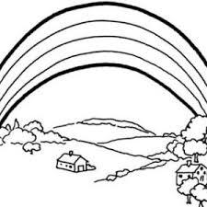

If a rainbow comes your way, draw attention to the beautiful colors in the sky. Respect the wonder of a child’s first observation by waiting to offer explanations until the children ask "Why?" You might answer, "When sunlight moves through falling rain, we see all the colors of sunlight. Did you know all the rainbow colors are inside sunlight?" If the child is intrigued, try to make your own rainbow – see the “Experiment” sections for the options.

* For kids that keep asking questions, explain that rainbows are formed when light shines through water, like when the sun shines through the rain. This light is bent and reflected, like a reflection in a mirror, and this causes all of the amazing colors that you see. Rainbows normally appear from the rain, but they can happen wherever light is being bent inside of water droplets. We can see rainbows in mist, fog, spray, sprinkler water, and dew.

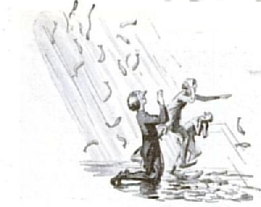

**Interesting story**

Once upon a time, it started to rain in a small village in Honduras (a country in South America), yet instead of simple rain falling from the sky,,, it rained fish! People were grateful and thought it was a blessing. Now we know though that the rain of fish has been reported in Australia, Mexico, India, Ethiopia, Alaska, and other places. And not just fish! Any number of small animals have been reported falling from the sky, including frogs, ants, small fish and worms.

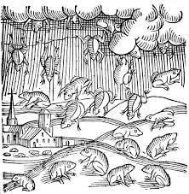

Scientists believe that small frogs or fishes are picked up by a powerful whirlwind, tornado or just updraft, and can be frozen into hail in the cold air above earth's surface.

When tornadoes traverse over water, they become known as waterspouts. Waterspouts suck up lake or ocean water along with the fish, eels or other creatures swimming in the water. According to Bill Evans' meteorology book (a book about weather) titled It's Raining Fish and Spiders, creatures such as these fall from the sky about forty times a year!

**Fun Facts**

* Cats and dogs: The phrase “It’s raining cats and dogs” has several origin theories. One is that when houses used to have thatched roofs, pets and other small animals like squirrels or groundhogs, used to nestle into the straw for warmth. When it would rain, however, the straw would become slippery and the animals would slide out, creating the illusion that it was literally raining cats and dogs.
* Rain and electricity: Rain is also used to create electricity. We call this hydroelectricity or hydropower.
* Does everyone see the same rainbow? No two people see the same exact thing when they look at a rainbow. Since it all depends on how the light is being bent and reflected back to you, everyone sees something different. Someone who looks like they are standing right underneath it to you will actually be looking at the rainbow and seeing it from far away.
* Where do rainbows end? Actually, there is no end to a rainbow. Even though they look like an arch to us, or an upside down letter U, rainbows are actually full circles. We only see some of the circle because we usually view the rainbow from the ground.

**Fun Facts for Parents**

* Cloud Harp: Do you think clouds can sing? Nicholas Reeves, a University of Quebec professor of architecture developed an unusual kind of instrument called a Cloud Harp, which has been programmed to respond musically to clouds passing overhead. It operates through a large laser beam and a telescope while the clouds above act as sort of a CD. The beam “reads” how high the clouds are, their speed, temperature, lightness and so on. When it was originally installed in Canada, people would bring their sleeping bags and listen to the cloud music all night long (well, unless you have a cloudless night – in this case there is no music). See this link for more information about the [**Cloud Harp Installation**](https://www.voanews.com/archive/us-professor-makes-clouds-sing-2004-06-23) in Pittsburgh. Also, watch this [**video**](https://vimeo.com/5235502)!

**Imaginarium**

What do you think would happen to our planet if it rained for 2 months straight? Would everything get flooded? Maybe people would have to relocate, especially from places that are too close to water? Would we need to build more boats? Or maybe even moved under the ground? What about if it rained even longer?

And now imagine the opposite situation – what if the rain would just stop? Would we live in a desert? What would happen to plants and wild animals? What would people need to do to help?

**Experiment**

If you happen to see a rainbow, it will double the dun to make one yourselves! You can use a prism, an old CD, or even a glass of water. You can also use a prism. Kids love this “trick” and often will try repeating it using different light sources and different angles. Here are a few options depending on resources you have at hand!

* To make your own rainbow with **a mirror**, place a small mirror inside a clear glass or jar. Next, fill the glass with water, then place it on a table in a dark room or simply hold it. With the lights off, shine a flashlight onto the mirror to create your personal indoor rainbow.
* For a **CD rainbow**, simply hold a CD in the sunshine. Or if it's a cloudy day, turn  the lights off and shine your flashlight at the CD. Hold a piece of white paper so that the light reflecting off the CD would shine onto the paper. Voila!
* Just turn on a **water hose or sprinklers** on a sunny day and stand with your back against the sun – you might just catch a rainbow or two.

If those options aren’t available, you can make a rainbow with a glass of water and a flashlight (even one from your phone).

* Fill the glass almost to the top with water.
* If you are using sunlight, place the glass so that it is half on and half off the edge of a table, and so that the sun shines directly through the water, onto a sheet of white paper on the floor.
* Adjust the paper and the glass until a rainbow forms on the paper.
* If you are using a flashlight, place the glass of water on the white piece of paper, and move the flashlight around until you see a rainbow on your piece of paper!

**A few more activities for a rainy day**

* Find your favorite **puddle and decorate it with flowers and leaves**! I can’t wait to do it in fall with multicolored foliage leaves, but get inspired with our examples in Appendix!
* Bring some kitchenware like measuring cups to **make a puddle soup**!
* **Listen to the rain**. Notice how it can make different sounds as it hits different places (a puddle, road, a metal tube). Try to find descriptions for the sounds!
* Make some **paper boats** and let them sail in a local puddle
* **Jump** in some puddles of course!
* **Measure** several puddles against each other with a stick - which one is deeper? Or measure the length with your feet - how many rain boots long is this puddle? How about that one? Also a great way to introduce measurements and experience them (bring a measuring tape to see how many cm/inches each puddle measured on that stick, make marks and compare)
* Fill two dark **bowls with water**: one with regular water, and one with rain water, and let them dry. See the difference (your little one will notice residue on the second one, but it does take a few days).
* Mark an empty plastic bottle with 1-2-5-10 inches and leave it outside in the morning to see how much **rain water** you will be able to **collect** through the day!
* Find a puddle with a **cool shape** (we found a heart! – check it out in Appendix)
* Take a photo of your **reflection in a puddle**!
* Take a picture of your **house in a puddle** or of a cool building nearby! What other cool reflections can you find? Do they go away with the ripples? Where do the ripples come from (good reference to everything we’ve learned in our walk about the Air and wind).

**Activities to continue the conversation at home**

* The Man Who Rode the Thunder Do you think a person is able to fly through a storm cloud? In reality, it’s very dangerous, even airplanes avoid them by flying above or underneath. There is one man who is able to fly through a storm cloud and survive! His name is William Rankin, an American pilot. His airplane malfunctioned flying over a huge storm cloud and the only option he had was to catapult himself out of it. Watch [this video](https://www.youtube.com/watch?v=0cqQzcChFG0) (or [this one](https://www.youtube.com/watch?v=LfcbYMVK5k0), more cartoon-like) to learn more about William (who survived and later wrote a book “The Man Who Rode the Thunder”).

**Books to read**

**“Come on, Rain**” by Karen Hesse - [Amazon link](https://www.amazon.com/Come-Rain-Karen-Hesse/dp/0590331256)

[Read out loud on YouTube link](https://www.youtube.com/watch?v=NRsNf8r5rQA)

The language of "Come on Rain" is as colorful and vibrant as the beautiful artwork.

**“Cloudette**” by Tom Lichtenheld - [Amazon link](https://www.amazon.com/Cloudette-Tom-Lichtenheld/dp/1627795014)

[Read out loud on YouTube link](https://www.youtube.com/watch?v=fiTvZofEJ60)

I have recommended this book for our “Sky” walk, but it would be a good fit for this walk as well – kids will be happy to come back to the book or the Read out loud!

A cute book about a little cloud called Cloudette. Sometimes being small has its advantages.

A poem by Christina Rossetti to read with your kids. Do they think clouds are prettier than ships and boats? What about bridges – are they just pretty as the rainbow, a nature’s bridge?

**The Rainbow**

Boats sail on the rivers,  
And ships sail on the seas;  
But clouds that sail across the sky  
Are prettier than these.

There are bridges on the rivers,  
As pretty as you please;  
But the bow that bridges heaven,  
And overtops the trees,  
And builds a road from earth to sky,  
Is prettier far than these.

**“Sun”**

**Walk 10**

**Before the walk:** Today we’ll be observing the Sun. This subject is connected with other topics we’ve talked about, such as sky, shadows, and rain. If things you’ve talked about come up again, that’s great – repeat, ask more questions, and let your child’s curiosity grow! Also, if you didn’t have a chance to do some of the experiments from other walks, e.g., sun dial or play with your shadows, they will fit right into this walk as well.

**Let’s begin!**

Let’s talk about the Sun! We can’t really watch it closely though - always remember this: never look up at the Sun directly, especially on a very bright day, it can hurt your eyes.

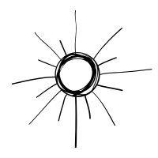

Tell your child that the Sun that we see in the sky is actually a star. But we see the Sun during the day while we only see the stars at night. Why do you think this could be? Why can’t we see the stars during the day? To help your child come up with an answer, use the flashlight you brought with you (or simply one on your phone). Light it up and ask if they can see the light clearly, shine it on the surfaces around you. It would be great to repeat this experiment at dusk or even when it gets much darker outside to demonstrate the difference. Or you can simply use your flashlight in a dark room as an alternative. Ask them again why you think this happens.

If you have a chance to come out at night and look at the stars, your kid will likely ask why they seem so small compared to the Sun. Explain that the Sun is the closest star to Earth, so that’s why it looks so big, and other stars that are further away look small.

During your walk, point out where the Sun is in the sky. Draw their attention to the Sun moving across the sky several times. *You can repeat the shadow play from our walk on Shadows (when you draw your own shadows, and then come back to the same spot several times to see how they are in different locations now as it shows that the Sun is moving).*

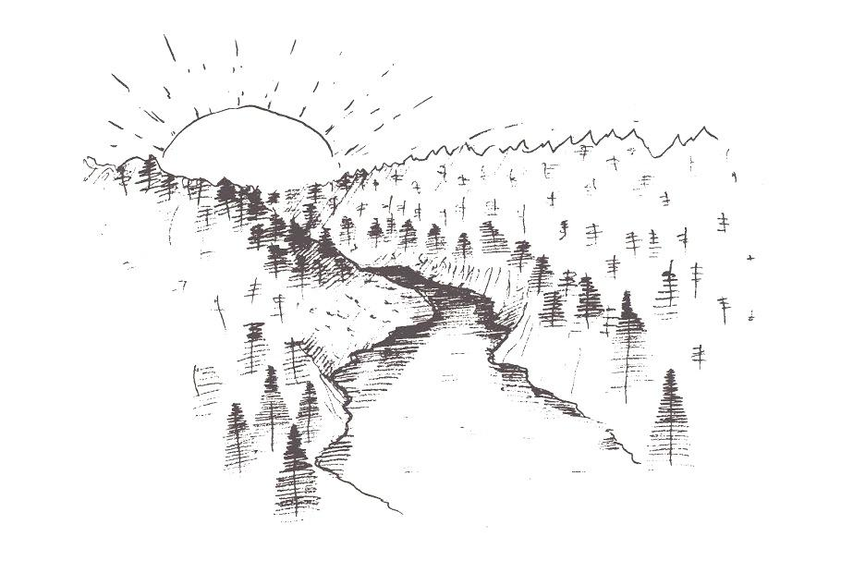

We see the sun in one part of the sky in the morning, and another part of the sky in the afternoon. Then at night, we don’t see it at all. Is it moving? Are we moving? Where does it go at night?

There are very bright sunny days, but on some other days you can’t really see the Sun and the sky seems gray. Where do you think the Sun goes? And why is it light even when we can’t see the Sun? What does the Sun give nature on our planet? Why do we need it? We’ve talked about it in the past, and they might remember that the Sun helps living things because it gives them light and warmth they need to live.

What other useful things can it do for us? *Maybe warm up the water to allow us to swim and play, or help things dry.* But can it cause damage too? What are bad things about a sunny day? (*can cause sunburn, that’s why we wear sunscreen; can hurt your eyes, some areas can go into drought if they lack rain and have too much sun*).

* If it’s a sunny day and you bring a mirror, catch some sun rays in it and play with sun reflections, teach your child how to do it.
* Remember our walk about shadows: look at the objects around you and see if they have shadows, point out how sometimes they can “hide” because the sun is hiding or just covered by other bigger objects.

**Interesting story**

The Sun has a huge influence on Earth and because of this, many ancient cultures saw the Sun as some type of god. For example, the ancient Greeks thought of the sun as a handsome god named Helios. He was the son of the Titan Hyperion and the Titaness Theia. Helios was also the brother of Selene, the goddess of the Moon, and Eos, the goddess of the dawn. The Ancient Egyptians had a god called Ra, and Aztecs had a Sun god named Tonatiuh. 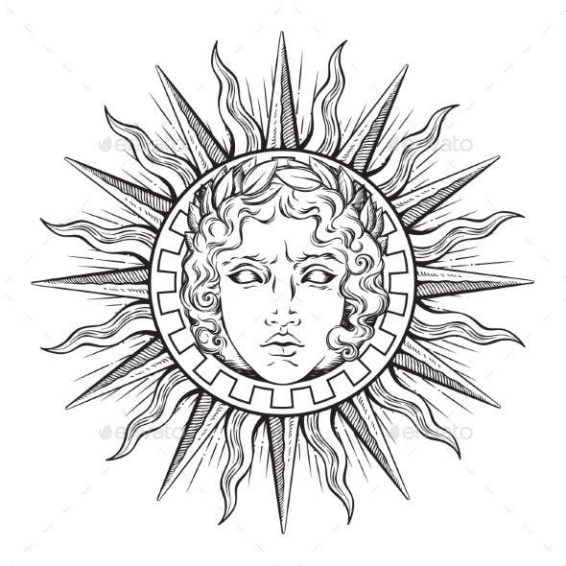

**Fun Facts**

* Can Sun shine all day? In Norway and some other Nordic countries at a certain time of the year the Sun shines all day and all night for three and a half months. How do they get any sleep I wonder?
* We rotate around the Sun Now we know that the Sun is the center of our Solar system and planets rotate around the Sun. But many, many years ago, people believed that the Earth didn’t move and that the Sun rotates around the Earth.
* The Sun is very big! If the Sun were the size of a beach ball then Jupiter would be the size of a golf ball and the Earth would be as small as a pea. Now that makes it a bit easier to picture.
* Sunlight is super fast: It only takes the Sunlight 8 minutes to reach the Earth. People think that nothing travels as fast as the light. You can set your phone timer for 8 minutes and see how long it takes for the sunlight to “be born”, leave the Sun and reach you. The light we see from the stars takes years to reach us because they are much further from us than the Sun. Most likely this light was “born” even before you were born!

**Imaginarium**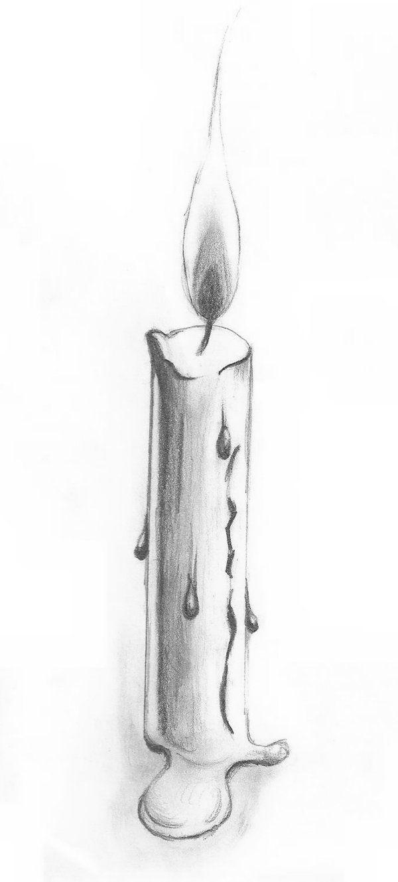

There are a lot of things we do during the day because of the light, such as walking, playing outside, working, reading. If we need to do something at night, we need artificial light, such as electricity, to help us. What if we didn’t have any electric lights? Would the things we do at night be different? What could we do instead? Maybe use candles, or come up with a different way to preserve sunlight for the dark time? How would people’s jobs change?

**Experiment**

How big do you think the sun is? It’s huge (see the fun fact on our list for today). Why do you think it might be that the sun looks as big as a coin but it really is humongous? Let your child try and answer first. Then conduct an easy experiment with a car or a tree. Come close to an object and see how big it is, try to measure it against your own body. Then when you move further away, turn back several times and keep measuring until it looks tiny and you can “measure it with your fingers”. Explain that the reason for this is the further we get from something – the smaller it seems. If your child has ever been on a plane, remind them about the experience and try to spot one in the sky – see how small it looks from here.

Then explain that the Sun really is huge, but it’s extremely far from us, much further than the Moon, or the clouds. The further an object gets from us, the smaller it seems. If you can, make an empirical experiment – show them a beach ball for the Sun and a pea for Earth, it’s much easier to understand and grasp a concept when they see things and experience them vs, just pointing it out.

**Fun ideas to continue the conversation at home:**

Make your own sun catchers

If you have time, you can create your own sun catchers. Here is a relatively easy option to make one with melted beads: [**https://artfulparent.com/making-melted-bead-suncatchers/**](https://artfulparent.com/making-melted-bead-suncatchers/), you can find another option made with simple white glue and food coloring in the Appendix.

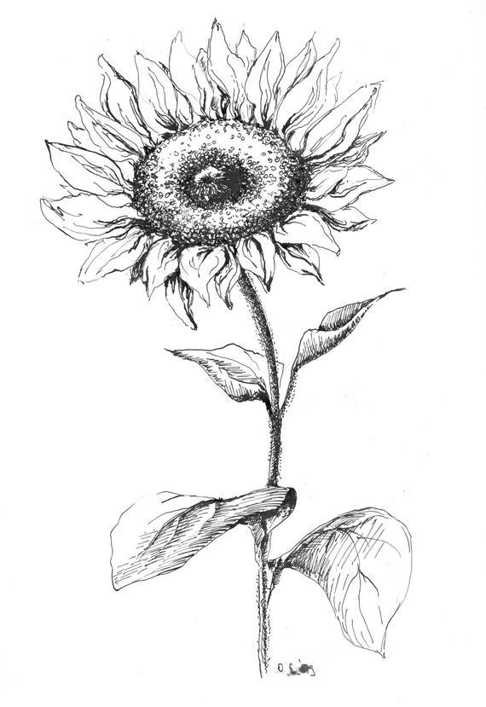

Make your own raisins

And if you have some grapes and would like to give your little ones a lesson in patience, another fun experiment is… making grapes. Here is an example: <http://www.learnplayimagine.com/2014/05/making-raisins.html>

**Books to read**

**“To Be Like the Sun**” by Susan Marie Swanson - [Amazon link](https://www.amazon.com/Like-Sun-Susan-Marie-Swanson/dp/015205796X)

[YouTube read-out-loud link](https://www.youtube.com/watch?v=jZ1A4hqLc8E)

Cutest book ever about the life cycle of seeds & growing! Simple yet thought provoking for kids... or anyone who loves sunflowers!

**“Bees”** 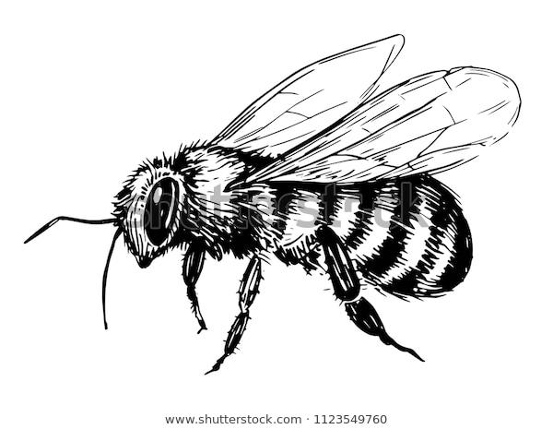

**Walk 11**

**Before the walk:** In some of our previous walks we talked about living and nonliving, so now it’s about time to start observing some of those living beings!

This walk would be better suited for a sunny day. If you have a meadow, some flowers, or maybe a linden tree in blossom in your vicinity where you’ve seen bees buzzing, that would be a perfect day to visit it and talk about bees, honey, and even touch base on pollination. This walk is full of facts and information, as always, don't’ try to talk about everything at once – pay attention to things that your child is more interested in and stop when the focus of attention is gone. You can always watch the bees again and talk about other facts and stories later, but make sure to observe and play the game (see *Activity: Build your own bee hive*) that I offer in this walk – through active games we not only help their gross motor skills development, but also help them integrate the information more through using different parts of their brains!

**Let’s begin!**

Ask your child what are bees: animals? Birds? Many kids at 3+ already know that bees are insects. Ask what other insects they can think of. Try to find a bee. Point out that bees are much harder to observe closely than, for instance, butterflies or ladybugs and ask why they think that is (the answer of course is because they hardly ever sit still – they are constantly flying from one flower to the next trying to get the nectar).

* You must have heard the term “busy as a bee”? Bees are very hard working. The worker bees go from one flower to another, collecting nectar, sweet juice produced by flowers. In one collection trip, a bee visits 50 to 100 flowers! 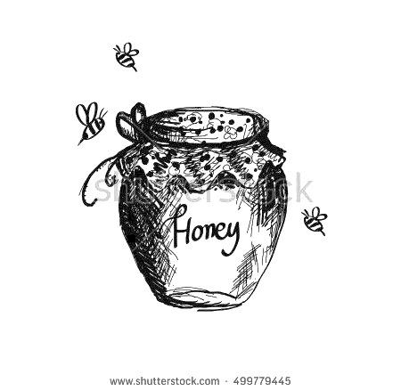
* Ask your child what product is produced by bees. Most kids at 3+ will know it’s honey, if not, tell them, and it would be great to have some on hand. But bees also indirectly produce one-third of the common fruits and vegetables we eat, via pollination! For example, plants like avocado trees, almonds, celery, and coffee depend on bees to grow! The bee will normally collect its weight in pollen flying from one flower to another. When they have a full load, they fly back to the hive, a big home where many bees live.
* There, they pass it on through their mouths to other bees who chew it for about half an hour. It's passed from bee to bee until it gradually becomes honey. Bees build honeycomb cells, which are like tiny jars made of wax, in their hive to store the nectar. Bees in the hive fan their wings over the honeycomb to evaporate most of the water from the nectar, and then cover the cells with wax to keep honey clean.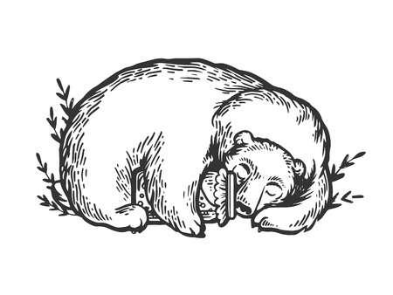

Ask your child what animals like honey. Bears, of course, love honey for its high sugar content as it helps them build up fat to prepare for hibernation, and try to discuss together how they can get it. Would the bees be willing to share?

* Now point out the buzzing that bees make. Ask your child what they think it is. Many kids assume that’s how bees talk to each other. Before explaining that it comes from the wings, pick up a stick, move it quickly up and down and notice the swooshing sound– for some kids that’s enough to make a conclusion about the bees as well, if not – explain that they flap their wings extremely quickly to stay in one spot in the air, and that’s what makes the sound!

*On your way back (and if you want to watch the bees again on a different walk):*

Bees are man’s best friend as they provide us with honey and also help in pollination. They are an important part of our world, as they help to pollinate plants that create the food that we eat (so by flying between different plants they help fruits and veggies grow).

But bee numbers have been dropping, so it’s important to help them by not touching them (they can also sting as they have a dangerous stinger, a tiny pin filled with poison inside, it can hurt, and some people are allergic to it). To help bees we can plant different types of flowers and fruit/veggie plants, and use mostly organic produce.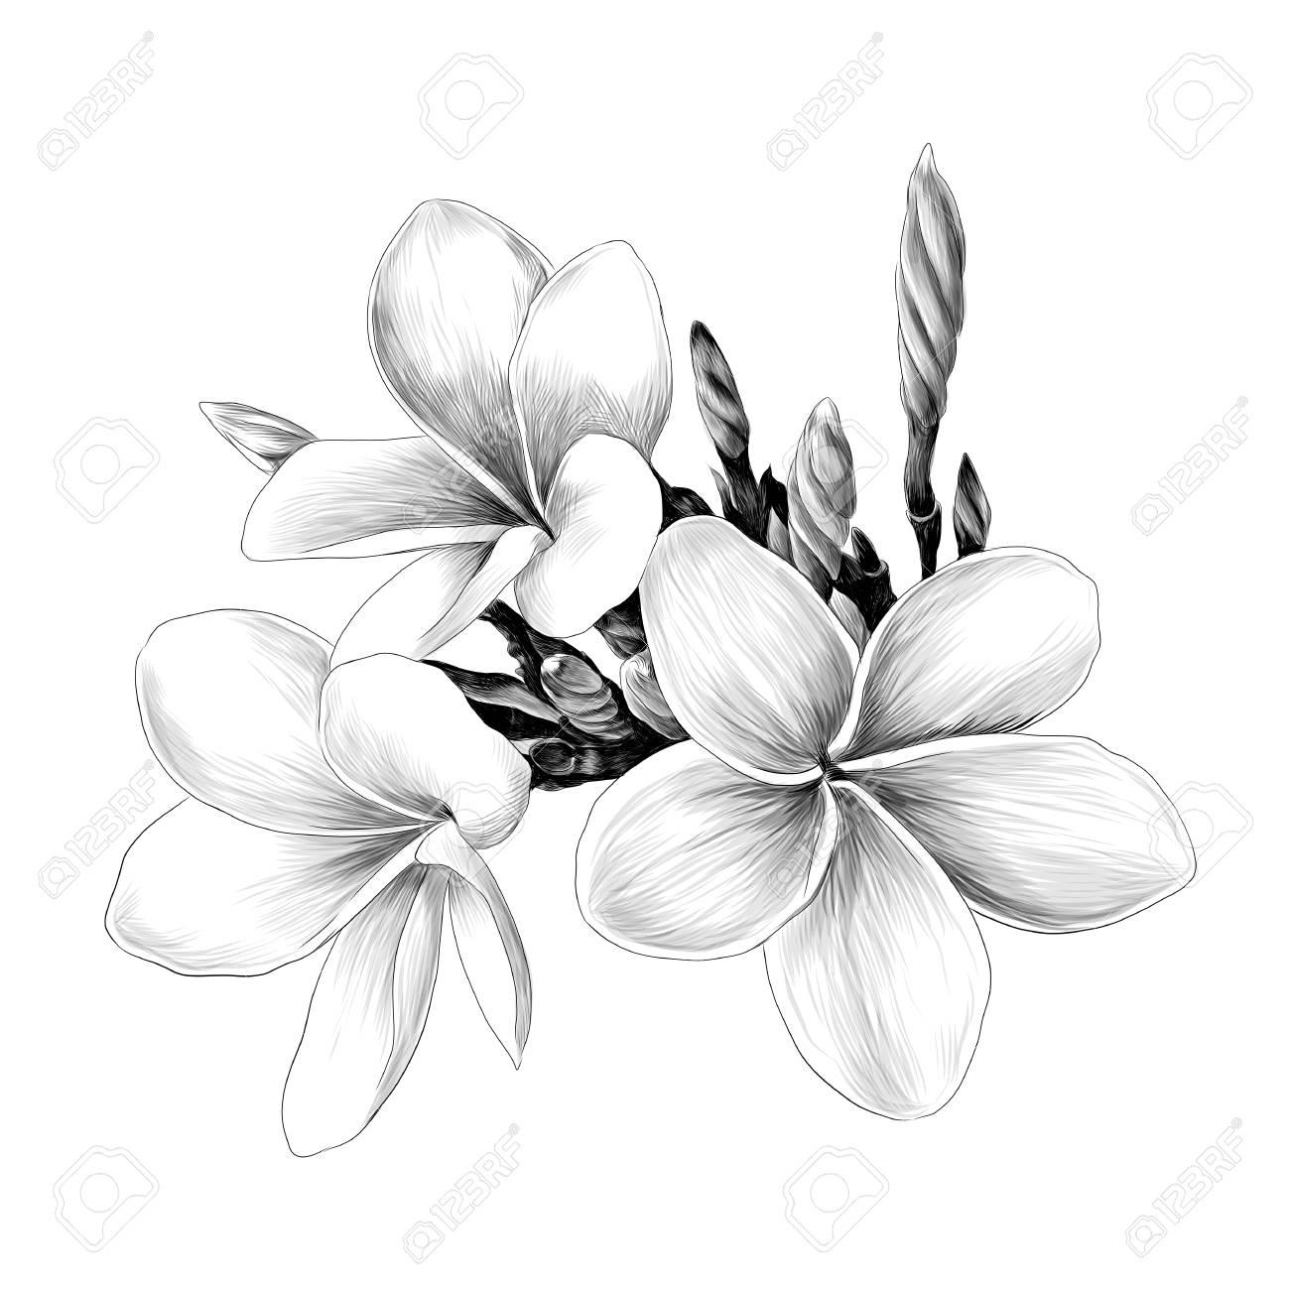

**Fun activity**

Observe the flowers

Try to find a meadow or a place where you can see a few bees and different types of plants. Try to notice (and count!) how many bees you see on different types of flowers and plants. For instance, if you are around clover flowers or linden trees, those are very likely to attract a lot of bees. Discuss why that could be the case.

Build your own bee hive

With all the talking, your child might be losing interest, and it’s important to let them run around and play as play is the best way of learning at this age. Encourage them to pretend to be bees and set up a tent or hive, right outside under a tree or if you are back home right in the living room. The kids can buzz around collecting pollen from flowers before bringing the pollen back to the hive to make honey.

**Interesting story**

Bees have a fascinating life!

Most bees live together in colonies. A colony has a queen, many worker bees (all females) and male bees. Each worker bee has a job to do. The worker bees are divided into different groups each with its own task. Some bees fan the hive to keep it cool while others guard it against other insects. Some worker bees produce the wax which is used to build the combs.

Male bees are called drones. They live in the colony in spring and summer but are kicked out before winter.

The queen bee is the leader of a beehive and the only one in the hive that lays eggs (that’s how new bees are born). The queen bee lays the eggs in cells of the comb. Larvae are hatched from the eggs in three to four days. The worker bees get food for the larvae. It takes 21 days for an egg to develop into an adult bee!

A legend from Thailand about bee hives

This folktale explains why bees build their hives in cozy places, such as tree trunks:

Long, long ago, elephants did not have trunks. One day a terrible forest fire swept over the land. To escape the smoke, the honey bees hid inside the elephants’ mouths. The elephants roared angrily, but the bees would not come out. The elephants blew so hard, their mouths stretched out into trunks. In desperation, the elephants breathed in the stinging smoke of the fire and the bees finally buzzed off. Since then, bees have always built honeycomb in hollow trees, because it reminds them of elephant trunks.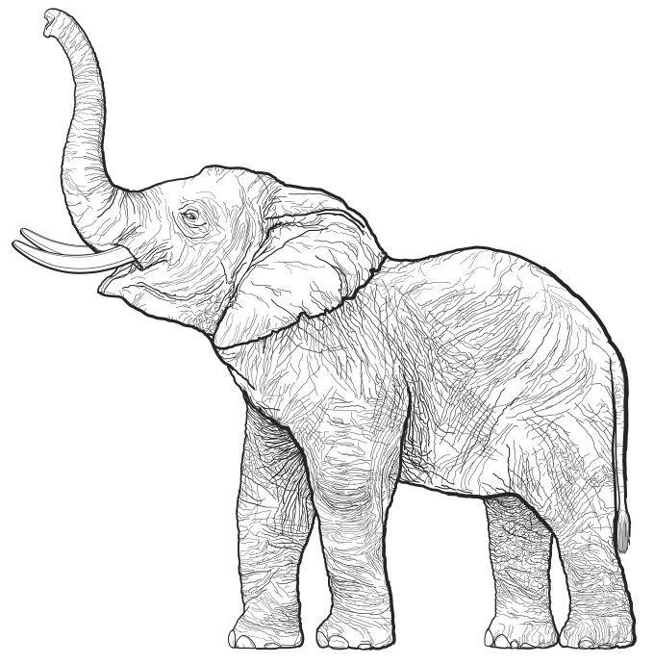

* *That’s also a good segway to talk about legends in general* and explain that legend is an old story that is widely believed in some places and told from one generation to the next, but cannot be proved to be true.

**Fun Facts**

* How much do bees work? It takes 8 bees to produce 1 teaspoon of honey, and 12 for a tablespoon.
* Are there bees everywhere? Bees are found all over the world except Antarctica.
* Sting: Only female bees sting.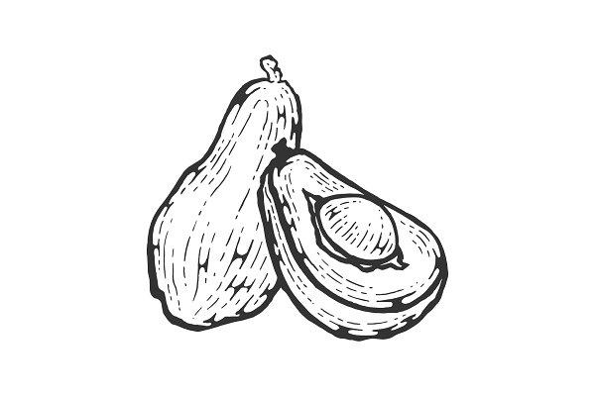

**Fun Facts for Parents**

* Are avocados vegan? Some people consider products like avocados and cherries NOT vegan because they fully rely on bee pollination to spread and grow. What’s your take? ;)

**Imaginarium**

To work on our imagination (and critical thinking too!) we will use another “scientific creativity” method today called The Method of Focal Objects *(it involves synthesizing the seemingly non-matching characteristics of different objects into something new)*. We will take a bee’s sting and any other man made object and we’ll look for a way to improve this object by combining it with the sting and its ability to pickle something.

For example, a bicycle with a sting – what POSITIVE can prickliness improve a bicycle? E.g., a bicycle that can measure your pulse and if a rider begins to fall asleep, lightly prickles him or her to wake them up. Or it feels that you are losing balance and tingling sensations are meant to help you understand which way to lean. Or maybe a bike that releases a sting when someone is trying to steal it. 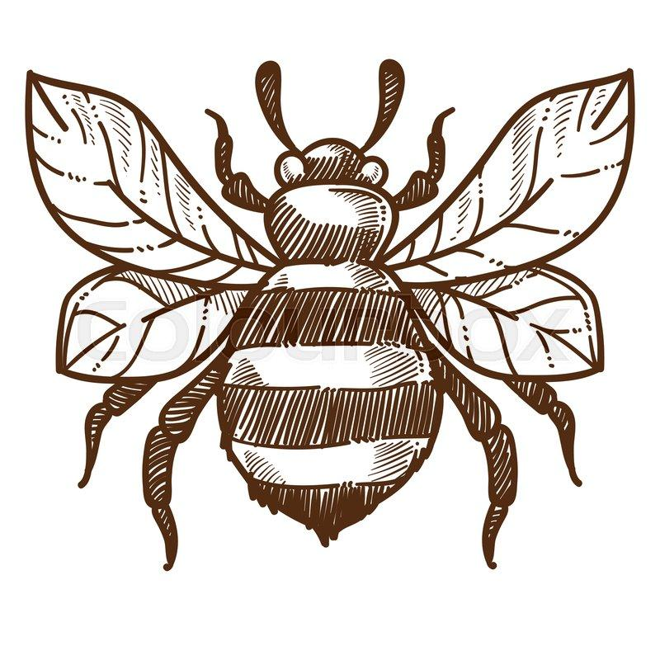

You can use any other man made objects to “improve” – feel free to send your ideas and inventions to my email (mentioned on top) for a chance to be featured on the website!

**Note for parents**: Also, *keep in mind that in the beginning when you start using this one and similar creative thinking focused exercises, your child will likely take time before sharing ideas too. Just keep on sharing yours and do it more often – and eventually they’ll get into the groove!*

What other natural objects can “sting”, be it animals, insects or plants (many insects, roses and other plants)? What do you think is the main purpose of it?

**Riddle**

Here is an old English riddle for your little one with a pretty obvious answer. You can begin the walk with it, then it will be less obvious:

Behind the king’s kitchen there is a great vat,

And a great many workmen working at that.

Yellow are their toes, yellow are their clothes.

Tell me this riddle and you can pull my nose.

**Books to read**

# **“Five Bizzy Honey Bees - The Fun and Factual Life of the Honey Bee”** by Lance Douglas – [Amazon link](https://www.amazon.com/Five-Bizzy-Honey-Bees-Captivating/dp/0692997873) - [YouTube read-out-loud](https://www.youtube.com/watch?v=M8k4wA2mMWU)

This cute story is an adorable add on to this topic. It takes us on a fascinating journey into the hive and explores the highly organized life of the honey bees sharing cute insights and fun facts on every page. Readers from 1 to 100 will be amazed at the fun facts and beautiful illustrations.

**The Bee series** by Frank J. Selio, PhD: **“Bee Calm”, “Bee Still”, “Bee Heartful” –** [Amazon link](https://www.amazon.com/Bee-Heartful-Loving-Kindness-Frank-Sileo/dp/1433831570) - [Bee Still YouTube Read-out-loud](https://www.youtube.com/watch?v=wmDSEwMDOQw)  
If you are into mindfulness and would like to introduce it to your little ones, these books would make a good intro. Bentley the bee lives in a busy hive and learns meditation and a few beginner’s yoga poses. The message is great and the illustrations are lovely.

In case your child really gets interested in this subject, here **is a fun resource**. This page allows you to take a quiz about different types of bees:

<http://beesforkids.org/wp_quiz/what-bee-is-this/>

**“Boating, Floating, and Sailing”**

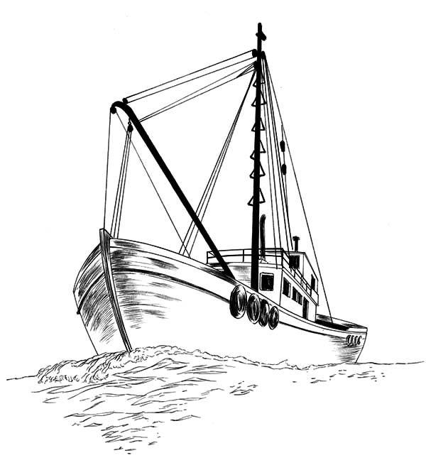

**Walk 12**

**Before the walk:** Today we’ll talk about different types of boats and observe how they float, so it would be great to plan this walk around a fountain, local pond, or at least a deep puddle.

Make sure to bring a piece of paper on your walk, along with some tin foil and a few Lego Duplo figures or similar (not a must, but fun to experiment with if you have access to a shallow water source, like a fountain or a kiddie pool) 

Another thing you need to do before the walk is remember (or learn) how to make a paper boat. Here is a simple [step by step guide](https://www.youtube.com/watch?v=b3QZpBL8-Tg) from Youtube.

*Note for parents: These activities will allow kids to explore the concept of buoyancy.*

**Let’s begin!**

Have you ever seen a boat or a ship? Have you been on one? Let’s build a boat today! But first, let’s see what we can make boats with. Pick up some leaves, sticks, and rocks around you and try to put them on the water. Your child, we notice that some go to the bottom while the others continue to float. Ask them for their theories on why that is and listen to their answers.

If you are by a fountain, a puddle or a kiddie pool, try using different materials (tin foil, wax paper, bark) and putting one or two small figures on them to see if it will be able to carry them. Now fold the tin foil and see if it is able to hold more toys (or simply use sticks). See Appendix for our version.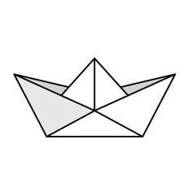

Now suggest making a paper boat, and follow the guide to make it. See if it’s able to float and have your child check if it can hold little sticks. Can it hold more sticks than a leaf or vice versa?

See if your little boats are moving. If they are, ask what is causing them to move? If they are still, blow on the water and see how the waves propel them in a certain direction.

* *Note for Parents:* Always follow your child’s interest and use the situation as a foundation. For example, when we did this activity, the wind was pretty strong and the waves in our local fountain caused a shipwreck ☺ My daughter was a bit upset at first, but it was a great segway for us to talk about **shipwreck, dangers at sea, Titanic, and ships disappearing in Bermuda triangle**. Seeing “a shipwreck” on such a tiny scale boosted her interest toward this subject so much that she kept asking related questions for days to come.
* *Discussion for older kids:* What do you think we can substitute ships and boats with? What can we use instead of them? If they don’t understand the concept, start with asking what boats and ships are used for: e.g., traveling (like on a cruise ship), transporting goods, travel, transportation to work across rivers and bays. Now what other things people use instead to get those things done? E.g., planes for travel; bridges and tunnels to cross rivers or lakes, rafts. See what ideas they might have and what’s the logic behind them, don’t correct.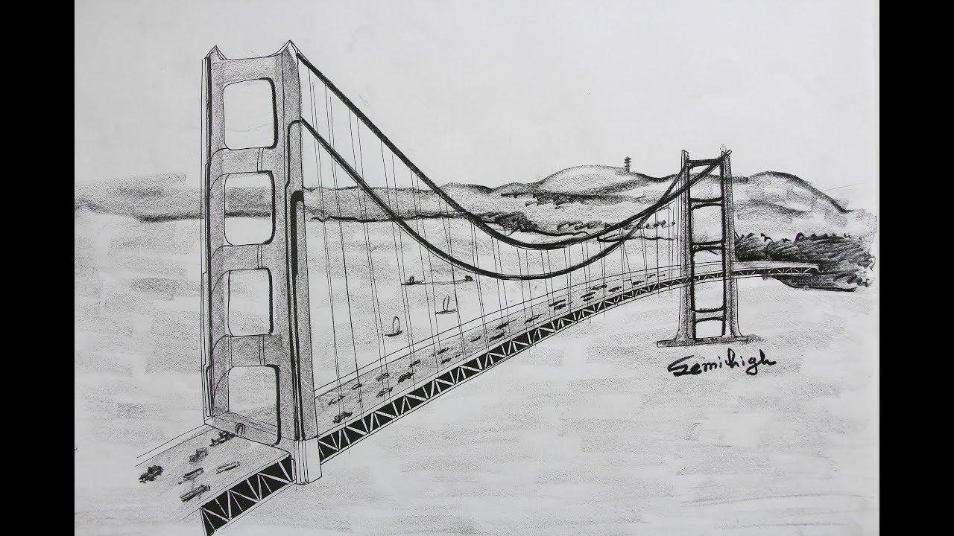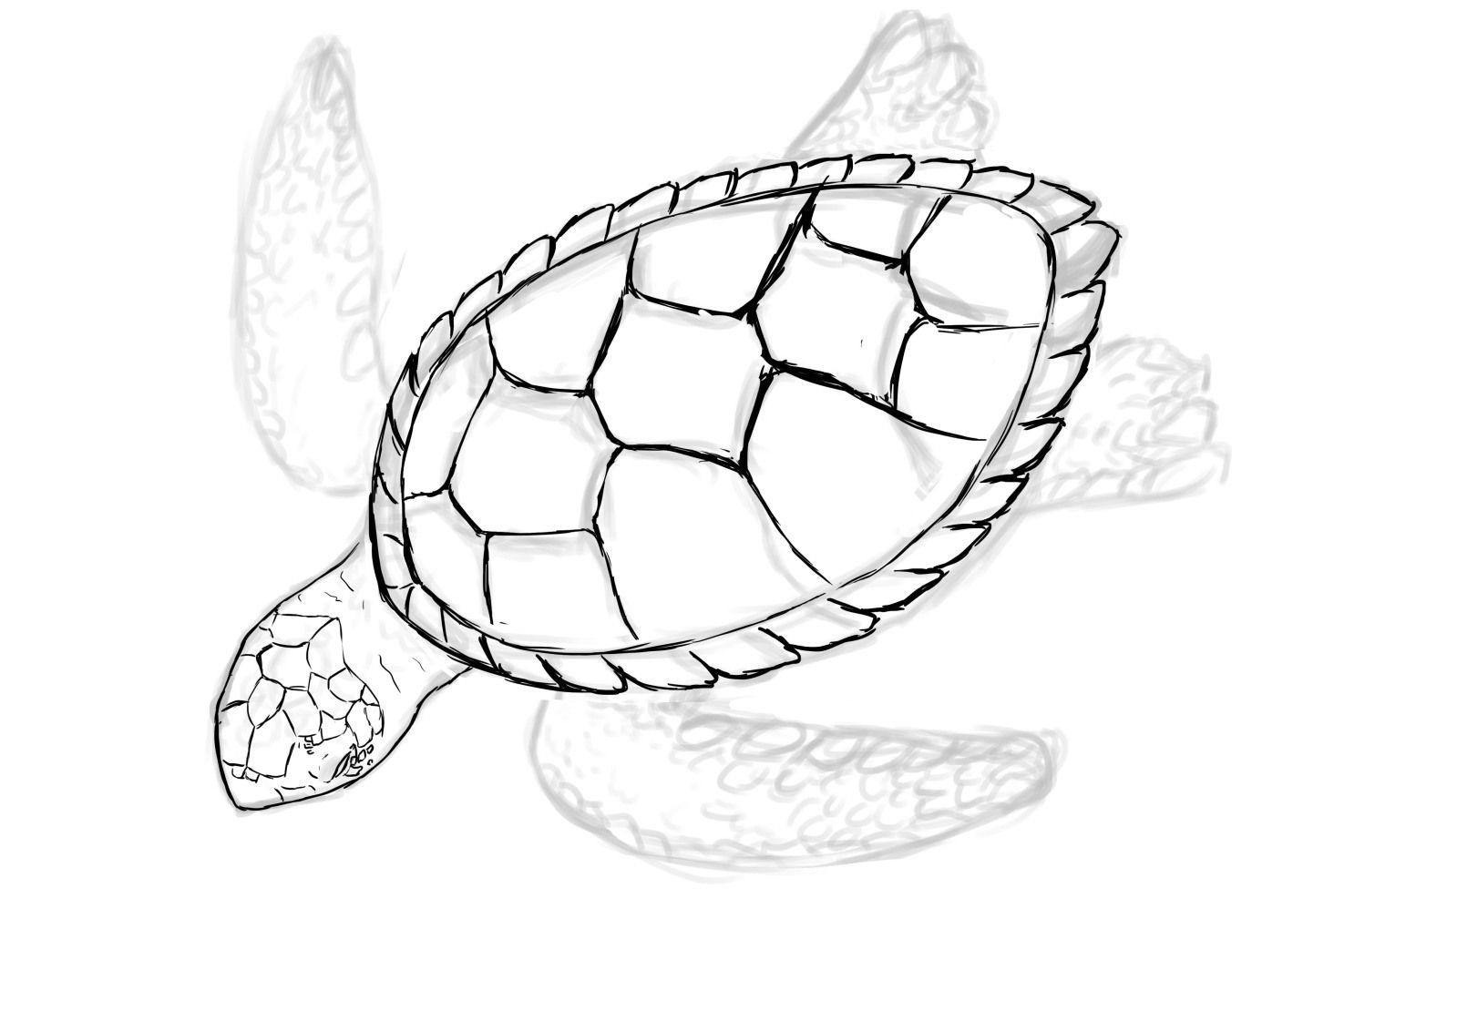
* We know boats and ships are man made. What about natural boats? Ducks and geese are able to float on the water – can we call them natural boats? What about turtles? Whales?

**Interesting story**

When it comes to ships and boats, you can tell so many interesting stories! Pirates, shipwreck, ships that went missing in the Bermuda triangle. When we did this walk with my daughter, our paper ship sank because of waves, so she loved the story of Titanic and I had to re-tell it multiple times. Based on your child’s interest and what seemed particularly exciting during the walk, pick the story that you think will be most interesting to them at the moment. One of the fun things to tell them is about superstitions that are common across sailors.

Spending weeks or months on a ship, stories and **superstitions** became a big part of a sailor’s life. E.g., whistling is considered bad luck as some believe it can bring about strong winds and cause a shipwreck. However, there is one person on a ship who is allowed to whistle. Guess who? It is a cook as it means he is not eating the food.

Another superstition that has to do with food is about…bananas. Bananas might turn a boat’s luck ill, too. Especially when it comes to fishing boats as it is believed that if bananas are aboard, the fish won’t bite and there might be mechanical mishaps. As soon as the hidden bananas are discovered and removed, the boat’s luck turns around.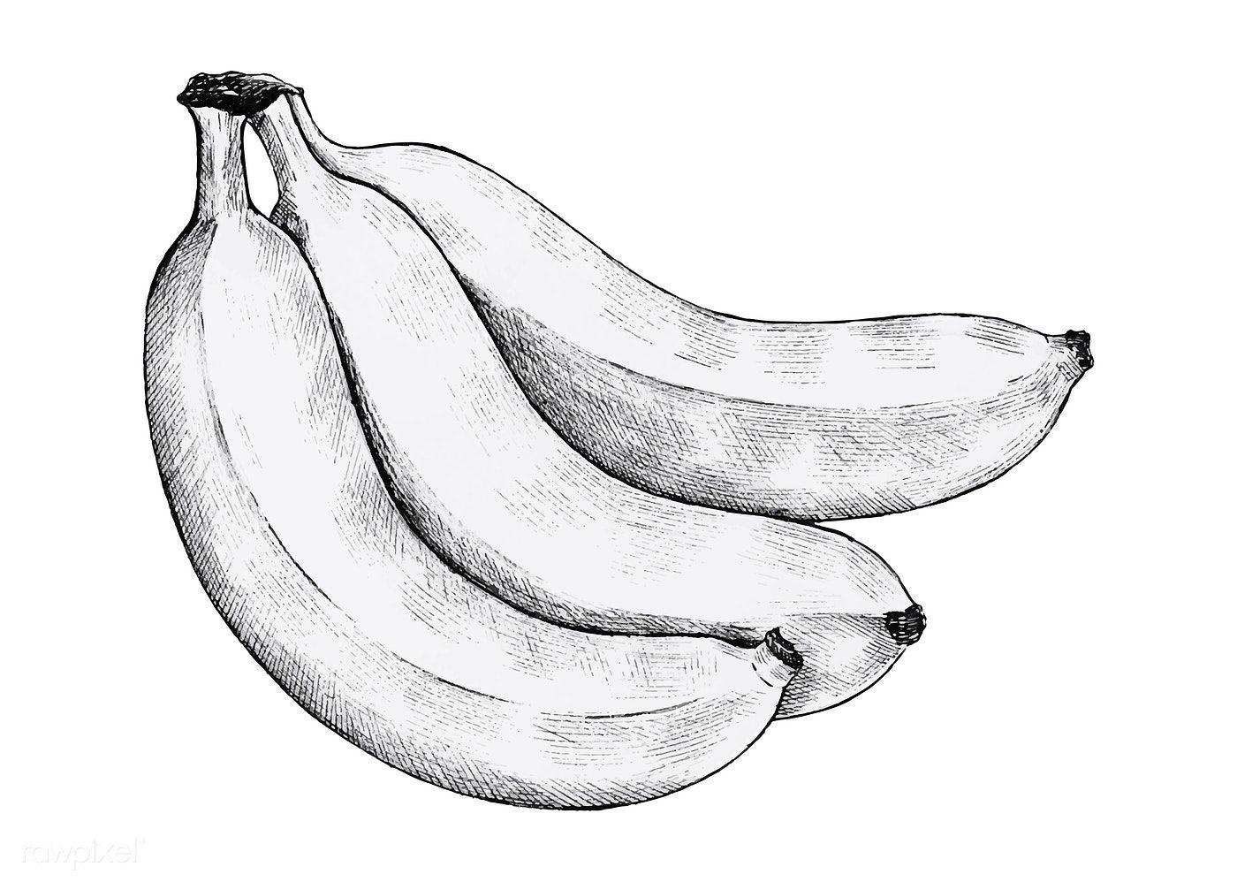

On the other hand, it is believed that cats bring good luck. British and Irish sailors would often adopt a black cat and bring it to ship. Some cultures actually believe that a black cat is a sign of bad luck. However, there is logic to cats bringing good luck to sailors: after all, cats hunt down and get rid of rodents, who usually live on ships and might chew on ropes or eat food. This practice was even adopted by Vikings in Northern Germany many many years ago. 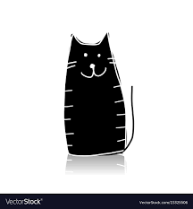

**Fun Facts**

* Ships and Quarantine: The word “quarantine” has smth to do with ships. It comes from Italian “quarantina giorni” or forty days. Venice had a policy of quarantining ships from plague-stricken places for 40 days, ensuring no one infected is on board and wouldn’t spread sickness.
* Bermuda Triangle: An unsolved mystery, the Bermuda Triangle is an area of the ocean in which many ships and airplanes have disappeared. It is also one of only two areas on planet Earth where magnetic compasses operate differently than normal.
* It is located in the Atlantic Ocean between Bermuda, Puerto Rico and Florida. Reasons for those accidents that people named include aliens, pirates, gas deposits, hurricanes and bad weather, and even a lost continent of Atlantis. Most scientists believe the causes are bad weather and human error.
* *For older kids*: One of the explanations scientists are looking at for some of the disappearances has focused on the presence of large fields of methane hydrates (a form of natural gas) in this area. Experiments carried out in Australia showed that their bubbles can sink a scale model ship by decreasing the density of the water, and any wreckage rising to the surface would be quickly dispersed by the Gulf Stream. So periodic methane eruptions (sometimes called "mud volcanoes") could produce regions of frothy water without adequate buoyancy for ships which would cause it to sink very quickly and without any warning.

**Imaginarium**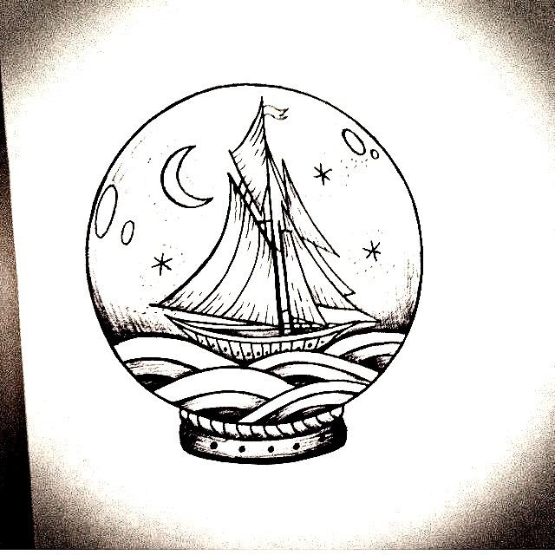

People used to travel around the whole world by boat, and some still do now! If we decided to go around the world on a boat or ship, where would you like to go? What countries would you like to see the most? Who would you bring with you? What should people bring with them for this trip? Or come up with a story of a family traveling around the world, seeing amazing things like icebergs, volcanos, and their adventures if you prefer stories!

Another option is to come up with your own ship. Talk about different types of ships first - fisherman’s boat, a yacht, a cruise, a fregate, a submarine. Then look at the pictures. What they can and cannot do. Now come up with your own ship, no limits! Maybe its a flying ship that can carry you over the mountains? Or it can “release” skies to go through a snowy mountains? Or it could be an edible ship - a chocolate fegate or a marshmallow yacht? Who would sail it, where, and what are the pros and cons?

**Books to read**

**“How I Became a Pirate**” by Melinda Long - [Amazon link](https://www.amazon.com/How-Became-Pirate-Melinda-Long/dp/0152018484)

[YouTube Read-out-loud](https://www.youtube.com/watch?v=ro5E4BUaHeo)

I’ve recommended this book for our walk about Maps, but it’s a perfect fit to encourage a conversation about ships, pirates, and sea superstitions too.

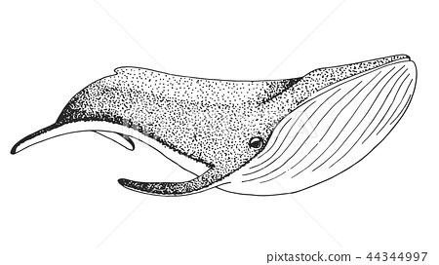

**“The Snail and The Whale”** by Julia Donaldson - [Amazon link](https://www.amazon.com/Snail-Whale-Julia-Donaldson/dp/0142405809/ref=sr_1_1?crid=1C88L4PF5FP6J&dchild=1&keywords=the+snail+and+the+whale+by+julia+donaldson&qid=1600801897&s=books&sprefix=the+snail+and+%2Cstripbooks%2C157&sr=1-1)

[YouTube Read-out-loud](https://www.youtube.com/watch?v=EmMnaSkeKqQ) - There is a lso a cartoon available through Netflix and other sources

Absolutely adorable story about an adventurous hungry snail and her exciting travels around the world with her new humongous friend. Perfect compliment for our Imaginarium that will give some ideas of what one can see traveling around the world!

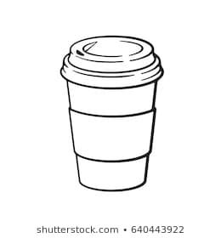

**“Coffee and Disposable cups”**

**Walk 13**

**Before the walk:** Today we’ll have a fun subject to talk about, especially for city dwellers who love to start their walk with kids at a local coffee shop. If you normally don’t, I’d suggest to save this walk for a time when you stop by a coffee shop, or simply bring a paper cup with coffee, tea, or juice on your walk so that we could use it for our fun experiments! We’ll learn some fun facts about the history of coffee, tea, paper cups, and of course talk about recycling.

**Let’s begin!**

Ask your child what he or she knows about coffee (or tea if you prefer tea). Listen to their answers, some kids will give you fun ones about “coffee being disgusting brown liquid that only adults are allowed to drink because it helps them work”.

Guess how much coffee people in the world drink. The world’s average coffee consumption is three cups a day per person! This means 587 million cups a day. Even if we count them all as the smallest cups, put together into a pile, they would make a pile taller than the world’s tallest skyscraper. Of course, most people are using regular cups, but many of those people who drink coffee on their way to work use paper cups. Recently many people started to bring their own cups with them to waste less paper.

But even paper cups are recyclable. Do you know what it means to “recycle”? Explain that Recycling is the process of taking an organic material such as glass, plastic, metal, or paper (including paper cups), and processing it so that it can be used all over again! It gets a second life as paper, tissues, newspaper, or even greeting cards! Why do you think it’s important? Let them elaborate, but explain that to make paper cups, people need to cut trees. So we recycle to save trees and be kind to our planet. If your city or town offers recyclable trash bins, show them to your child.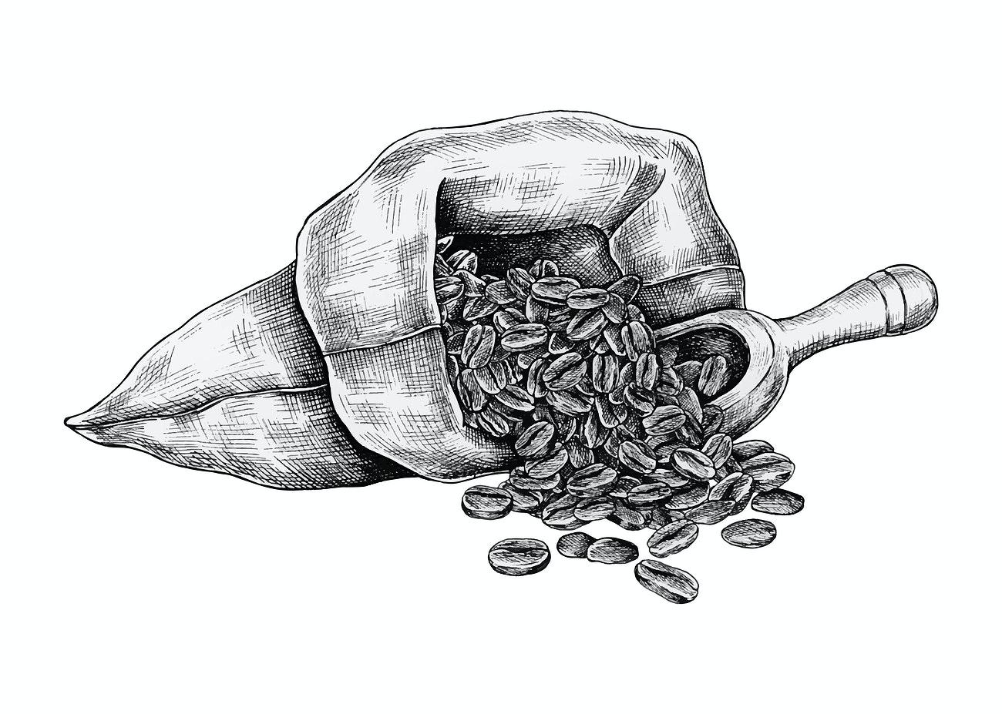

* *For kids 4+:* Talk about what it took for you to get your coffee and how “international” it is. “Did you know that most coffee is grown around the equator and comes from Brazil and Africa? So the beans were grown there, then roasted and brought to our country. Paper cups are manufactured on a plant, and then delivered here. Then we need water (and maybe milk or sugar depending on how you drink your coffee). Then the barista made it (Another fun fact for your kid: “Did you know that a person who makes coffee is called a barista?” Imagine how much work went into this little cup of coffee and how many people contributed to it. That’s why we need to work together, and make sure we are kind to our planet too. Even if we don’t notice it, we are all connected and help each other, even people in different parts of our planet.

**Interesting story**

Legend has it that 9th-century (many hundreds of years ago) a goat herder in Africa (Ethiopia) noticed the effect that caffeine had on his goats, who appeared to "dance" after eating the fruit of the Coffea plant. He shared this with the local monastery, and a monk then made a drink with the said fruit, and realized that it kept him awake at night, that’s how the original cup of coffee was born and started its travel all over the world!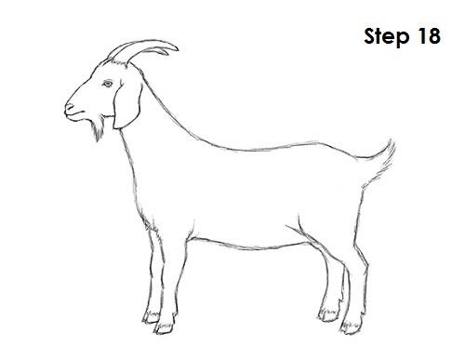

**Fun Facts**

* Coffee is a fruit! Coffee beans grow on a bush. They look like beans, but… They are actually the pit of a berry, which makes them a fruit.
* Fun fact for car lovers: Scientists have successfully turned ground coffee into biodiesel, so one day coffee may be fueling your car.

**Fun Facts for Parents**

* Coffee ban: Back in 1511, leaders in Mecca believed that coffee stimulated radical thinking, and due to that fact banned the drink. Some 16th-century Italian clergymen tried to outlaw coffee because they believed it was "satanic." However, Pope Clement VII loved the drink so much that he lifted the ban and had coffee baptized in 1600.

**Imaginarium**

What if paper cups were never invented, how would people go about life? Bring a cup with them anywhere they go? Use plastic bottles to drink water? Maybe even drink less! See what your kids have to say and prompt them to further ideas and deliberation!

**Experiment**

You have two choices for your experiment today. The first one will likely be more fun for younger little ones, and the second one might be more exciting for kids 5+. Or you can try and do them both on different days, or just extend your walk a little longer.

A disposable cup drum

These drums are pretty cool and basically take no time to make. Blow a balloon up and let the air out to stretch it out a bit and then cut the tip off. Stretch the balloon over the top of the cup, grab a couple of paper straws from that coffee shop and voila: you have a drum! If you don’t have a balloon, you can easily use a simple plastic bag, just cut a piece to fit the top of the cup and use a simple scrunchie to keep it in its place. You can use a couple of twigs instead of straws as well. They actually sound really good when you have a few different sizes to play and experiment with!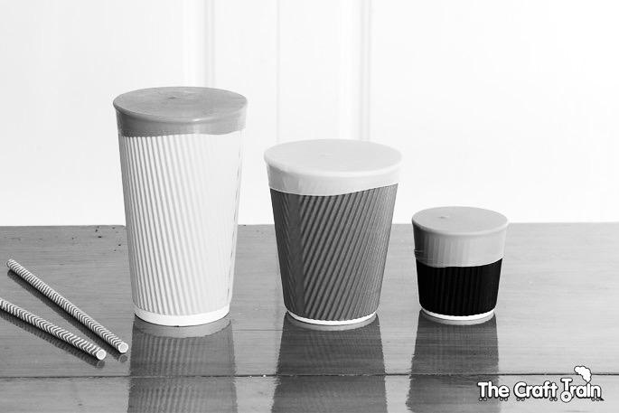

A paper cup phone

Step back in time and use a couple of paper cups to make an old fashioned string phone while learning about sound waves. If you didn’t bring paper cups on your walk, I’m sure you can get a couple from that local coffee shop.

What we need:

* 2 paper cups
* A sharp pen, pencil or sewing needle to poke holes
* String (simple kitchen string and fishing lines work well, about 60 feet or 20 meters, but you can try different lengths too)

A Step-by-step guide:

* Poke a small hole in the bottom of both cups.
* Thread the string through each cup and tie knots at each end to stop it pulling through the cup (alternatively you can use a paper clip, or a small stick, rock or other object to hold the string in place).
* Move into position with you and your child holding the cups at a distance that makes the string tight (making sure the string isn't touching anything else on its way).
* One person says smth into the cup while the other puts the cup to his or her ear and listens. Can you hear each other?
* And now let’s add on a learning component of course. Ask your child why they think it happens?
* For kids who are interested in *more detailed explanations (most often, 5+*), explain that speaking into the cup creates sound waves which are converted into vibrations at the bottom of the cup. The vibrations travel along the string and are converted back into sound waves at the other end so your friend can hear what you said. Sound travels through the air but it travels even better through solids such as your cup and string, allowing you to hear sounds that might be too far away when traveling through the air.
* For younger kids, you can explain it using the tiny humans method used in the TRIZ methodology for children. Basically, we use a metaphor of tiny humans to atoms, molecules, or in this case sound waves. Explain that when we speak, we create a sort of a “wave”, a group of tiny humans that runs from one person to the other. Tiny humans can travel through the air, but if they have smth to cling to, like a string, they move much further than without anything to hold on to.

**Books to read**

**“Happy Little Pine**” by Nirdesha Munasinghe – [Amazon link](https://www.amazon.com/Happy-Little-Pine-Nirdesha-Munasinghe-ebook/dp/B0887FL479)

[YouTube Read-out-loud](https://www.youtube.com/watch?v=6Objhf-SPqc)

Sweet and meaningful story about how humans can choose to destroy or embrace nature that would fit into the conversation about recycling. One of the books you can read to kids 3+, as most books on this subject are meant for older age groups.

**A 5 minute animation about history of coffee -** [YouTube link](https://www.youtube.com/watch?v=4U7W6fYrYuQ)

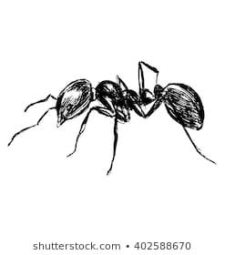

**“Ants”**

**Walk 14**

**Before the walk:** We’ve previously observed a lot of things in nature, plants, trees, and bees. Textbook approach is focusing on one area at a time, but for our purposes of growing curiosity and developing understanding of how different the world around us can be, we will introduce different subjects during every walk and observe the ants today. Also, it’s a better approach for motor skills development too. For instance, today we are looking up at the sky and talking about the clouds, tomorrow running around and buzzing like bees in a hive, and the next day watching the ants crawling on the ground looking down.

This walk would work great in the woods as it’s easier to find a real anthill or a large ant nest. However, you can definitely find some ants in the city and even at a playground. So try it where you are today, but keep it in mind for your next outing into a woodsy area, and then go deeper in the woods and look for an ant hill, you are likely to find one by a stomp or an old fallen tree.

**Let’s begin!**

Ask your child – how much weight they can lift up. Can they pick up a full cup of water? What about a large pot with water? Now how about a car?! Believe it or not, an ant can lift 20 times its own body weight, some of them even up to 50 times! If you were as strong as an ant, it means you would be able to pick up a car! Some kids might say that people are still stronger because we can pick up heavy objects when we grow up – explain that strength is defined by the proportion of your own size/weight to the size/weight of the things you can lift.

Refresh the material from the previous walks:

* Who created ants – humans or nature?
* Can there be non living ants? (of course, for example the ones we draw on a piece of paper or with chalk – good time to practice btw!)
* Are they plants or animals? Here older kids might argue that they aren’t either because they are insects. Explain that they are still animals because unlike plants they need food from outside to grow and live, while plants produce food within. Then, animals are divided into mammals, reptiles, insects etc.

Now it’s time to look for some ants – the more you find, the better. Use your magnifying glass to observe their activities. Are they running away from you? Do they all look the same? Pay close attention and you see that some look bigger than others, they have different colors, and a few even have wings!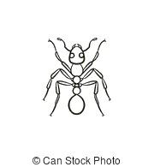

Did you know that ants don’t have ears? Then how can they hear? (let your little one guess first!) Actually, they can feel the vibrations (the tiny movement the Earth makes when we step on it for example) through their feet and through their antennae! Speaking of which, let’s count how many legs they have (6) and how many antennae (2)?

Unlucky with hearing, but they are lucky with eyesight – it’s pretty amazing as they have a lot of lenses in their eyes (*if your child asks more questions, that’s a great segway to Googling and talking more about the human eye and vision by the way! – always follow their interests, that’s the best way to learn and teach!)*

* Ants have antennae, like many insects, to sense their surroundings (hear, taste, touch and smell).  Do we have antennae?  What do we use to feel and understand our surroundings?  (talk about the 5 senses).
* Ants even use them to touch one another and “talk” to each other in “ant” language. Actually, they are great communicators. When ants meet, they run antennae over one another, ‘sniffing’ for smells and tastes that function in the same way as facial expressions, words and tone of voice do for us.
* *For older kids*: They also use pheromones, chemicals produced by their bodies, to communicate. For example, alarm pheromone, with which ants warn the colony of danger even as they are dying. That’s why if you kill one ant in your kitchen, a mob arrives soon to protect and fight.

Ask if ants are “good” or “bad”. Likely if you find a few in your picnic lunch or in your kitchen, you will be unhappy. But ants do plenty of good things too. What could the be?

Try to think together first. Ants are important to pollinate/help grow low-growing flowers; they are even more helpful for soil health than earthworms because they tunnels help more air get into the soil and as they smuggle pieces of food (plant and animal matter) from the world above, they improve the nutrient levels of the soil. Point out how we can find good and bad in everything around us.

**Experiment** 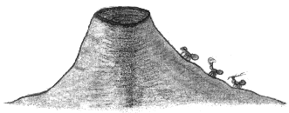

I hope you brought something sweet for your walk, like a piece of candy, cookie, some bread crumbs or even sugar. If you found a little hole in the ground where the ants crawl into, that would be a perfect spot to put your treat next to, or simply find a place with quite a few little crawlers. Now watch them “take the bait”. They will likely start inspecting the object closely and when they realize it’s edible (and even sweet!), they might try to pick it up and move it to their home!

**Fun activity**

Draw the outline of an anthill plus a few tunnels with some chalk. Draw and talk about “rooms” for the eggs, the larvae, pupae etc; the queen’s room; the soldiers protecting the nest; the workers, bits of food. Have your child pick up some leaves and sweets and carry them to set up their “home”. Especially if you have several children around, you often won’t have to persuade them to make it into a longer game (and let you take a coffee break ;) ).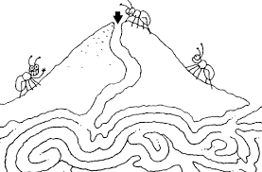

**Ideas to continue the conversation at home**

* Fingerprint ants: dip fingertip in paint or stamp pad.  Print lots of ants with 3 touching body parts.  When dry, add 2 antennae, 6 legs on each.  Do some counting: here we have 3 ants, with 6 legs each.  Let’s count and see how many legs altogether.
* Make ant headbands with 2 pipe cleaners for antennae.
* Playdoh ants with toothpicks or pipe cleaners for antennae and legs.
* Make an ant “environment” or anthill on a paper plate with dirt, leaves, bits of bead etc. We often make habitat for insects with soaked or just crumbled leftover chocolate cookies (see a picture in Appendix).
* Sing “The Ants Go Marching One by One”

**Interesting story**

Can you believe this? Ants have survived on Earth for more than 100 million years. There are hardly any other species that have been able to adapt so well in order to survive for so long. Let’s talk about how they organize their lives to be able to do it!

Most insects live on their own. Ants, along with bees and termites, are social insects. It means they live together, as a community, not on their own. Their homes (or rather towns) are similar to ours: they have roads and multiple rooms, including bedrooms, storage rooms, and even rooms for “children” (larvae, pupae, and eggs).

A typical colony contains an egg-laying queen and many adult workers. Ants have different jobs: building the next, digging tunnels, hunting and gathering food such as seeds, pieces of plants or mushrooms, little bugs and caterpillars, defending eggs and the queen, and much more. Nurse-worker ants are very attentive to the eggs, larvae and pupae that they are responsible for - licking them to protect from bacteria in the soil, and moving them from room to room at different times of the day to ensure they are kept at good temperature. Ants rush to sacrifice their own lives in defense of the colony as a whole from enemies: grasshoppers, big bugs. They take care of one another like a family. E.g., when a colony shifts to a new nest site, and one of the ants isn’t feeling well, it is picked up and carried.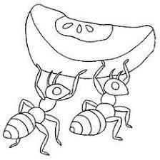

*Note for parents: You can simply tell this as a story or draw the line between our societies to showcase how altruism, caring, and cooperation help them survive for so long and be the largest species on our planet.*

Ants have other similarities with people. They can even grow plants and have domestic animals! Herder ants, as their name suggests, tend to aphids - the little green bugs that drink plants’ nutrients and are considered pests by every farmer on earth, except for ants. Ants love the sugary substance aphids exert, called honeydew, and treat the bugs as their dairy cows, that’s why they are often called “ant cows”! Ants can even “” their herds by tickling them with their antennae.

In return, ants shepherd their bug flocks to better pastures and shield them from rain, sometimes they even carry them from one plant to another. Ants care for and protect aphids’ eggs, treating them as their own and keeping them safe inside their colonies for winter. *Check out Appendix to see a couple of pictures of aphids.*

Ants are even able to grow plants – some of them garden fungus, believe it or not. It’s like a fruit tree for them – they domesticated fungus the same way people domesticated many plants.

**Fun Facts**

* How do ants breathe? Ants don’t have lungs. How do you think they breathe? Oxygen enters through tiny holes all over the body! They can survive under the water for 24 hours because of this! An ant can appear to be drowned, but when the water evaporates (remember this term from one of our previous walks?) and the air starts circulating through those holes, it can just get up and go!
* Ants and food: Adult ants can’t chew and swallow solid food, so what do they do? They swallow the juice which they squeeze from pieces of food. They then throw away the dry part which is left over.
* Ants never sleep: Did you know that ants never sleep? Imagine having no sleep for your entire life, you’d probably be very tired. (*or with some kids, this would be their dream come true ;)*
* Life span: Ants only live for about 45 to 60 days.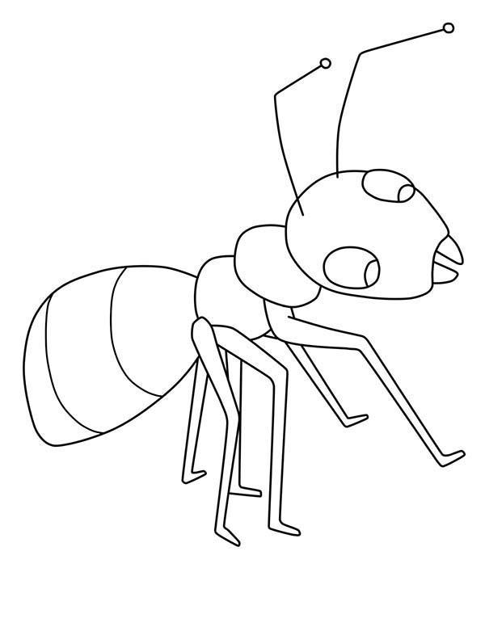
* Honeypot Ants: Did you know ants can makehoney?! “Honeypot ant” is a common name for the many species of ant with workers that make honey and store it in their abdomen. They usually live in dry environments - see a picture in the Appendix.

**Imaginarium**

One of the fun facts we’ve learned about ants today is that they never sleep! If people didn’t sleep either, how would our lives change? Would we be able to work more? Or have more time to read, play and do other things? More transportation would need to work at night. What else would be organized differently?

Another option for Imaginarium is to talk about how long the ants have been on Earth and how their lives could be different through different experiences. Did they annoy dinosaurs at their dino picnics as much as they annoy us? ;) How did they survive the ice age?

**Books to read**

**“March with the Ants**” by Karen Latchana Keney - [Amazon link](https://www.amazon.com/March-World-Karen-Latchana-Kenney/dp/160270788X)

This book is a very decent intro to the subject. The illustrations are beautiful. The words read like a story even though the book is mostly non-fiction describing lifecycle, environment, and body parts. Perfect for 3-5 year olds!

**“Are You an Ant**” by Judy Allen – [Amazon link](https://www.amazon.com/Are-You-Ant-Backyard-Books/dp/0753458039) - [YouTube Read-out-loud](https://www.youtube.com/watch?v=T-O32k8pw1E)

This one is my other favorite. Accurate natural history with some humor mixed in! And can be of great help for children who are afraid of ants.

**An Ant Song**

Ants aren't long

But they are strong

Ants are small

But they can crawl

Heavy loads, they can carry

They're busy as bees, just not as scary

**“Mail”** 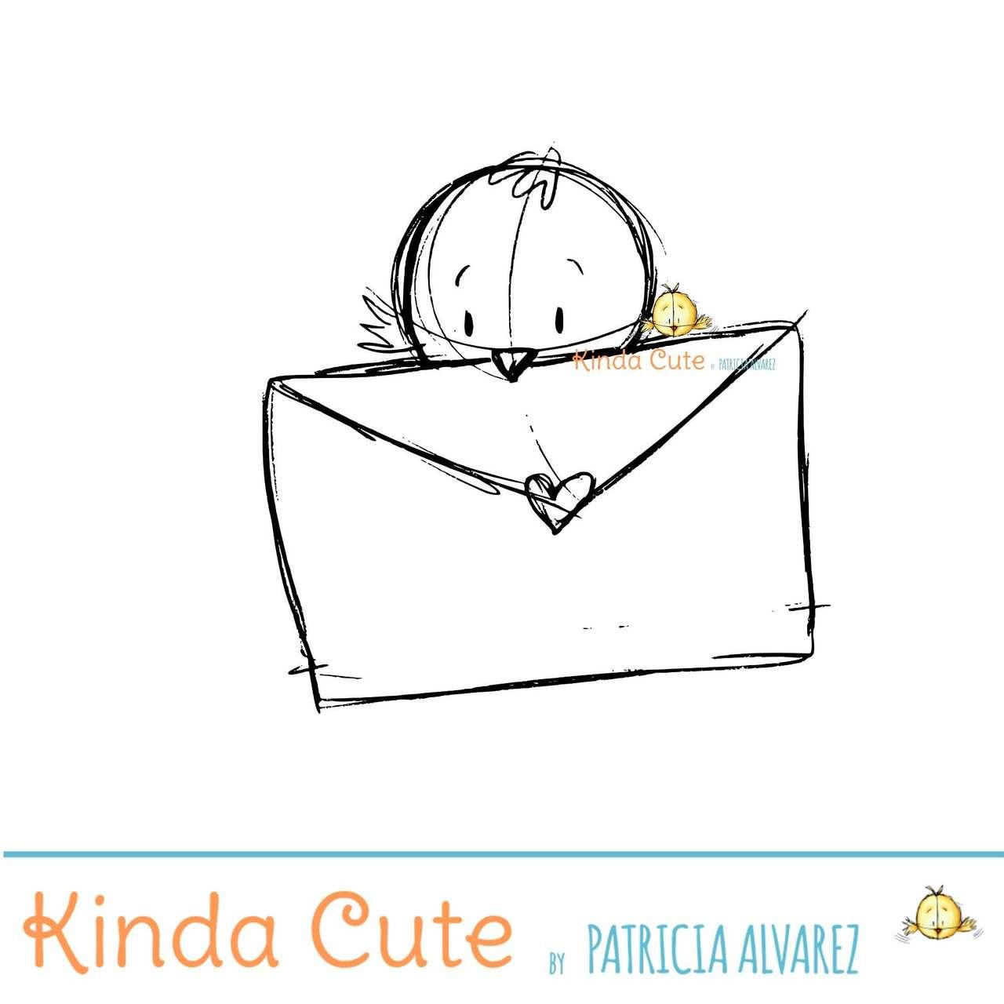

**Walk 15**

**Before the walk:** Today we’ll be investigating the work of the mailman ☺ It would be great if you know the schedule of mail delivery and would be able to catch the mail truck (or UPS, FedEx, DHL truck) come by, and maybe even talk to the mailman! If not, you can always point it out earlier or later, and today just stop by the mailbox during your walk and do other activities.

Talking about mail is a good way to encourage interest in reading and writing in your kids as well.

**Let’s begin!**

Let’s play detectives today and watch the work of our mailman! *Note for parents: if you have time and would like to do that, you can even do a little dress up with a hat, maybe binoculars for extra fun, if not, that’s no big deal. Even if you can’t find the mailman, just save your mail in the mailbox for a few days, and stop by your mailbox to pick it up – that’s already a good start.*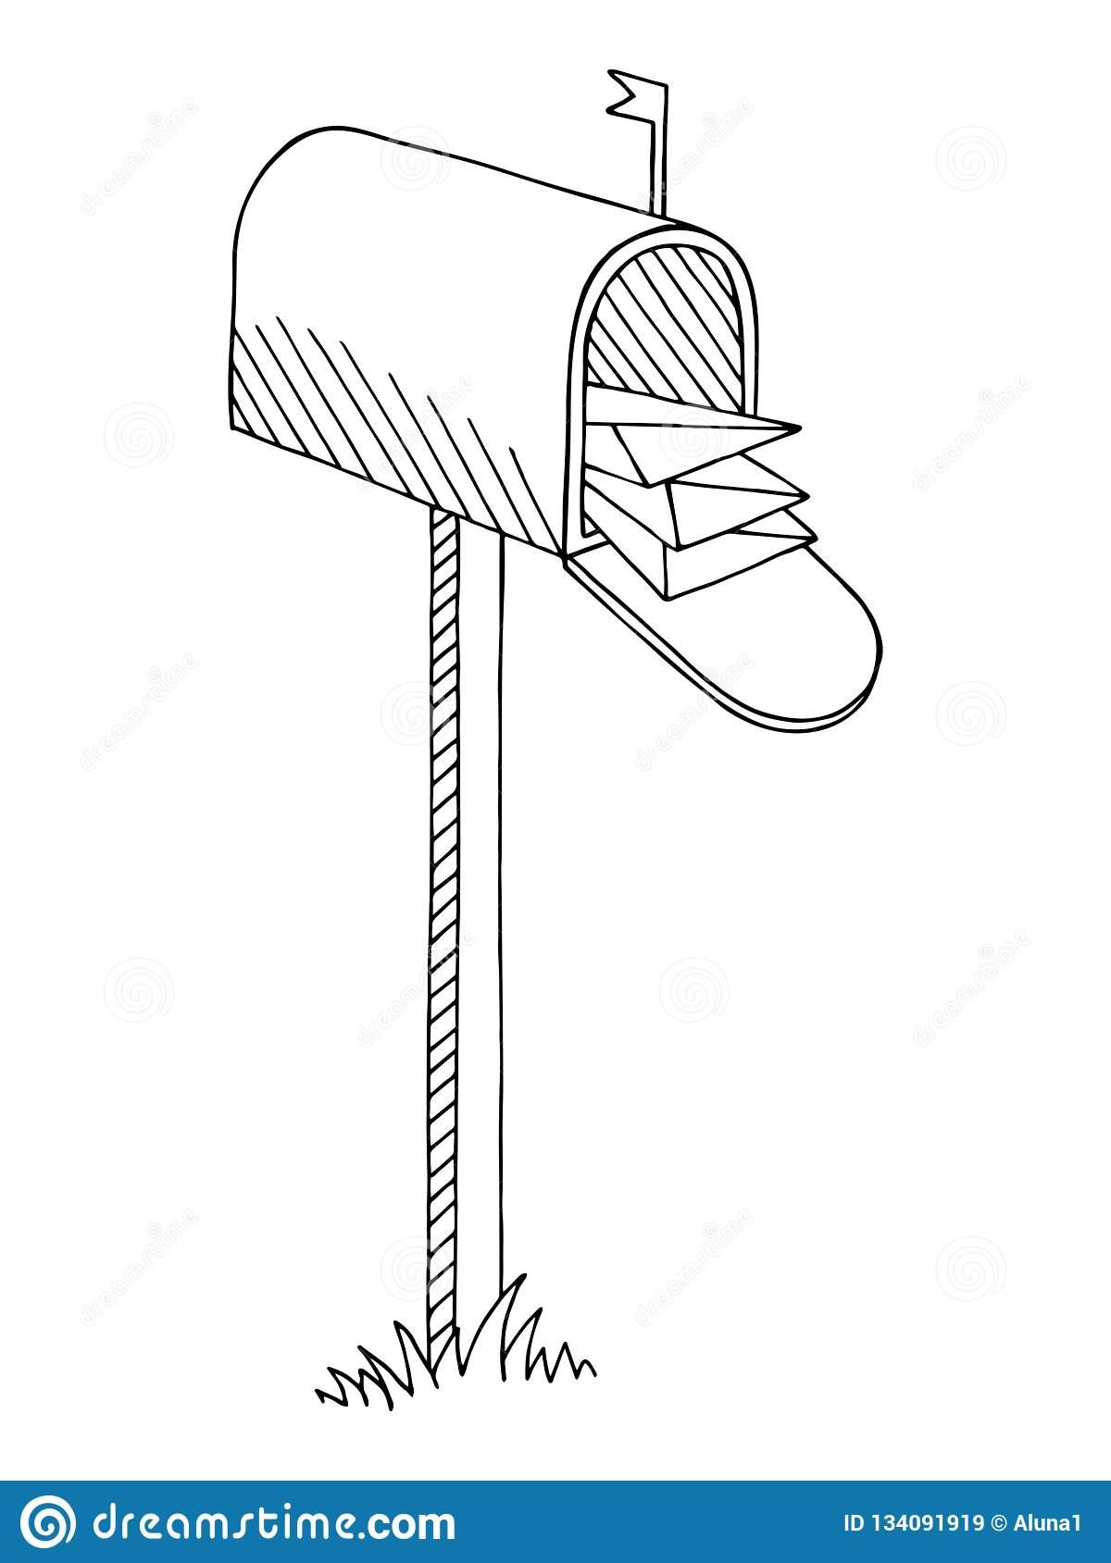

Notice the car the mailman is driving (or observe a UPS or another delivery truck). What kind of packages do they deliver? Letters? Boxes? Where do you think they came from? Do you often get mail? Have you ever gotten a real letter (if not, it might be a good time to correct that!)

Take a neighborhood walk and check out mailboxes at peoples' homes: some are on porches, some on the sidewalk. What do they look like? Ask your child what he or she thinks mailboxes used to look like many years ago. You can tell them that an ancient milkwood tree in Mossel Bay, South Africa, is believed to be one of **the first mailboxes!** And not just a tree… but **a boot dangling from this tree!** In 1500, a Portuguese sea captain named Pêro de Ataíde lost most of his fleet in a storm and before returning to India, he wrote a message of warning of rough waters. He tucked the message in a boot dangling from that tree near a spring where sailors often drew water.

Joao de Nova, another captain, somehow found it the very next year. The tree became a sort of a post office box, where sailors would exchange letters protected in boots, iron pots, or under the rocks. Seamen would leave their messages behind, their countrymen would pick them up and deliver them to their destination, but very slowly. *See Appendix for a picture of the 600 year old milkwood tree in South Africa and a shoe monument too)* 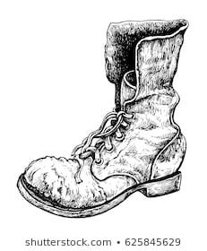

Today we send most information through the Internet – e-mail, text messages, or just phone calls. But years ago mail took much longer. It traveled in ships and took months, or even years to be delivered. For example, a letter from New York to Philadelphia took 2 weeks to travel!

* If you have a chance, stop by the local Post Office and see what they are doing. You can even call ahead to see if there is some type of tour or if the supervisor can talk to your child for a bit about what they do.

**Interesting story** 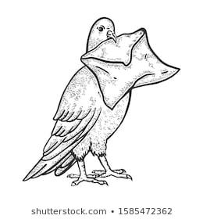

In the past, when people didn’t have computers to send email and talk, phones to chat or video chat, or even official mail services and post offices, different ways of sending letters and messages were used. For example, they would use their friends, merchants and traders to pick up the mail, and drop it off. There even was a profession to help people write letters if they couldn’t write. Another way of sending mail was sending it through pigeons!

Pigeons were effective as messengers because of their natural homing abilities. The pigeons were transported to a destination in cages, where people would attach a message written on then paper and rolled up, to a pigeon’s leg. Then the pigeon would naturally fly back to its home where the recipient could read the message! They were called carrier pigeons or homing pigeons.

In Ancient Greece, the winners of the Olympics were announced via pigeon mail. Also, pigeons often delivered the news about the results of a battle.

In many books and stories authors gave this errand to other birds, such as crows, or even owls (e.g., Harry Potter series).

*Ask your child how they think pigeons found the way home* (unless they ask you first!) Try to come up with a few ideas first (e.g., maybe they communicate with other birds on the way?) Or you can simply explain that a pigeon's compass mechanism likely relies upon the Sun. Like many other birds, they can use the position and angle of the Sun to understand where to go.

*For older kids:* Some researchers believe homing pigeons use magnetoreception, which relies on Earth's magnetic fields for guidance.

**See play time for play ideas featuring pigeon post and more!**

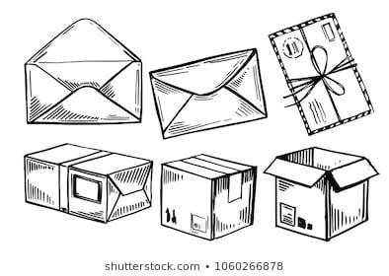

**Fun Facts**

* First mail service: The first postal service we know well about was that of Rome. Organized at the time of Augustus Caesar, the service was called cursus publicus and was provided with light carriages pulled by fast horses.

**Imaginarium**

To continue with creativity development, let’s use the “Fantastic binomonal” technique described by Gianni Rodari. We’ll take two words: one of them will be “*mail*” and the other one – whatever you’d like. For example, a penguin, an orange, a car, or almost anything else you come up with, the further away from mail it is, the better. Then, based on these two words joined with a preposition, we need to come up with a story with our child.

For example, let’s take the example with “mail” and “penguin”. Now we have:

* Mail and penguin: For some reason, everyone believes that elves are Santa’s helpers, and they help Santa Claus package and deliver gifts to children around the world. What no one seems to know is that Santa’s real helpers are…penguins! A few weeks before Christmas, Santa flies over to South pole where penguins live, and together they work on all the gifts and packages, to make sure everyone gets the right thing. One year it was too cold, and somehow Santa wasn’t able to make it to the South pole, so he had to ask elves for help. The problem was that they didn’t have much experience, so they were caught as Santa’s helpers, and after that one year everyone believed that elves were really Santa’s helpers, not penguins. Seems unfair, doesn’t it? Here you can continue the story in the direction you’d like.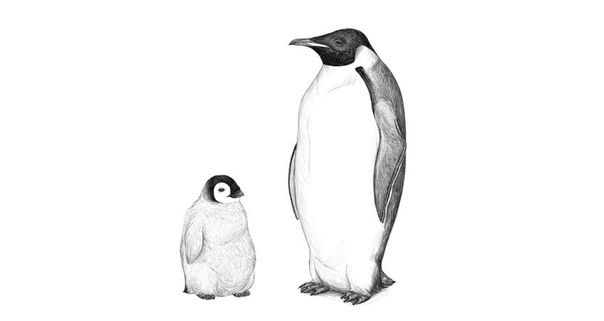
* Penguin in the mail: There lived a boy named Andy. He is a happy boy, but sometimes he feels very sad because his daddy works far, far away in Antarctica, and he misses him very much. He is a researcher and he studies different kinds of snow and how it melts there. He sends him letters that are the most fun letters in the world: he tells Andy about brave penguins, beautiful albatrosses (those are huge cool looking birds!), and even arctic foxes (they are completely white!) Andy can’t wait for his letters to come. But one of the days when they talked on the phone, daddy understood that Andy was sad. And just a few days later, the most unusual package arrived at Andy’s and his mom's doorstep. It was big, and somehow it seemed like something was moving inside the box. When he opened it up, he realized it was a real…penguin! His dad sent him a penguin in the mail to cheer him up!
* Mail of penguins (penguins’ mail): Most people know that there are penguins in Antarctica. But many of us don’t know that they have an extended family in South Africa, right across the Southern ocean. How do you think they talk to each other? Of course, they use the penguin mail! Here we can talk about ships delivering mail between them, imagine penguins sending letters in the bottles, or maybe using albatrosses as postal pigeons.

*As always, let your imagination run wild! I LOVE to hear the stories you and your little ones come up with, so please email me, or if you post on Instagram, please tag me @zenfullmama and add #learningwalks hashtag, help us inspire more people around the world to help their kids learn through seemingly mundane things and fill learning with fun.*

**Play time**

* Shipwreck and the mail: Play out the shipwreck we talked about in the beginning. Make a storm in a sink or bathtub, bring some sticks from outside and add some playdough to make it into a tree. Borrow a shoe from a doll (or make it with playdoh), leave a little note in it. Role play is called the work of childhood for a reason – it helps them process and retain information much more than simple learning or listening.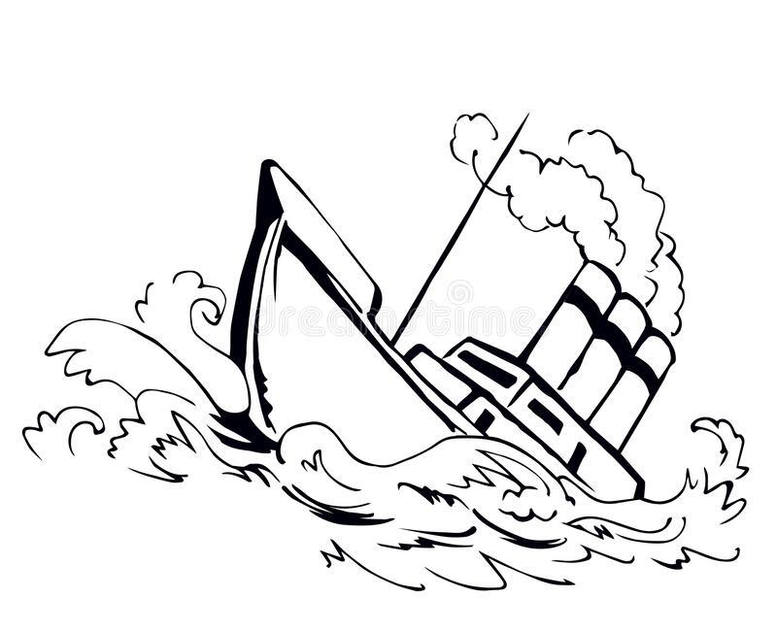
* Message in a bottle: Legend has it that a Greek philosopher Theophrastus used bottled messages to determine if the water from the Atlantic Ocean flows into the Mediterranean Sea (*Note for parents: Make sure to find it on a map!)* Since then, people have been using messages in the bottle. Suggest your child to play shipwreck, bathtime is perfect for this play. You can use a simple carton and little toys for travelers who go through a shipwreck or a giant octopus attack, and the travelers have to send out a message in a bottle asking for help. SOS is a good start for 3-4 year olds, and a more detailed message is a great intro into writing for older kids. Write a small note, out it in a tiny bottle, seal it with play doh - and send it out to the other end of the bathtub where fishermen can “catch it” with a fruit net or a fishing rod (you can make one with a stick and metal wire hook) and come to the rescue! Check out our pictures in the Appendix.
* Pigeon mail (perfect for some outside time in the park) You can make paper wings (or skip this part), write a note, roll it up and attach it to your child’s leg with a thread. Then they pretend to be a pigeon and deliver notes this way!
* Mail at the playground: Role play being a mailman at the playground delivering letters from one part of the playground to another! You can write “in code”, e.g. drawings, or the mailman can deliver packages to friends and toys.

**More Fun Activity at Home**

* Sorting activity: Pick up your mail during the walk, maybe save some of the junk mail for a few days before this walk. Place the junk mail on the table in a large bin, along with several boxes. Ask your child to sort the mail into the shoe boxes by attributes: large vs small; letters vs magazines; by color. You can even suggest they sort by size AND color, and at some point they will realize that things can belong to several categories at once. At this age, it’s an interesting thing to understand and think about.
* Mailbox in a boot: Remember the boot that sailors used as a mailbox? Leave little notes and surprises in each other’s shoes today. The key is to find which boot or shoe was used to “safekeep” the message ☺
* Mail game: Makeshift a mailbox from any box available to you (we used Amazon box). Deliver mail to each other, including little rocks or tiny treats. Show your child how to use post stamps. For children who are learning to write and read, it’s a great way to practice: write short funny notes to your child, or for older kids who’ve progressed more in writing you can start a game where you write a sentence – they write the next sentence, and then again and again to put together a little story.
* More Ideas: Play with mail and different types of post is a favorite for many kids 3-6, so if this is your case, it’s a great opportunity to expand your child's interests: for example, explore other ways people used to send information to each other. You can look at some pictures of cave paintings and then play cave people - put a piece of brown paper on the wall and use drawings to tell a story of your “cave family”. Talk about the benefits of this way of transferring information (e.g., you don’t have to speak the same language as the writer) and think about downsides. Next time you go to the store, try to identify where drawings are still used in the modern day and age - what can you understand from the signs at the store? Road signs? You can also talk about smoke signals as a way of sharing information.

**Books to read**

With so many options around the mail system, I struggled picking and decided to share all 5 of my favorites (just in case!)

**“Never Mail an Elephant**” by Mike Thaler and Jered Lee - [Amazon link](https://www.amazon.com/Never-Mail-Elephant-Mike-Thaler/dp/0816730199/?tag=wwwprekpagesc-20)

[YouTube read-out-loud](https://www.youtube.com/watch?v=KMvAjWJOBGs)

This one is a funny book about a little boy who tries to mail an elephant to his cousin for her birthday. Nice watercolor illustrations add great details. The story is cute, fast paced, and positive. Excellent supplement to our investigation on the postal services!

**“The Long, Long Letter**” by Elizabeth Spurr - [Amazon link](https://www.amazon.com/Long-Letter-Elizabeth-Spurr/dp/0786812028/ref=rtpb_2/146-2496367-0001523?_encoding=UTF8&pd_rd_i=0786812028&pd_rd_r=c372ab4e-5b45-4f50-96c1-b49a95d3920d&pd_rd_w=B3lDb&pd_rd_wg=9hbX7&pf_rd_p=49740592-2805-416d-896c-b825ad91c2c)

[YouTube read-out-loud](https://www.youtube.com/watch?v=ob2UL91UaK4)

The illustrations are lovely, and so is this story of a lonely old auntie who looks forward to receiving mail from her family, who live far away. It gently inspires kids to reach out to those around them.

**“The Giant Hug**” by Sandra Horning - [Amazon link](https://www.amazon.com/Giant-Hug-Sandra-Horning/dp/0553112627/?tag=wwwprekpagesc-20)

[YouTube read-out-loud](https://www.youtube.com/watch?v=mZvrJY1F2uc)

This delightful story will make you want to hug everyone you love (maybe even the mailman!)

**“Dear Mr. Blueberry**” by Simon James - [Amazon link](https://www.amazon.com/Dear-Blueberry-Aladdin-Picture-Books/dp/0689807686/ref=rtpb_6/146-2496367-0001523?_encoding=UTF8&pd_rd_i=0689807686&pd_rd_r=c372ab4e-5b45-4f50-96c1-b49a95d3920d&pd_rd_w=B3lDb&pd_rd_wg=9hbX7&pf_rd_p=49740592-2805-416d-896c-b8)

[YouTube read-out-loud](https://www.youtube.com/watch?v=bjBum_cTAcg)

This one's a classic and some of you might have it ready to read to your little ones.

Good to use to show how letters are a form of communication as they are fading from our day to day life, as well as introducing environmental issues to young children.

**“Delivering Your Mail**” by Ann Owen - [Amazon link](https://www.amazon.com/Delivering-Your-Mail-Community-Workers/dp/1404804854/?tag=wwwprekpagesc-20)

[YouTube read-out-loud](https://www.youtube.com/watch?v=3AeupTFfw0g)

This book is for kids who get interested in the subject and want to know more details about the different jobs of mailmen, their routes, and even safety.

**Mail Carrier's Song**

*~Sung to Row, Row, Row Your Boat~*

Write, write, write your cards,

and *lots* of letters, too!

I will bring them to your friends,

And maybe they'll write back soon!

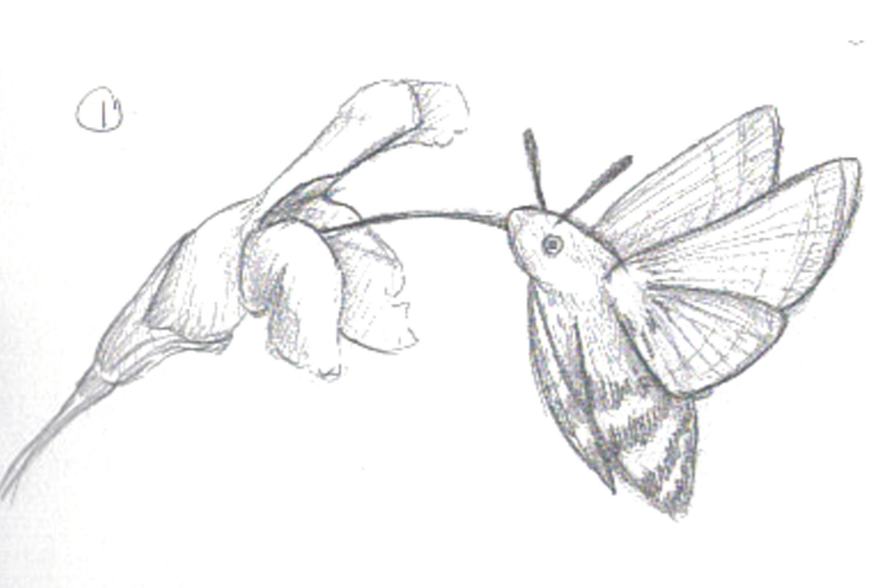

**“Plants vs. Animals”**

**Walk 16**

**Before the walk:** Today we’ll be observing and looking to understand the difference between animals and plants. As always, we don’t want to simply tell our child about the differences, but guide them to the realizations instead – the knowledge / understanding acquired on your own through a process is much more valuable, and studies show that our memory retains information we get this way much better.

**Main point for parents to showcase**: animals need food while plants are able to make their own food

**Let’s begin!**

Talk about Living and Nonliving things again, remind your child that rocks, mountains, houses etc. don’t need to breathe while animals or plants do (better ask them). Ask your child what else living things can’t survive without. Help your child by remembering together the cases when they were really thirsty and how hard it was to wait to get a drink (so living things, like us, need to drink). Remind them of a case when they were hungry – living things need food. Without energy / warmth – in winter we need to wear warm clothes and heat to stay warm. Also you can suggest to hold your breath for a few seconds together to showcase that living things can’t survive without breathing.

Suggest your child take a picture of a plant (they can use your phone or some type of simple camera) – and then suggest they take a picture of an animal: an ant/bug/bird, maybe several. Ask what was easier to take a picture of? Why is that? Most likely, your child will realize and point out that animals moved vs. plants stood more or less still (maybe some movement from the wind, but not much, so they are easier to take a picture of).

* Explain that they are both living things and that plants and animals share many characteristics, but they are different too. For example, animals usually need to move around to find their own food, while plants are usually immobile and can create their food, so they don’t have to go for a hunt when they are hungry like a lion or cheetah!

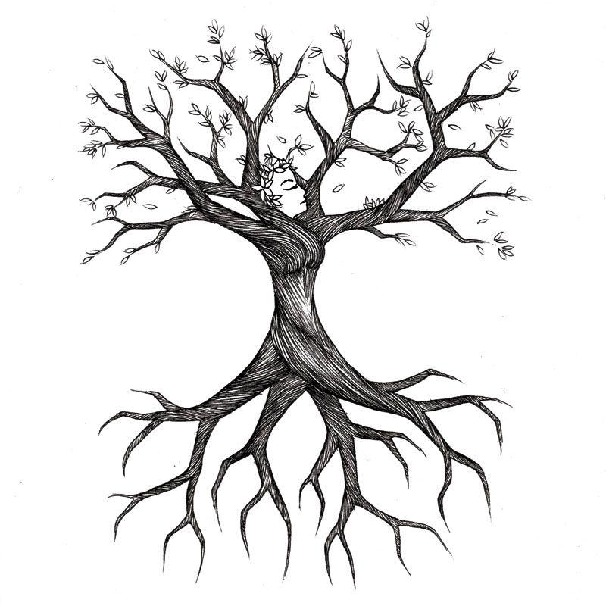

* Use your magnifying glass to look at some tree and other plant roots that are coming through the soil. Ask your child – what do you think plants need roots for? What do they get through them from the soil? Explain that plants need three things to create their own food: water (from the soil, through rain), light, and air/oxygen, and if one of those things is missing – they can’t create their food.
* Try to find a darker place on your walk and compare it to a light place – which one has more plants?
* Do animals or humans make their own food? Where do they get it from then?

**Fun Facts**

* Symbiosis for kids: Plants and animals can help each other and need each other. For example, flowers, plants and trees need bees and hummingbirds to pollinate them – to help them create new plants. When animals eat a plant's fruits, it helps disperse the seeds of the plant (via the animal droppings, etc.) A bird eats a cherry, a cherry pit stays in its tummy while it’s flying – and then it poops it out in a different place and a new cherry tree could grow! Animals eat plants and sometimes make homes in them (*Do you know of any animals who live in tree trunks?*)
* NOT for highly sensitive children: When animals die, their bodies decompose, and they enrich the soil with nitrates that stimulate plant growth, this way they help plants grow too.
* How plants attract animals: Flowering plants need animals to help pollinate the, and they typically attract animals via colors, scents, and chemical signals.
* Do plants feel when we touch them? **Ask your child first!** Scientists reveal that plants can feel when we touch them. It's something that plant lovers have suspected, but now Australian scientists have found evidence that plants really can feel when we're touching them.

**Interesting story**

It’s not just animals that can feed off of plants – some plants have developed an ability to eat animals (mainly insects – flies, mosquitoes and dragonflies!) too! Pitcher trap, Venus Flytrap are among the most well known ones (see pictures below). These plants have different ways they “hunt” insects: stay open and then snap shut when an insect is inside looking for nectar, sticky leaves or glue like liquid covering some parts of the plant, or even “sucking in” the water with tiny insects in it. These plants can make their own food through water, light, and air as other plants – but they also add these insects to their diet. Turns out, plants can eat animals as well. Check out Appendix for some pictures and examples!

**Imaginarium**

What if plants around us forgot how to make their own food and now needed to start hunting – how would the world change? What would it mean for insects and animals? How would their behaviors need to change?

What if vice versa people learned how to make their own food – what would it change for us? How would the world change?

Ask your child how they would explain the difference between plants and animals to a person who just came to the Earth from a different planet!

**Books to read**

**How Plants and Animals Need Each Other** - an educational video from Diggy Dog, interactive and shows some great examples - [YouTube video](https://www.youtube.com/watch?v=VTHTYExiDpM)



**“Houses and Homes”** 

**Walk 17**

**Before the walk:** We can talk about different types of homes and houses for a long time! If you can, plan to build your own little “home” or a fort outside with sticks today, take a large sheet or a towel and make a tipi tent outside (unless you have one at home – then just bring it outside, or “build” it in your living room when you get back after the walk), take a piece of cardboard and draw a window on it and put it on the side of your “house”. If not – let’s just observe and talk about homes around us, big and small, and as always try to point out and inquire about a few things that are a little less than obvious.

**Let’s begin!**

As you are leaving for your walk, ask your child where you live. Take a look at what the building looks like. Ask them what your address is. If you have an address plaque on your building, show them, or look for those plaques on your way. Ask why they think homes need an address? What would we do if we didn't have one?

* Ask your child if a home is a living or non-living thing and if it was created by nature or humans. What about homes animals live in – nests, dens, holes or forests? Are they nature made (*trick question, interesting to see how your child will define nature and if they will put animals in the realm of nature or not; there is no right or wrong answer – just interesting food for thought*). There is a fun print out in Appendix for proper animal home names. Also, watch [**this video**](https://www.youtube.com/watch?v=r_Fnk7dGq8U) to learn about animal home names!
* Why do animals need homes? What about people?
* Tell them that ages ago, people used to live in caves. Are caves man made or nature made? *Make sure to show your child a picture of cave drawings, there is one in the Appendix. Then wonder together why ancient people made those!*

Play this game as you walk:

* Where do we live? – In a house
* And where is our house? – in let’s say New Jersey (city/town/different state – whatever they say).
* And where is New Jersey?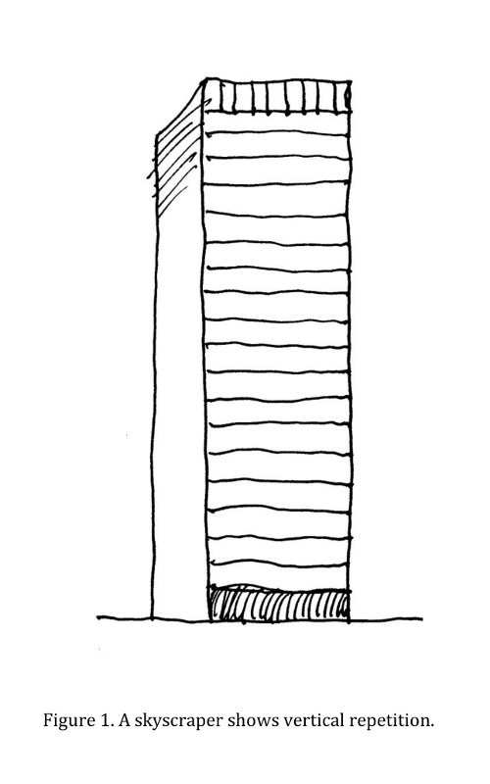
* In the US!
* Where is the US? – In North America
* And where is North America located? – On Planet Earth.

Of course, the older the child, the more engaged they will be and more answers they’ll know. If they aren’t there yet, tell them and talk about it, always great to illustrate on a map or a globe.

* Now look at homes at houses around you. How many floors does your house have? What about the homes around you? If you live in a multi-level building and there are a lot of tall buildings around you, ask your child why they think people build homes with many floors? What are the benefits of buildings with many floors? Where are they most common? What about homes with 1-2 floors? What are their benefits? Where are these more common?
* If you know of a **construction site** in your area, make sure to stop by on your way today. Watch the cranes work, and try to be observant: What is the building being built of? Is there glass? How many floors can you count? How many people are working on this construction (hi, math skills!) What professions are needed to build a house from design to completion? Why do you think people put in so much time and effort into building houses? Wouldn’t it be easier to just dig a hole like a mouse and live under the ground? Talk about pros and cons. Can you see the windows? Talk about why people usually include windows in the buildings.
* Are there animals who build complicated multi-level homes? Remember ants? And bees? Termites and moles can have complicated “homes” as well.

**Interesting story**

For thousands of years, people moved from place to place, living in tents or even in caves. They traveled in search of food. When people learned how to grow crops and keep livestock, they could settle down in one place. They began building permanent homes.

The first homes were simple one-room structures made from clay or wood. Later, people learned to use other materials, such as bricks, cement and glass.

But even today, homes look different from place to place. It depends on the climate, weather conditions, and what materials are easier available. For example, in New England or Canada people need to worry about preserving warmth in long cold winters, while in Mexico or Arizona they need to worry more about keeping their houses cool, so homes will look different. In Africa trees are scarce, so homes are often built out of mud and grasses. Check out the Appendix for some cool homes around the world!

**Fun Facts**

* Places with No Address: Did you know there are whole countries where most places don’t have an address? E.g., in Ghana most houses don’t have a house number or name, and rarely the street signs are visible. It must be so hard for people who aren’t from there to find things they are looking for! It was so challenging, that someone has actually developed a phone app to help people get around (read a BBC article on it [**here**](https://www.bbc.com/news/world-africa-35385636)). Costa Rica doesn't have a standardized system of addresses and traditional street names either!

*Extra assignment for kids 4+:* When you get home, take a map or a globe and see where Ghana and Costa Rica are located, and find a way (make an itinerary) from your home to that country.

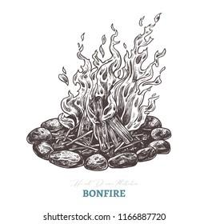

* Housewarming: The term “housewarming party” comes from a tradition that used to occur before electricity. Every time a person built or bought a new home, guests would bring firewood as gifts and light fires in the house’s fireplace. This “christened” the house, and was said to ward off evil spirits.
* Boat homes: Hong Kong is a crowded city and homes are very expensive. Many people live on small boats, called sampans, which float in the harbor.
* Olympics: Did you know that Architecture used to be a part of the Olympics, as well as town planning, “mixed sculpturing,” compositions for orchestra!

**Fun Facts for Parents**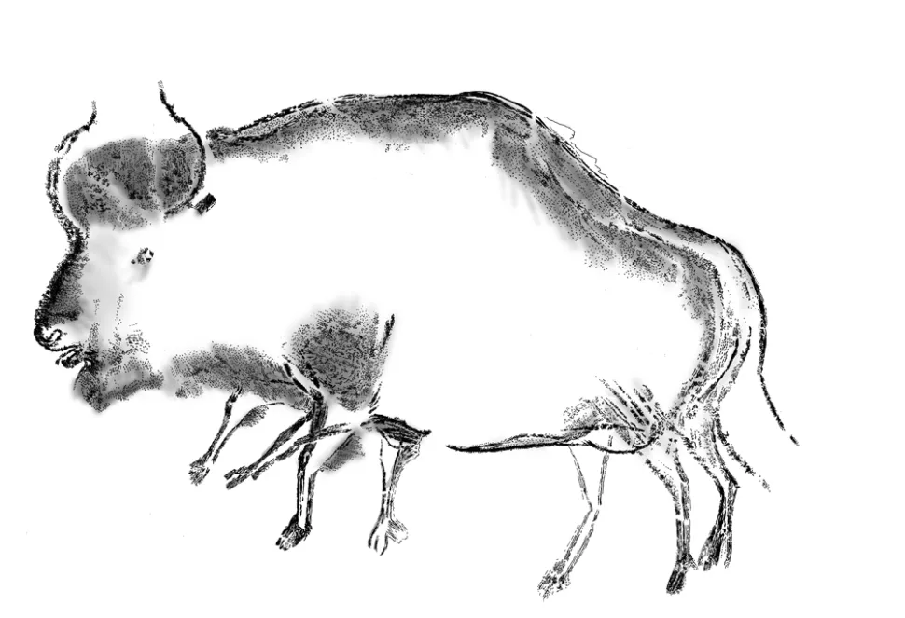

* When we talked about the caves, I mentioned the cave drawings. Here is a fun fact for you, and if your child was interested in talking about the reasons ancient people made those drawings, you can talk to them about this as well: The modern idea that Paleolithic people were depicting nature for more than artistic reasons gained traction at the end of the 19th century and was further developed in the early 20th century by Abbé Henri Breuil, a French Catholic priest and archaeologist. He interpreted the stylistic bison and lions in the cave paintings and carvings of southern France as ritual art designed to bring luck to the hunt, not just as a creative expression.
* In the 1960s, a journalist–turned–amateur anthropologist proposed one more interesting idea with even more practical purposes for these drawings: They were created for telling time.

**Imaginarium**

Tell your child that there are some amazing houses in the world and look at the Appendix for some inspiration. Now try to think about what kind of home you’d like to build! They can even try building it with magnetic tiles, cardboard, paper, or simply draw it when you get home, or use chalk. You can use any materials outside as well.

**Fun activity**

* Draw a “map” with some chalk - a square with a few houses and roads. Draw the numbers of the houses. Use the little toy car you’ve brought to “drive” into house number 1-2-3… You can name the house numbers in a different language if your child is beginning to learn it, or for younger kids you can color them in different colors or even shapes - and have them drive the car to the star shaped house or a blue house. Fun way to work on numbers, shapes, forms, or even languages!
* Bring a large towel or a sheet outside and build a fort or a home in your backyard or even in a park. Let your child pretend it’s a new home and they are having a housewarming, bring some snacks, or pretend that it’s a bear den!

**Books to read**

**“A Squash and a Squeeze”** by Julia Donaldson – [Amazon link](https://www.amazon.com/Squash-Squeeze-Julia-Donaldson/dp/1405004770)

YouTube read-out-loud

This is a sweet take on an old Romanian folktale. It's cute, rhymy, and illustrated beautifully. A lady lives in a smaller sized home… and a nice lesson to learn ☺

**“If You Lived Here”** by Giles Labroche - for kids 5+ - [Amazon link](https://www.amazon.com/If-You-Lived-Here-Houses/dp/0547238924)

[YouTube read-out-loud](https://www.youtube.com/watch?v=BU8-XAh5OwQ)

“If you lived in the mountains of southern Spain, your bedroom might be carved out of a mountain. If you lived in a village in South Africa, the outside of your house might tell the story of your family. And if you lived in a floating green house in the Netherlands, you could rotate your house to watch both the sunrise and sunset.”

**“All Kinds of Homes**” by Emma Damon

No read-out-loud, but maybe you can get it at your local library.

Looking at dwellings around the world, this lift-the-flap book explores what homes can look like, what they’re made of, and who lives there. It includes Bedouin tents, Dutch barges,  African mud houses, Moroccan houses with tiled courtyards, glass houses, and more.

Some unusual homes around the world – [Article link](https://www.scoopwhoop.com/Strangest-houses-from-around-the-world/)

**13 Most Unusual homes in the World** – [YouTube video](https://www.youtube.com/watch?v=mv7BXQue5cI)

**“Water”** 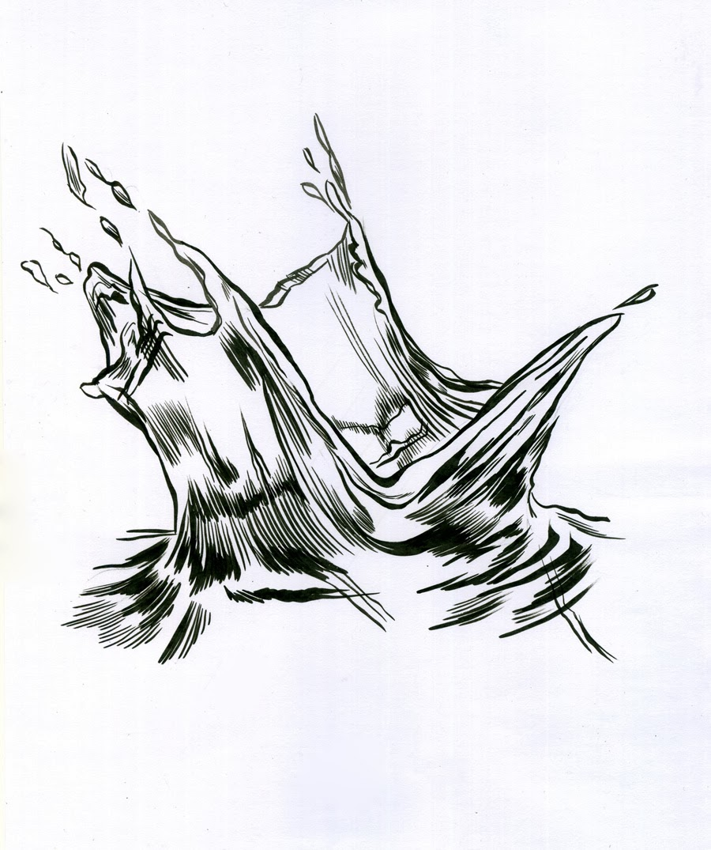

**Walk 18**

**Before the walk:** We’ve talked about the Sun, the rain, living and non-living things, and clouds in our previous walks. It’s important to help our kids to not only see secluded subjects, but also notice connections between them, and water is one of the subjects that is a connecting element between many. This approach helps kids develop systemic thinking. It’s very important to develop because it helps grown up people see things in the world as systems and small parts at once – and see how our actions and changes in one part of a system affects the rest. This walk would be great by a lake, river, or at least a pool or a fountain.

**Let’s begin!**

Ask your child where we can find water. Can we find water in the ground? In the sky (remember what the clouds consist of)? What about Antarctica? And how about Death valley and the Sahara desert? How about the Moon or Saturn?

When you ask about water in the sky, ask how it is stored there, or maybe they will be interested in a conversation about where the rain comes from.

* Bring a bottle of water with a few holes poked in the cap from your walk, especially if it’s a sunny day. Use it to make a few drawings on the asphalt and wait them for 5-10 minutes and watch them disappear. Where did the water go?
* Remember that plants need water to grow and “make food”? What about places where it doesn’t rain often? Find a place where the soil is dry on top if you can and look at it. How do plants manage? If your child can’t find an answer, use a stick and dig a bit to show them that inside the soil is likely still wet. Why is it the case that the soil is dry on top but still wet inside? *If you live in a drier climate, that’s an excellent segway to talk about drought and lack of water, how it affects the ecosystem, and what we can do about it.*
* It’s perfect to spend this time by a lake or a river, or at least by a pool or a fountain. Ask a few abstract questions: what shape is water? What color is it? If your child tells you it’s white – clarify “white like milk/chalk/cauliflower”? Or if they think it’s blue, then “blue like blue paint”? Use a transparent glass or a jar to get some water in it and see what color it is. Explain the term “transparent”, something we can see through, and then talk about why the water in a pool or a lake looks different when it’s there. Maybe the pool walls are colored blue? Or what could reflect in it? The sky? The trees? *Make sure to read the “Interesting Story” before talking about water color so that you could tell your child - it’s relevant!*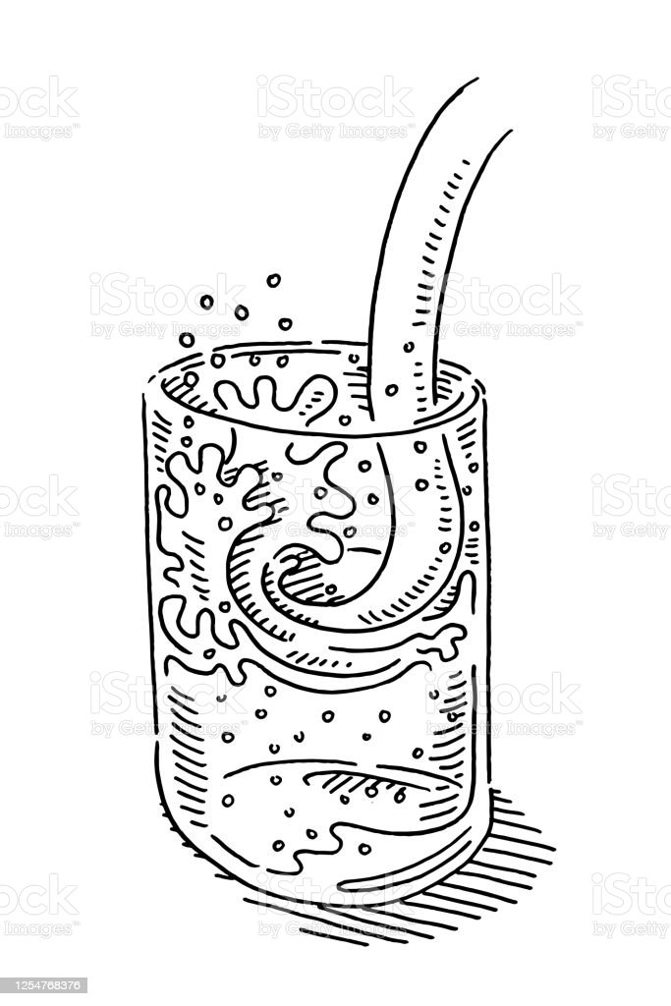
* Where can we find water in the world? Sea, ocean, rivers, lakes, pools… Talk about differences between different types of water masses. How big are they? What are the differences: how can you tell the lake from a river? What about a lake from the sea? Can you see the banks everywhere? Which ones are man made? Why would people want to make ponds?
* Can animals make or change ponds, lakes or rivers? How? If they can’t think about something, tell them that beavers build dams across streams to create a pond where they can build a "beaver lodge" to live in. Talk about why they do it (these ponds provide protection from predators like wolves, coyotes, or mountain lions, and provide easier access to food). *If your child is interested in this, check out the experiment section - we’ll watch a couple of videos about beaver dams and they can even build their own dam!*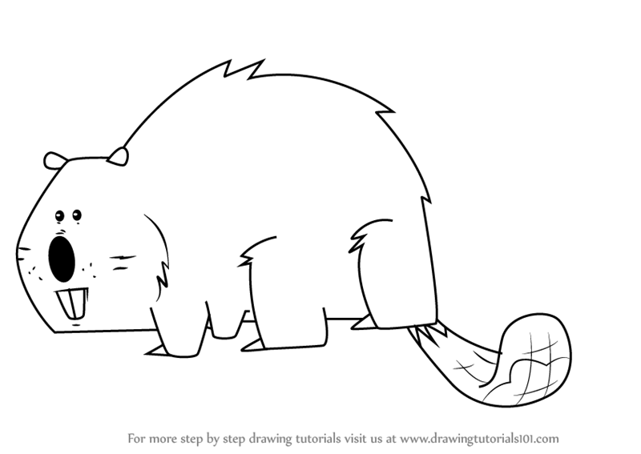
* Try to figure out where the water in the lake comes from. Ask why does it not disappear like the water we poured on asphalt in the beginning of our walk? Does it only come from rain?
* Look at the lake/fountain and try to come up with an idea how you could measure the depth without getting into the water. In a smaller fountain or shallower pool, use a stick to measure!
* What about its width? Maybe by the length of the bridge, or based on how small/big the objects on the other side seem?
* If you grabbed a sponge from our list on your way out, show your kid how it absorbs water, and then follow by a washcloth, followed by smth non absorbent around you like a rock or a block/tile. Make predictions about what will “take in” more water. Explain using the “tiny humans method” tiny humans the sponge is made with are thirsty and they have lots of space between them. The holes between the sponge “humans” absorb the water, and so the sponge swells up with water. This stops the water coming out of the sponge when you lift it out of the water (try first!). When you squeeze the sponge you are forcing the water out of the holes in the sponge.

**Interesting story**

There are many amazing and unusual lakes in the world. One of them is a pink lake located in Australia, Lake Hillier. The scientists suspect that the pink color is because of the high level of salt in the water reacting with soda and certain bacteria or algae.

There are other interestingly colored bodies of water in the world. The hot springs at Beppu, referred to as the Hells of Beppu, on Japan’s Kyushu Island. The eight springs range in color from turquoise to rust. Chinoike Jigoku (Bloody Hell Pond) is a must-see—it boils blood red, as its name would suggest. *Check out the Appendix for more!*

**Fun Facts**

* Asphalt Lakes: Did you know there are lakes in the world that consist of things different from water? For example, the Caribbean island of Trinidad is home to the world's largest deposit of natural asphalt, it’s called Pitch Lake. The surface of the lake is mostly solid and consists of asphalt that one can walk on! There are other asphalt lakes in the world located in Azerbaijan, Oklahoma, California, and Venezuela.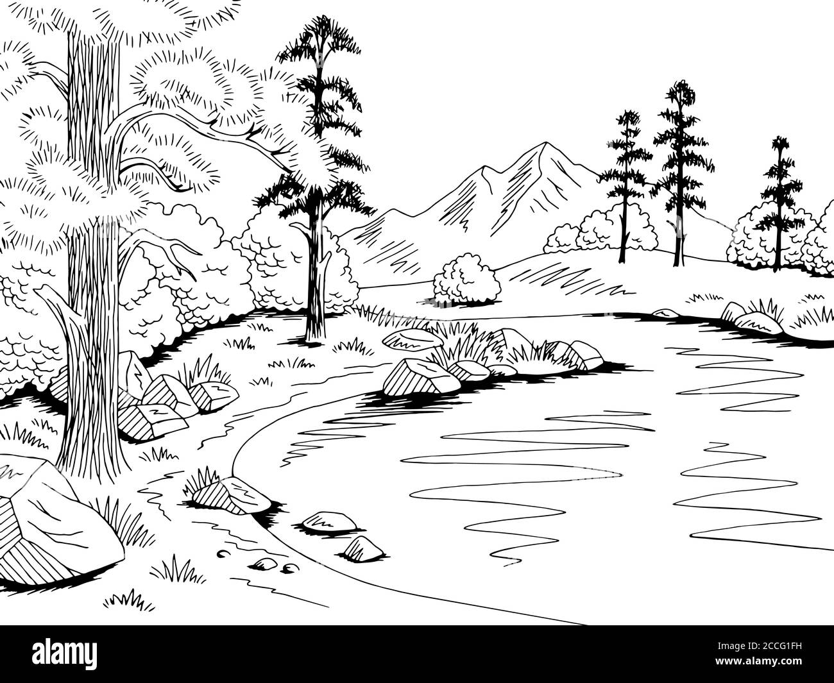
* Ink Lake: Another unique lake located near the city Sidi Bel Abbes in Algiers (find this North African country on the map!) is filled with… ink! There are neither fish nor plants in it, since the ink with which the lake is filled instead of water is poisonous to living organisms and is suitable only for writing. For a long while people had no idea how that is the case. But recently scientists have finally figured out the cause of this phenomenon. There is a chemical reaction that happens from two rivers that flow into the lake. One of them contains a lot of iron salts, and the other contains other elements from the nearby valley. As a result of mixing chemical reactions with the formation of ink, which fills the lake. How would you use this ink?

**Imaginarium**

We’ve learned a lot about different types of lakes - made of some crazy colored water, ink, and even asphalt. If you could create any lake of your choice, what would it be made of? Milk? Or hot cocoa? What kind of creatures would live in it? Maybe marshmallow people? What would they need to use to build homes? How would life there be? Can you wash something in it? Why yes or why no?

**Experiment - more in the Appendix section**

If your child was interested in the part about beavers making their sheds or dams, watch this video about the reasons why beavers build dams: [YouTube Beaver Video.](https://www.youtube.com/watch?v=OMdYIvbyGd4)

Remember, in the very first walk we talked about the things and ideas people borrowed from nature, like the way a helicopter flies? You probably noticed in this video that people build their own dams too, just like beavers!

You can even build your own beaver dam if you’d like! Watch this video to see how to do it: [Build your own beaver dam](https://www.youtube.com/watch?v=OMdYIvbyGd4).

Here is the list of supplies you’d need:

* A large plastic container
* Some sand or mud
* Some rocks, sticks, and tree bark you can find outside
* Water
* Your thinking cap :)

**Books to read**

**“Tiddler**” by Julia Donaldson - [YouTube Read-out-loud](https://www.youtube.com/watch?v=521VoSb1i1M)

Not exactly an educational book, but it does take place in the water :) And since Julia Donaldson is my absolute favorite, I couldn’t but recommend it.

**“Water is Water”** by Miranda Paul - [Amazon link](https://www.amazon.com/Water-Book-About-Cycle/dp/159643984X) - [YouTube Read-out-loud](https://www.youtube.com/watch?v=FRwaAfRjPiQ)

Lovely read about the water cycle and all different forms and shapes water takes, from rain - to snow - to fog - to mist, and more, it nurtures the sense of wonder.

**A video about pond habitat:** [YouTube link](https://www.youtube.com/watch?v=GsHFSLUwEsg)

**“Birds”** 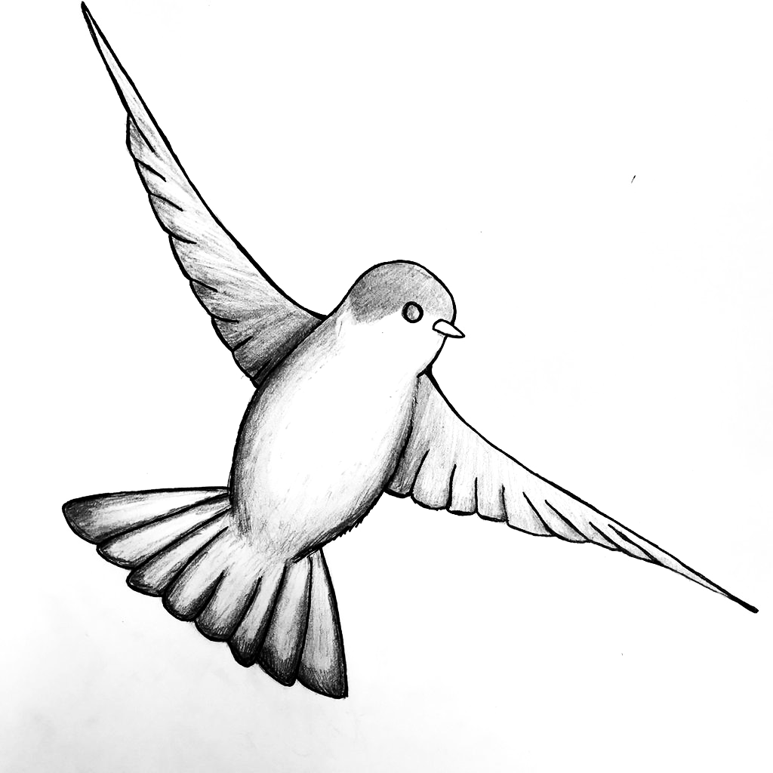

**Walk 19**



**Before the walk:** Today we’ll be talking about birds. We’ve talked about the animal world already. Ask your child if they think birds are animals, and if they don’t remember, remind them that any alive organism that doesn’t produce food within itself is called an animal. Birds can differ by size, what they eat, where they live, or the color of their feathers. For now, ask your child how they think birds are different from other animals, and they will likely point out the wings (they can fly…well, mostly), and the beak. Point out another difference - birds come from eggs.

Make sure to bring some food to feed the birds on your walk today: sunflower seeds, raisins, dried oats or small pieces of fruit such as apples or bananas

**Let’s begin!**

Start with asking your kid: “Who do you think there are more of in the world - animals or birds?” *(the underlying idea is that birds ARE animals, so of course there are more animals than birds). As a visual, you can draw a large circle with a chalk or a pencil and then several smaller circles within the larger circle, explaining that the large circle is animal kingdom, while the smaller ones are birds, reptiles, mammals, insects. This simple exercise is helpful in establishing an understanding of a whole and composite parts.*

* Try to remember as many birds as you know together. Which birds can you see where you live? Where do the other birds you thought about live?
* Look at the birds’ feet. What do they look like? If you can see some birds who live on the water (seagulls, ducks, geese) - now take a look at their feet. Are they different? Ask your child why they think that is? Can you think of other animals with similar “feet”? Remember when we talked about the inventions people “borrowed” from nature? What inventions do you think could be based on these “feet”? (they might think about the divers’ fins - any other ideas?)
* How can you tell there are birds around you if you can’t see them?
* On your walk, try to find a bird’s feather, look at it closely. If you can find a water bird’s feather, pick one up as well. Then try to put them both in the water in a fountain, pond, or when you get home and you’ll likely notice that the feathers of the birds who often interact with water doesn’t get soaked as a different bird’s feather (e.g., a pigeon’s or a sparrow’s) because it’s oily compared to a regular bird’s feather. Why does this help? Because the oil doesn’t dilute in the water. You can set an experiment at home: pour some oil into water and try to mix it in.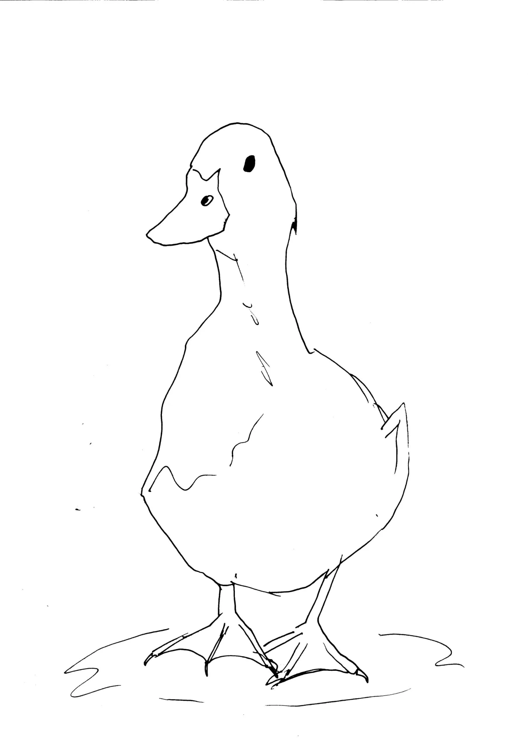
* Don’t throw the feather away on your walk and bring a few home. Tell your child that years ago, before pens were invented, people used feathers to write. They dipped them in ink and wrote with it. Try dipping your feathers into simple acrylic paints or gouache and write / draw! Notice that it has its challenges compared to using a pen or a marker - what are they?
* Make sure to bring a camera and take some pictures on your walk!
* Tell your child that there are birds with long legs, very bright colors, or even birds that can’t fly. Ask if they know of any of those! Can you see them where you live?
* You can play this game. Name a couple of colors and your child needs to guess which bird has those colors. E.g., blue, white and orange for a penguin; pink or orange for a flamingo; black for a crow.
* Pay attention to specific birds. Most of us can find ducks in towns, cities, or villages we live in. Point out that the ones with a green neck are male ducks while the brown ones are female ducks.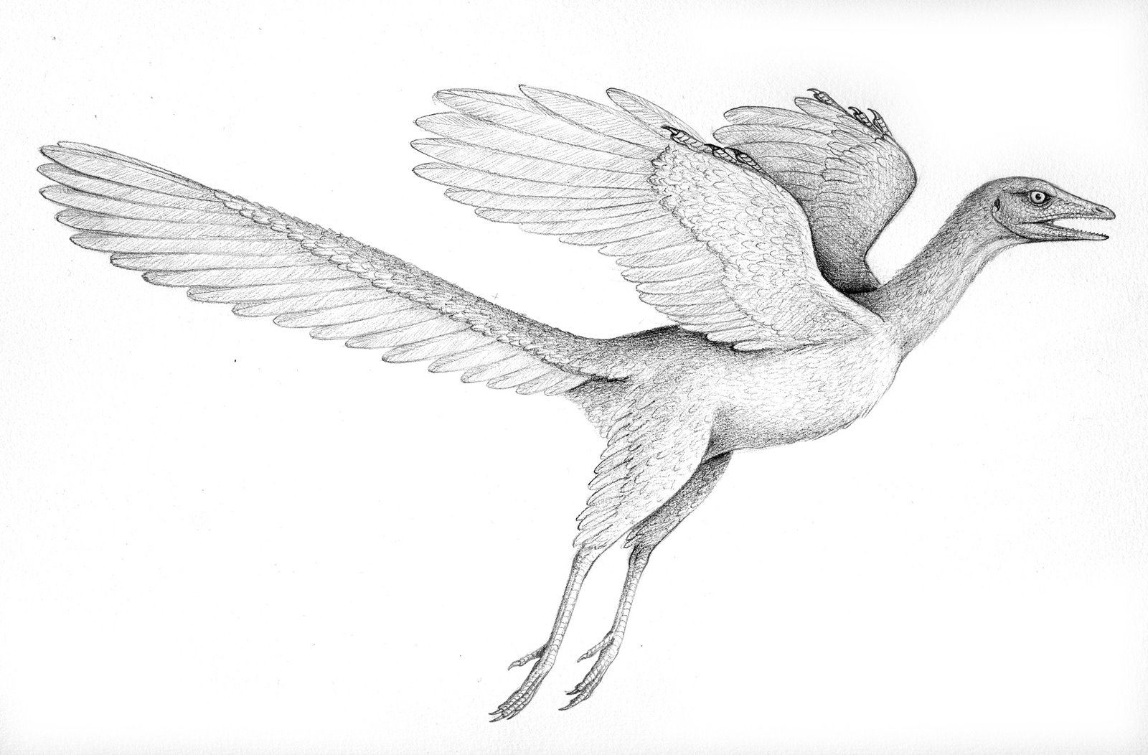

**Interesting story**

Where do you think the birds come from? Scientists found that today's birds evolved from… dinosaurs! Which makes them modern day dinosaurs! The same way bats are mammals, birds are a strange type of a dino with small, evolved wings who developed an ability to fly.

Birds evolved from a group of meat-eating dinosaurs called theropods. That's the same group that Tyrannosaurus rex belonged to, and also a smaller Veloociraptor. Although birds evolved from the smaller theropods, not huge ones like T. rex.

Watch this short video from the Natural History Museum to learn a bit more: <https://www.nhm.ac.uk/discover/why-are-birds-the-only-surviving-dinosaurs.html>

If your child is interested, you can read more about dino to bird transition here (For kids 6+): <https://australian.museum/learn/dinosaurs/bird-like-dinosaurs/>

**Fun Facts**

* You shouldn’t feed the birds bread: Although bread isn't harmful to birds, try not to offer it in large quantities, since its nutritional value is relatively low. A bird that is on a diet of predominantly, or only bread, can suffer from serious vitamin deficiencies, or starve. Also, if bread gets moldy, it can be dangerous to birds. And if the chunks of bread are too large, they can actually block the digestive tract.
* Cuckoo bird: ​​These birds are very famous in Europe because their voice is imitated by cuckoo clocks (and whose call, coo-coo, gave the name to the entire cuckoo family). This bird is also well known because instead of sitting on its own eggs, it sneaks their eggs in the nests of smaller birds who end up “bringing up” little cuckoos.
* Pelicans: Pelicans are famous for their throat pouch which they use to catch fish, though different species use it in different ways. This pouch can fit several buckets of fish!
* Philippine Eagle a.k.a Haring Ibon:A very unusual bird that enjoys eating monkeys for dinner, and has a shaggy brown hairdo that makes him look like he’s been out partying way too much. Check out his photo in the Appendix!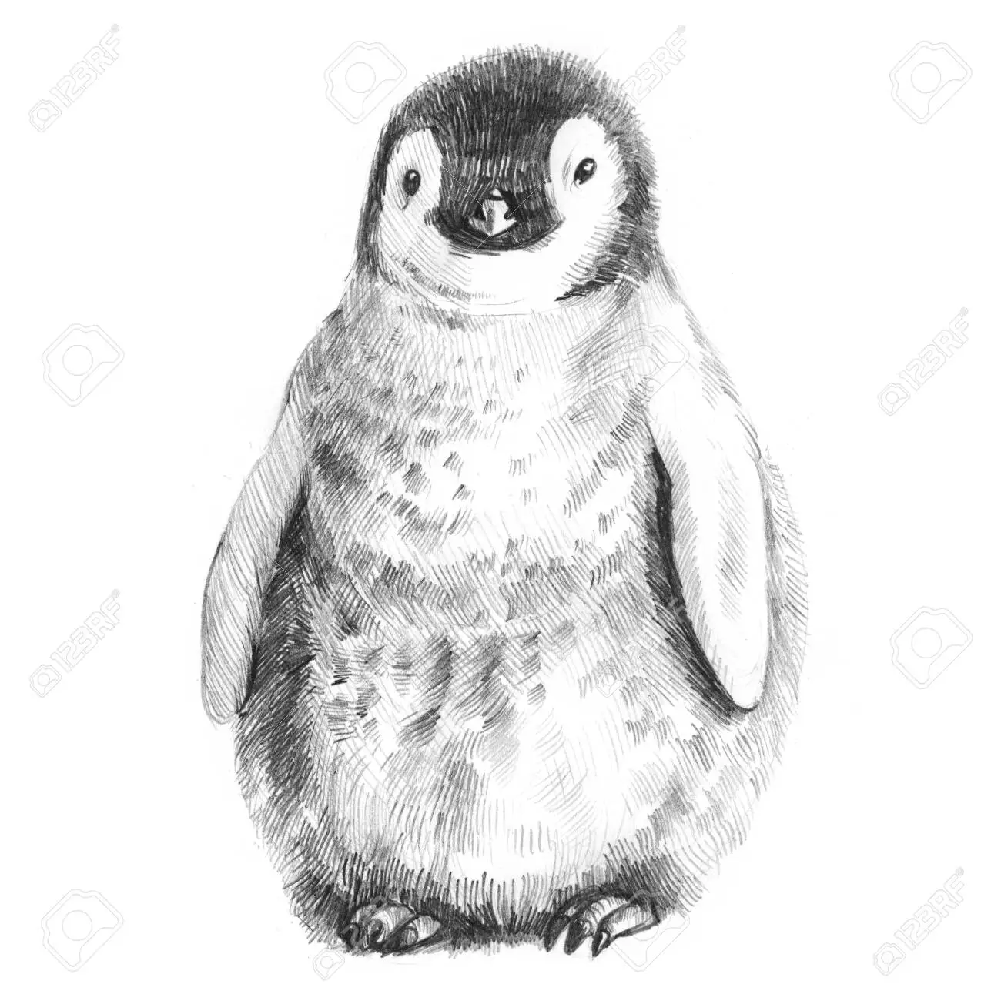
* Penguins: Do you think penguins only live in Antarctica? That’s what most people think because that’s where the large Emperor penguins nest. However, they have plenty of cousins in South Africa, Argentina, and even Australia! They all look different. Make sure to watch an adorable video about tiny penguins from Phillip island in Australia in the Appendix. And make sure to locate all of those spots on a map!
* Make Way for Ducklings: There is a statue (or a number of statues) dedicated to ducklings located in Boston Public Garden. It’s based on a story about mama and papa ducks raising their baby ducklings. If you are in Boston, visiting Mrs. Mallard and her 8 ducklings is one of the top Boston kids activities for the under-8 set (check out a pic in Appendix and read the story - link in the Books section).

**Imaginarium**

What ability would you like to borrow from the birds? Most kids would think about flying. In this case, talk about this new world - what if people could fly? Where would we live? How would our life be different?

How would this be possible in the real world?

Did you know that many people and companies have been working on developing flying cars? What will change if it happens? What would be good about it? What would be hard about it? What will people have to develop to avoid collisions in mid-air?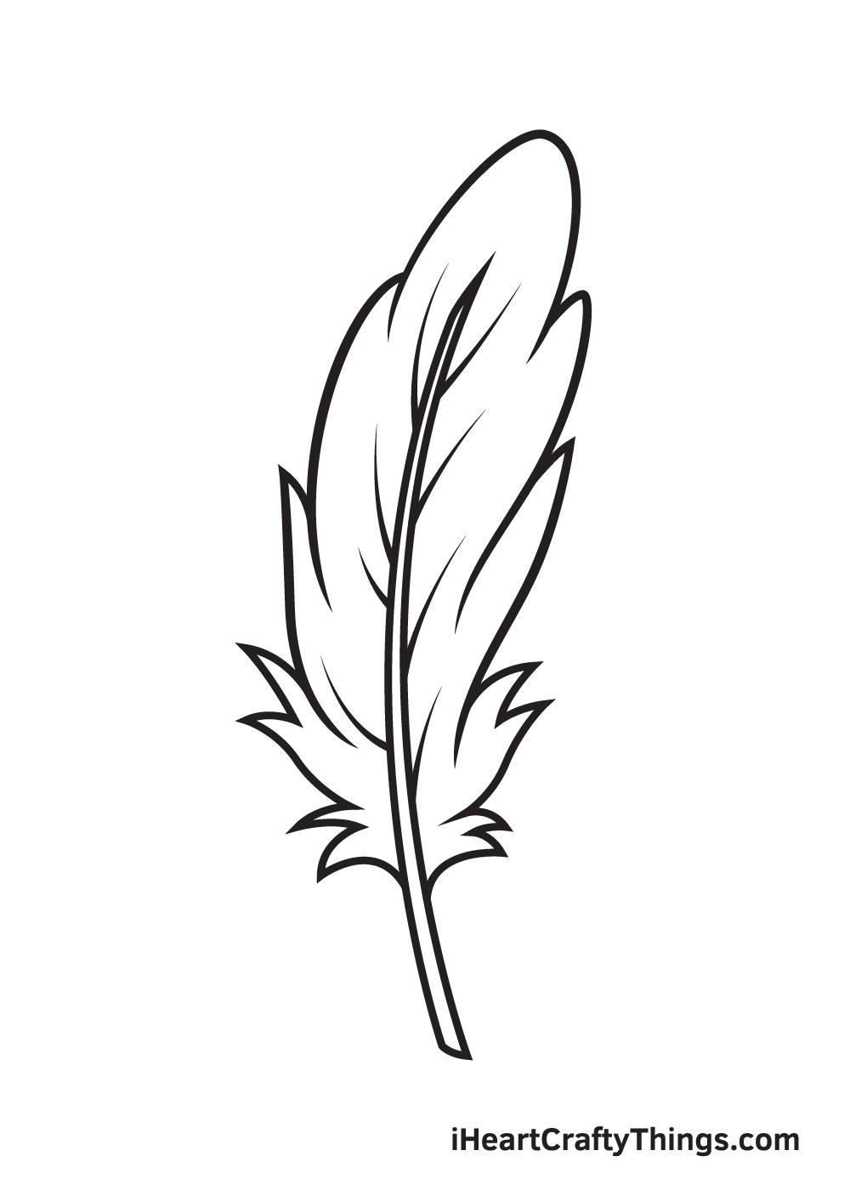

**Experiment (if you have access to sea/ocean)**

Try using the feathers you brought home from your walk to write with gouache or acrylic colors and see how people used to write with ink years ago! You can make some drawings too. You might have to use thicker paper to avoid tears.

**Books to read**

**“Make Way for Ducklings**” by Robert McCloskey

You can download a .pdf [here](https://www.yumpu.com/en/document/view/63833858/read-online-make-way-for-ducklings-viking-kestrel-picture-books-pdf) or watch a [YouTube read-out-loud](https://www.youtube.com/watch?v=LBNjJmR5Yzw)

A very cute introduction to duck behavior from egg to adult. Anyone who lives in or wants to visit Boston will appreciate the 1940s vision of ducks bringing up their little family on an island in Boston Public Garden.

**“Moon”** 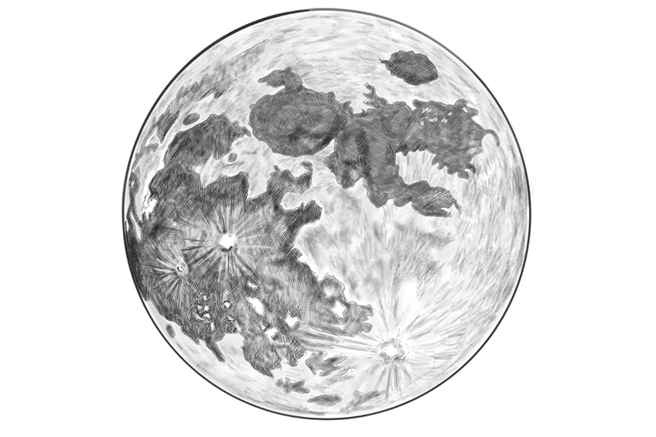

**Walk 20**

**Before the walk:** Today we’ll be talking about the Moon. It’s great to do this learning walk in the evening when it’s visible, or on a day when you can see the moon in the sky even during daytime, just makes it more fun. If not, ask your child if they’ve ever seen the moon during the day and why they think it is.

**Let’s begin!**

First, ask your child: “What do you think the Moon is? What do you think it’s doing in our sky?” Many kids know that the Moon is the satellite of the Earth, but ask them if they know what “the satellite” means? “Is the Moon the only satellite the Earth has?” If they seem interested, explain that satellite is a word for a planet orbiting another planet. Other planets, like Jupiter, have multiple satellites “almost like multiple Moons!) while Earth only has one “natural satellite”. People have created many artificial satellites for other reasons, like phone connection, we can see some of them at night like “moving stars”.

* On your walk, take a look at the moon (that’s why we need to do it in the evening or on a day with high moon visibility) - and tell your child that people didn’t always believe that the Moon is a satellite. For example, several **science fiction** books take place within a hollow moon inhabited by aliens, so some people believe it’s a real planet and a home for “lunarians”. Also, 50 years ago two Soviet scientists took this idea a step further, and proposed that the moon is actually a shell-like spacecraft built by the aliens with superior technology and intelligence to watch the Earth!
* **What does the Moon look like today**? Is it a full circle? Or half a circle? More like a small apple slice? What does it remind you of? Have you seen it look differently before? Come up with your own story why the moon changes its shape through the month. Maybe a cosmic owl bites pieces of it off all months and then puts them back together?
* If they ask, explain that the **new moon** happens when the Moon cannot be seen because we are looking at the unlit half of the Moon. The new moon phase occurs when the Moon is directly between the Earth and Sun.
* Ask your child if they think the Moon shines the light on Earth just like the Sun. Remind them what we discussed about the Sun - we shouldn’t look straight at it because it can hurt our eyes. Is the Moon the same? Then you can explain that the Moon does not emit its own light. We can only see it from Earth because it reflects the light from the Sun!
* Can you see some “spots” or “blemishes” on the moon? Where do you think they come from? If they don’t know, explain they are called “**craters**”, they look sort of like tall rings with elevated sides. Wonder together where they came from. Does your child have an idea? Before telling them, turn on your imagination: maybe they used to hold water? Or could they be homes for the creatures who inhabit the moon? Or giant telescopes observing Earth? Then explain that the craters on the Moon are caused by rocks and asteroids hitting the lunar surface. The Moon's surface is covered with thousands of those rings - craters. Build some craters with sand, play doh, or draw them with chalk. *There is an activity associated with this below as well.*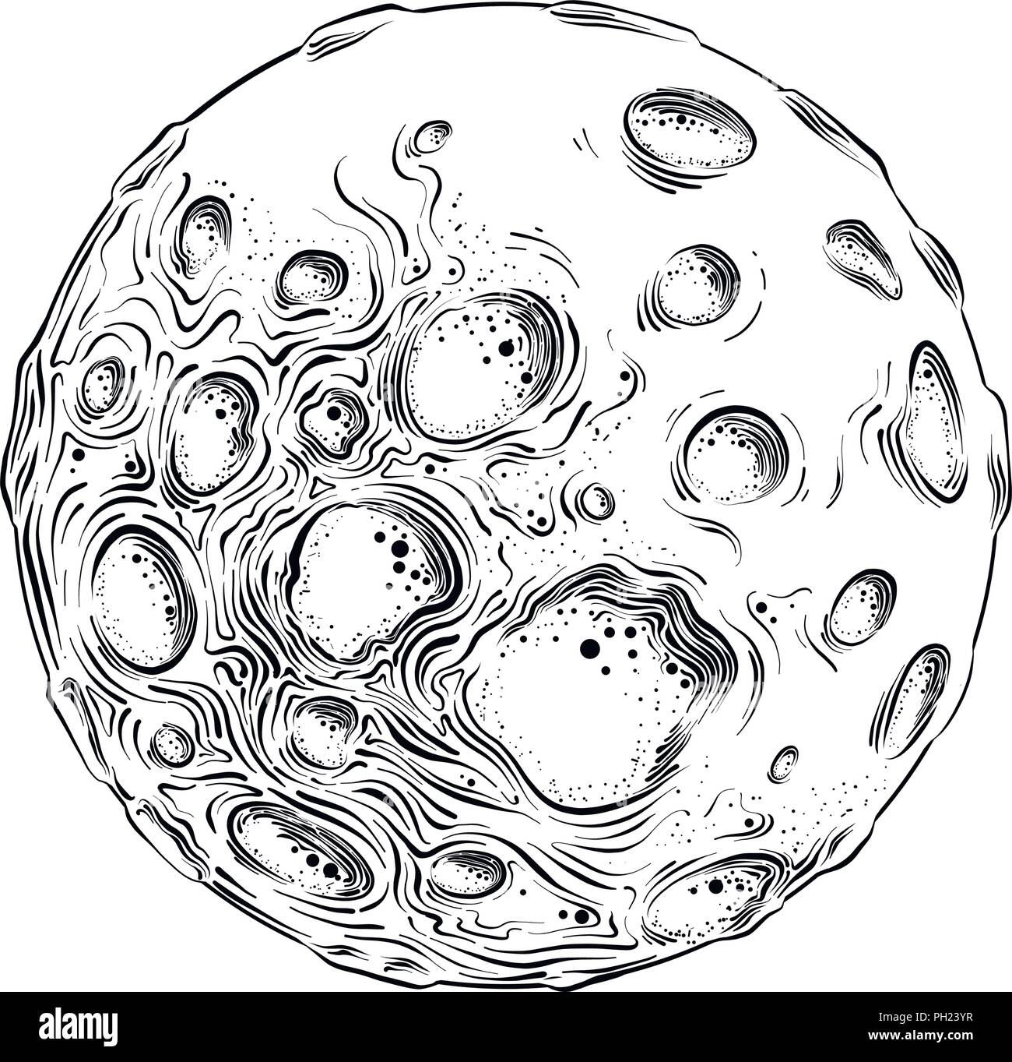
* Why does the Moon have so many craters compared to the Earth? Remind them about the walk we did on Air and how our Earth is surrounded by an atmosphere, a protection layer. That’s the difference: unlike the Earth, the Moon has no atmosphere to protect itself from impacting bodies, so they have way more craters!

**Interesting story**

There is a myth in Peru about a **Fox on the Moon**. All that this Fox could think about was getting to the Moon. After braiding a grass rope long enough to reach the Moon, he got help from the birds to fly it up to the Moon for him.

Then, once that was done, the Fox climbed up the rope. Now the birds say they can see Fox in the Full Moon. Can you?

Challenge: Take a picture of the moon on your walk (or print one out - there is a couple in the Appendix section). What do you notice about the Moon in that picture? Can you see some figures in the craters? How about a fox?

Moon stories from around the World: <https://nightsky.jpl.nasa.gov/docs/MoonStoriesASP2019.pdf>

Challenge part 2: How do you think one could get to the Moon? You can tell them the stories of Jack with a beanstalk, or Baron Munchausen who used the same means to climb up to the Moon, and then a rope made of straw to come down. What other ideas can you think of?

**Fun Facts**

* Calendar in the sky: Since it reliably changes its phases, ancient people used the moon as the calendar in the sky. Remember that some scientists believe that the cave drawings were “early almonachs” (books about events that happened at some period of time)? Many of those drawings include the Moon.
* Home of souls (if you are comfortable talking to your child about death): Some ancient Greeks thought that the moon was the home of the dead, and early Hindus believed that the souls of the dead returned to the moon to await rebirth (*good intro point to talk about different religious beliefs).*
* Where did it come from: Scientists think that the Moon formed during a collision between the Earth and another small planet, about the size of Mars. The debris (pieces) from this collision collected in an orbit around Earth to form the Moon.
* First man on the moon: We’ve imagined ways to get to the Moon, but did you know people have actually visited it? The first man on the Moon was Neil Armstrong in 1969!

**Fun Facts for Parents**

* Nazi station on the Moon: After World War II, rumors circulated that German astronauts had not only traveled to the Moon, but established a whole top-secret facility there. A few even speculated that Adolf Hitler actually faked his own death, fled the planet and was able to live for the rest of his days in an underground lunar hideout.

**Imaginarium**

We know that we can only see one side of the Moon because of how it rotates around Earth. The other side of the Moon is called “the dark side”. Who do you think could live there? Maybe Selenites (Selena is the name of the Moon in Greek and in ancient Greece Selena was the name of the Goddess of the Moon)? Or could there be a space station that aliens from a different planet have built there to watch us, people, on Earth? What’s your take?

**Activity to continue the conversation**

Grab some rocks on your walk and bring them home. Lay some flour on a tray ( the thicker the layer, the easier to see the result) and drop the rocks you’ve picked on it for a visual of how meteorites hit the surface of the Moon and how craters are formed! Kids usually love this activity, but it can get messy, so I’d suggest either doing it outside or covering the area around the tray with some plastic wrap.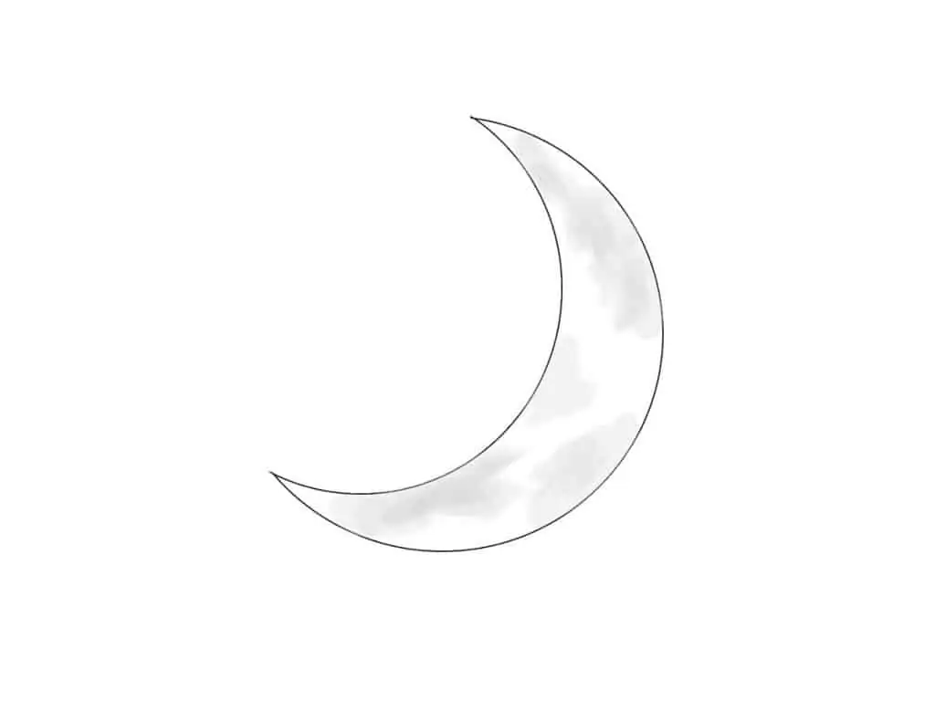

More Moon activities at home ideas: <https://www.preschoolplayandlearn.com/moon-preschool-theme/>

This [watercolor moon craft](https://www.preschoolplayandlearn.com/moon-preschool-theme/) is a fun one to consider.

**Books to read**

**“Papa, Please Get the Moon for Me”** by Eric Carle - [Amazon link](https://www.amazon.com/Papa-Please-Get-Moon-Miniature/dp/0887081770)

[YouTube Read-out-loud](https://www.youtube.com/watch?v=sGqAw7UM6qo)

A little girl named Monica wants the real deal Moon to play with, we follow her Papa as he tries to find a way to bring the moon home to his little girl

**“The Moon Book”** by Gail Gibbons - [Amazon link](https://www.amazon.com/Moon-Book-Gail-Gibbons/dp/0823413640) - [YouTube Read-out-loud](https://www.youtube.com/watch?v=EaGnMxFqfeY)

Best features are the section on the phases of the Moon (correct ones!) and the section on gravity and distances between the Moon, Sun, and Earth. As you already know, I love introducing children to different perspectives on things we are pondering, so I really enjoyed the part where this book talked about ancient people’s beliefs that the Moon is a god as it helps to spark up imagination and creative thinking.

Cartoon - **Peppa the pig goes to the Moon**

A Trip to the Moon is the twenty-first episode of the third Season of "Peppa Pig". It is the 126th episode overall. If your kid is into Peppa, a fun episode to watch.

**“The First Men in the Moon”** by H.G. Wells - for grown ups, it’s the book we mentioned above where aliens live in a shallow core of the Moon.

**https://www.whatdowedoallday.com/five-moon-activities-for-kids/**

**“Chalk”**

**Walk 21**

**Before the walk:** Today we’ll be discovering new things and looking at the world through the lens of a very common object that most of us already have at home and use - chalk. The goal is to SHOW things to your child, let them make connections and come to a conclusion on their own, not make it a boring lecture because our idea is to explore and encourage our children’s natural curiosity, bring about the interest in seemingly simple things around us, help develop critical and creative thinking rather than spoon feed the knowledge. So try to show, ask questions, wonder together and only insert some information sparingly through interesting stories and fun facts.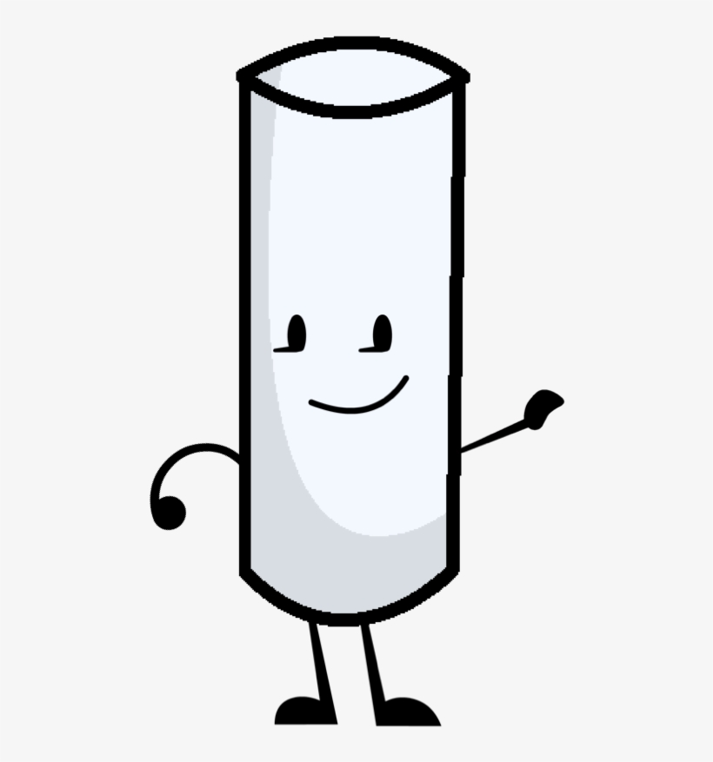

Grab the items from our Checklist, and let’s get started!

**Let’s begin!**

We have two options to begin this Walk. One is reading the book from our list (or watching the YouTube read-out-loud). It’s absolutely fabulous to open up some imagination and get some ideas to draw and create stories as you make some drawings on your walk (listed below). Or just start talking for option two and before you head out, ask your child what they think chalk is and where it came from. Let’s try and work on making hypotheses together: for instance, chalk is multicolored, maybe it’s made with some shredded crayons? It becomes soft when you press on it, could it be pressed coconut or pressed milk? The idea is to not only share your guesses, but also try to provide a justification for them, explain WHY you think so.

When it feels like you are done guessing, you can tell your child what chalk really is.

* Did you know that once upon a time chalk used to be alive and live in the ocean?! Chalk actually comes from nature. It is a soft, white type of limestone, and later on people add coloring to it to make it colorful. It originally formed deep under the sea by the compression of tiny sea creatures, plankton that had settled to the sea floor.
* Only if your child is interested, you can tell them those marine creatures are called “foraminifera”, “coccoliths”, and “rhabdoliths”
* Now it’s time to get that chalk out! Make sure to leave one or two new pieces of chalk in the box - to compare them later.
* Before you approach your destination, ask your child to stand still for a few moments (I know it can be hard) and use chalk to **draw around their feet and then their shadow**. Now keep on walking - and make sure to stop by the same spot again on your way back. When you come back, ask them to stand in the same spot (marked by their feet) and notice that the shadow shifted and changed its shape. Remind them you already did it for the walk on Shadows - do they remember why it changed?
* You can play **bubble hopscotch** (same game, but instead of squares, you make bubble drawings), **chalk twister** (hand on blue circle - foot on red square etc.) - just make a bunch of multicolored shapes with chalk and play like a regular Twister game. My favorite chalk activity that helps work on creative thinking is called **Venger drawings**. Draw a circle - and have your child come up with what it could be. Maybe a pizza? Or sun, or a face, or even Santa’s belly - now draw around it to follow through. Draw a triangle - maybe it’s the roof of a house, or a birthday cone, you name it. With younger kids, draw with them, with older kids you can make two shapes, face away from each other and each person needs to make their own drawing and then see who thought of what!
* After you are done, bring the chalk back and compare it to the piece or pieces you’ve left in the box - how are they different? The child will likely notice that the pieces you’ve left are shorter. Ask where he or she thinks the chalk went to? Now look at your hands (and maybe even clothes) - notice some chalk is left there.
* Another activity you can do on your walk is **a scavenger hunt**. Draw several items that your child can effectively find around you – leaves, grass, dandelions, rocks, a flower, etc. Once they find the item, they can bring it to the image and set it on top, or they can just put a big chalk “X” through it until they have located them all. For kids 4+ and more of a challenge you can work on their numeracy skills at the same time by asking for 5 leaves, 4 dandelions, 3 rocks, 2 pine cones, etc.

**Interesting story**

Chalk is often found in the sea since it consists of marine creatures and green algae that lived floating in the upper levels of the ocean. When the algae died, their remains sank to the bottom of the ocean and combined with the remains of other creatures to form the chalk that forms chalk and limestone cliffs today.

Chalk deposits occur in western Europe south of Sweden and in England, notably in the chalk cliffs of Dover along the English Channel (make sure to find some of these places on the map and explore their natural curiosity to get excited about the world and geography!)

Other deposits occur in the United States from South Dakota south to Texas and eastward to Alabama. So sometimes chalk is found on land even though it originates from sea creatures…Why do you think that could be?

**Fun Facts**

* Chalk and Police: Chalk was used by the police to detect fingerprints! Now different powders are often used. You can play detectives by using some leftover chalk powder to “detect fingerprints” and figure out who committed a crime - e.g., stole a cookie!
* Chalk and Sports: Chalk is often used by athletes, gymnasts, and rock climbers to help them keep their palms dry.

**Fun Facts for Parents**

* Natural Chalk is Edible: Chalk is edible, and some people actually like to eat it. However, the chalk sold at the stores has a lot of additives, and it’s only non-toxic in small amounts, so only share this piece of information with your child if you know they won’t actually eat it if they hear it.
* Chalk and babies: Chalk is a great art product for all seasons and a great supply to have on hand to introduce to your baby as soon as he/she is old enough to sit up unassisted and grasp onto the chalk. Both sidewalk and blackboard chalk are made from calcium carbonate or calcium sulfate, and are considered non-toxic in small amounts. *If large amounts are eaten, it can be irritating to the stomach and cause vomiting. Chalk can be a choking hazard for very young children, so please don’t leave them with chalk without supervision.*

**Imaginarium**

What if people started to build chalk houses and chalk cities - how would it change our life? Would we need to paint the walls? Or just pick the right chalk color? How would our life be different?

What if our fingers were made out of chalk - how would we get dressed? Or eat? Would we need pens or crayons?

**Experiment (if you have access to sea/ocean)**

Make predictions about what would happen if chalk is painted over with some water. Write out your child’s name, letters you are working on, etc. Give them a cup/bottle with some water and a paintbrush, as long as you don’t mind them getting a little dirty, and ask them to “paint” their name, specific letters you’ve identified, and drawings with water. Kids love watching the chalk magically transform as they do so.

**Books to read**

**“Chalk**” by **Bill Thompson** - [Amazon link](https://www.amazon.com/Chalk-Bill-Thomson-ebook/dp/B008P3J4QU#customerReviews) - [YouTube read-out-loud](https://www.youtube.com/watch?v=IT2VVPi4fJU)

Wonderful book for imaginative kids (and I haven’t met too many who are not, you just need to get it out of them). No words, just pictures, and this read-out-loud has lovely and very fitting music.

It allows the child to use the picture visuals to create descriptive language in order to tell their original story. There are a lot of questions you can ask as well as you read or watch it, such as: "How are they feeling?" - emotional intelligence development and feeling recognition; "Why do you think he's drawing a rain cloud?" - critical thinking and connection building; "What do you think will happen next?" - creativity development. The pictures are vibrant and each child can make their very own story on your walk!

**Appendix**

Walk 1 Created by Nature or Humans

A few additional ideas to continue the conversation at home. You can collect any leaves, flowers and rocks on your way and then use your imagination to create something fun, which is great for developing creativity OR you can look at these pictures and specifically look for objects that you can use to work on a similar project, which is helpful to work on systemic processing. See what works best for your kids (or do both on different days!):

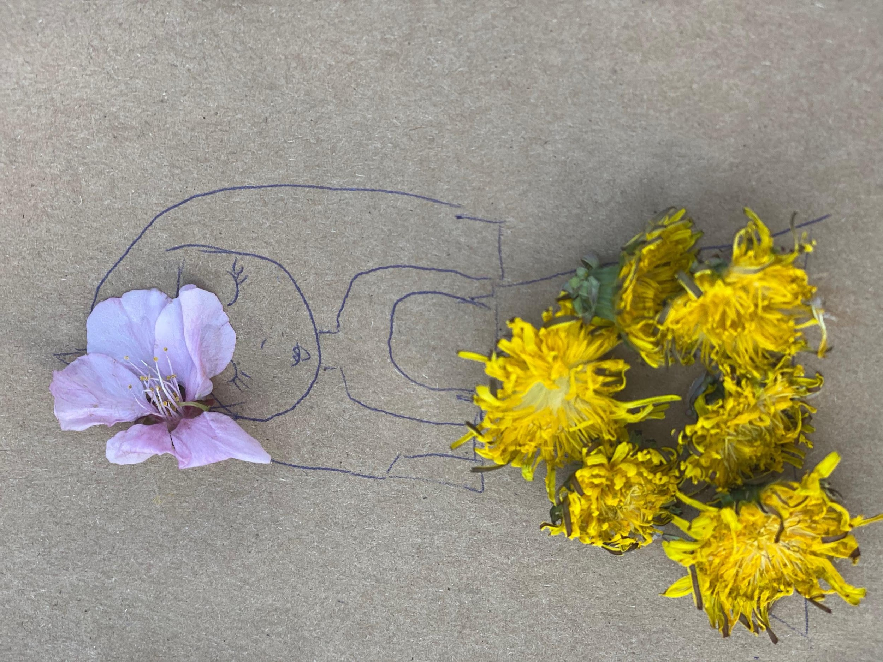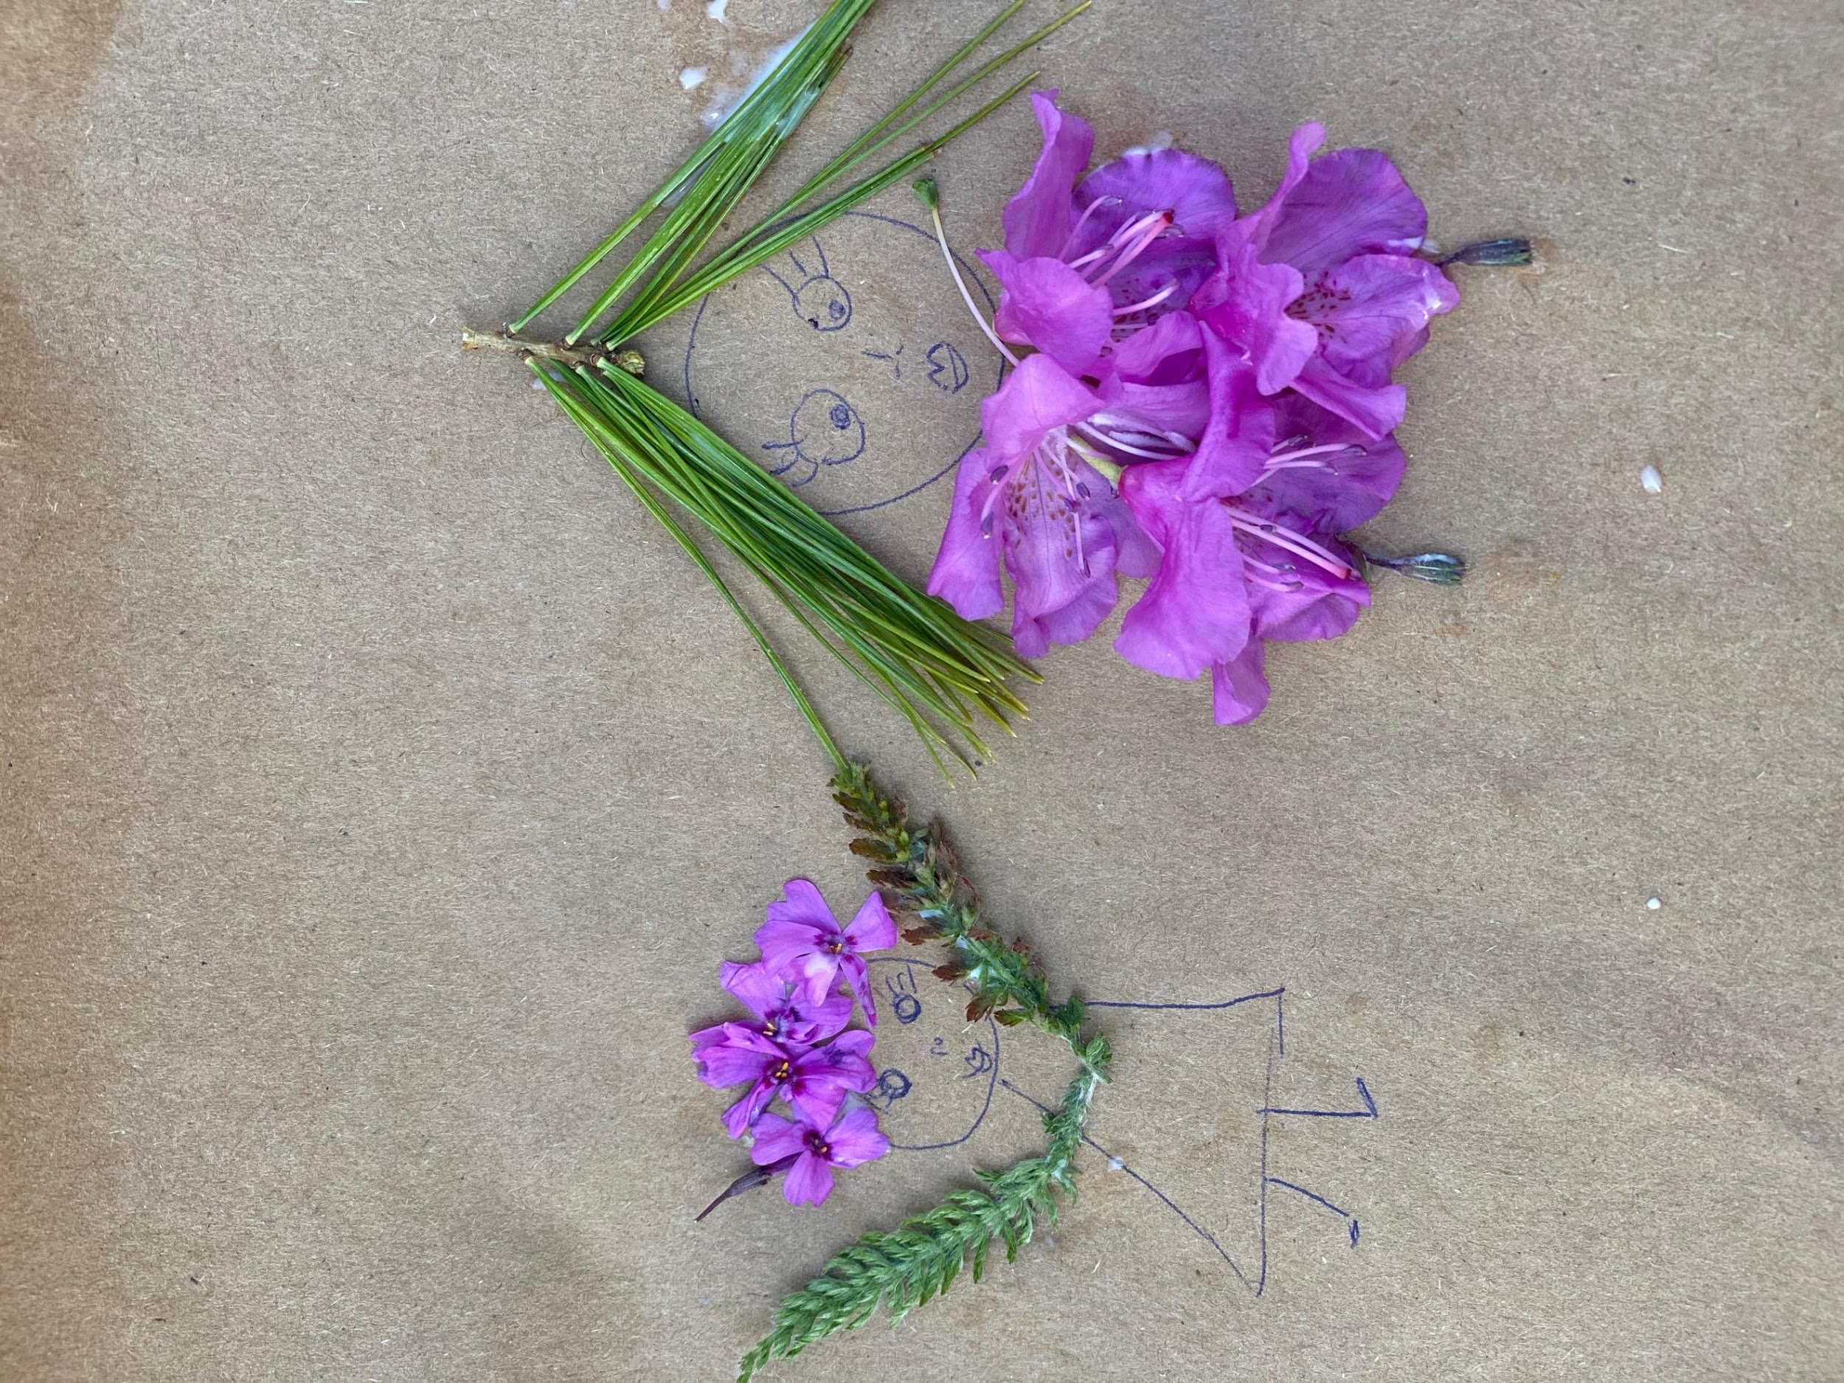

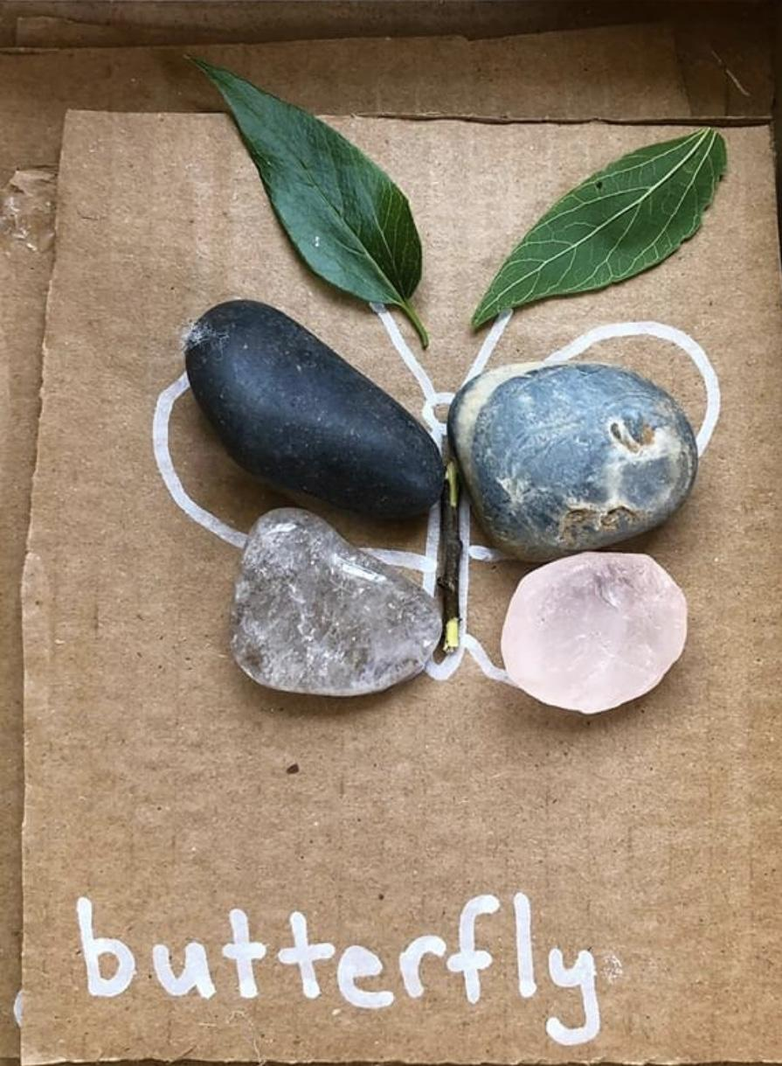

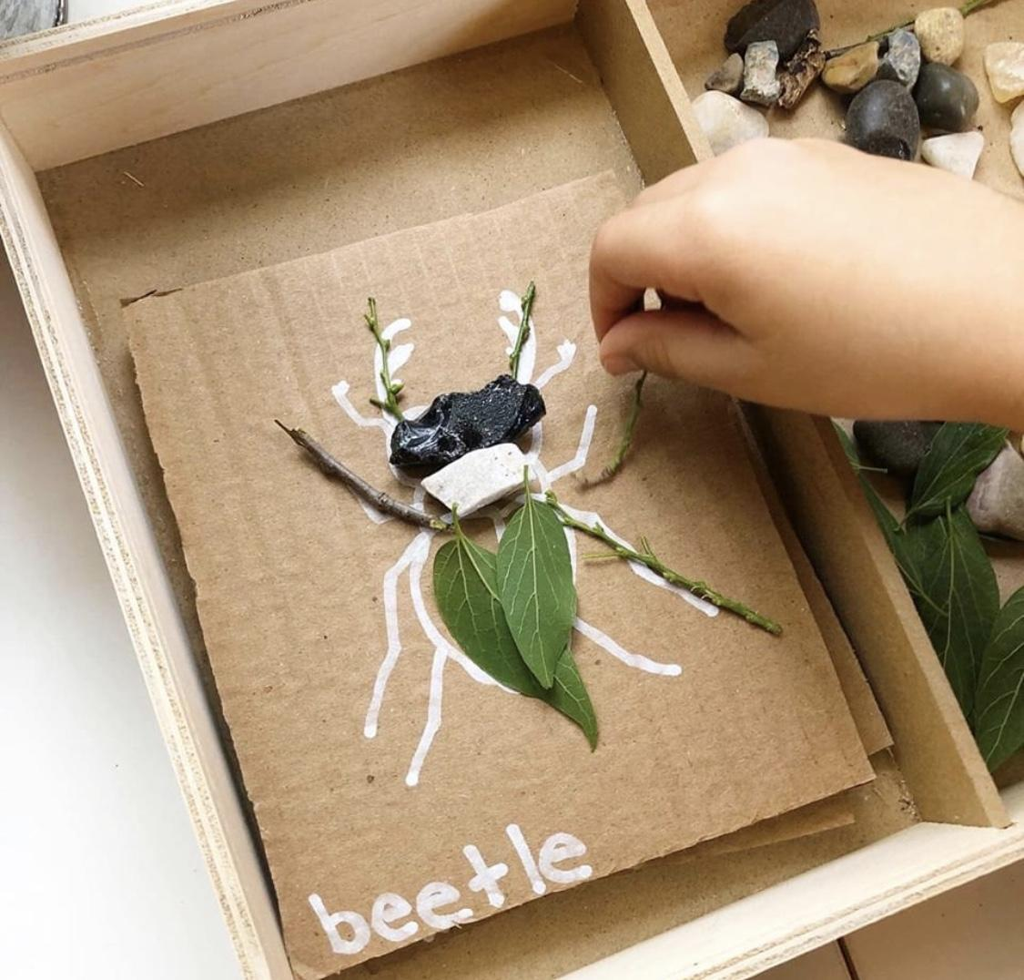

Walk 2 Shadows

Shadow doodle ideas

These funny and clever 'Shadow Doodles' are created by Vincent Bal. A Belgium filmmaker who loves to transforms the shadows of everyday objects into playful illustrations. His Instagram for inspiration (and fun): <https://www.instagram.com/vincent_bal/>

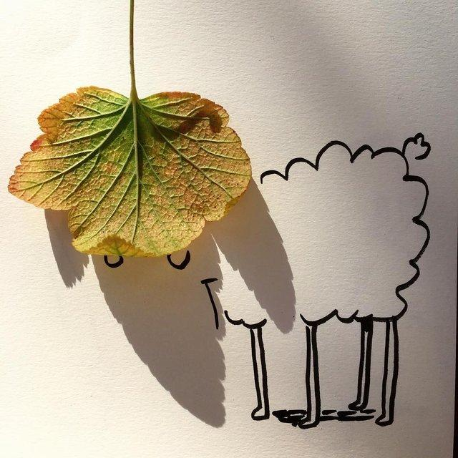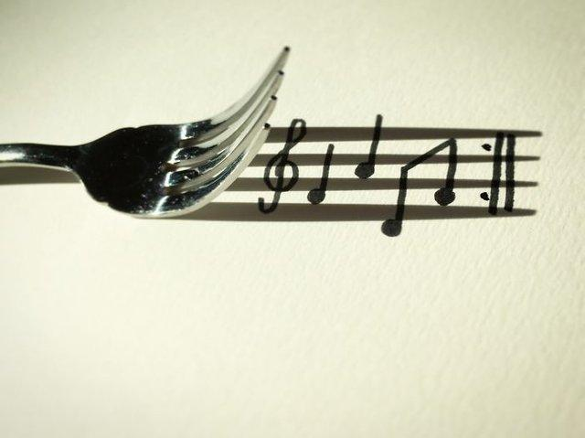

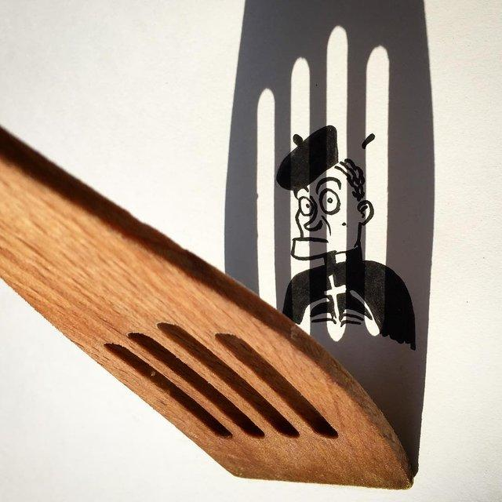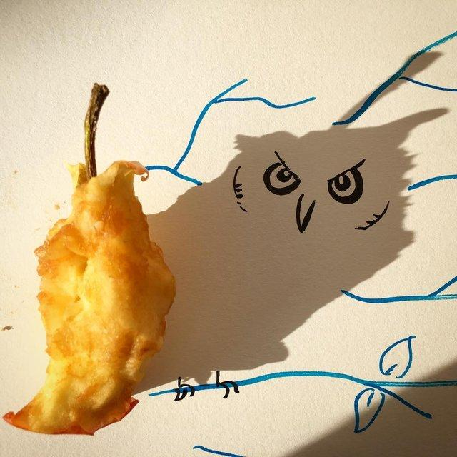

A few pictures from our experiments with Shadows discussed in the Walk:

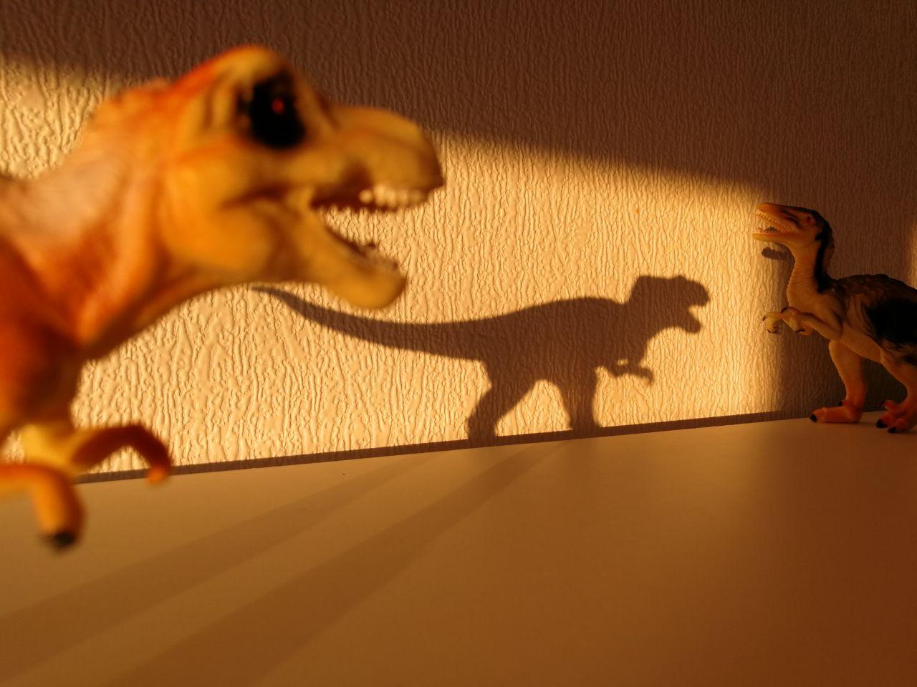

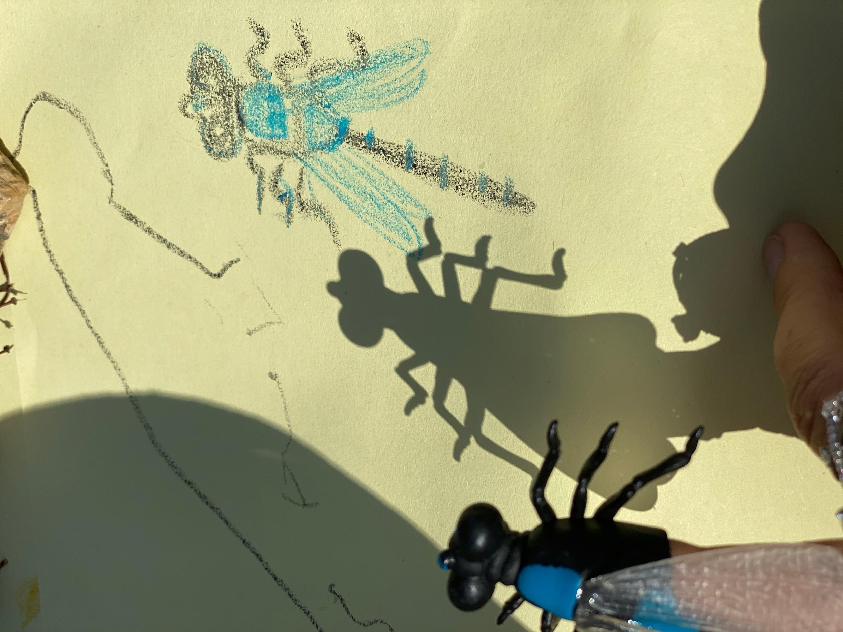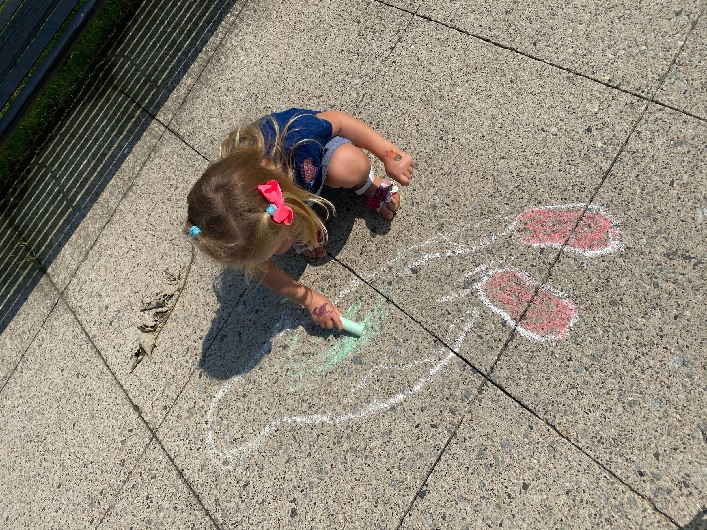

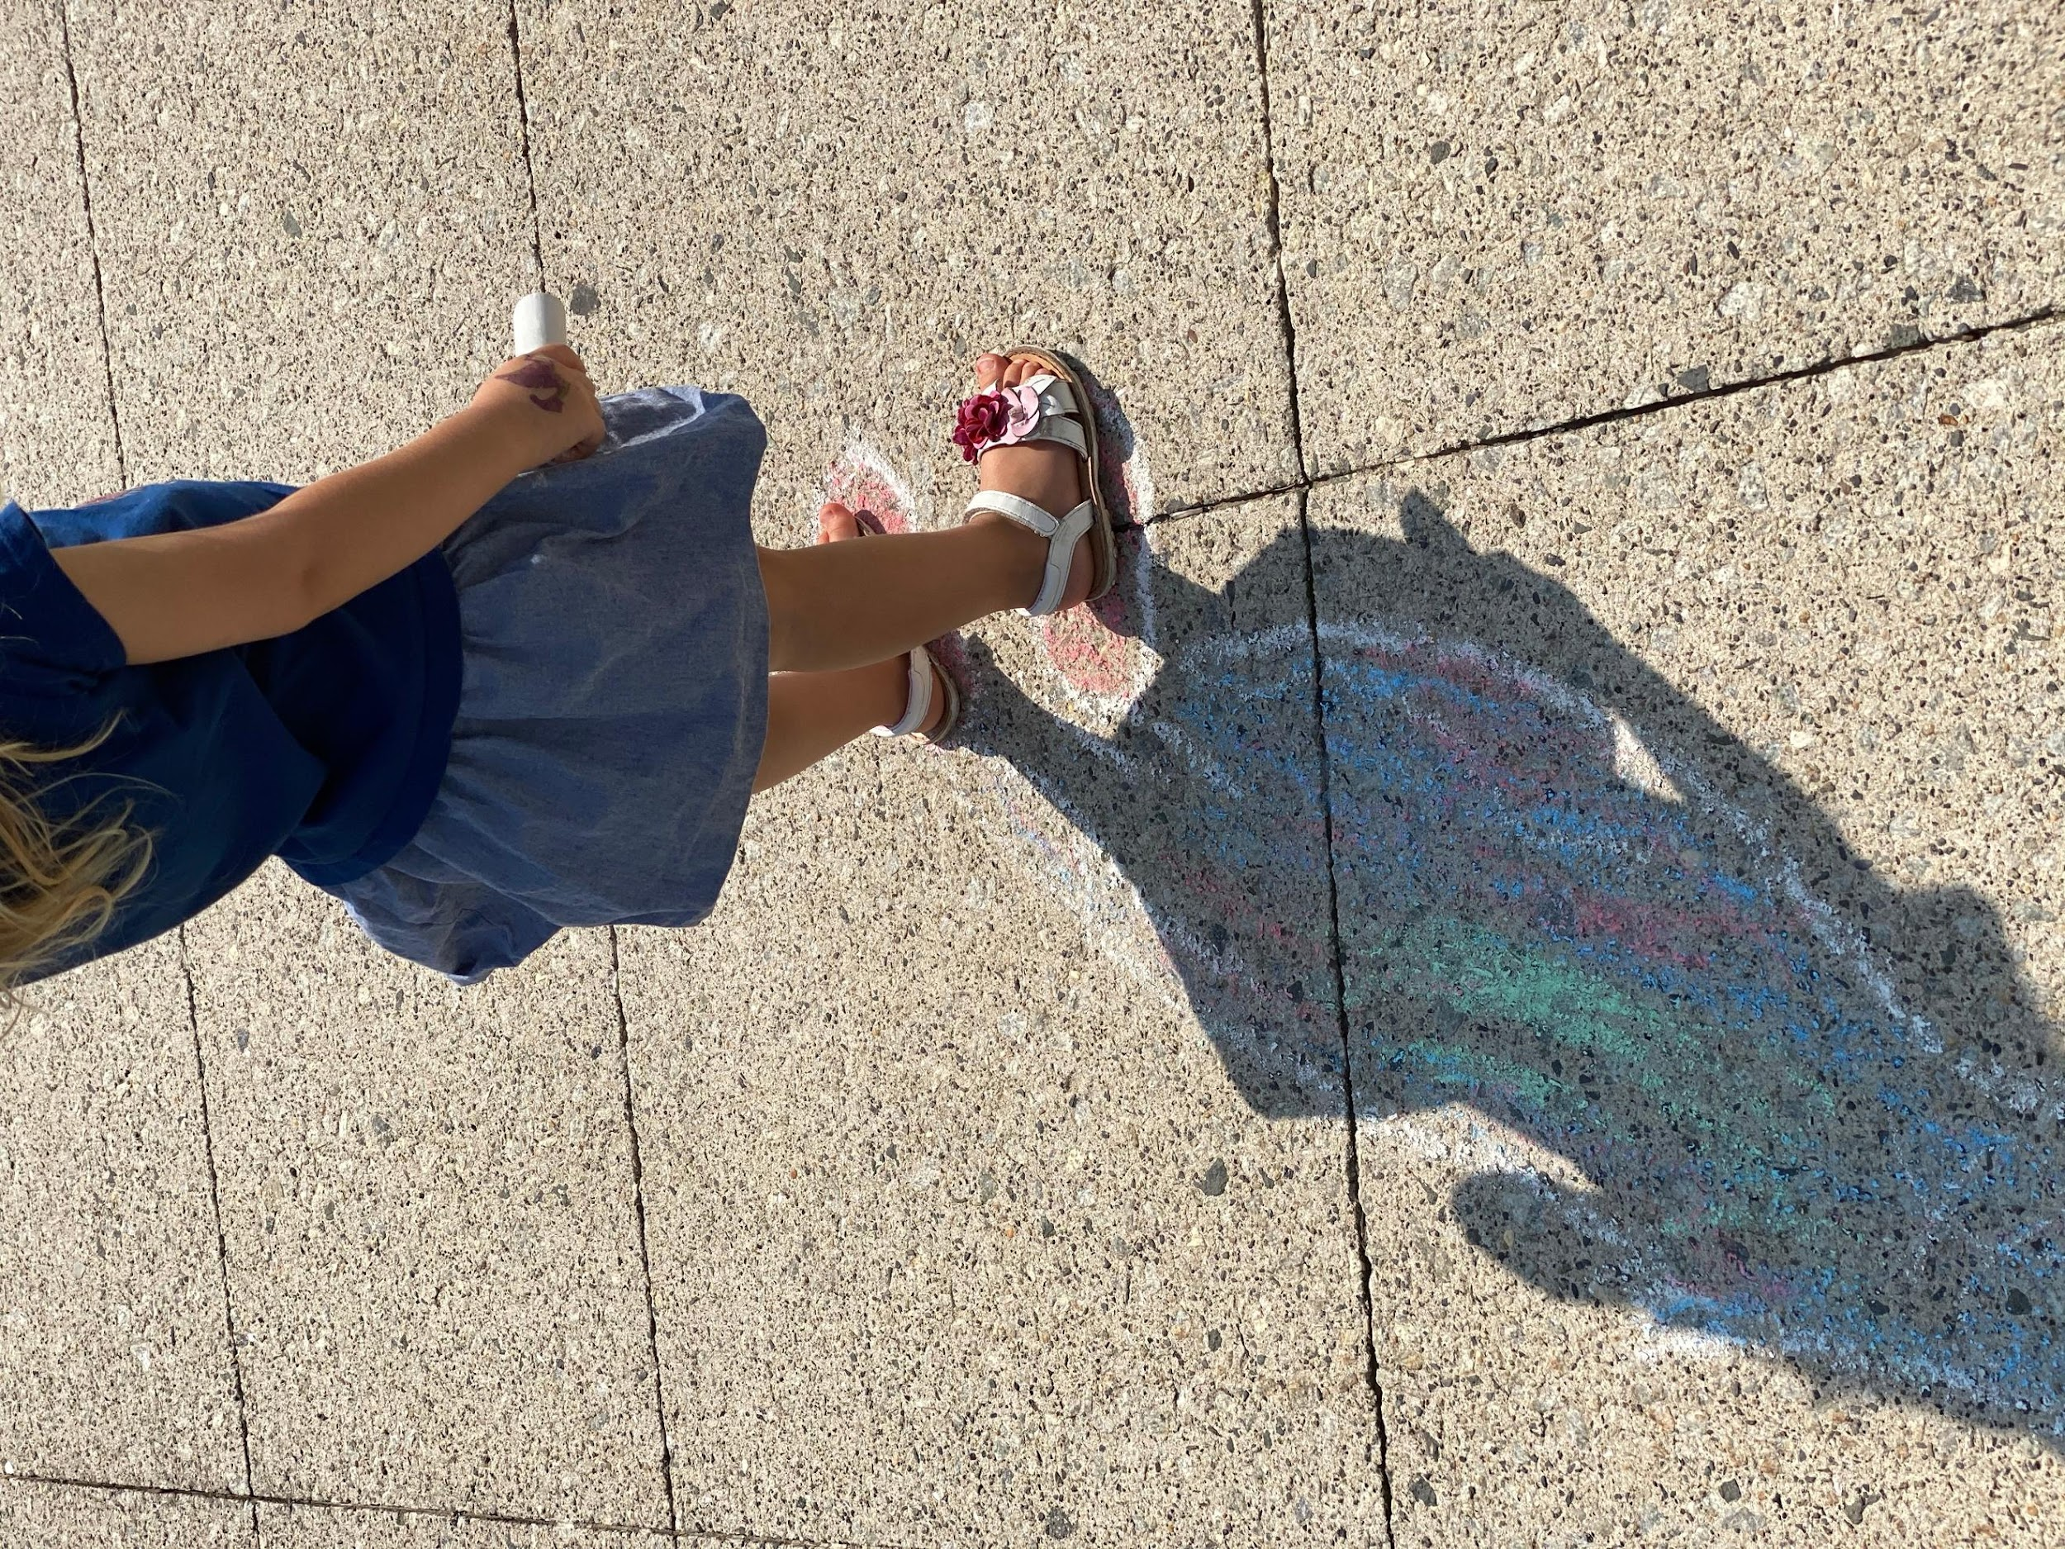

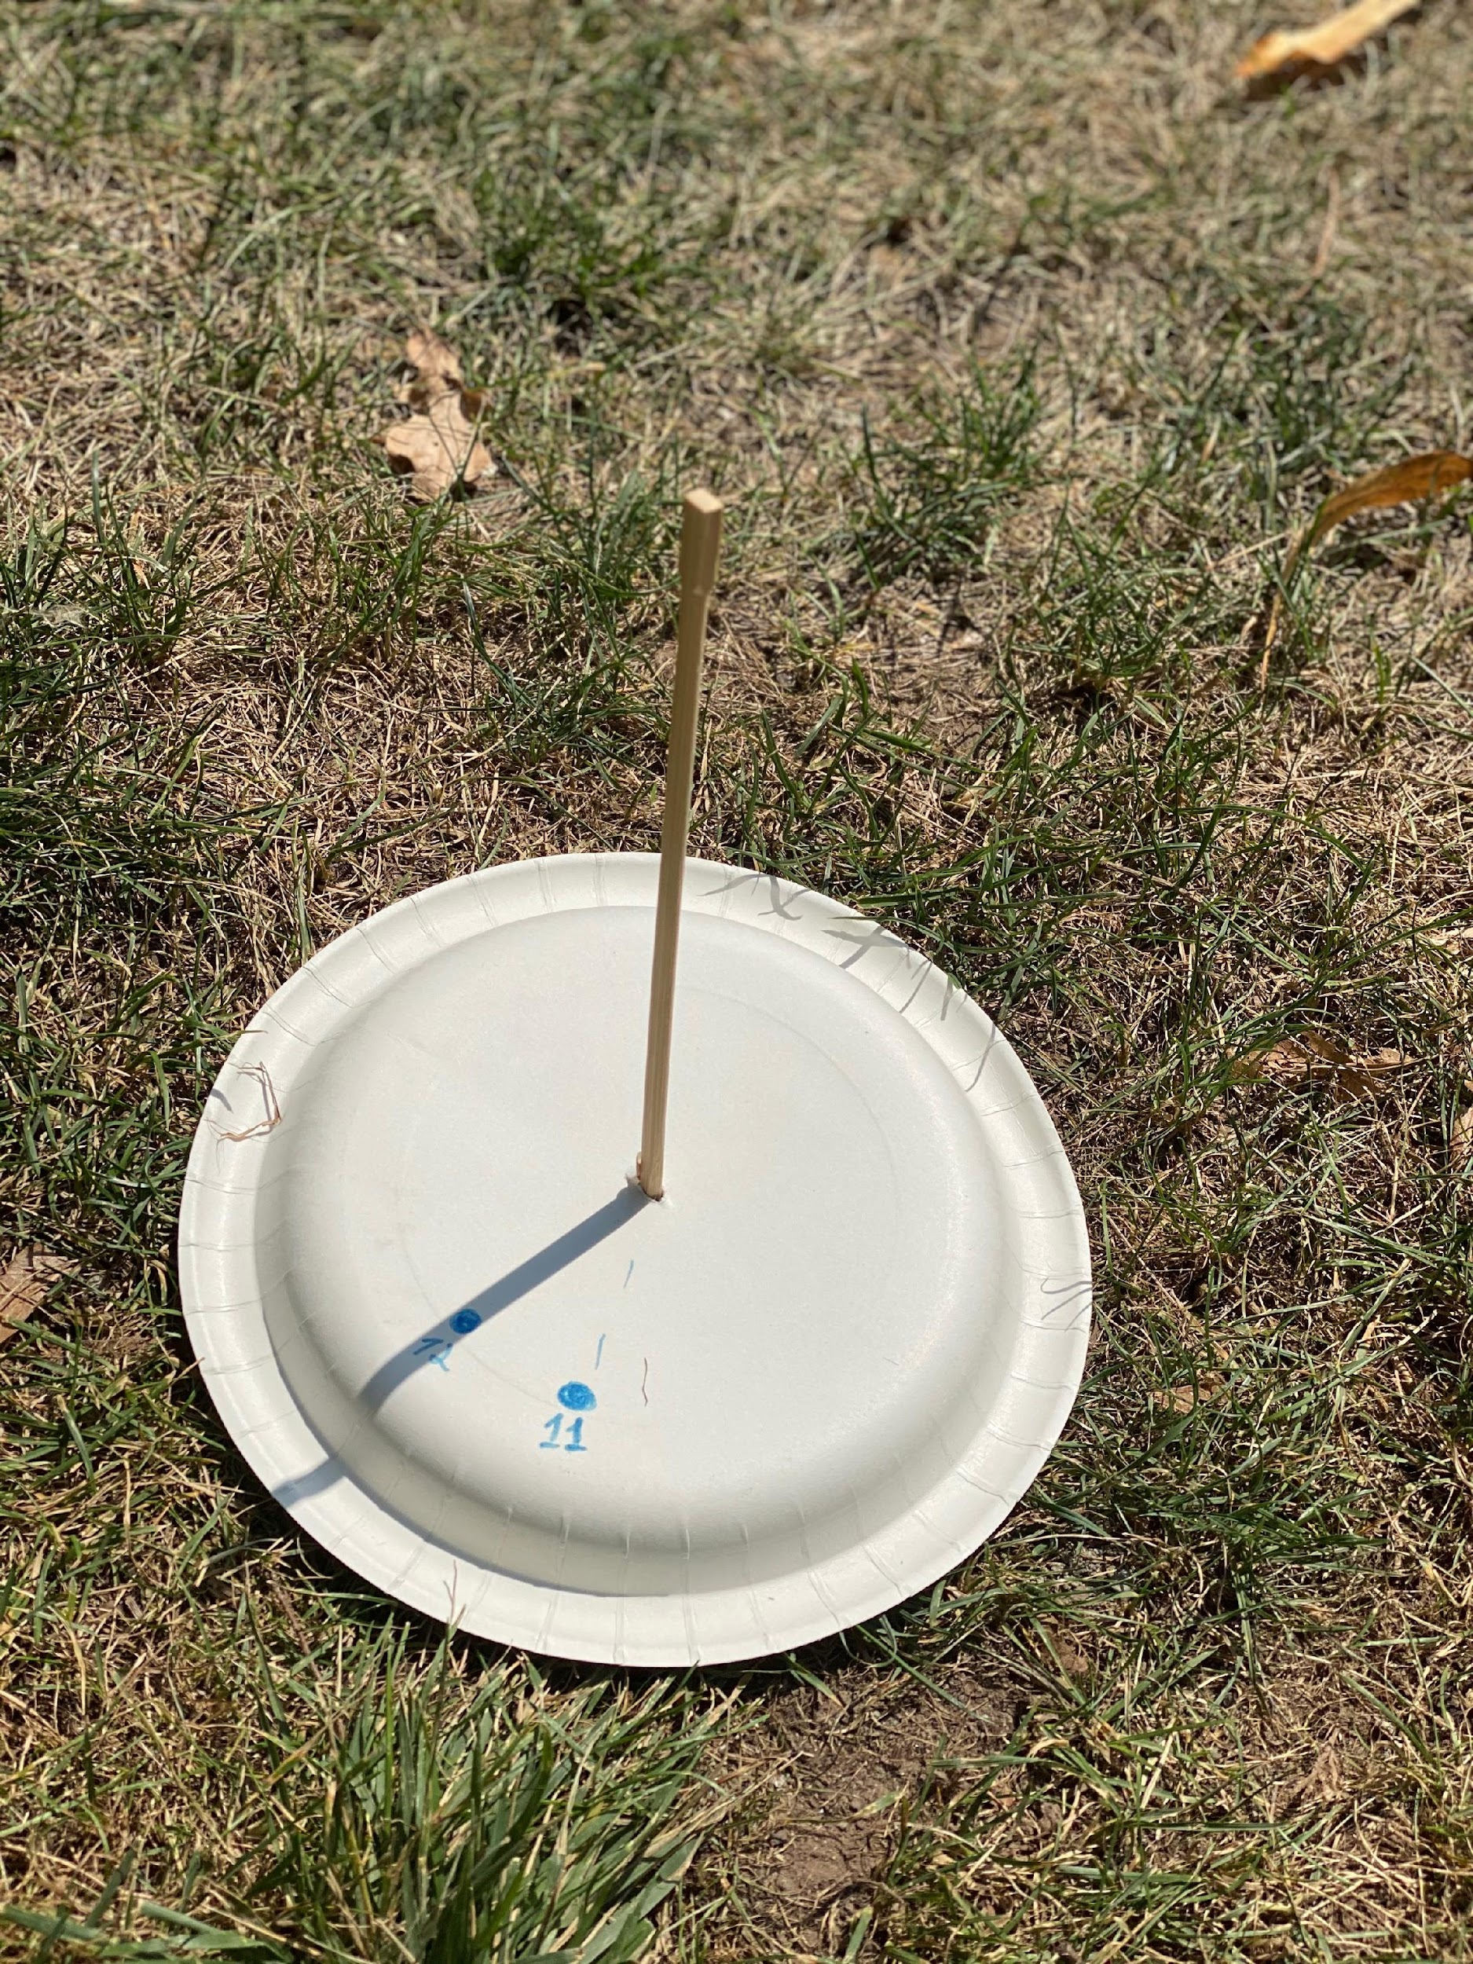

Walk 3 Sky

**Cloud watching fun**

Look at these clouds with your little ones. I used the Markup option on my phone’s Photo App to draw around the first one and show my daughter the puppy I was talking about. You can take some pictures of clouds, print them out at home and use some markers to see what fun shapes you can come up with! Here is some inspiration:

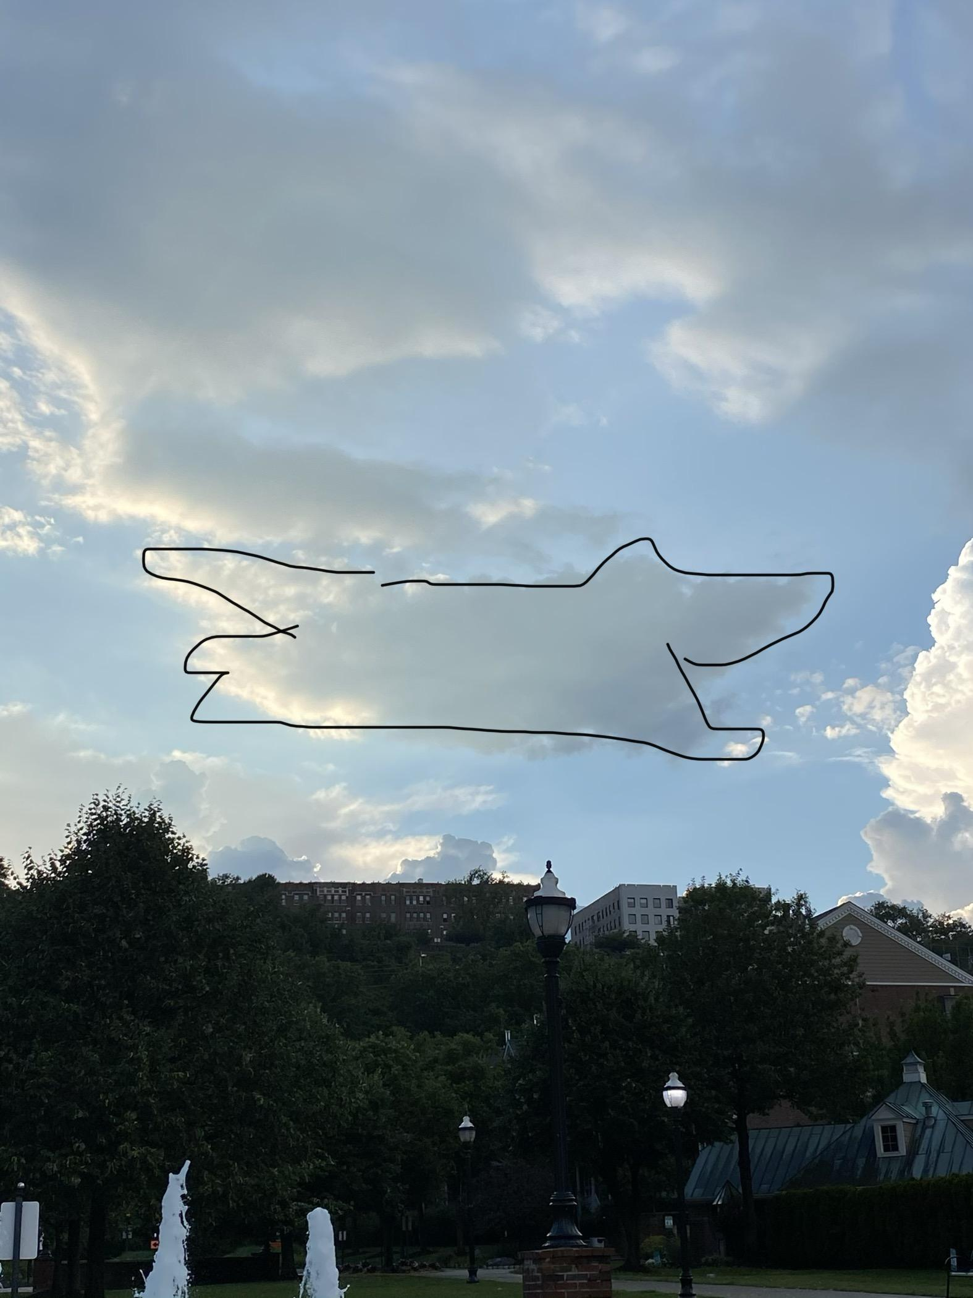

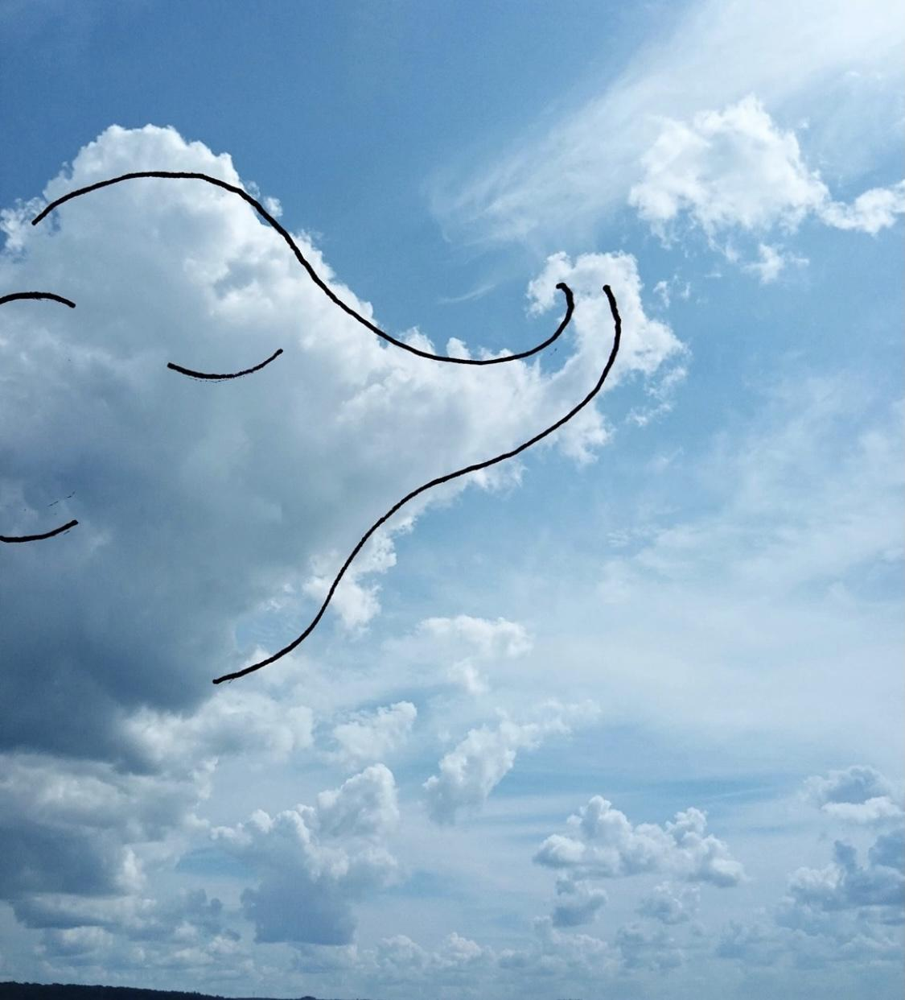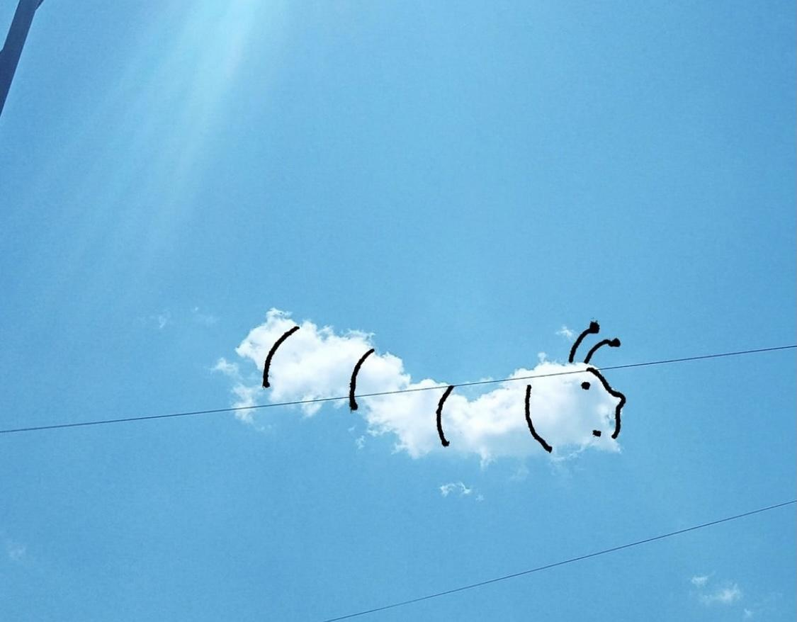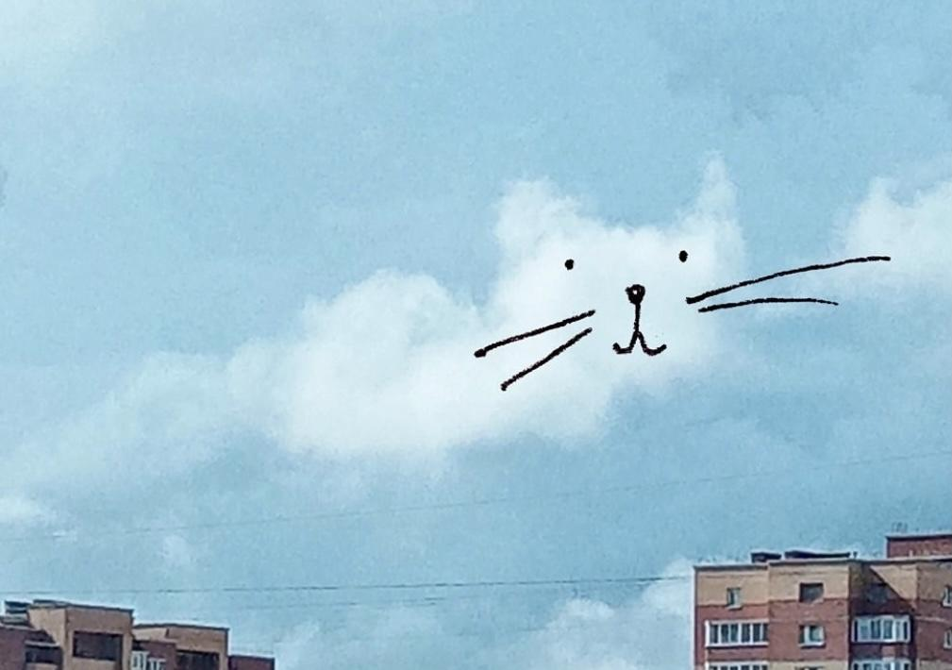

This one could be a bird… or an airplane!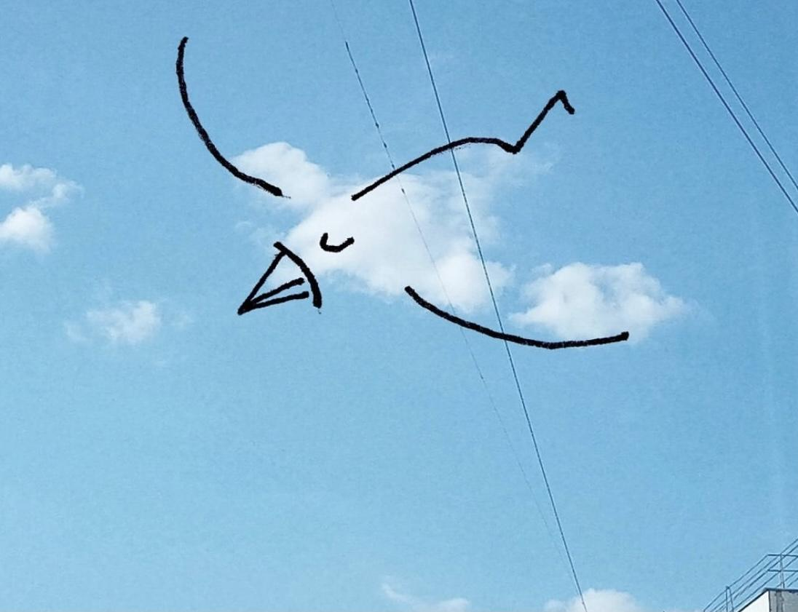

**Amazing and unusual clouds**

Did you know there is such thing as a “new” guy on the block when it comes to clouds? Asperatus – an official new cloud since 2017, most common in Tasmania region (find it on the map, it’s right near Australia!) Asperatus is so rare that they only appeared in the 21st century (so after your parents were born!) or at least that’s the first time someone noticed them. British “Cloud Appreciation Society” spent 10 years to add this type of cloud as an official type of clouds to the list!

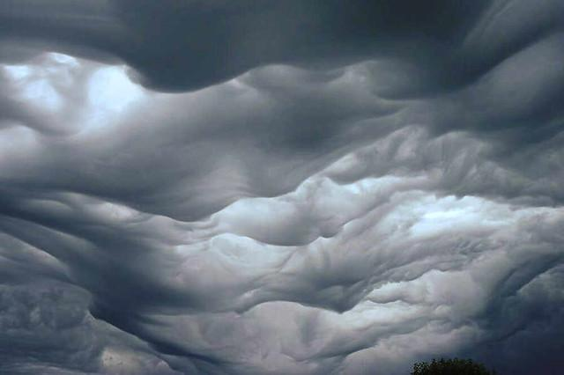

Here are some more unusual clouds!

This one was spotted in Canada.

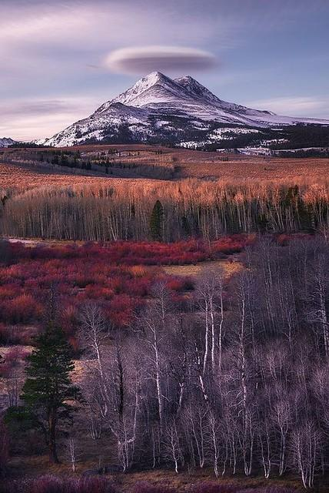

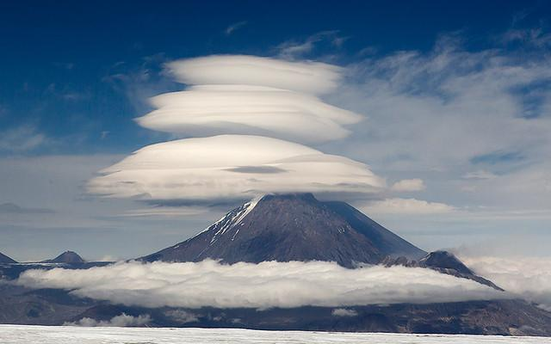

This one was right above a volcano and people thought it was a UFO!

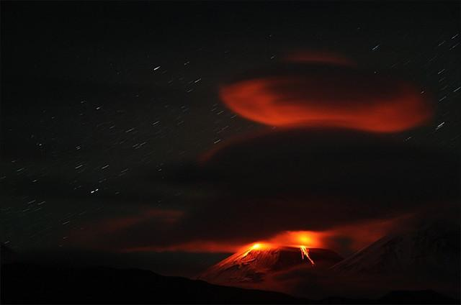

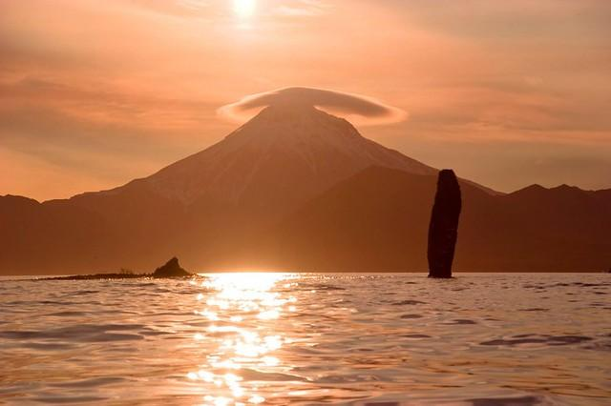

Have you ever heard about “cloud streets”?

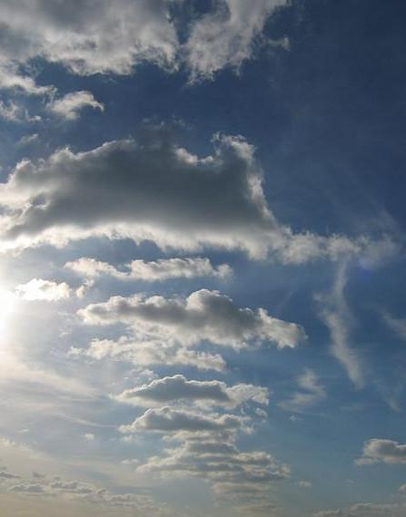

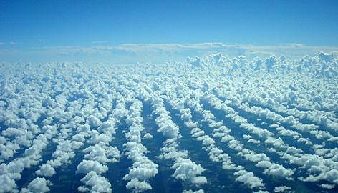

Walk 6 Treee

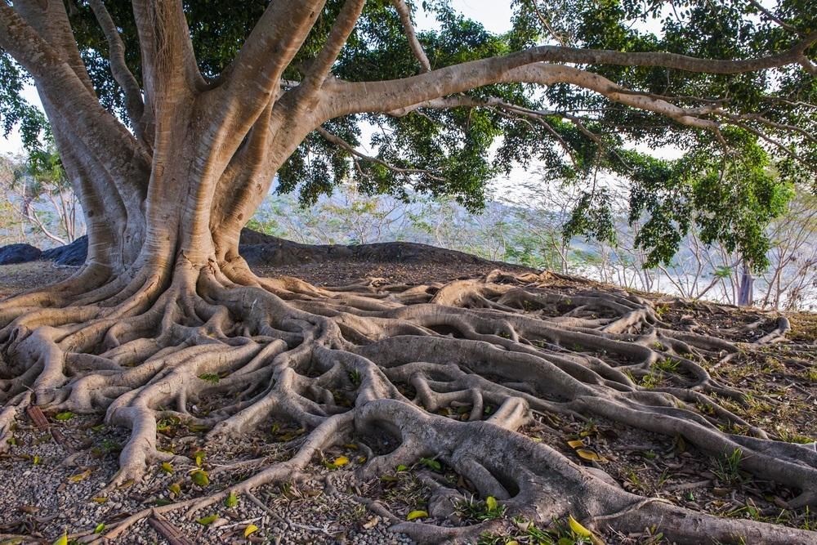

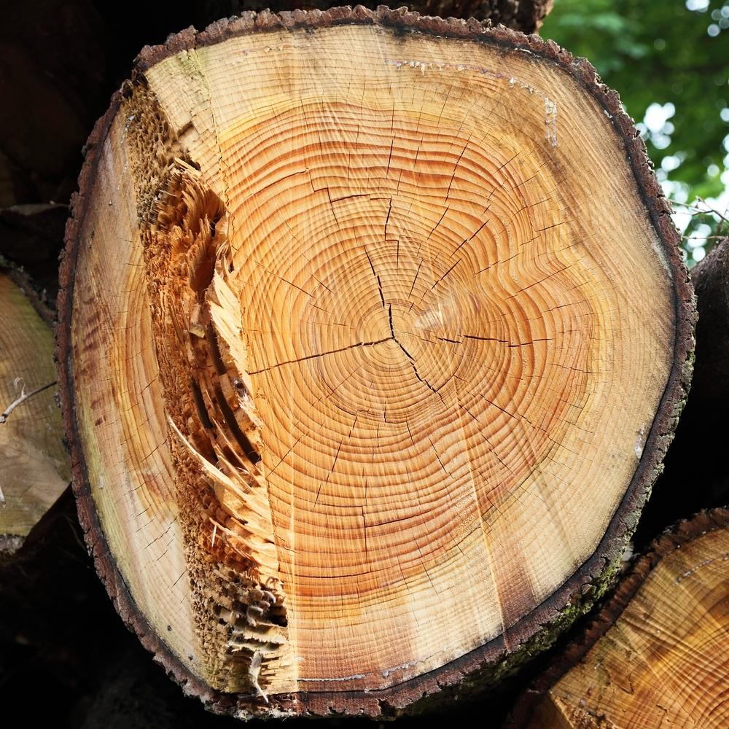

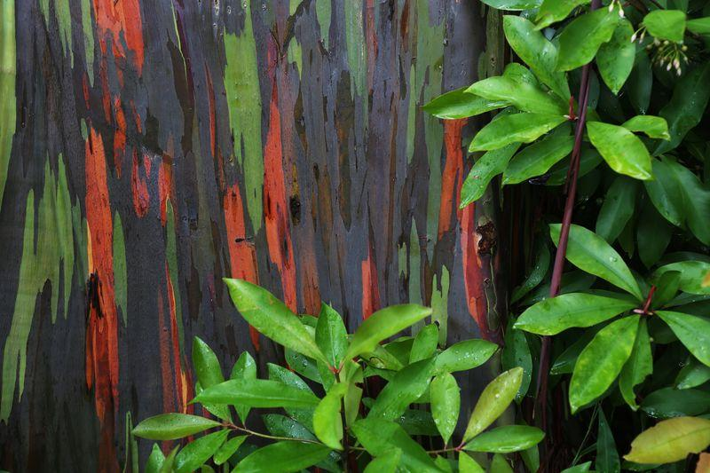

The colorful bark of Eucalyptus deglupta, widely known as "Rainbow Eucalyptus," on Maui's Road to Hana.

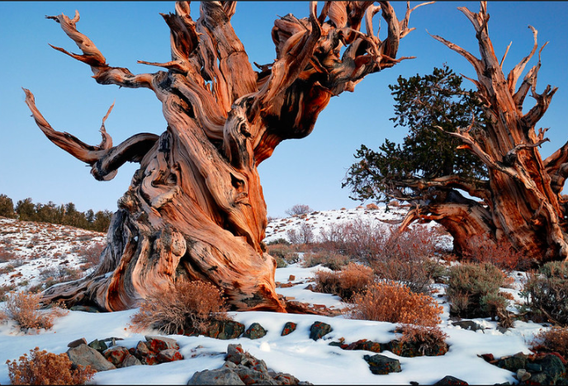

North America's bristlecone pines are especially long-lived, and one in California that's 4,848 years old (pictured above) was considered the planet's oldest individual tree until 2013, when researchers announced they'd found another bristlecone that sprouted 5,062 years ago. (The last woolly mammoths, for comparison, died about 4,000 years ago.)

Picture named “Gnarly” by Rick Goldwaser: <https://www.flickr.com/photos/21059999@N08/3082789230/>

Walk 7 Sticks, Twigs, and Change

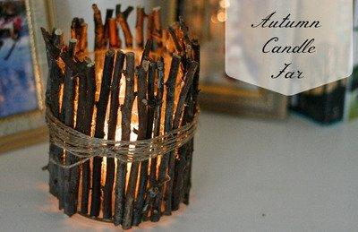

Pretty and eye appealing, this simple twig candle holder, with instructions by [Guide Patterns](https://www.guidepatterns.com/twig-candle-holder-ideas.php) will be a favorite homemade craft.

<https://www.yellowblissroad.com/handmade-christmas-ornaments-rustic-twig-arrows/>

Fun craft to make your own arrows (Christmas tree ornaments) with sticks, beads, and feathers if your child gets interested in this subject.

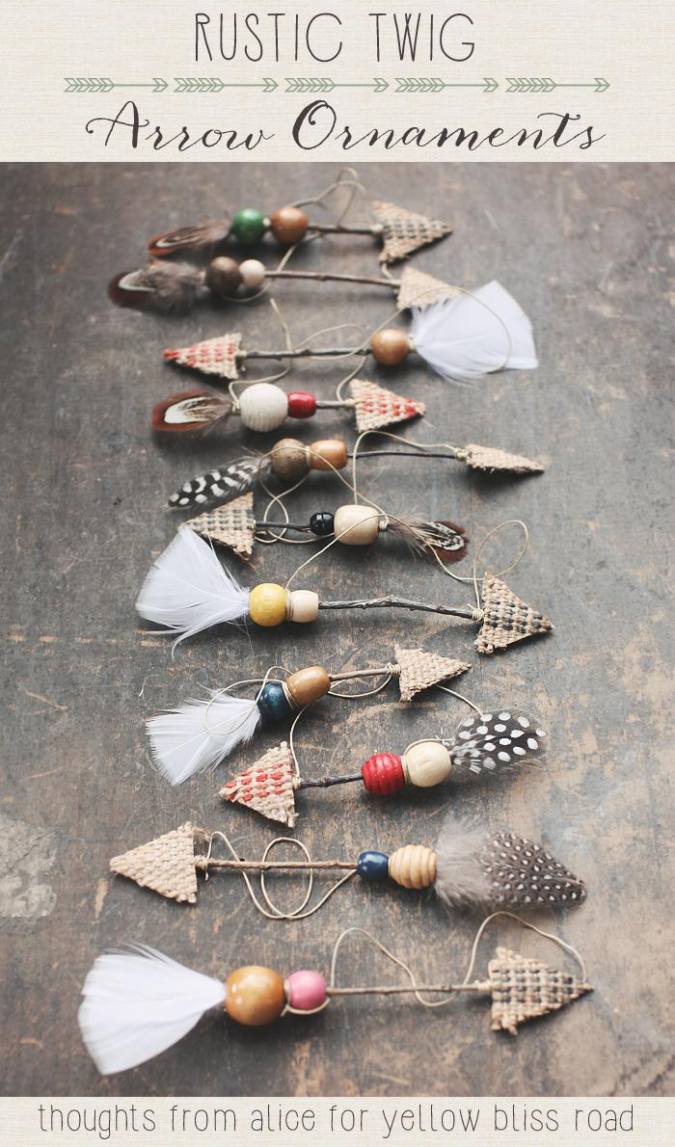

Use a stick or several twigs you find, glue it to a piece of paper, and then use colors, buttons, pieces of fabric, wrapping or tissue paper to make multicolored leaves.

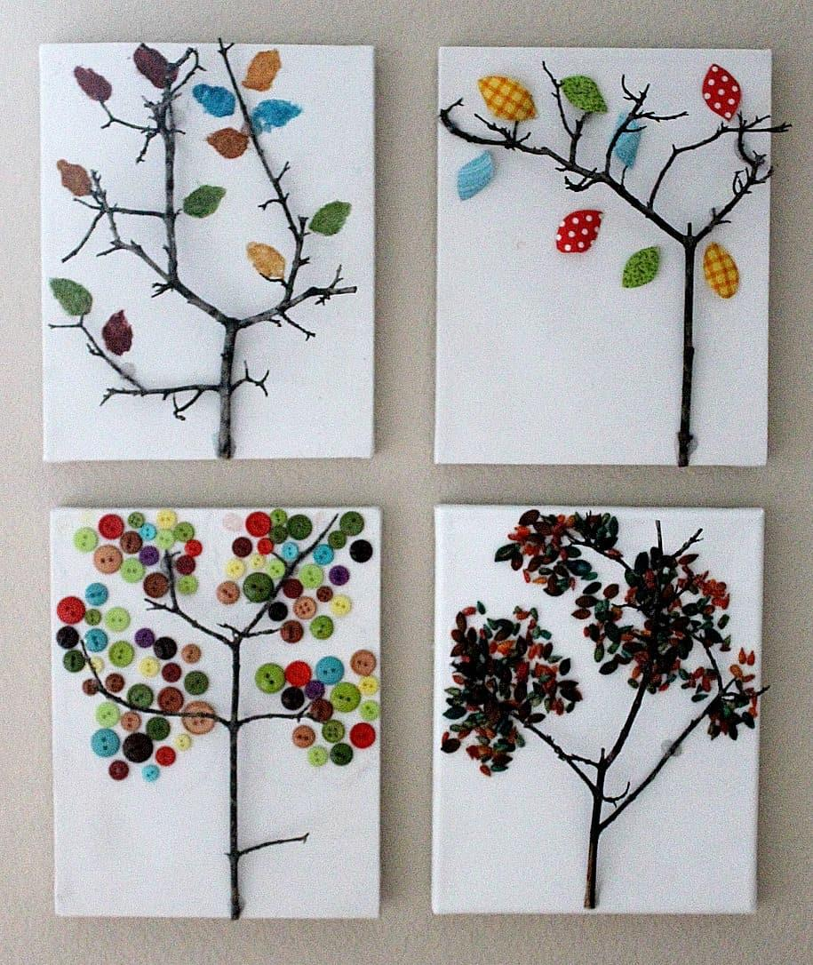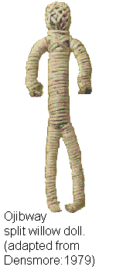

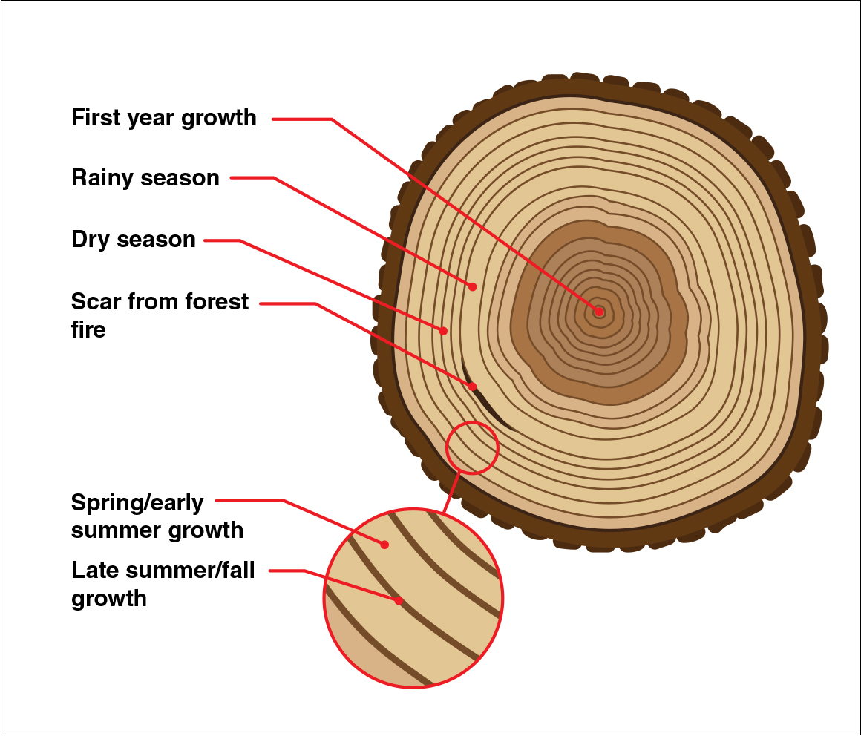

For more on how we can get a snapshot of the Earth’s climate through annual rings here:

<https://climate.nasa.gov/news/2540/tree-rings-provide-snapshots-of-earths-past-climate/>

Walk 8 Map

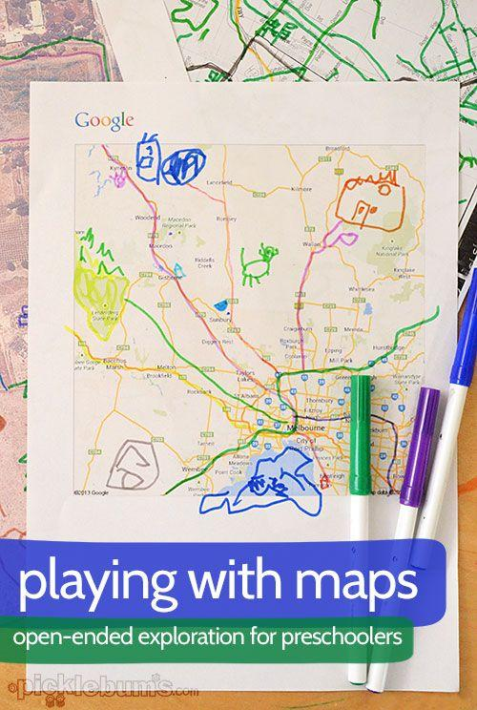

An example of a Google map printout with some markings

Primitive Map Symbols (on craft sand, or simply use corn meal or semolina!)

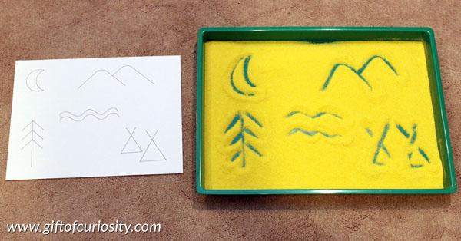

Walk 9 Rain

William Rankin - more info about the pilot and his fall through the thunder cloud for those who are interested.

<http://historynuggets.squarespace.com/nuggets/2015/12/31/into-the-thunderhead>

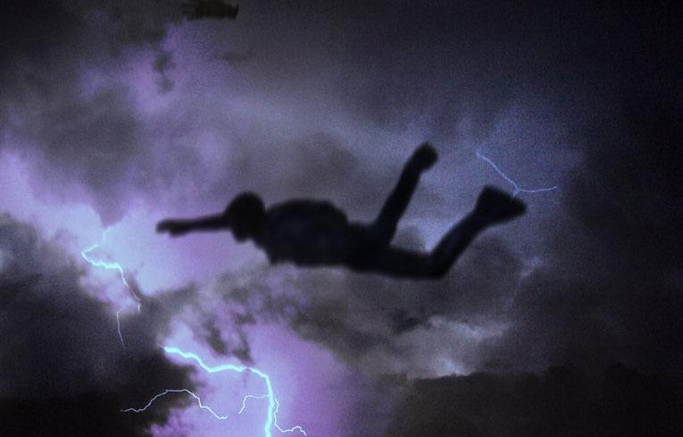

The “Cloud Harp”

See this link for more information about the [**Cloud Harp Installation**](https://www.voanews.com/archive/us-professor-makes-clouds-sing-2004-06-23) in Pittsburgh. Also, watch this [**video**](https://vimeo.com/5235502)

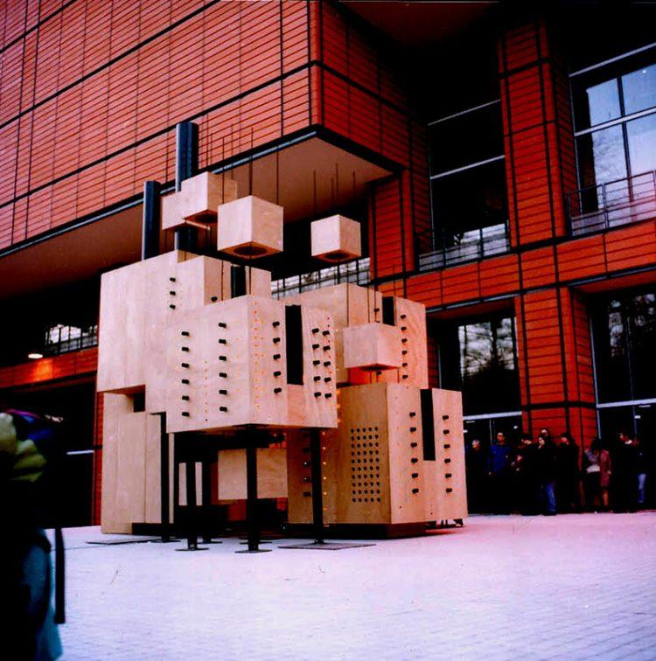

**A few more activities for a rainy day – Inspiration and Ideas**

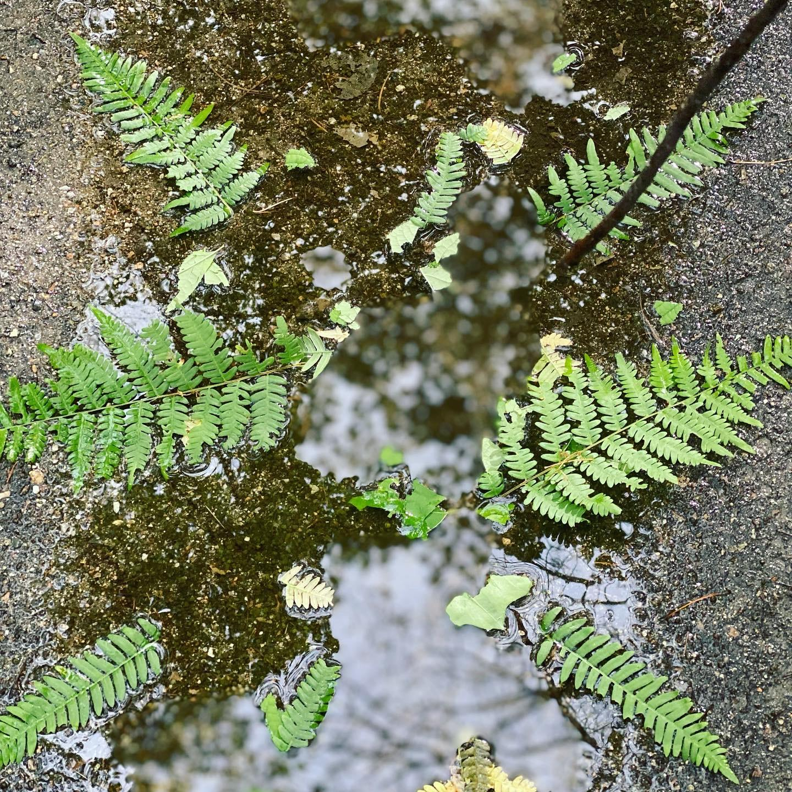

Decorating a puddle and making a puddle soup ☺

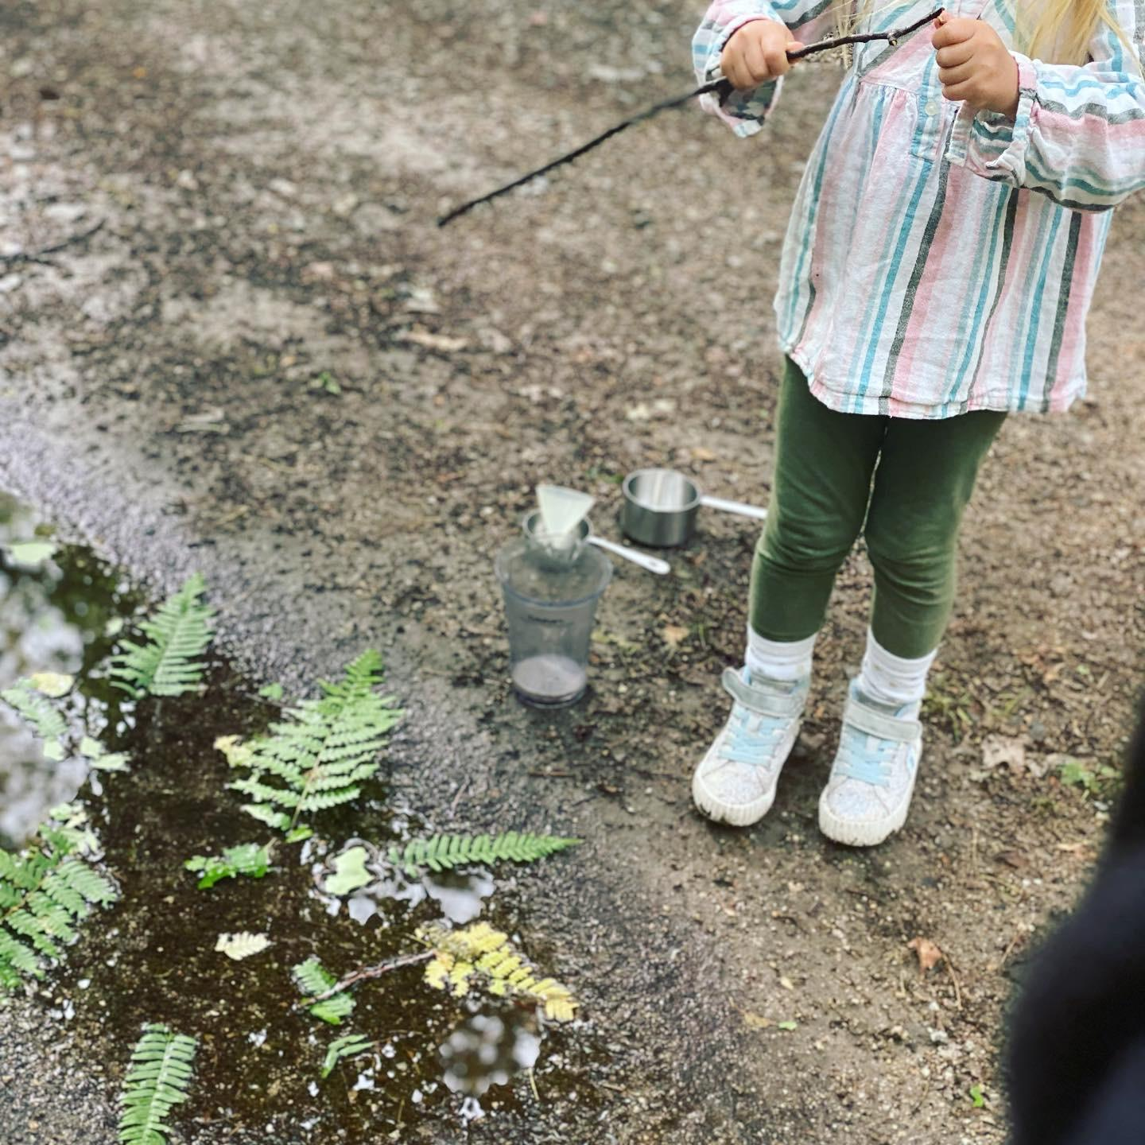

Heart shaped puddle!

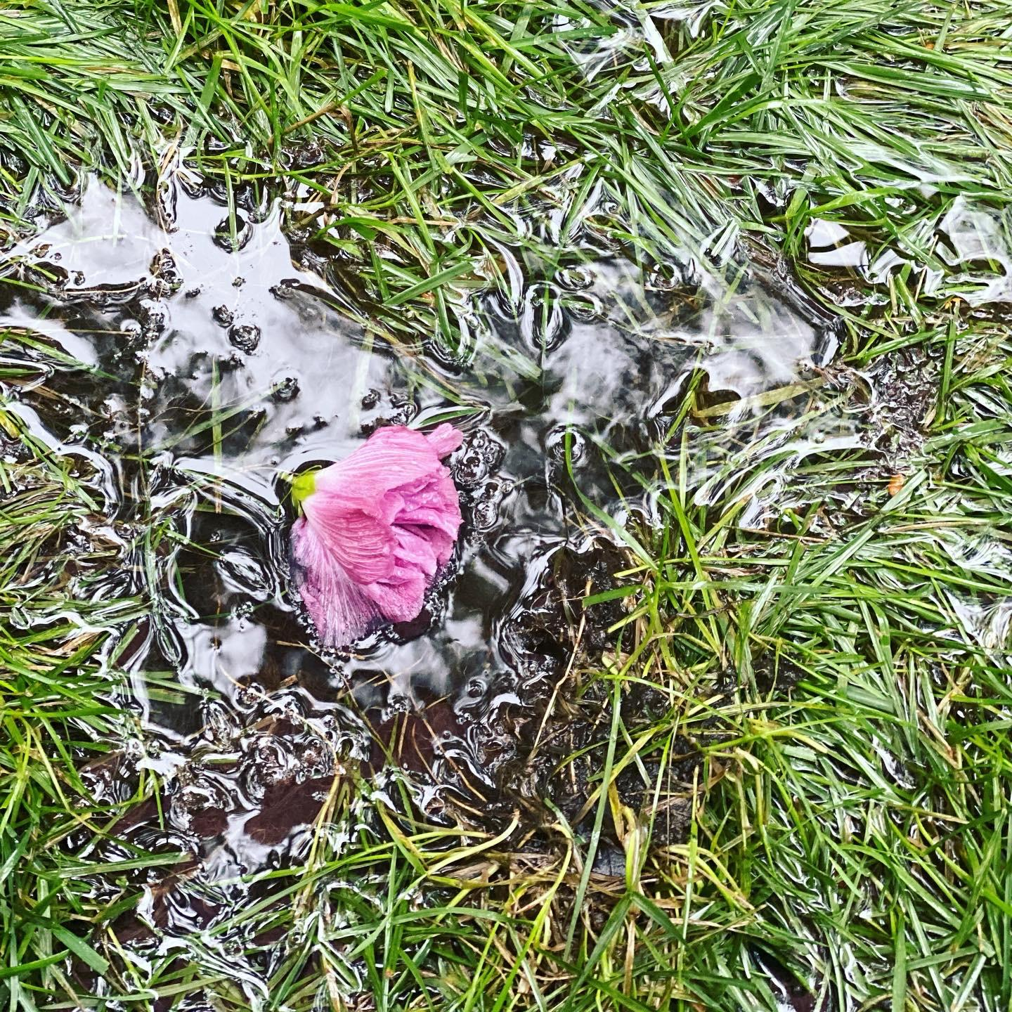

Reflections!

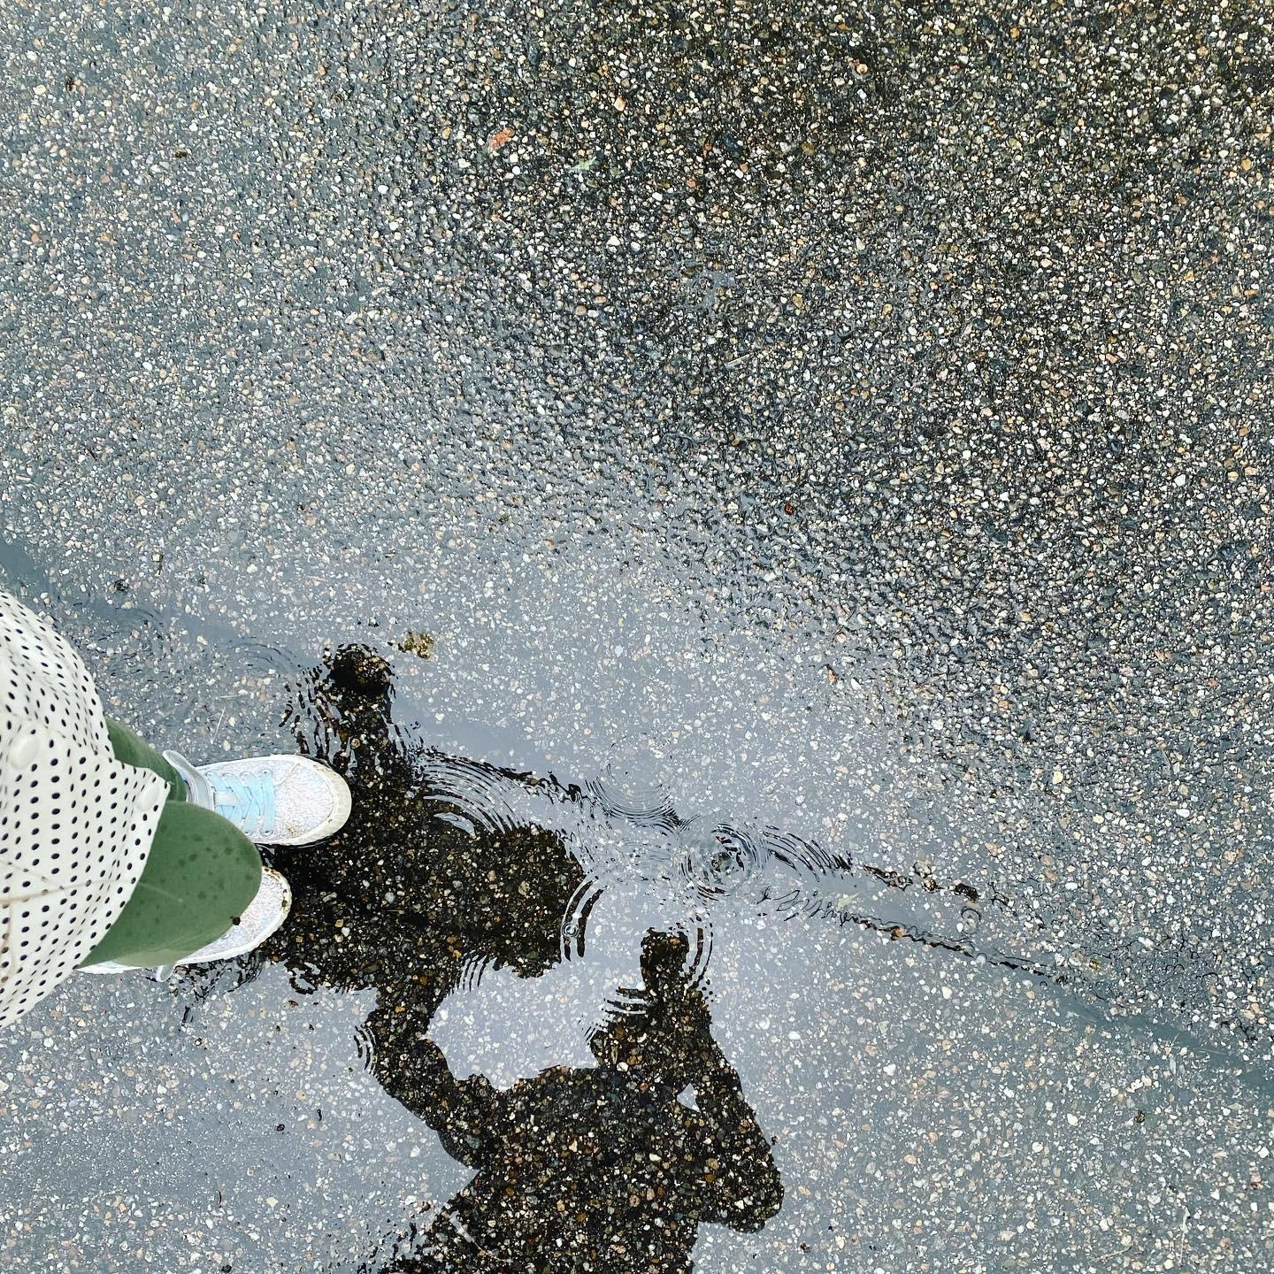

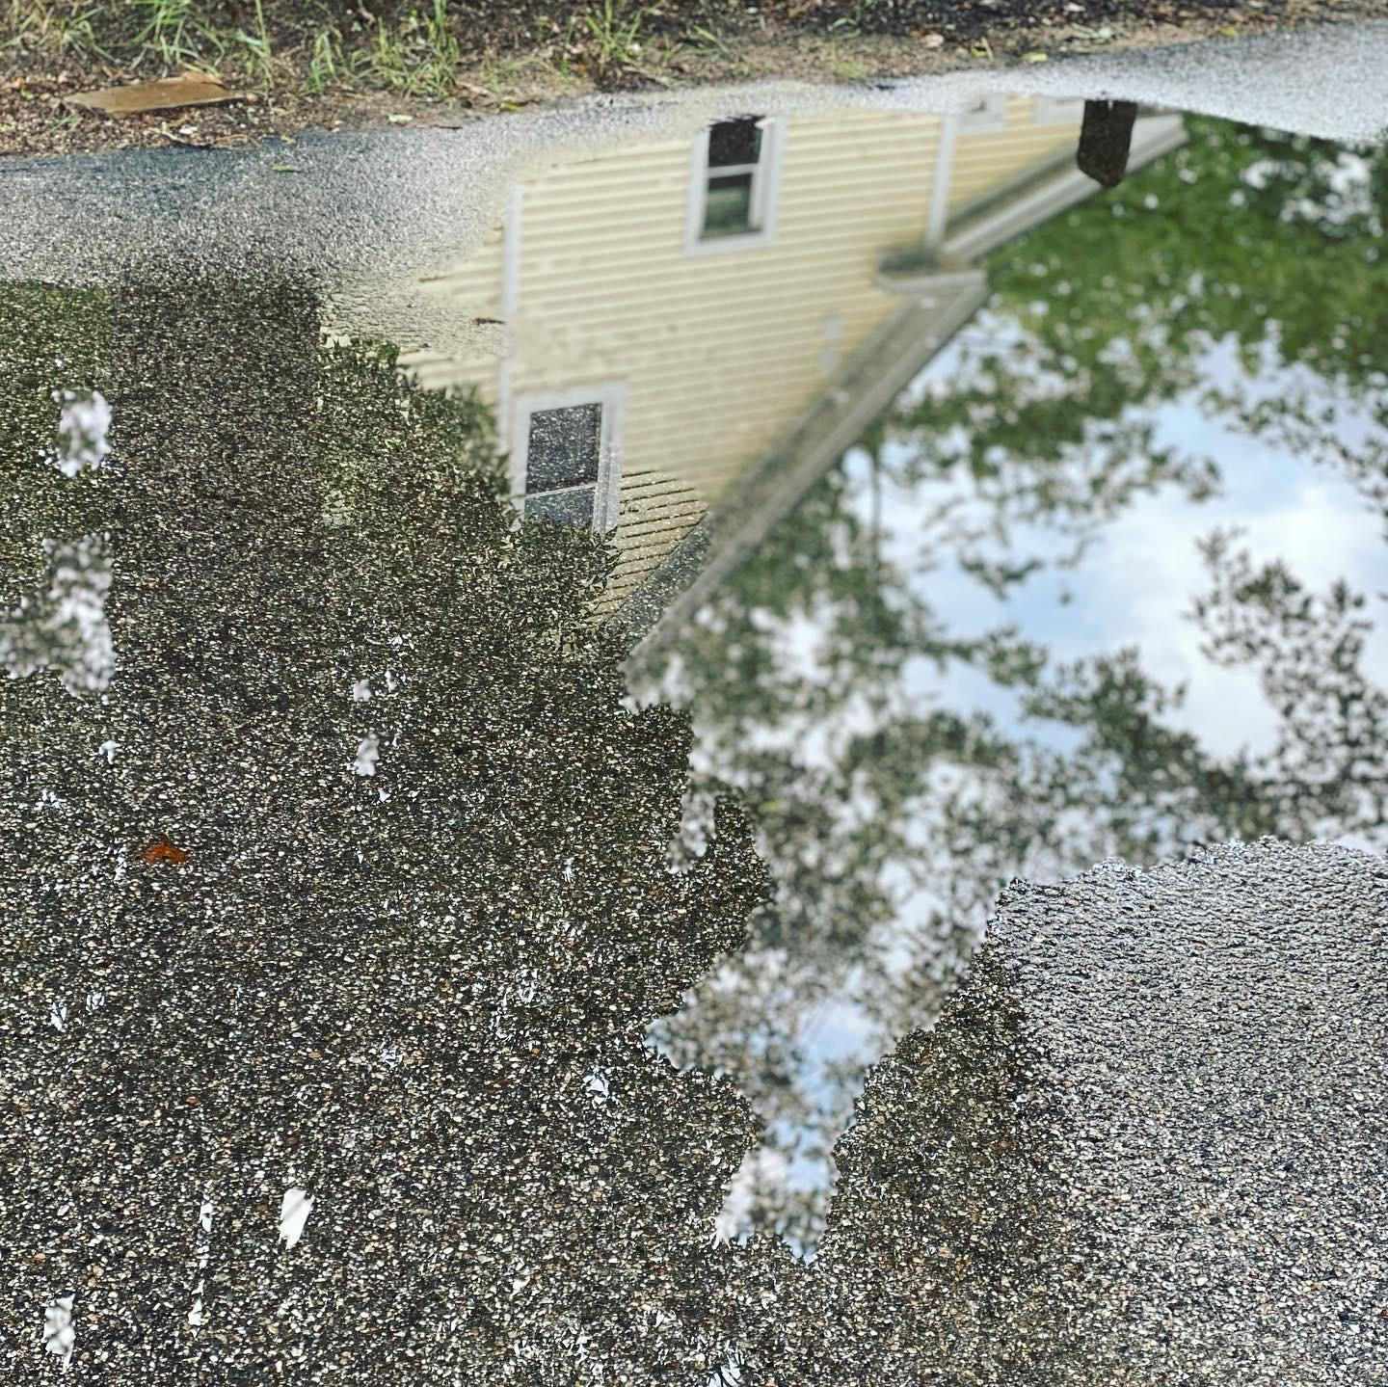

What did you find reflecting in the puddle?!

Walk 10 Sun

How to make the simplest Sun catcher with glue and colors:

<https://babbledabbledo.com/art-for-kids-cosmic-suncatchers/>

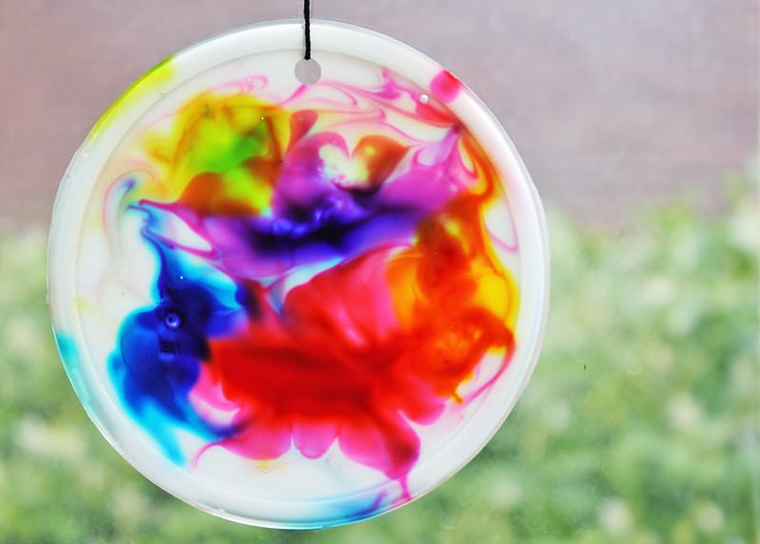

Water / oil / blubber experiment

<https://redtri.com/easy-science-experiments-using-water/slide/7>

Walk 12 Boating, Sailing and Floating

Some of our fun floating experiments

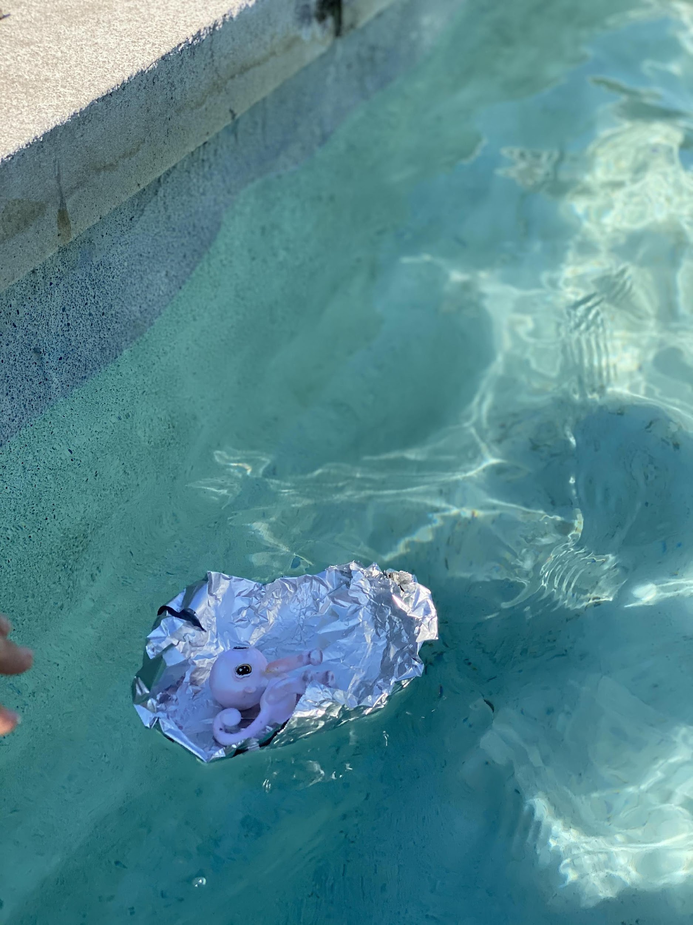

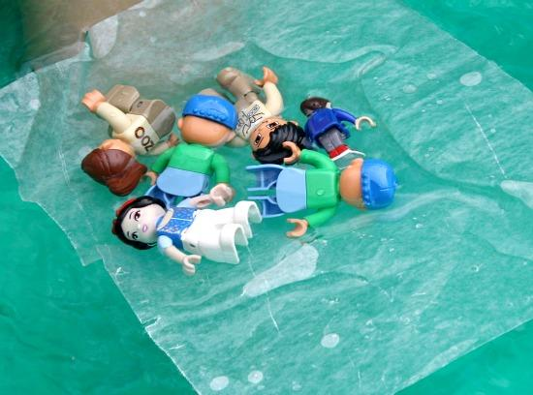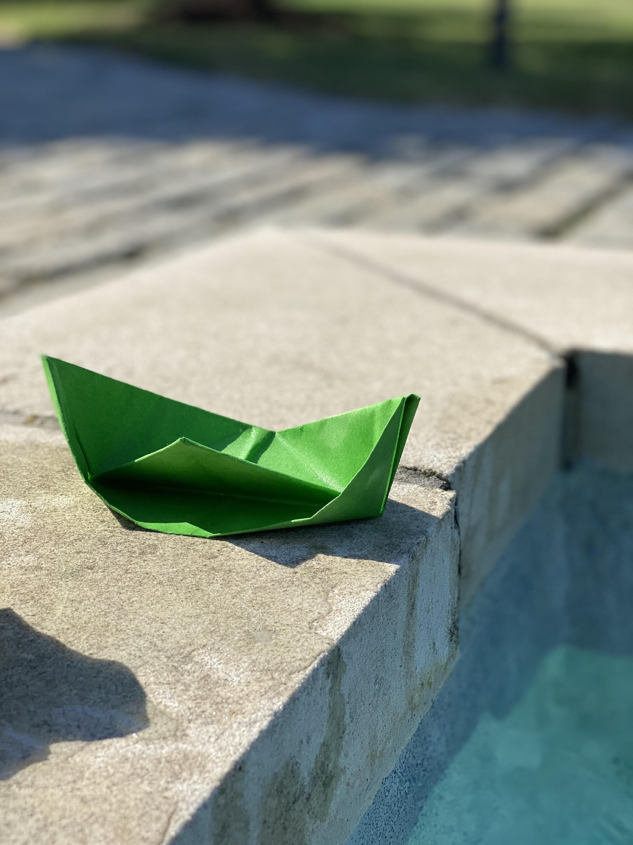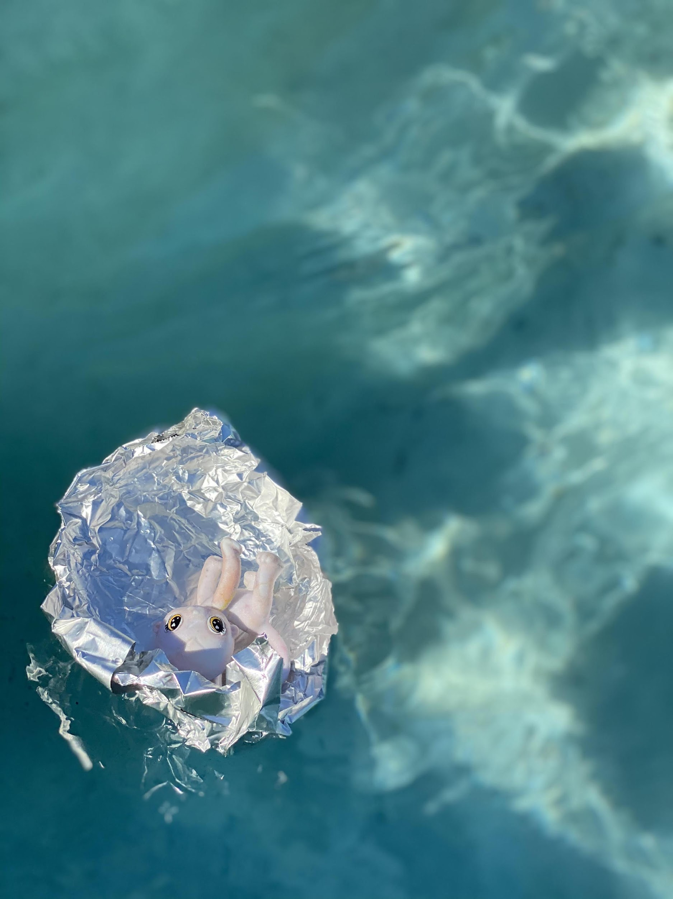

Walk 13 Coffee and Coffee Cups

Paper Cup phone

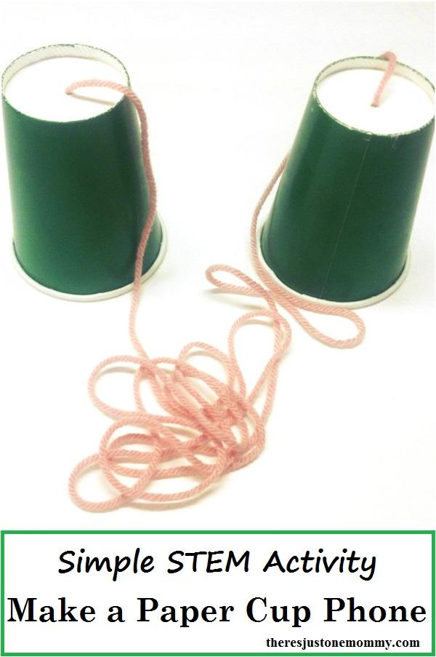

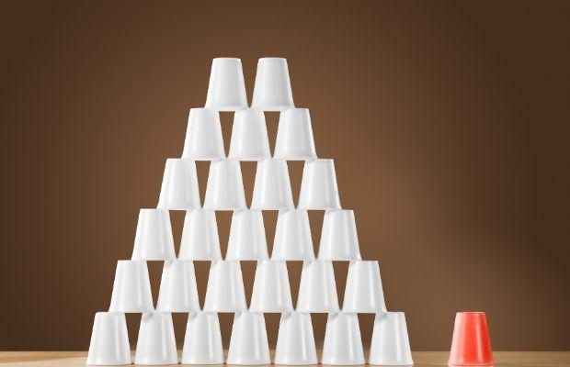

Paper cup castle

Some fun craft ideas if you have time on your hands:

<https://www.way2goodlife.com/20-fun-things-to-do-with-plastic-cups/>

Pomp om thrower craft:

<http://www.makoodle.com/wp-content/uploads/2012/06/mini-marshmallow-shooters-or-pom-pom.html>

Walk 14 Ants

Aphid (ant cows)

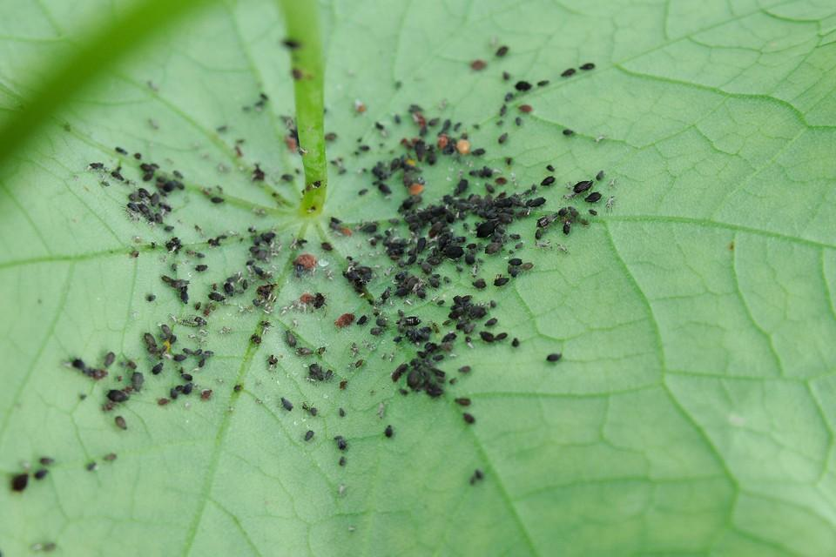

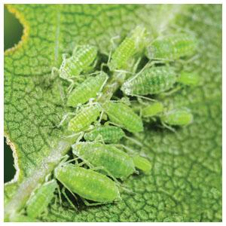

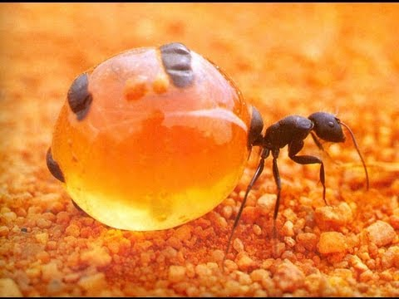

Honeypot Ant

Walk 15 Mail

The Milkwood tree in South Africa & monument to the boot that served as a mailbox (and still does, it just takes much less time for mail to be delivered!)

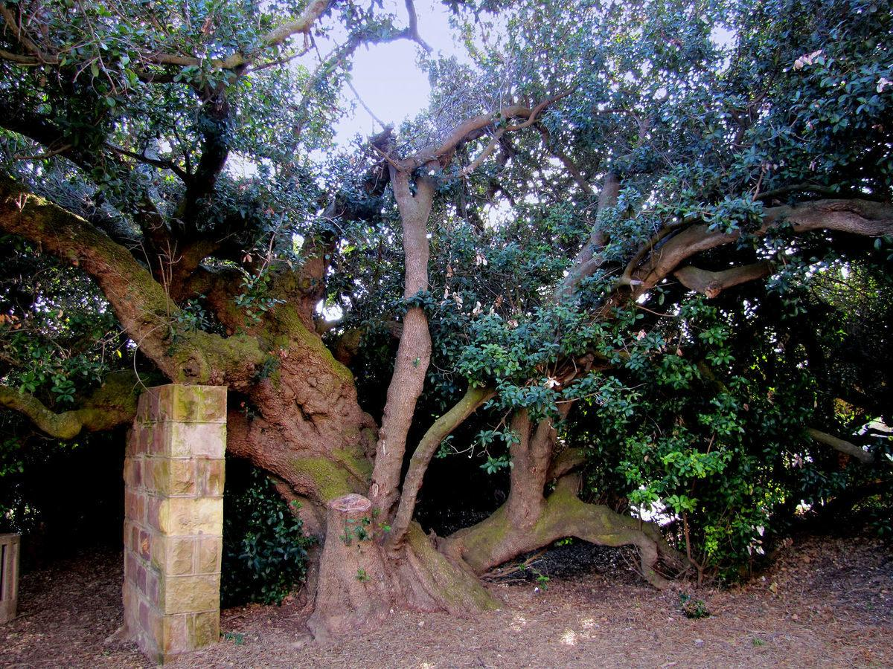

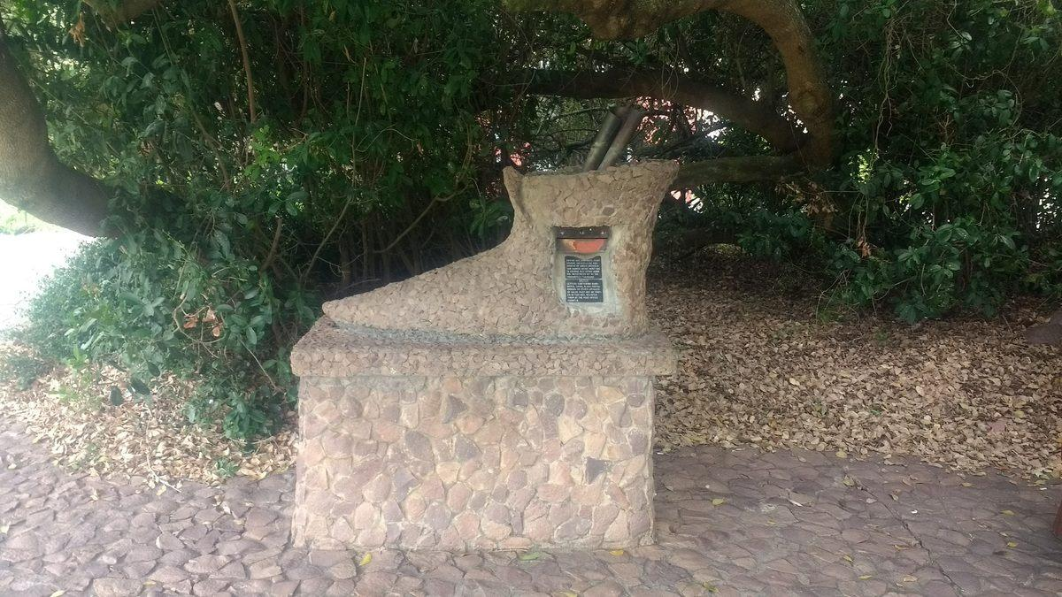

More creative ideas about mail if you need some:

<https://www.thechaosandtheclutter.com/archives/creative-mail-for-kids-5-unique-ideas>

Walk 16 Plants vs. Animals

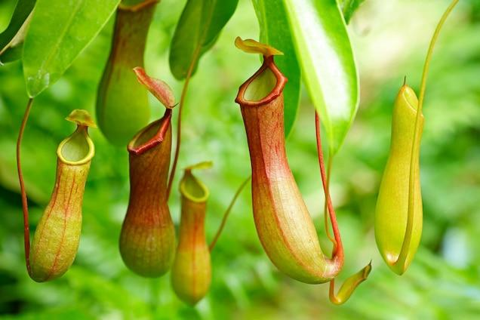

**Pitcher Plant**

All that’s left of unfortunate frogs caught by this plant are little frog slippers—the skin on the frogs’ feet is the only part the plant doesn’t digest.

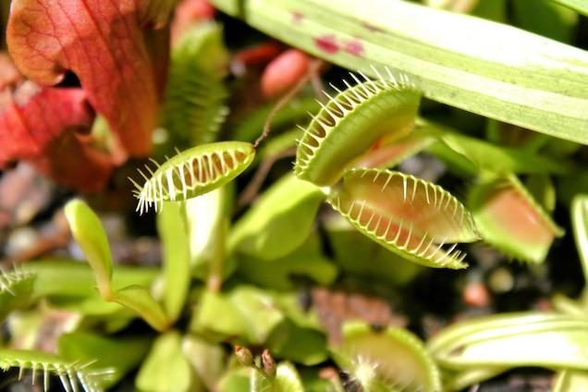

**Venus Flytrap**

The leaves of the Venus flytrap snaps shut if its tiny hairs are brushed twice by an unsuspecting bug.

**Australian Sundew Plant**

Thirsty bugs are drawn to what look like raindrops on the leaves. But the “water” is actually a glue-like substance to trap insects. Talk about a sticky situation!

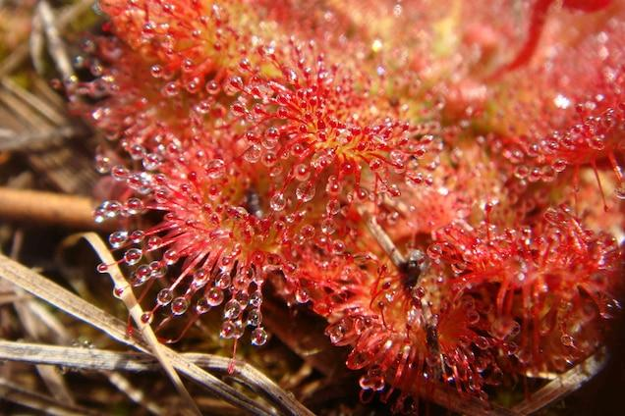

Walk 17 Houses and Homes

Animal home names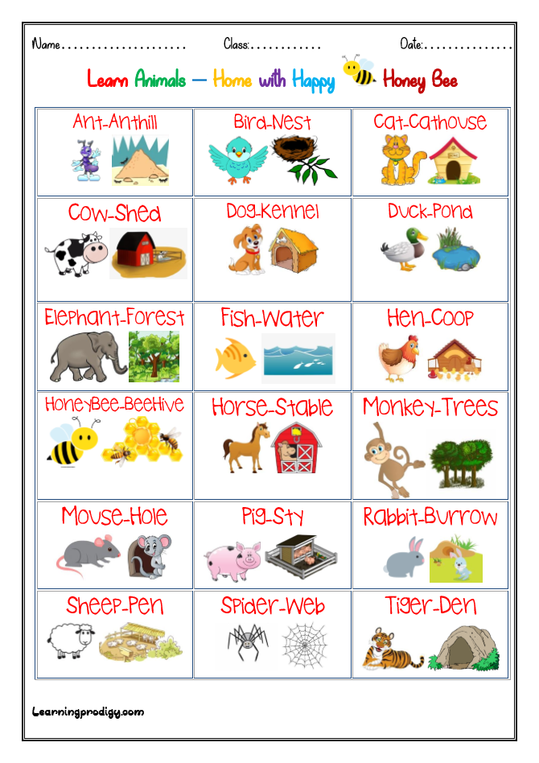

Also, watch [**this video**](https://www.youtube.com/watch?v=r_Fnk7dGq8U) to learn about animal home names!

Cave men in a cave

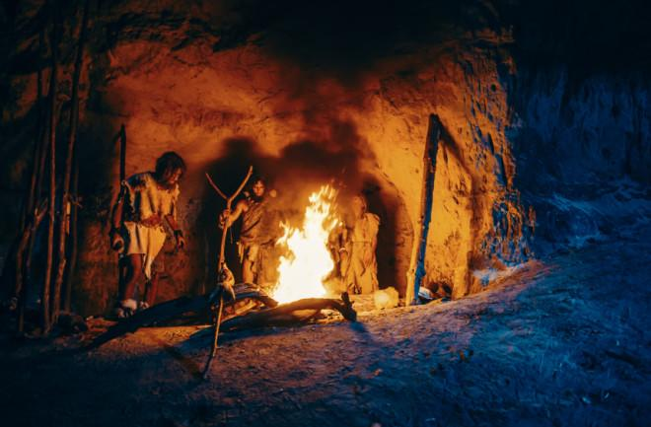

A short cartoon on cavemen if your kids seem interested [**here**](https://www.youtube.com/watch?v=9wtC1EuDlBE).

And [**this one**](https://www.youtube.com/watch?v=rLFGra2TiTE) for kids 6+ (a little more complicated).

**Unusual homes around the world**

Some unusual homes around the world – [Article link](https://www.scoopwhoop.com/Strangest-houses-from-around-the-world/)

**13 Most Unusual homes in the World** – [YouTube video](https://www.youtube.com/watch?v=mv7BXQue5cI)

**Images below**

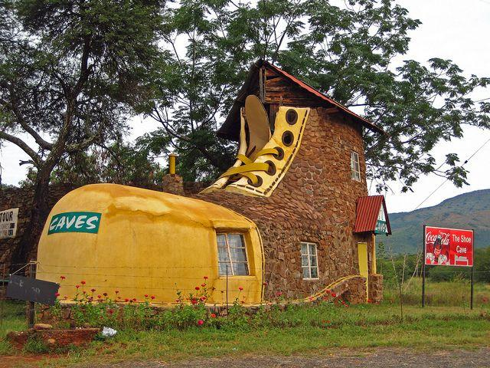

The Shoe House in South Africa

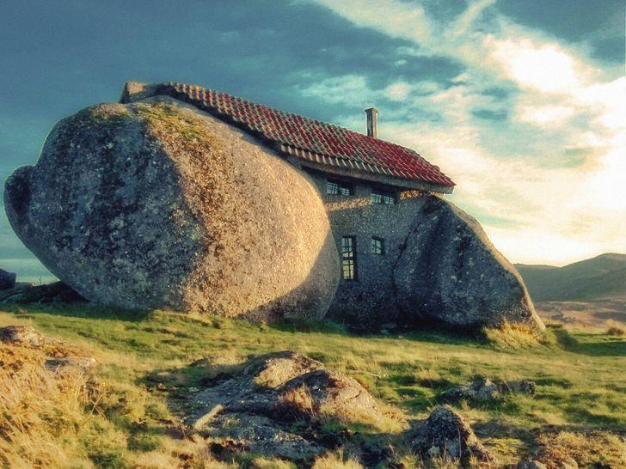

The Stone House in Portugal

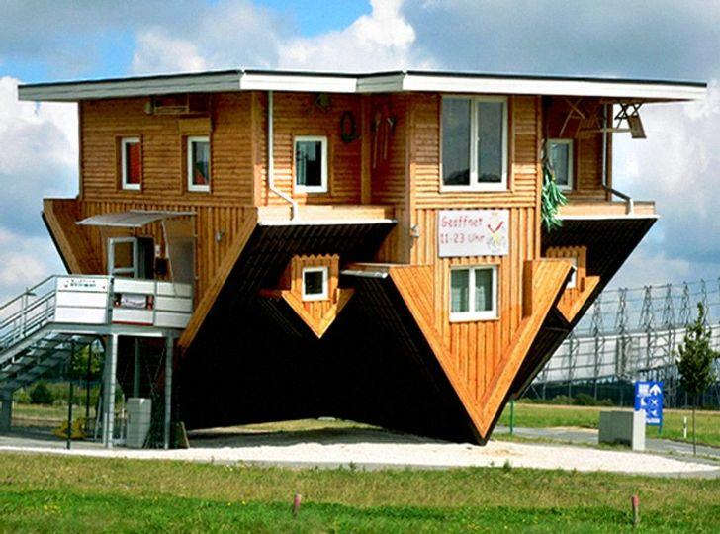

The UppSide Down House in Germany

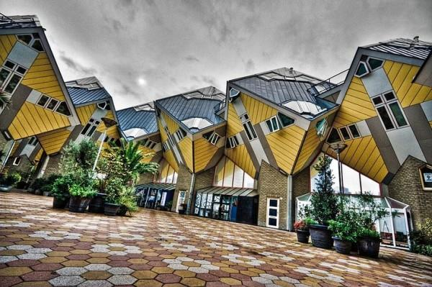

The Cube Houses in Netherlands

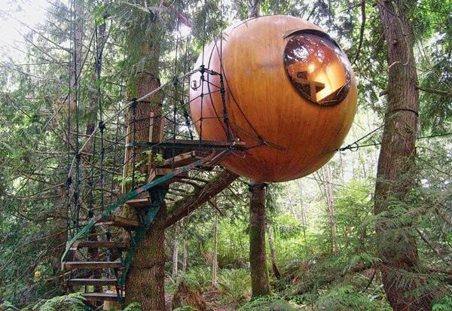

The Spherical Tree House in British Columbia

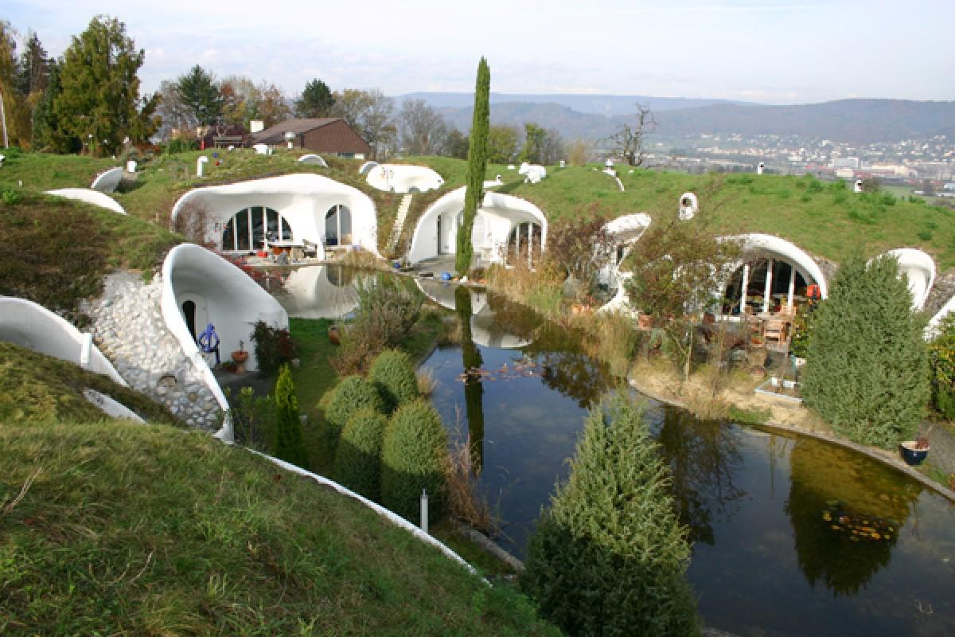

Switzerland’s Earth houses

Walk 18 Water

Lake Hillier, Australia - more information here:

<https://mybestplace.com/en/article/lake-hillier-the-mystery-of-the-pink-lake>

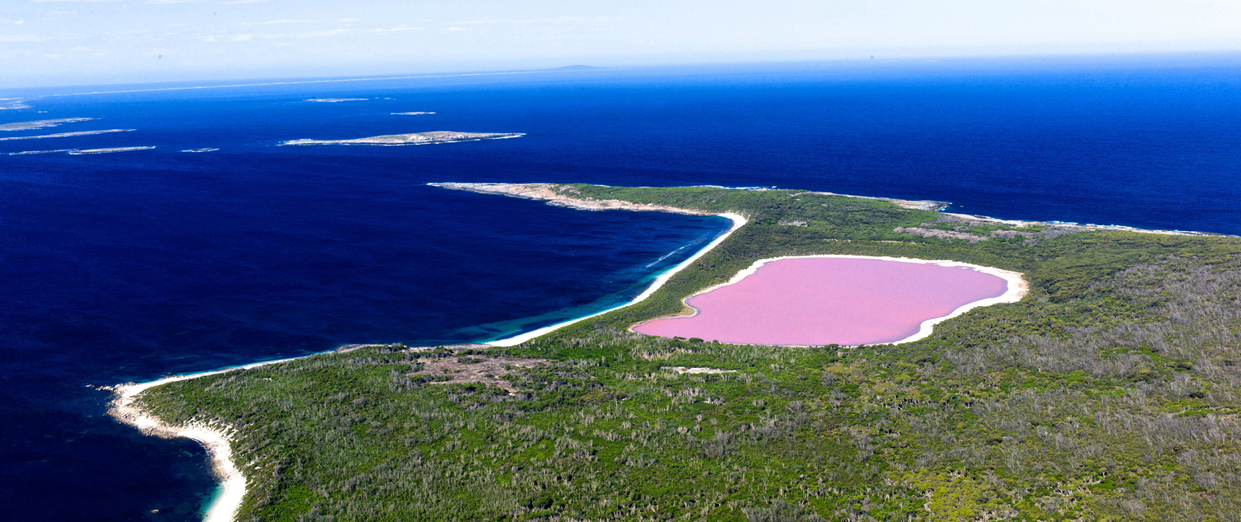

Lake Pukaki in New Zealand: This large alpine lake gets its color from the minerals running off of the surrounding glaciers.



The Garan Prismatic Spring, Yellowstone National Park, Wyoming

Its colorful water is a rainbow caused by different color bacteria and ranges from red to blue.

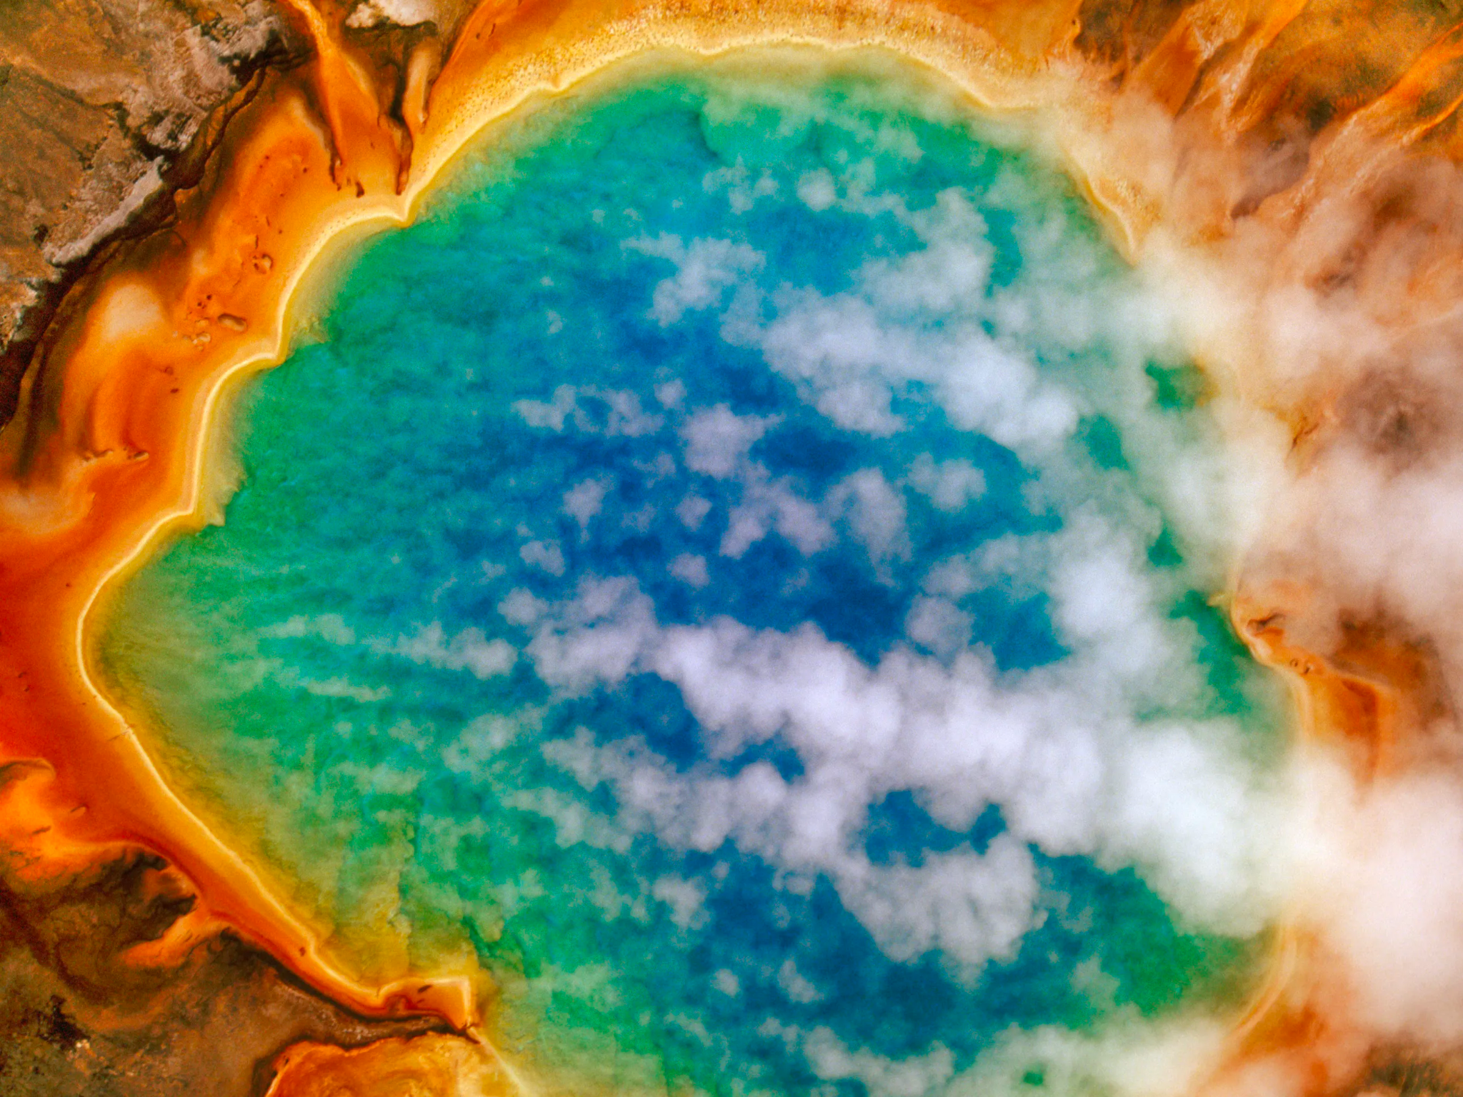

Laguna Colorada in Bolivia:

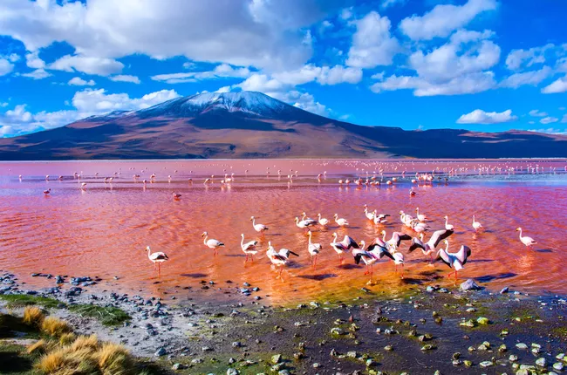

More on oddly colored lakes: https://www.cntraveler.com/galleries/2014-10-03/australia-s-pink-lake-and-other-oddly-colored-bodies-of-water

Explore the map and some unusual lakes with Google Earth:

[Unusual Lakes - Google Earth](https://earth.google.com/web/data=CiQSIhIgYjEyZmQzMjMwNDU4MTFlN2I1ZTEwMTQzMDUyMWMyZDQ)

[https://earth.google.com › web](https://earth.google.com/web/data=CiQSIhIgYjEyZmQzMjMwNDU4MTFlN2I1ZTEwMTQzMDUyMWMyZDQ)

Pitch Lake in Trinidad. It consists of asphalt!

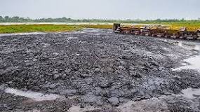

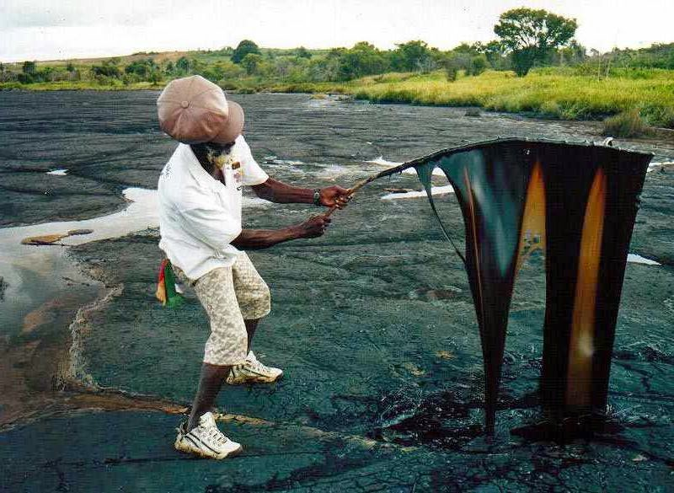

Read more: <https://explorersweb.com/trinidads-pitch-lake-the-wonder-of-the-caribbean/>

Fun experiments filtering water (you can use sand, rocks, dirt and more). You’ll also need a couple of paper coffee filters. Use the “tiny humans” method to explain that little dirt humans are mixed in with the water humans, but as they go through, they are a little too big while the water humans are smaller and more flexible so they can sip through the sand humans, while the dirt ones stay.

<https://www.science-sparks.com/cleaning-up-water-looking-at-filtering/>

Sone great absorption experiments: <https://www.science-sparks.com/absorbing-experiments-simple-science/>

Walk 19 Birds

* Philippine Eagle a.k.a Haring Ibon:

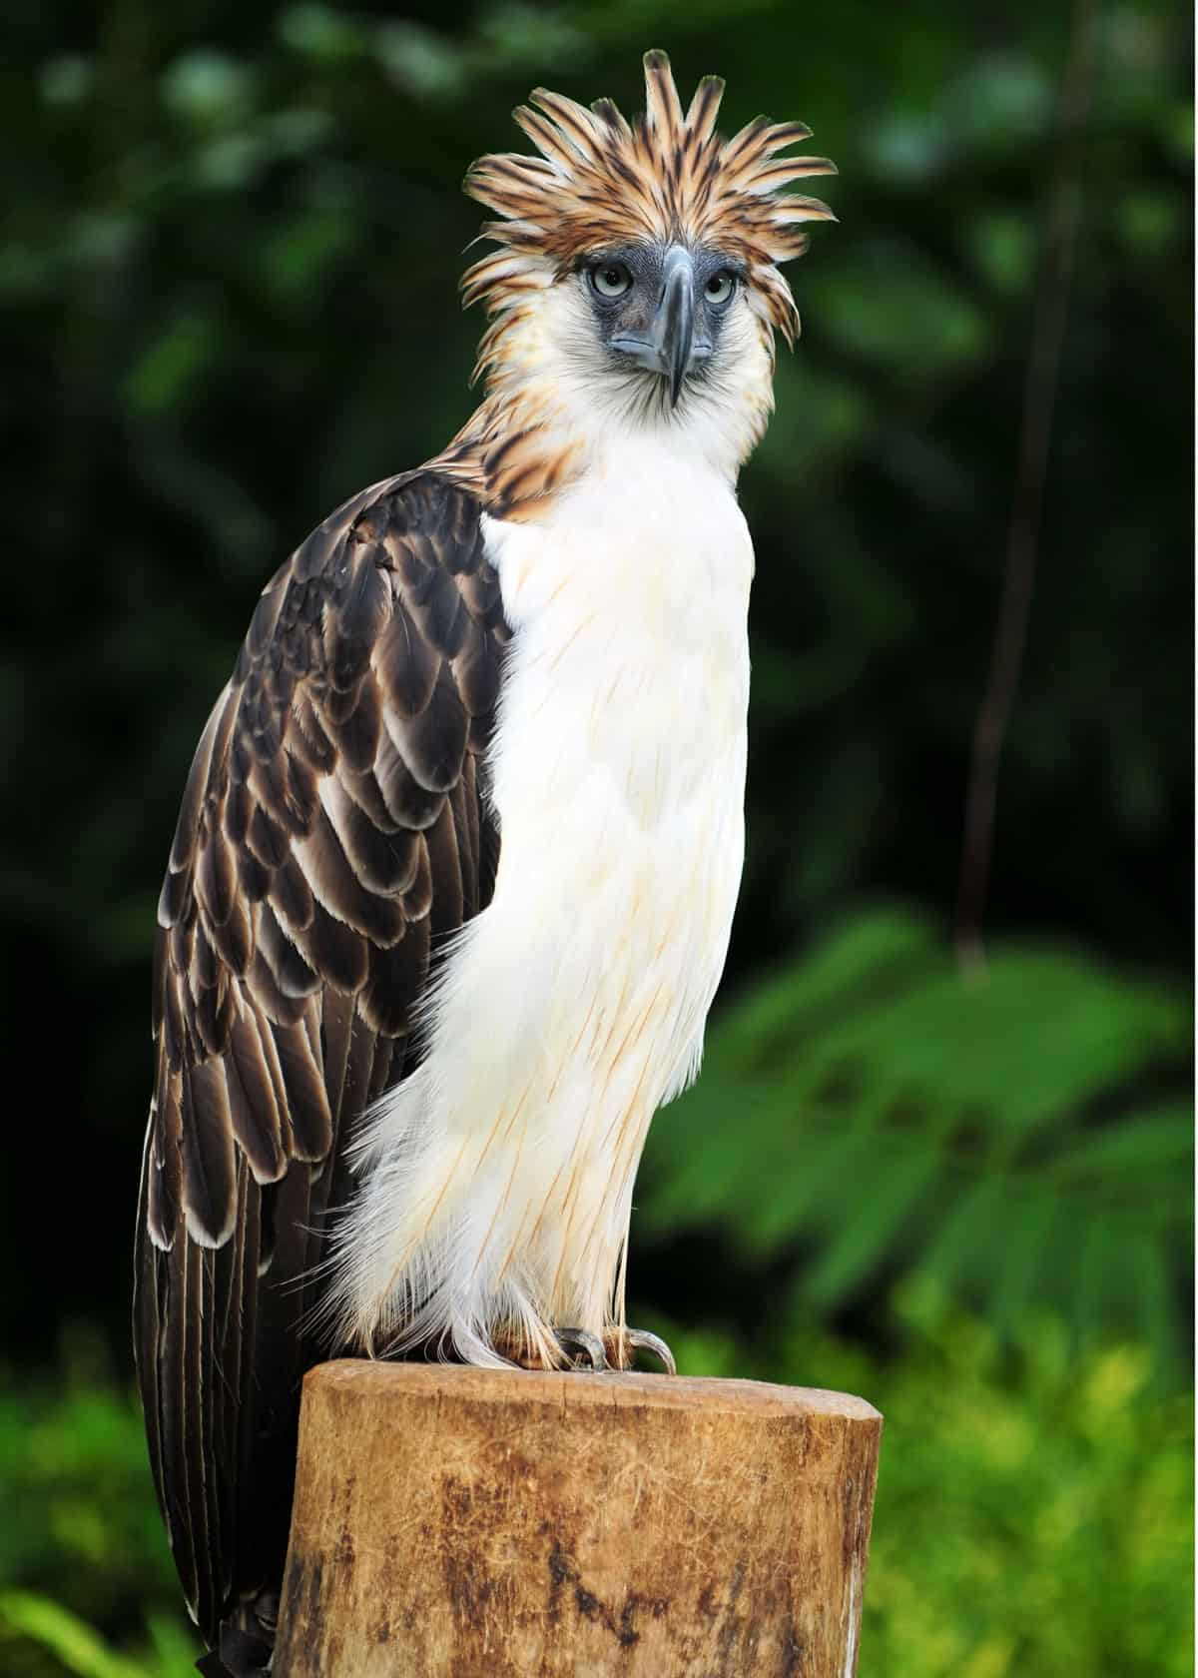

Check out this link for more information, photos, and videos about unusual birds:

<https://justbirding.com/weirdest-birds/>

Check out these little adorable penguins from Phillip Island, Victoria (in Australia):

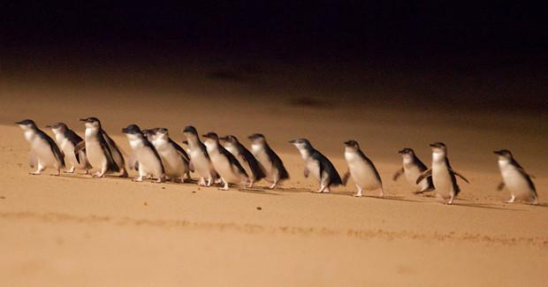

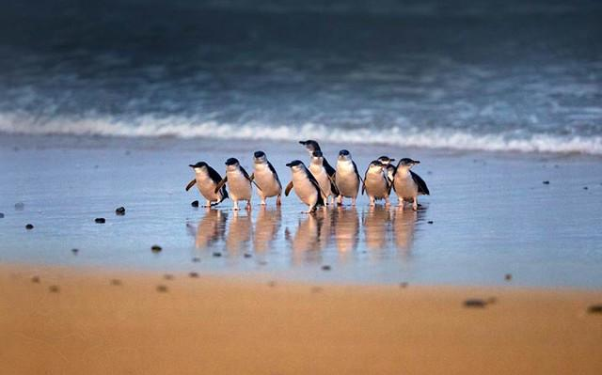

Make sure to watch this short video too: <https://youtu.be/yrUwMDHqNCE>

Make Way for Ducklings - a Statue in Boston Public Garden

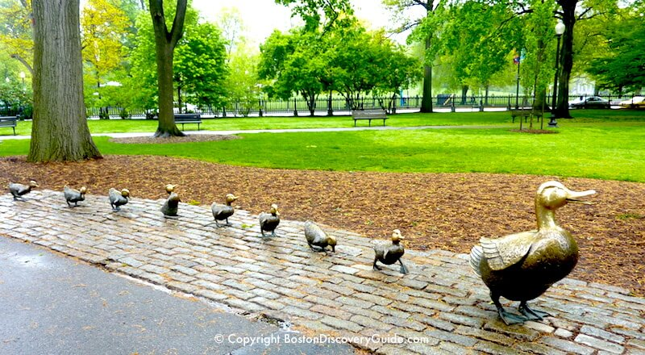

Bird Feeder Crafts: <https://www.redtedart.com/bird-feeder-crafts/>

Walk 20 Moon

Print out a few of these Super Moon photos and ask the child what they see on it. Fun to write or make drawings on it!

​​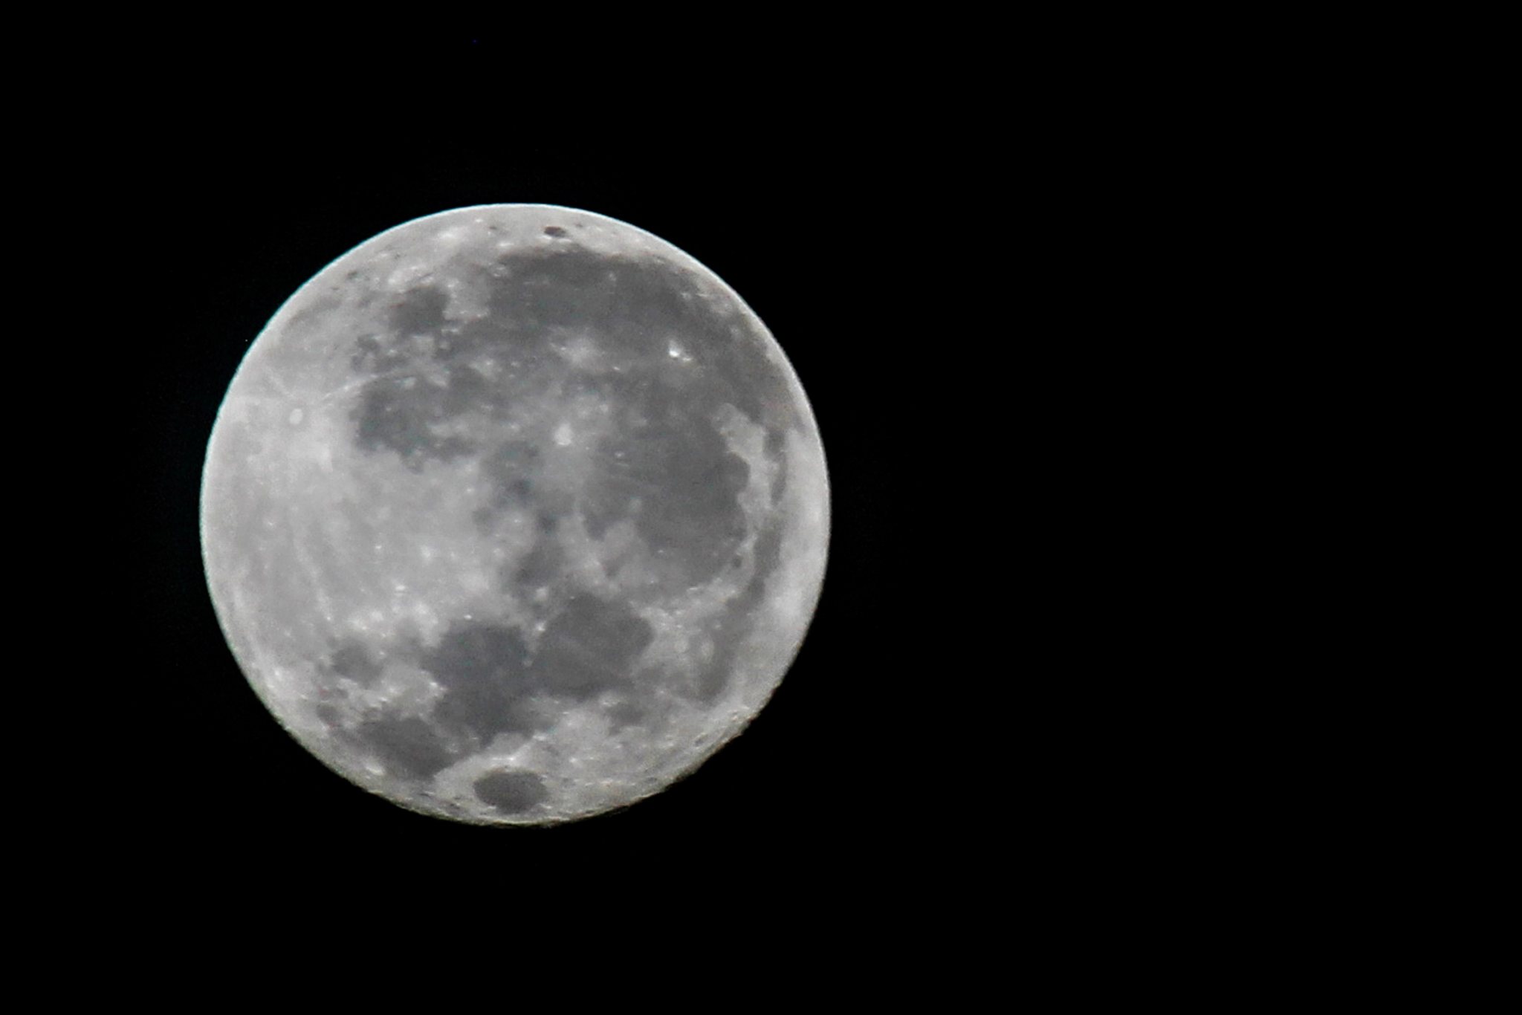

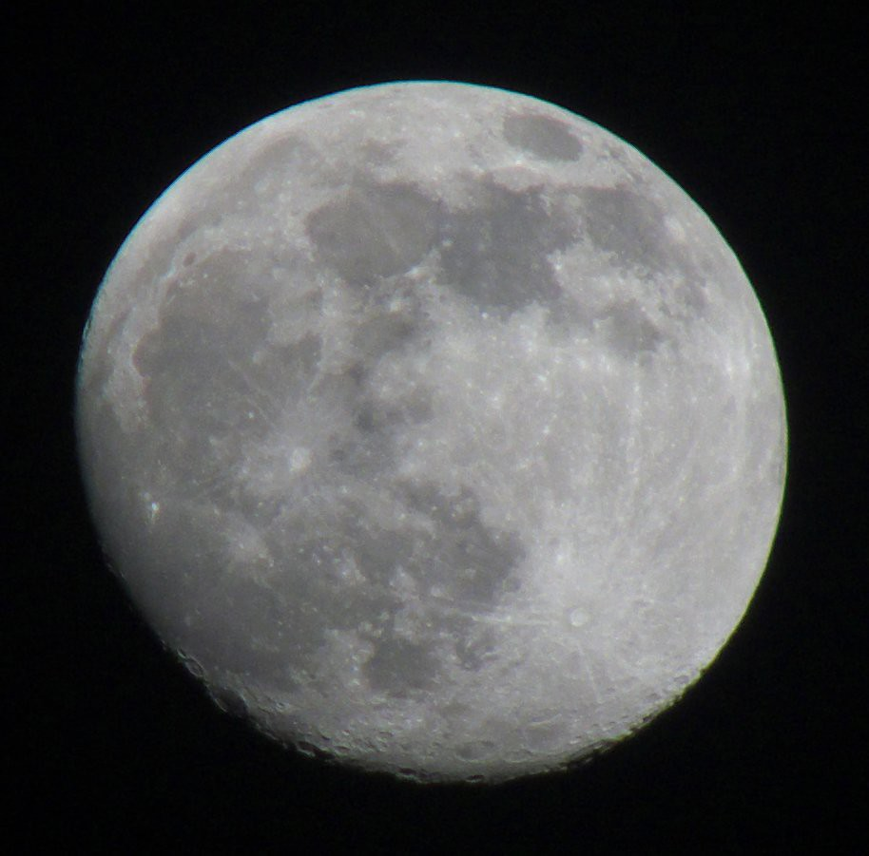

Walk 21 Chalk

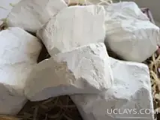

Edible chalk. Natural edible chalk chunks for food produced in a unique environmentally friendly fields in Ukraine, it is completely natural.

A 2 minute [video](https://www.youtube.com/watch?v=qDKf3igSPYg) from a place where chalk comes from.